How to Give

**FOUNDATION**

**THE GIFT OF A GIRL**

• Pray for The Gift Of A girl Foundation. We believe that nothing is accomplished that is worthy of the Lord without prayers and physical support.

• Support of each primary child at $10 per month which helps:

•  School Fees

•  Scholastic materials

•  Medical assistance

•  Transportation

•  Uniforms

•  Supervision

• Support for each secondary child at $35 per month for school fees.

• Children activity fees (examples below)

•  Seminars

•  Cooking competitions

•  Special educational tours

•  Transportation

•  Teaching materials

•  Tools

•  Contribution for means of transport

• Development of the land

• Director’s housing

Many needs have not been mentioned. Whatever your gift may be, it will be used to reach these needy children.

All donations are greatly appreciated. With your help, we will be able to do many activities with the girl child. Please know that ever y gift will be used wisely and under strict supervision by our board. The gift of a girl foundation financial position is small but focused in girl child support. Thank you for helping us.

hank you for help

ing

us help Ugandan children.

How to Give

**How Can You Help**

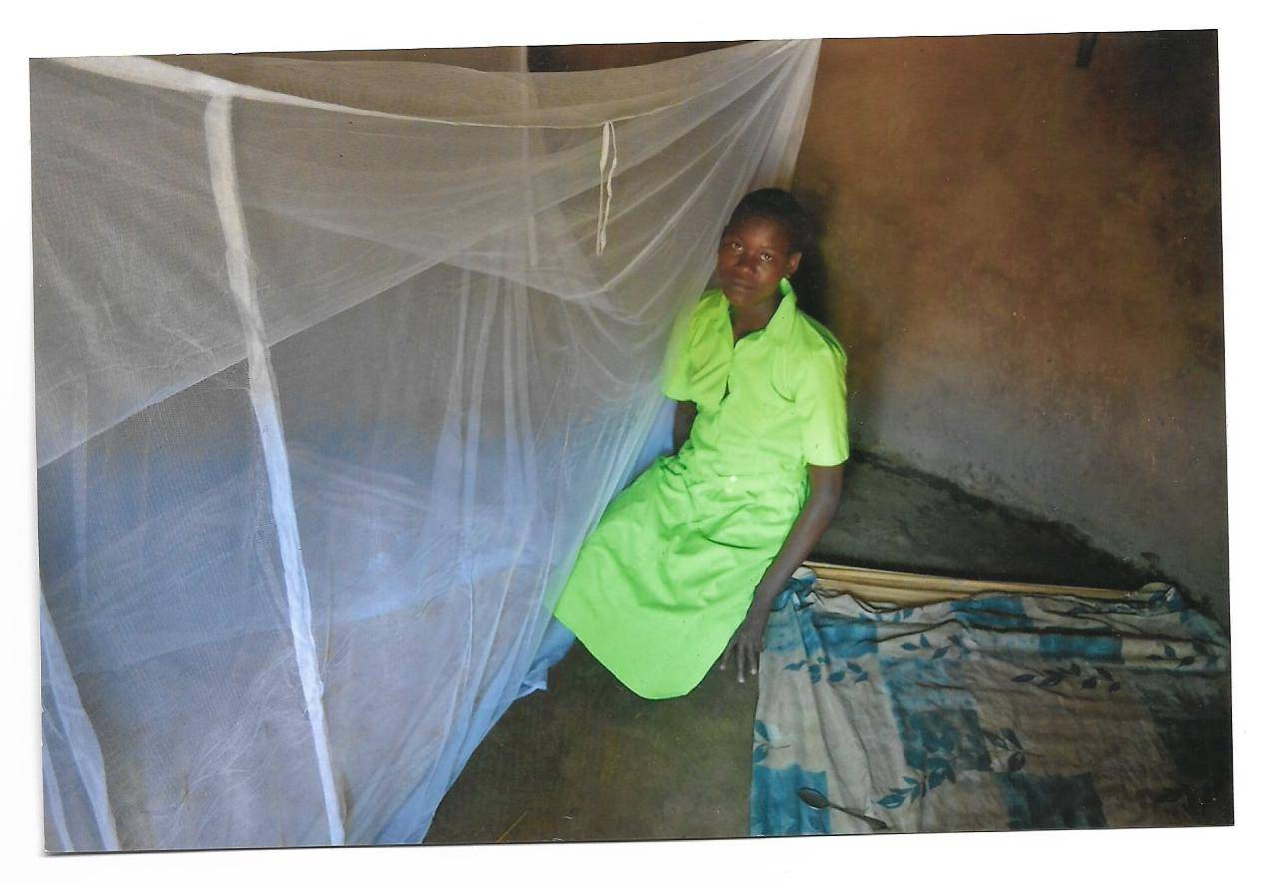

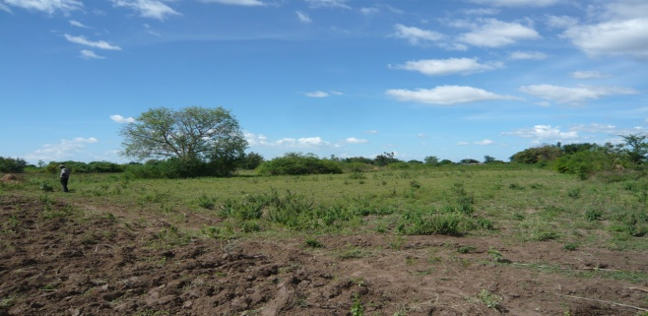 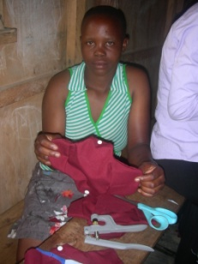

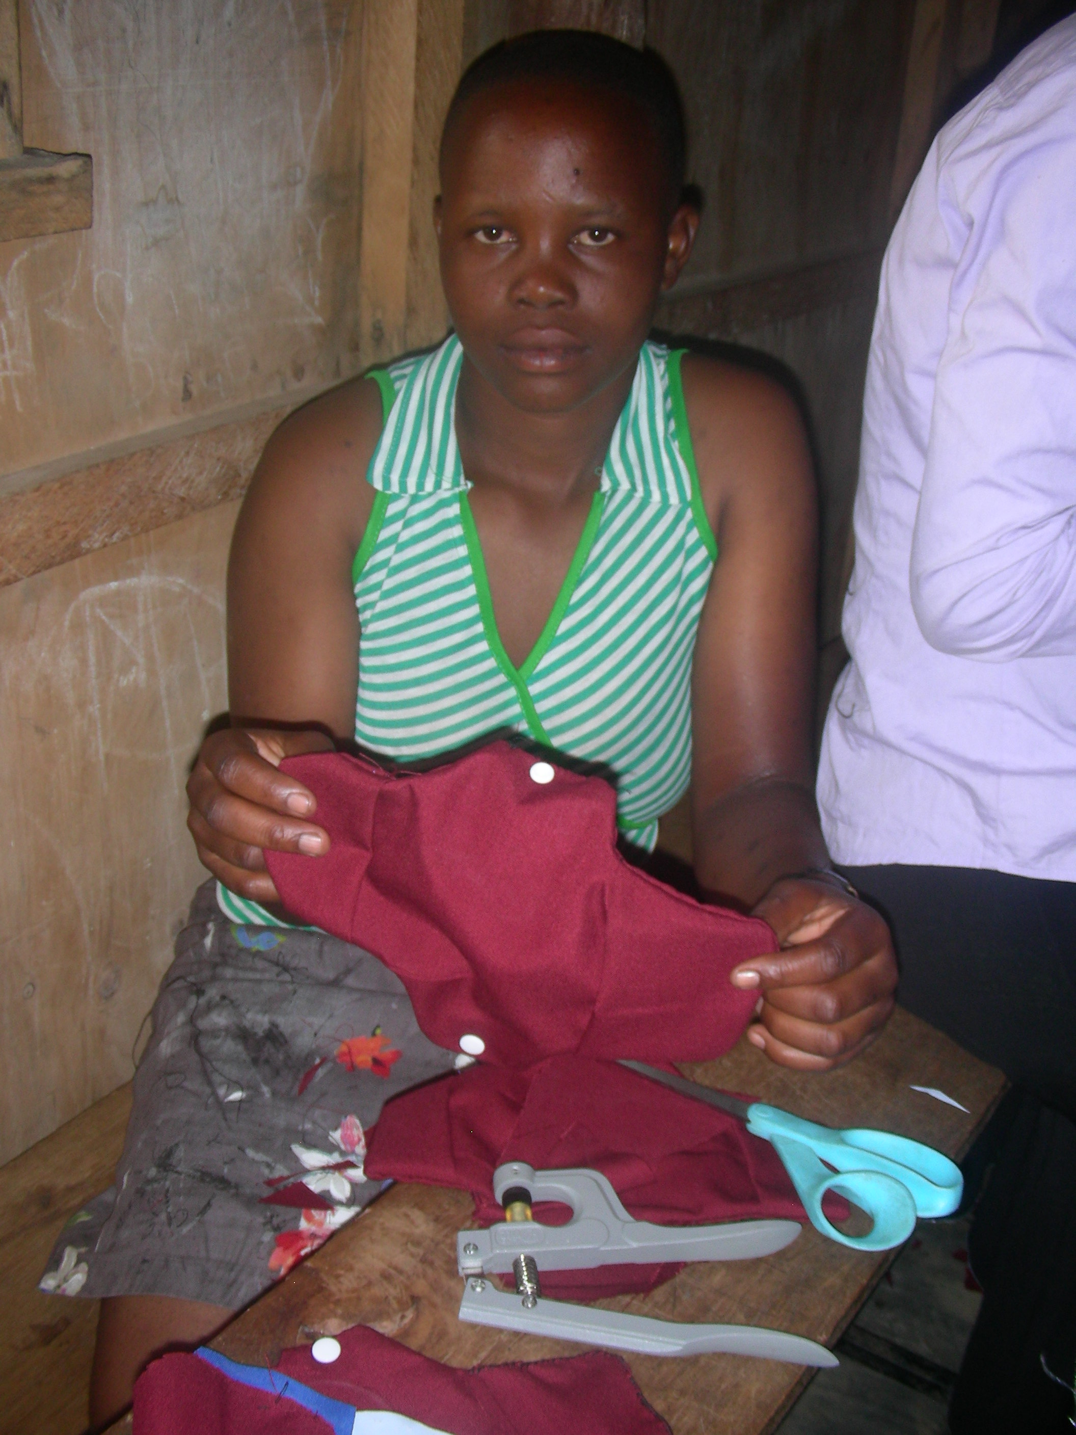

**Help a Girl child today,**

**You help the Nations**

**Tomorrow.**

*To help a girl child to growing in enabling environment good for learning and healthy growth mentally, Physically and spiritually so as to bring up well balanced, able and complete woman tomorrow*

***One of our girl.-Child receives a mosquito net***

In the u.s: Please make your contributions to

Ruth Ann Doane and attach a note of designation. Any donation should be follow by an E-mail to Sam Akora

E-mail: girlhelpwan@gmail.com

***A girl preparing to sing before the visitors***

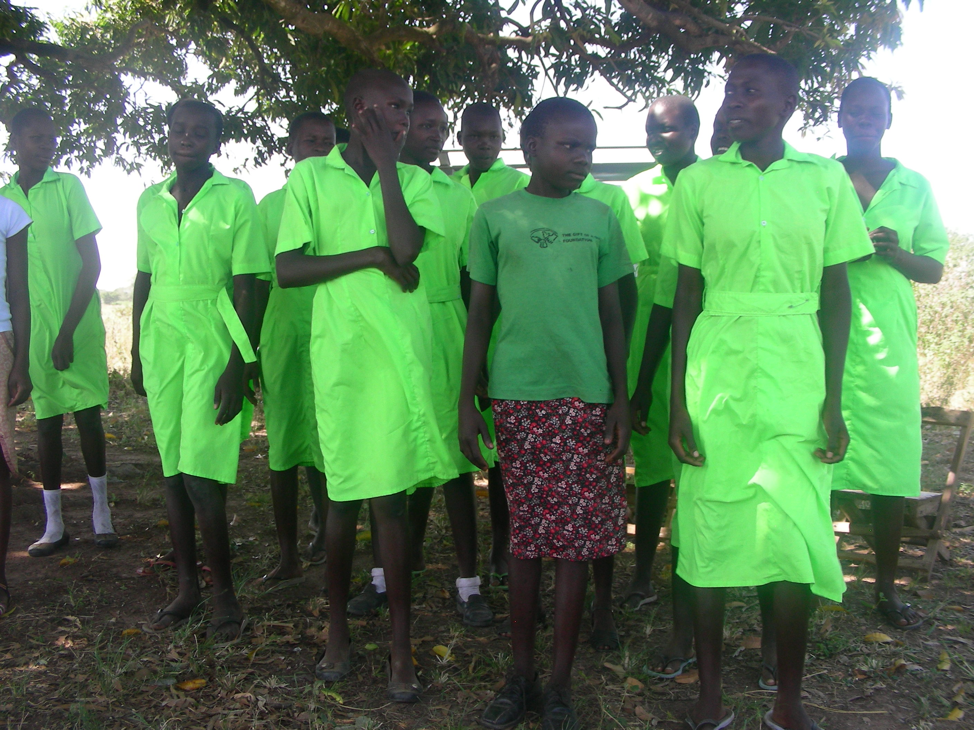

Phone: 256-772-547971

E-mail: girlhelpwan@gmail.com

P. O. Box 2245

Jinja, Uganda in East Africa

***The Site for The Gift Of A Girl Foundation***

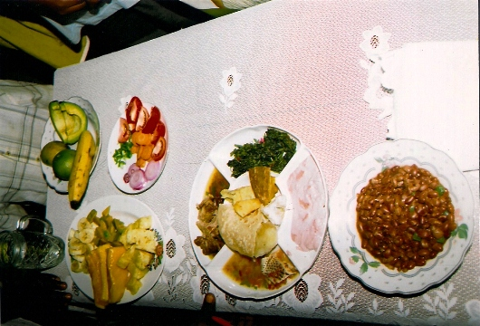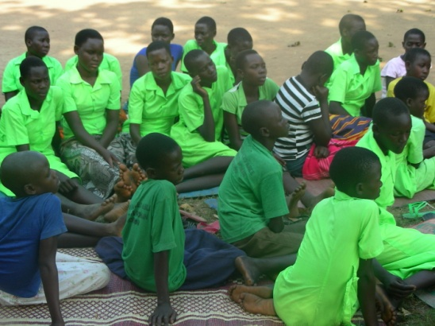

**Food cooked by children themselves**

***These are part of the girls we support their education***

### Future Goals:

### Goals to be Achieved:

### 1. Develop the land where we intend to construct facilities to facilitate the children’s learning and growth.

### 2. Link and partner with some donor groups and individuals so as to seek for support and those who are expert in children’s issues and other fields that benefit the girl child.

### 3. Get teams and interns (short/long term) to help develop the project.

### 4. The girl child becoming strong Christian and productive citizen that will bring strength to our country and fulfillment in individual lives.

### 5. That each child helped by The Gift of The Girl foundation will go through what we call community circle, meaning the child helped in the community will be required to go back and help others in the same way.

### The Way Forward:

### We are grateful to those who have helped us get to this point in the ministry. However, The Gift of the Girl Foundation has definite plans to build the ministry to help needy children.

### 1st Phase: Presently, We are using some one family compound. Not so convenient, due to luck of a facility we are there. There is a critical need to construct a facility where the children can meet for ministry activities. This facility would also be used to accommodate the children for a two week retreats where they are fed and taught the skills and educational materials

### 2nd phase: Setting up various games that excite and stimulate children’s learning. (A play ground for children) The items used for activities would be made using local materials. Internship would be good here.

### 3rd phase: When the funds are realized we will construct dormitories, dining hall and kitchen.

### 4th Phase: Vocational school to cater for school drop outs and those who stop in senior four.

### 5th phase: Clinic for children and community.

Other phases: To provide skills and learning opportunities for the community. Thank you for your support

**The mistreatment of a girl generally is another factor pushing me to stand with a girl child. They are molested by both parents and even guardian's, sexually and other ways of cruel mistreatment.**

**Inside look to The gift of a girl foundation**

### Mission Statement & Our Purpose

**Mission Statement**: To transform the status of a girl child through the gospel, education, and training and to engage in Socio-economic activities – for sustainability

**Our Purpose**: Holistically developed and transformed status of Girls and Women **Activities:** The gift of a girl foundation carries out various activities with the girl child meant to enrich their lives create a meaningful living and instill biblical values.

**Bible Studies**: We read scriptures allowing the children to internalize and to apply in daily living.

**Cooking Competition**: The girl child does not only learn about cooking, we also teach them various types of food and there food values. When to eat what and at what quantity. They also learn about hygiene

**Hospital Visit**: This helps our children to value health and to appreciate themselves as they visit the sick children. This also helps them to stand with others in times of need.

**Street girl ministry:**. This we go with our girl and share with street girls the word and the love of God. When we have the funds we take Christmas gifts for them.

**Seminars**: During December holidays we hold seminars to teach the girl child in details things pertaining the Word of God, reproductive health, hygiene, value for Education

Theburden of a girl child started way back when we were young, as we used to see the mistreatment of our mothers, sisters and some relatives. Girls were not given the same treatment with the boys in education, decision making and were denied privileges.

*My personal testimony (Mr. Sam Akora), I got involved in restoring back my mother to my daddy, and my sisters who were denied to go to school for early marriage, I started supporting them even when I was also a student. I used to do some part time job in order to provide for my sisters school fees, and other scholastic materials.*

*This has given me a lot of courage in supporting a girl child as I see my sisters doing well at the moment and supporting the family. That’s why if you support a girl child today in future you would have supported the nation.*