PROPOSAL FOR
VIDEO ENABLED MOTHER-TONGUE TO ENGLISH TRANSITIONAL EDUCATION (VEMETED)
by Foundation for Educational Advancement
45, Awolowo Avenue, Bodija, Ibadan, Nigeria.
Project Name: VIDEO ENABLED MOTHER-TONGUE TO ENGLISH TRANSITIONAL EDUCATION (VEMETED)
Project Background
Educational Advancement Centre (EAC) was founded in 1996 as an Advanced Level GCE School in Ibadan. Over the years, the Centre noticed a downward trend in student performance at the Senior Secondary School Certificate Examination (SSCE) but noticed that these students had the capacity to improve with the right factors. The Centre concluded that the students did not know their true status while preparing for the examination, otherwise, they would have done something about it. This led the Centre to introduce the concept of "Standardized Diagnostic Testing" in 2007 for final year Senior Secondary School Students. The Examination termed "Pre-SSCE" was designed to ascertain their readiness for the SSCE as a kind of formative assessment, with a breakdown of performance in the various components of each subject. In 2009, this Program was adopted by the Oyo State Government as her Mock / Qualifying Examination for some 60,000 students in SS3 classes all over the State. The result of the exercise showed the extent of decay in the educational system in the country and further stimulated the desire by EAC to do something about it. (At 30% pass-mark, only 4% of the students passed). Although there are many factors responsible for the poor performance of students, the most important factor as far as EAC is concerned is the "Teacher Quality." We believe that a good Teacher will achieve success, teaching students even in rural conditions!
EAC then embarked on the search for a solution that will use a “few good teachers to engage thousands of students”. This led the Centre into E-learning. In 2010, using www.mobilearn.mobi, EAC launched mobile learning in Nigeria in partnership with NTA Ibadan, with special focus on the JAMB UTME based on notes and topically arranged past questions. The project was a relative success, although the number of students who subscribed to the package were less than 10,000, the efforts won Pastor Muyiwa Bamgbose Global awards as Number 10 and 9 in the world of e-learning in 2011 and 2012 respectively. EAC also went on to partner with the Distance Learning Centre of University of Ibadan (DLC) and Exact Learning Company of Italy for the production of materials for mobile learning for DLC students. The partnership is still operational today.
VIDEO IN LEARNING
Not fully impressed with the attitude of students to e-learning, EAC kept on searching for friendly solutions and eventually stumbled on “video in learning”. EAC set up a studio and contracted RRSAT of Israel for Satellite broadcast via Amos 5 satellite to the African continent on the first of January, 2013 as “Calvary Network”. She later moved to the more popular Intelsat 20 (My TV) which covered Africa better than Amos 5 as “Schoolonair TV”. The impact was tremendous!
A few testimonies!

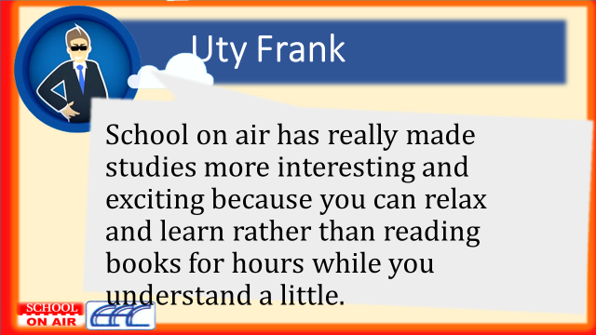

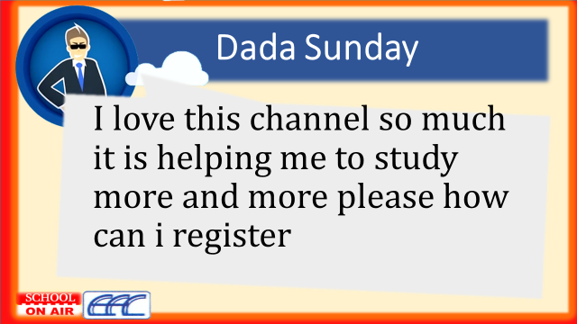

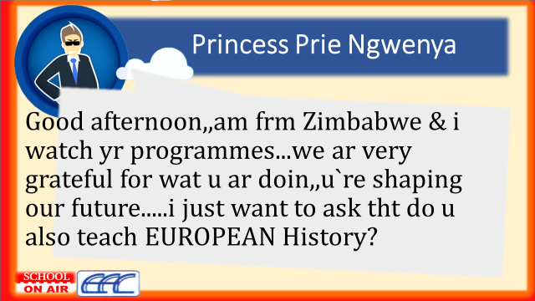

Then came the avalanche of requests for the video CDs. The State Government in appreciation of the positive effect of the materials on the study of students purchased and installed it in all the 630 Public Senior Secondary Schools in Oyo State in an effort to upgrade the performance of the students in the State. The student population for this group of students is well in excess of 400,000. While deploying the High School videos, the Centre realized that a high percentage of the students could not comprehend the contents due to extremely poor Primary School education. This prompted EAC to develop the Primary School version of Schoolonair materials.

The Foundation came into existence at this stage with a view to promoting the deployment of video lessons to IDP Centres, Rural and Sub-urban areas to help students without adequate access to education. The Centre decided to run Trial operations in two Public Primary Schools in preparation for a Pilot Operation with SUBEB. (See attached letter from Oyo State SUBEB on identified Pilot Schools). During the Trial operations, it was discovered that many of the children in the Public Schools could not comprehend even the Primary One School lessons. Investigations revealed that the children were from homes where they do not speak English at all due to the literacy of the parents. To mitigate this problem, the Centre had to bring in interpreters into the classes to interpret what the teacher was saying to the children. After a lot of brainstorming, the Foundation came up with the idea of Mother-tongue to English Transition, in which the lessons will be interpreted into the mother tongues of the children with gradual withdrawal between Primary One and Three. In Primary one, there would be 100% interpretation, 70% in Primary Two and 40% in Primary Three. Thereafter, there will be no interpretation. This marked the birth of VEMETED!

To test-run the concept, a pilot broadcast was introduced on the Facebook transiting from Hausa and Yoruba languages. The acceptance of the intervention is quite impressive as can be seen below. The Facebook Pages are “Makaranta a Iska” for the Hausa language version and “Ile Eko Ori Afefe” for the Yoruba Language version. The Ibo version, termed Ulo Akwukwo N’ikuku will take off very shortly.

Project Objectives
The project seeks to introduce an intervention in the provision of learning opportunities to improve the living standard in the IDP camps and for inhabitants of the rural areas by providing Affordable and sustainable quality education with the use of video technology. The same resources can be used for Adults desiring formal literacy education.

Project Method
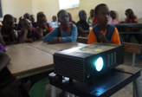
- Using a Laptop and Projector, class lessons are projected for students to watch.
- The unit is managed by a Facilitator who does not necessarily need to be a trained teacher but trained in supervising children and handling the laptop, projector and solar power system.
- Assessments of students are done using Moodle server set-ups on the same laptops while the students can use smart mobile phones.
- Questions from students, which the Facilitator cannot answer can be sent via WhatsApp to EAC for clarification.
- Electricity power is supplied by our designed 500 VA Solar power system.

Project Benefits
To Internally Displaced Persons
- The project will offer internally displaced exposure to sound education at an accelerated pace.
- The project will provide total improvement in the livelihood of the IDPs and their family members.
- The project will engage the youths in the IDPs gainfully and thus curb propensity for anti-social activities
- Provide opportunity for the upcoming generation of the IDPs to move out of poverty range.

To the Rural Farmers
- The project will reduce the rural urban migration in search of education for children.
- The project will provide total improvement in the livelihood of rural farmers especially, and their family members.
- The project will make rural farmers to become self-reliant and independent in their finance and operations with availability of manpower for the farms.
- The project will improve the farming practices in the rural area

Rural Communities
- The project will give Adults and children in the rural areas access to quality education that is affordable, sustainable and compatible with their lifestyle as farmers.
- The project will encourage the reversal of ongoing youth migration from rural to urban areas.
- The project will expose the rural dwellers to basic information about citizenship and their vocation
Government
- The project will increase the population of tax payers and improve the national income.
- The project will improve the productivity of the rural community and encourage them to embrace rural mobile banking system and integrate them into the national financial cycle.
Conclusion
The Video Enabled Mother-tongue to English Transition Education Program is expected to bring transformation to the social well-being and economic empowerment of IDPs, and rural dwellers and give them sustainable access to quality education.
