Proposal for promoting dignified menstruation and livelihood of girls and women through MITERI enterprise in Chitwan, Nepal

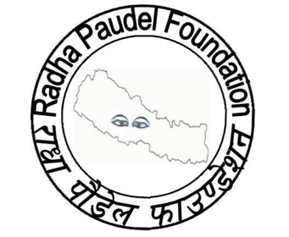

PROJECT TITLE: Promoting dignified menstruation and livelihood of girls and women through MITERI enterprise in Chitwan, Nepal

Region: South Asia
Country: Nepal
Estimated start date: August 10, 2019
Estimated end date: January 10, 2020
Executing agency: Radha Paudel Foundation
Estimated budget: $11,000

OVERVIEW

Challenge

Each girl deserves dignity during menstruation. Women and girls around the world face challenges in managing their menstruation. According to the World Bank at least 500 million women and girls around the world lack adequate facilities for menstrual hygiene management. It is not only the infrastructure that they lack but the challenge menstruating girls and women face is deeply rooted within social norms and beliefs where false perceptions and unsafe practices often continue to thrive. Often these notions have huge implications on their human rights; their right to health, education, work, non- discrimination and gender equality.

The available empirical evidence within Nepal clearly suggests lack of adequate knowledge about menstruation. Less than half of adolescent girls have knowledge about menstruation and only 1 in 10 practices good menstrual hygiene (PSI, 2017). In terms of access and affordability, the practice of using modern pads is relatively new in Nepal. The use of sanitary pads among adolescent girls in urban areas is higher in comparison to the rural areas (50% in urban vs. 19% in rural) (Paria et al., 2014). There are also existing beliefs surrounding menstruation which promotes restrictions, with menstruating women and girls being unable to carry out domestic work such as cooking, entering religious sites, unable to intake regular nutritious food and actively participate within their communities during celebrations.

Solution

The Radha Paudel foundation has long been an advocate for dignified menstruation. It has advocated for not only promoting hygiene and infrastructure but the need to move beyond, to emphasise on human rights, empowerment and the overall effect on the environment. With this in mind, The Radha Paudel Foundation in collaboration with the Women Forum for Justice have launched the production for MITERI bio-degradable sanitary pads for the first time in Nepal. Coupled with health and advocacy, MITERI is looking to promote menstruation hygiene management through:

- Challenging false perceptions and unsafe practices by providing access to education on dignified mensturation
- Access to bio-degradable menstrual hygiene materials to collect menstrual blood

Furthermore, the project also addresses the socio-economic problems of marginalised women in Chitwan, Nepal. The proposed project seeks to train 50 marginalised women (belonging to lower caste group with low household income) as distributors. In addition, their training will also incorporate education on dignified menstruation. Empowering them towards economic development will not only facilitate in improving their socio-economic condition but the financial independence gained will also provide confidence to assert their rights and improved livelihood.

Positive social and environmental impacts is also generated throughout the value chain. Women are included at all stages of value chain- as entrepreneurs or employees in production, distributors, health educators and consumers. This allows MITERI to contribute to a variety of Sustainable Development Goal’s across multiple chain activities particularly directly delivering targets in Goals 1, 3, 5 and 8 (See Figure 1).

Figure 1: Our value chain
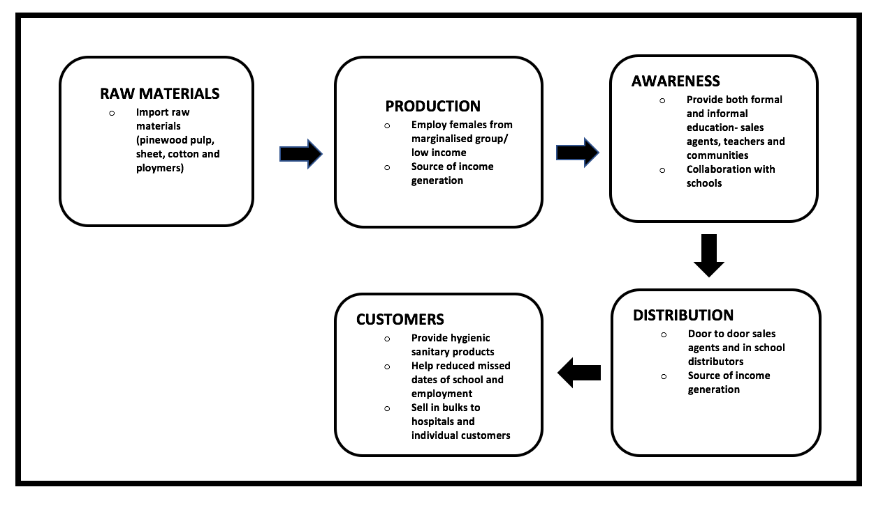

This project will be implemented during a period of 4 months. Considering the socio-cultural and financial needs of the villages, the proposed project is socially feasible, economically viable and environmentally sound.

We have been working on the issue of dignified menstruation for the past 2 years in Nepal. The vision of Radha Paudel Foundation is emancipation for girls and women from poverty, injustices and discrimination.

OBJECTIVE

Objective 1: To provide sales training and education on dignified menstruation to 50 identified marginalised women.

Objective 2: To engage with 5 public schools within the district and facilitate a workshop with 10 female teachers (2 from each school) on dignified mensturation

Objective 3: Distribute pads to 5 selected public schools

Objective 4: To engage with community members about dignified menstruation.

IMPLEMENTING STRATEGY

- OUTCOME: ESTABLISHING PARTNERSHIPS AND SECURING FUNDING

- Defining program partnership needs i.e. funding, venue, networks, logistics, human resources, technological resources, knowledge
- Meeting with key stakeholders to finalise partnership

- OUTCOME: PROGRAM DEPLOYMENT

- Finalised logistical arrangement such as venue, purchase of equipment, printing workshop toolkits etc.
- Employ sales agent trainers to facilitate training of sales agents on selling techniques

- OUTCOME: TRAINING OF DISTRIBUTORS (combining training on both selling techniques and education on dignified menstruation)

- Create evaluation criteria (ie. Low income household, at risk or belongs to a marginalised group) to select female sales agents
- Hold introductory sessions to brief prospective distributors about the program, its objectives and recruit them.
- Finalise employment salary and commission structure
- Revision of progress on sales of distributors
- Conduct 2-day workshop for follows; adjust for any dropout.
- Training on sales techniques- door to door selling, bulk selling to shops and hospitals
- Training on dignified menstruation

- OUTCOME: CREATING SYNERGIES WITH SCHOOLS

- Create evaluation criteria to select schools
- Conduct workshop with teachers from selected school for training on dignified menstruation
- Implement education on dignified menstruation for kids age 10 and over (age of menarche; accounted for some anomaly)
- In school distributors openly advocate menstrual hygiene management
- Distribution of pads

- OUTCOME: WORKSHOP AT COMMUNITY LEVEL

- Engage with community members about dignified menstruation
- Beneficiaries: mothers, fathers, village elders and CSO leaders

- OUTCOME: MONITORING AND EVALUATION PLAN

A proper evaluation plan will be finalised to measure outputs and outcomes and evaluate the programme for further refinement before the start of the project. Evaluation will be conducted mid-way through the project, as well as final evaluation at the end of the project. The evaluation will assess:

- The impact of the programme on menstrual hygiene practices and livelihood
- Generate learning insights into complex processes of change in order to inform on- going and future programme roll out and development

This will include defining elements such as:
- Evaluation strategy e.g. mixed method evaluation strategy, potential threats to validity and solutions
- Outcome indicators
- Theory of change
- input, activities, output, outcome and impact.
- Assumptions, potential unintended outcome, potential constraints and risks
- Baselines, targets and milestones e.g. number of trained stakeholders in the first month, number of workshops held, number of pads distributed
- Writing end of project evaluation report

PROJECT RESULTS

OUTPUTS

- Income generation for 50 women as distributors.
- Community members aware about dignified menstruation
- Awareness of 10 female teachers on issues on dignified menstruation
– lead to awareness of students on dignified menstruation
- Delivery of bio-degradable sanitary pads to school children

OUTCOME

- Increase demand of sanitary pad in surrounding areas and beyond
- Improved motivational level of women working in production

IMPACT

- Increased income and confidence of stakeholders (production staff and distributors)
- Improved livelihood of women through income generation
- Better hygiene practices of school children- lower reproductive health risks, increased participation in schools (better learning outcomes)
- Impact on sustainable development goals 1,3, 5 and 8

BUDGET

Activities | USD
Programmes
1- Training of women as distributors plus education on dignified menstruation | $900
2- Engage with community members | $500
3-Workshop for school teachers on dignified menstruation | $500
3- Distribute pads to selected schools | $1,200
Total | $3,100
Staff Cost
1-Programme coordinator | $1600 (4 months)
2- Sales manager | $3,600
3-Finance and admin officer | $1,200
Total | $6,400
Operational costs
1-Communication | $100
2- Rent | $640 (4 months)
3-Utilities | $360
Total | $1,100
Travel costs
1- Local transportation | $400 (all staff member)
Total | $400
Total expenses | $11,000

*Amount stated is for the period of 4 months for all operation except for the pay of sales manager which is an estimate for the whole year

(These are preliminary estimates and are open for revision)

BENEFICIARIES

- School children
- 50 women from marginalised community and low-income households
- Community members
- 10 teachers from 5 public schools

SUSTAINABILITY

- Community Participation: We will ensure that the local people actively participate in the entire project so that they own the project.
- Multi- stakeholder engagement/partnerships: We will involve stakeholders which include local CSOs, NGOs and government line departments and develop synergies with them. It will enhance the visibility of the project and also reduces duplication of activities.
- Expanding resource and donor base: We will always engage new donors and stakeholders in our programs and have multiple funding sources, which includes membership fees and funding from individuals and institutional grants from donors.

