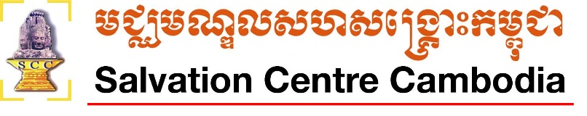
Music and Dance School in Siem Reap
Project Document
Organisation Context
Salvation Centre Cambodia (SCC) is a local NGO that supports vulnerable children and families affected by HIV/AIDS. The organization started in 1994 and has grown over the last 25 years to be a well known and well respected organization helping local communities across Siem Reap, Phnom Penh and Battambang.

The School and Students
Several years ago, SCC established a a Music and Dance School in the Chreav District of Siem Reap. This dedicated school provides part time classes to 52 students to progress their traditional arts and culture education by offering two programs: Music Program and Dance Program.

The Music Program offers teaching and learning of traditional music with local instruments for youths from various villages and communities. The Music program employes one local Khmer teacher who is experienced in traditional music. There are currently 19 students enrolled in the Music Program ranging from 9 years old to 21 years old. The student come from four local communities (Tachek Village, Krasang Village, Vean Village and Boshkralang Village) which are all within the Chreav Sangkat province of Siem Reap.

The Dance Program also employs one local Khmer teacher who is experienced in traditional dancing. There are 33 students enrolled in the dance classes and they range from 8 years old to 20 years old. Students come from two local villages near the school: Tacheck Village and Boshkralang Village and there are currently 12 males in the class and 21 females in the class.

Costs and Budgets
As of July 2019, the Music and Dance School will no longer receive funding and will be forced to close. In order to continue the Music and Dance School for another year, SCC requires additional funding. The funding requirements for 1 year of operation (from July 2019 to June 2020) are:

No | Activity | Budget details | Total Cost
1.1 | Wages for 2 teachers | $235 x 12 months | $2,820 USD
1.2 | Night security guard | $120 x 12 months | $1,440 USD
1.3 | Utilities and electricity to run the school | $50 x 12 months | $600 USD
1.4 | Mainteance of instuments & equipment | $70 x twice a year | $140 USD
 | Grand Total |  | $5,000 USD

Benefits of the School
The Music and Dance Program provides students with the opportunity to connect to their local arts and culture community. As this school is in additional to regular public school education, the students are able to participate in extra curricular activities to enhance their education. In addition to this, many of the previous students of the school have gone on to become Music and Dance Teachers allowing them to gain additional income. Many of the current students are also invited to perform at local community events including special occasion hotels, restaurants and weddings, which allows them to earn additional income for their families.

