*"Soft skills are really important. Through this skill, people are able to help themselves, their community and their society,” said a Khmer traditional music teacher.*

Saron is 16-year-old. He lives in Siem Reap province. Having seen the difficult living condition of this young boy, SCC staff members based in Siem Reap province, including a teacher of Khmer Traditional music, decided to select him to study Khmer Traditional music at SCC center. He has been learning this skill since 2017; as a result, he is now able to play many Khmer Traditional musical instruments, such as drumming, Sampo, Roneath and Kong. While taking a break from his studying at schools or being invited to play traditional Khmer music in restaurants, hotels, or different events for many times with many of his friends. He has used this knowledge to raise some money to support his education, in part, he also use this money to help their parents as well. Another important thing is that he is continuing the Khmer national heritage from one generation to another. As a civil society organization, we continue to support him in his efforts to continue his studies because Mr. Kimsot, who is his instructor, has observed that this young boy has a gentle attitude and tries his best to study. He said that. "This young boy does not come to school one hundred percent regularly because he is busy helping his parents who have up to five children in charge. His family has to spend a lot of money." According to the father, he told us by telephone: "My son is a good child, obedient to his advices, knows how to help with household chores, such as helping to sell things, he was born with this skill, he learns and understands quickly." He added that based on the current living conditions, he could not afford to help his child finish university, only high school. However, lest the child move forward, he will be able to support his own education, then it is up to him. The parents’ obligation continues to support and encourage the child as much as possible. This is because I have many children; the young boy told his father that, “I need to attain the high level of education; it was because it is easier to find a job and have more opportunities to help my family, community and country. Last but not least, as a young person, I would like to urge other young people to study hard, do not take this precious time to hang out with gangsters. In particular, stay away from drugs. Let's prevent the spread of HIV and COVID-19. Brave Cambodian young man!

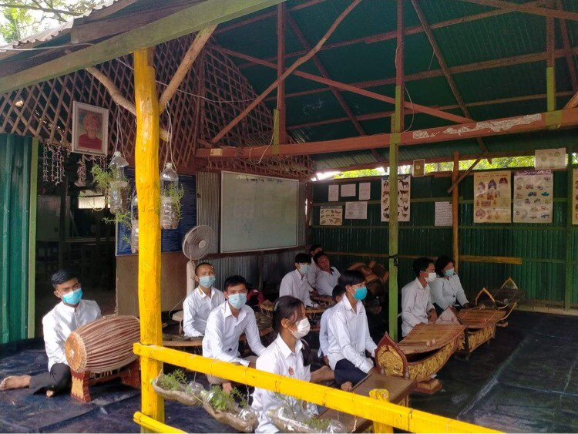

Saron was in welcoming guest event at SCC-CBE School

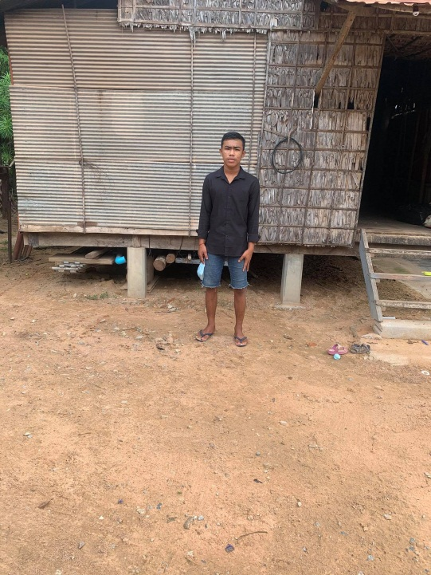

Saron standing in front of his house at Siem Reap