Impact and growth of Cambodian children in Khmer classical music

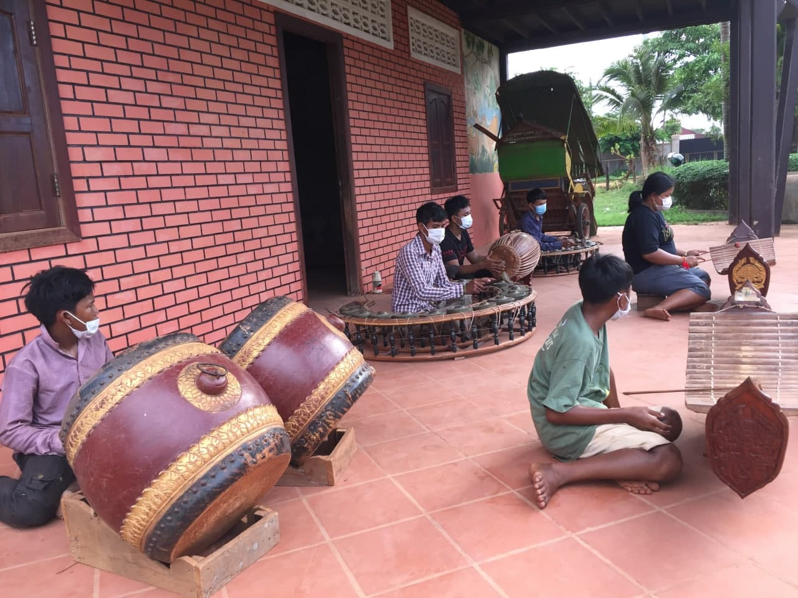
At the time of reporting, COVID-19 is still endemic almost everywhere in Cambodia, seriously affecting the lives and livelihoods of the people, especially, families of orphans and vulnerable children. According to SCC field staff in Siem Reap province, the families of children who have practiced the classical music with SCC are having a hard time in living and studying, especially Cambodian classical music. They were not allowed to come to practice at the center at the same time together. The school committee and music teacher have allowed only 4 to 6 students to come to practice for 45 minutes a day according to the schedule set by the music teacher.
Cambodian Music Children practicing, SCC Siem Reap, 5-06-2021

During the practicing, all students are required to wear a mask, use alcohol or gel for hand washing, sit at a distance of 1.30 meter or more, in accordance with the guidelines of the Ministry of Health of the Kingdom of Cambodia. For example, on June 6, 2021, six students were allowed to practice music at the SCC center.

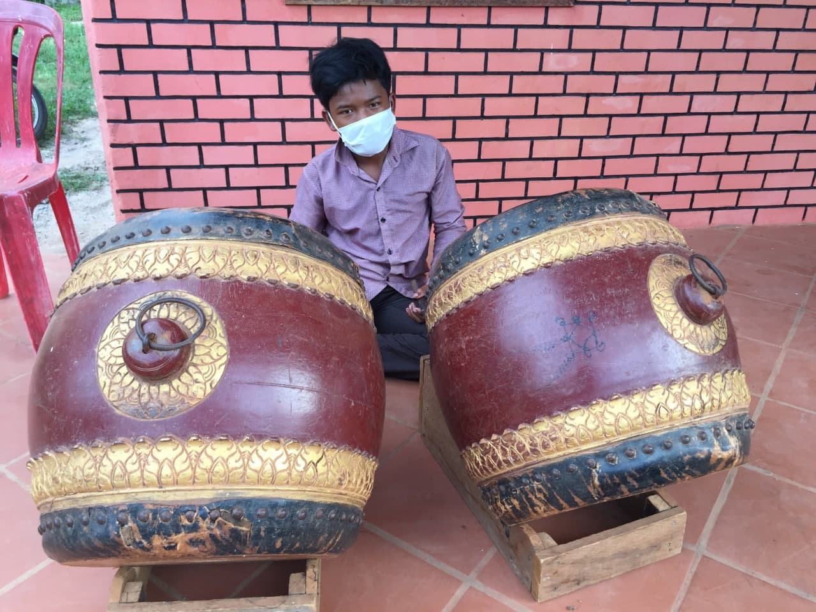
Learning online is very difficult for them because they have no music instruments to practice hands-on and if they did not come to school, their past acquired knowledge may be forgotten. Please note that this classical music requires students to practice hands-on, not reading books. On the other hand, this method also can be monitored the students who came to study by the music teacher.
SCC child practicing drums (Skor), SCC Siem Reap, photo: 5-06-2021

The growth of the Cambodian children in classical music, the music teacher informed the staff of SCC that today there are a total of 30 students, 8 of whom are female. Of these music students, 15 were able to play music well. They are able to go out and make money by playing music with other bands. It should be noted that during the outbreak of COVID-19 in the communities, all of them did not go out to earn money by playing music because any event and wedding ceremony were suspended. Among the 15 students who are able to play the music well, only three were well versed in the traditional Khmer music they are learning and practicing today. All three of them have a lot of opportunities to perform at festivals and other wedding ceremony often.
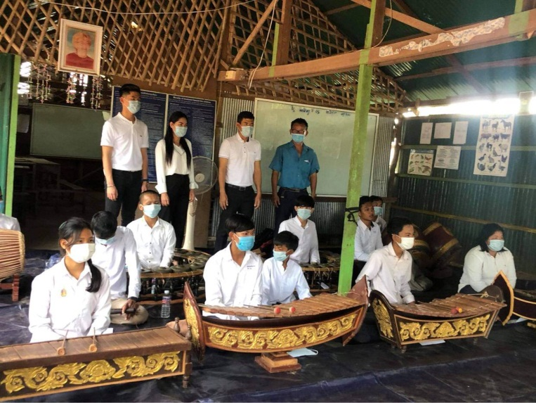
On 13 January 2021, the event was hold at SCC CBE School in Siem Reap province. SCC Founder and president, SCC teachers and the SCC music band welcomed a family that had three people (dad, mom, and son). Visitors’ purposes: parents wanted to show their son of the loving kindness, how to share what they had to the poor needed families, doing good things in society, start doing things when they had enough time to do, best morality to their son. During that time they helped 30 poor students such as study materials, school uniforms, 10 liter of alcohol, brought us story books for our library, and coloring books for kindergarten. 4 bicycles were provided for other 4 kids from community. For SCC team, we prepared Cambodia music. What they played were: The first, the music for blessing guests to be happy (welcome music). Second, Krawan ​Siem Reap music, it made guests happy because they came to Angkor Wat, wonder of Angkor. Third, the ploysuoy music, it is original from the ethnic minority living in Oral district, Kampong Speu province, also made the guests happy because they have seen the ethnic minorities. Fourth, many modern music, the special feature is that Plengpinpeat (Khmer Pinpeat music) can play many modern music.
SCC musical group welcomed guests, On 13 January 2021

After having finished performance of Cambodian music, SCC’s president made a short speech – welcomed guests, parents and kids and also introduced about SCC, CBE founder and donors, CBE goals and little chat with kids from CBE School and Kids living in the community. Then our Guests/visitors made a short speech with their sons/kids. They shared what they had challenged. They told kids to study hard, be brave and doing the right things. They also shared their compassion and loving kindness to everyone. They felt surprised and excited of what we arranged for them. They couldn't believe that the event made them quite emotional.

Finally, SCC founder and president, gave them a thanks giving certificate and said thank you to all and visitors after they offered the gift for the kids. At last but not least guests spent an hour extra for chilling out with SCC staff and SCC CBE Christine school supervisor and teachers.

