UPDATED REPORT ON MUSIC AND DANCE AT SCC SIEM REAP PROVINCE
A Traditional Khmer Music and Dance School was established in September 2013 at SCC-Community Centre in Bosh Kralanh village, Chreav commune, Siem Reap district, Siem Reap province. Decidedly, the school has been reopened since January 18, 2021. This was informed by SCC Management Team and allowed by Ministry of Education, Youth and Sport of Cambodia.
Success story
Nith right now lives with her parents in Bosh Kralanh village, Chreav commune, Siem Reap district, Siem Reap province. Her mother is a farmer and her father’s name is a farmer too.

Nith, 23, was selected to study a Traditional Khmer Music since 2013 until now based on her wish. It was because she wants to be specialized in a Traditional Khmer Music. Currently she is able to play many styles of a Traditional Khmer Music. She can play Traditional Khmer music well. The styles which she can play many songs likes chounopor, Apsara, Kohtralaok, Pin Peat, roam vong and so on. She usually performs her music at the ceremony at Siem Reap province. Nith can earn amount 20 US dollars for one time of playing. She gets this income to support her family members. She has got 6 family members of which 3 males and 3 females in her family. Nith said that, “I want all young people loving, supporting and preserving the Khmer culture.”

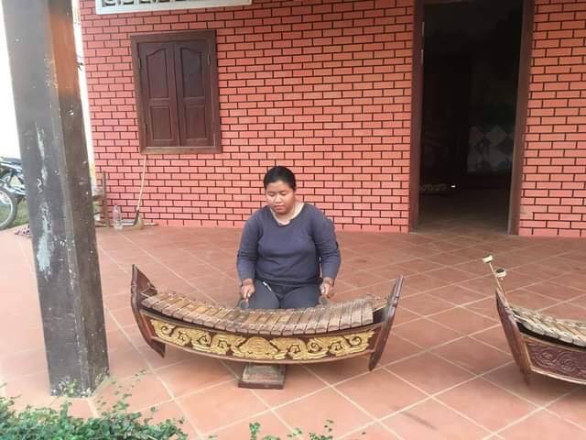
Sreynith playing Roneat Aek (Bamboo/wooden xylophone at SCC Center in February 2021

Besides learning and practicing a Traditional Khmer Music, Nith has participated in youth group (the most at-risk group to HIV/AIDS transmission) She has gained knowledge on how HIV transmission, misconceptions about HIV and how to prevent and care HIV transmission.
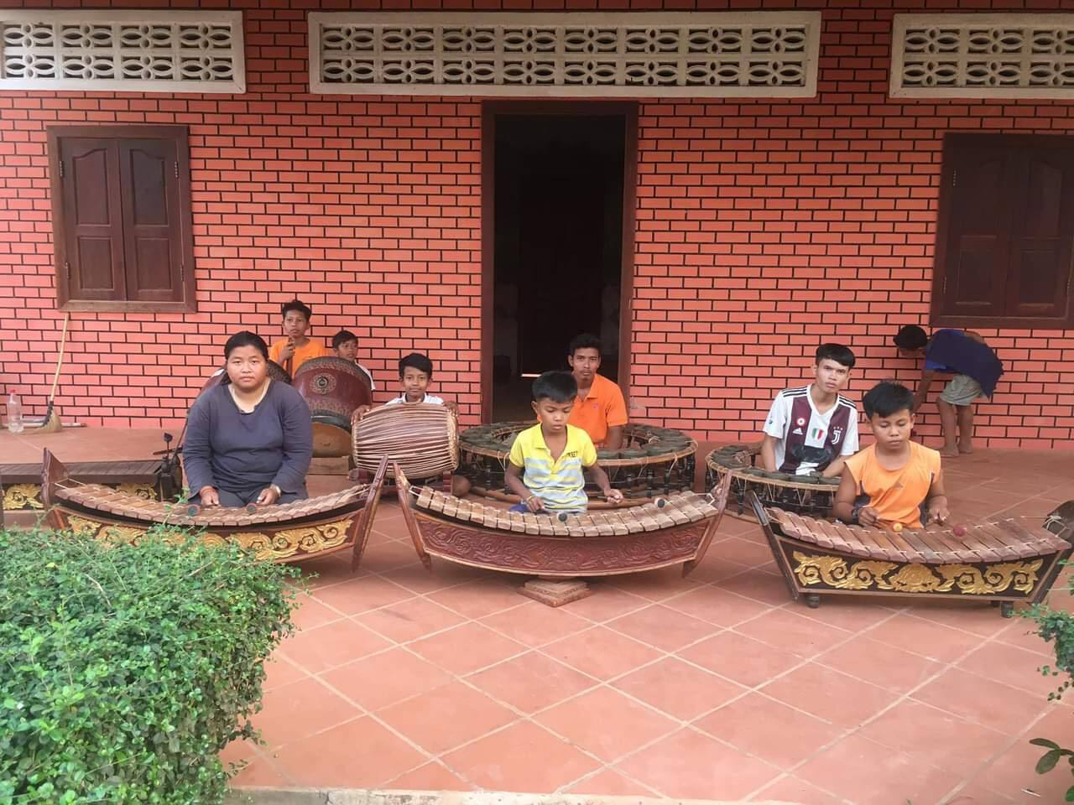Sreynith and her classmates playing Roneat Aek (Bamboo/wooden xylophone at SCC Center in Feb. 2021

