UPDATED REPORT ON MUSIC AND DANCE AT SCC SIEM REAP PROVINCE
ON SUCESSFUL STORY OF A DANCING STUDENT
A Traditional Khmer Music and Dance School was established in September 2013 at SCC-Community Centre in Bosh Kralanh village, Chreav commune, Siem Reap district, Siem Reap province. Unfortunately, this school was postponed due to COVID-19 pandemic and doing fundraising has not enough for expenditure on monthly salary for both instructors. Therefore, a monthly salary of traditional Khmer dance and music instructors has been postponed from May 2020 onwards. We will reopen when we have enough fund to support teachers. Even thought, we have not enough fund to implement the project for two months ago we have a significant change of a dancing student.
Sotheary, 15, was selected to study a Traditional Khmer Dance since 2014 until 2019 based on her wish. It was because she wants to be specialized in a Traditional Khmer Dance. Currently she is able to dance many styles of a Traditional Khmer Dance. She can dance a Traditional Khmer dance well. The styles which she can dance like rbam kohtralaok, rbam nesaeat, rbam ken, rbam ploy suoy, rbam kngaok bailin, rbam veay krab, rbam chounopor, rbam tep mnorom, rbam neang sovann mochchha, rbam kevomnei mekhea la, rbam absaara and rbam chrautasrauv. She usually performs her dancing at Mekong restaurant and Sokha Hotel at Siem Reap province. Sotheary can earn monthly incentive amount 80 US dollars. She gets this income to support her study and family. At the moment she is studying grade 11, the government high school. Sotheary said that, “I want all young people loving, supporting and preserving the Khmer culture.”

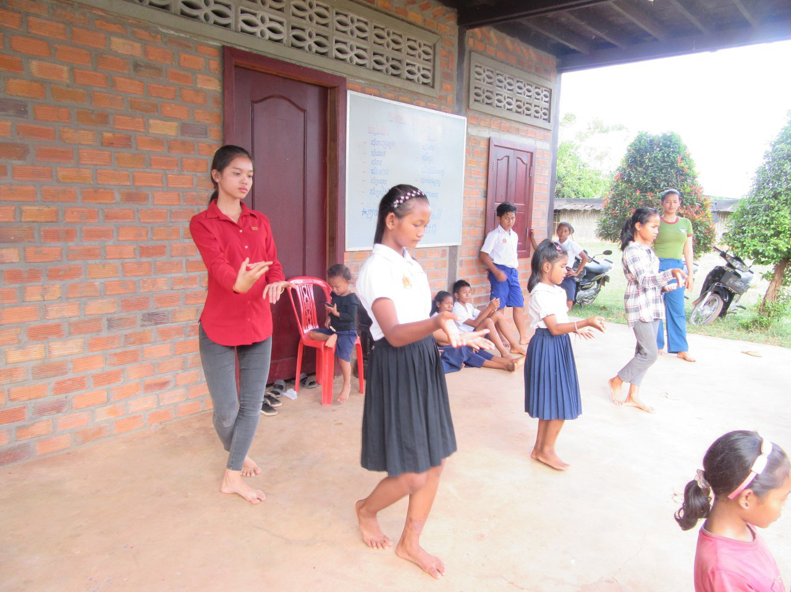
Sotheary practicing dance at SCC community Center
Sotheary right now lives with her parents in Bosh Kralanh village, Chreav commune, Siem Reap district, Siem Reap province. Mother’s name isSokha, a farmer and her father’s name is Vid, a farmer too.
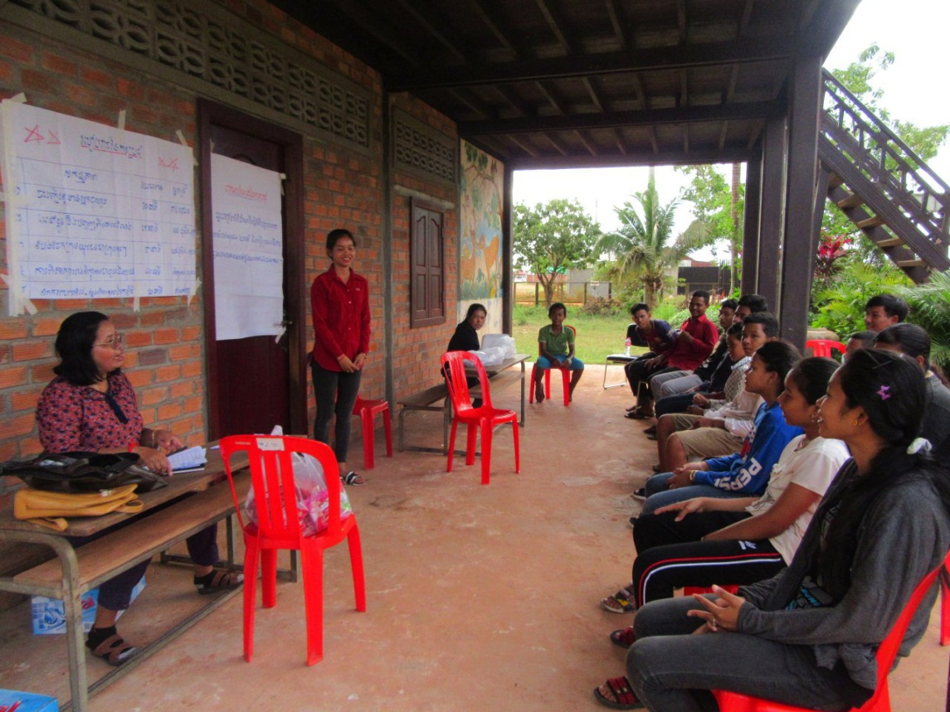
Sotheary present HIV/AIDS knowledge to youths participated
in SCC Project in December 2019
Besides learning and practicing a Traditional Khmer Dance, Sotheary has participated in youth group (they are at risk relating to HIV/AIDS transmission) meeting led by SCC’s staff members in SCC target community in Siem Reap province. She has shared her knowledge concerning transmission, misconceptions about HIV and how to prevent and care HIV transmission.
Finally, she would to generious supporters who ever support music and dance program to continue contributing their small money to open this school again. Without this school children who living around the school will force to do the contraction worker or any labor abuses by their parents or care giver Sotheavy’s speech.

