History Case of Mr. Kamsoth
“I want to specialize in Khmer Traditional Music”
When his mother and SCC’s staff heard the above sentence, they took pity on him because they hoped for his dream to come true and be more than just an idea.

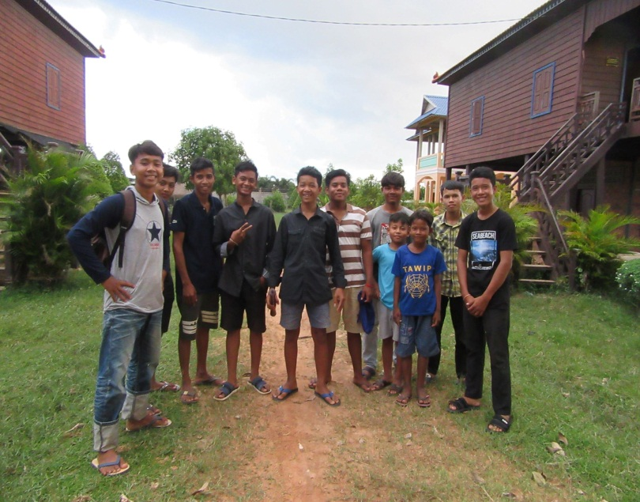
A young youth named Kamsot, who is 25-year-old lives in one of SCC’s target areas located in Siem Reap province. His family has 5 members of which 4 are females and he is the fifth child. Kamsot is at present is living in Boeng Village, Chreav commune, Siem Reap municipality, Siem Reap province. He has been enrolled in the Khmer Traditional Music program supported by SCC since 2008. SCC’s staff members decided to select him to study at SCC’s Khmer Traditional Music class because his family lives in poverty and had a lot of debts due to the lack of farm land for agriculture and no permanent job. He also was affected by HIV/AIDS because his parent infected by HIV/AIDS. Due to his family’s difficult living conditions, and because Kamsot was incredibly eager study the Khmer Traditional Music, SCC decided to give him the chance to realize his dream and support him in his studies. Significantly, he studied music with SCC’s musician free of charge from 2008 until the end of 2012. The “Free of Charge” by SCC has not only supported Kamsot but all SCC beneficiaries who are willing to study this type of music since 2008. In his family, he is the eldest son; therefore, he also has to spend a lot of his time to look after his sisters while his parents are at work went to earn income for their family. His musical training gives him the chance to earn some money from his skills, performing Khmer Traditional Music with his friends and his musician. The opportunity of studying with SCC, gave him a lot of experience and skills, as he realized when he did a reflection on both theory and practice. This opportunity made him strong. He has never forgotten his words that, “I want to specialize in Khmer Traditional Music.”
A small group of Kamsot's students studying music

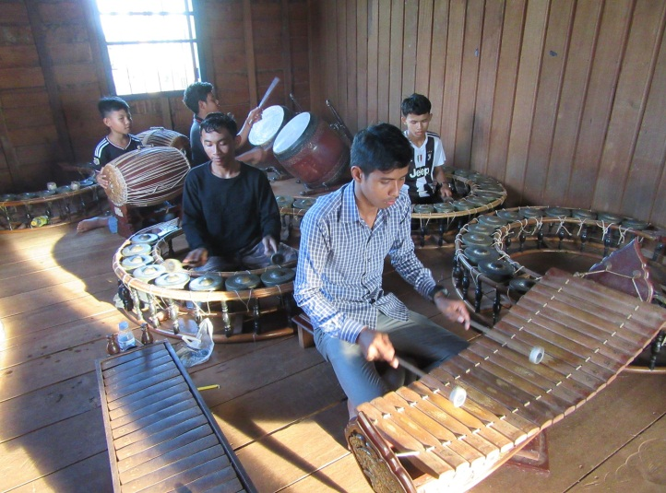
Kamsot spent 6 years studying the music with SCC (2008-2012). In 2013, seeing his ability and experiences in learning and teaching Khmer Traditional Music, SCC decided to select him as a teaching assistant. He has gradually learnt the music and to help to teach other classmates who didn’t know how to play the musical instruments yet. He worked as a teaching assistant for five months. Now he has become a (fulltime) teacher of the Khmer Traditional Music and is very committed to his career. He told us that, “I have had bad experiences in my life; now is the time I can use my skills to help poor children coming to study the Khmer Traditional Music at SCC and give back to the community.” He added that, “I have never forgotten my bad living conditions. I have a better standard of living today because of the support from SCC’s staff members, especially Mr. Thoeun, the SCC Founder and President. He always encourages and supports me both mentally and physically. I have never forgotten his good deeds and it was his heroism that motivated me to help myself and other poor children living in the target areas of this organization.
Mr. Kamsot teaching his students at SCC office

Kamsot is able to teach many the Khmer Traditional instruments such as Chhing (Cymbals), Khimm (Dulcimer), Khloy (Bamboo Flute), Korng Thomm (Low-pitched circular frame gongs), Roneat Aek (Bamboo/wooden xylophone), Roneat Thung (Large xylophone), Sampho (Small double-headed barrel drum), Sralai Thomm (Quadruple-reed shawm) and many Khmer Traditional Songs (Pleng Pin Peat). For instance, Saathukaa, Chheut, Kraonai, Kraonoak, Chongnoak, Tepromdaul, Tepnimett, Seenaunbeychhaann, Kamsansaukea and many more.

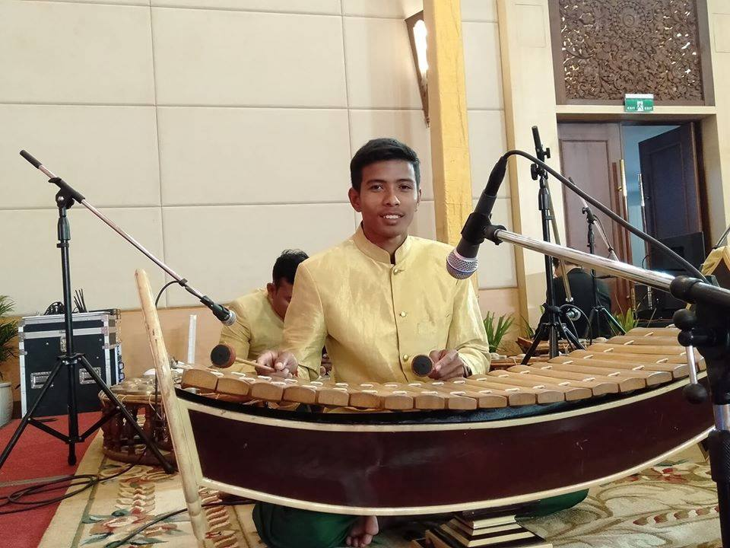
Besides teaching Khmer Traditional Music at SCC, he also performs the Khmer Traditional Music at restaurants, hotels or different ceremonies when needed. He works permanently at the Department of Culture and Fine Arts in Siem Reap province. His total income per month is 500 USD which he uses for supporting his family.
Mr. Kamsot performing music at
Department of Culture and Fine Arts

Closing: SCC’s support really changed his life and gave him a brighter future. The training gave him many skills, not only about music but also about life in general which he used to change his life.

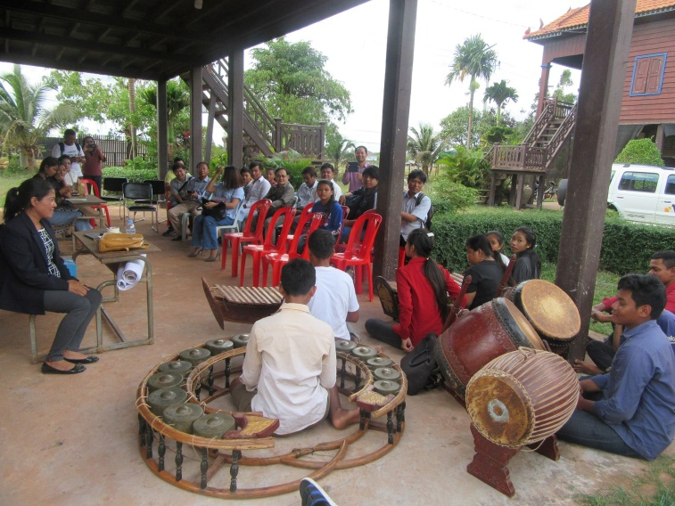
Visitors led by VBNK visiting our youth performing in SCC Siem Reap Province, Cambodia

On the 27th of November 2019, SCC’s youth group which studies Khmer Traditional Music and the Khmer Apsara Dance in SCC branch located in Siem Reap province warmly welcomed the 16 visitors. The honored guests came from various Non-Government Organizations (NGOs) led by VBNK organization in Cambodia. They were kind, friendly, and courteous to our kids, music teacher and SCC’s staff members. The visitors enjoyed watching the performance of the students playing the Khmer Traditional Music with different songs and types of instruments. Our youth were also able to play music based on requests from the visitors. The visitors encouraged our youth to continue learning the Khmer Traditional Music and the Khmer Apsara Dance. The youth group was very delighted to welcome the visitors.

