**2ND REPORT ON MUSIC AND DANCE AT SCC SIEM REAP PROVINCE**

**ABOUT MUSIC AND DANCE PROGRESS PROGRAM**

The first generation learning Khmer Traditional Music at SCC Siem Reap 2018

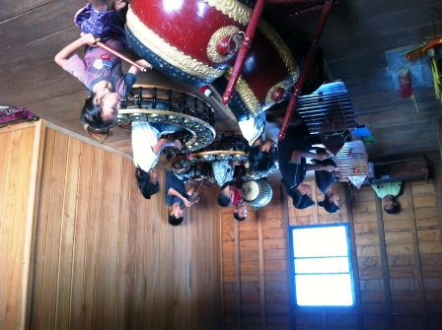Music and dance program were established in September 2013 at SCC-Community Centre in Bosh Kralanh village, Chreav commune, Siem Reap district, Siem Reap province. The program has organized and supported two groups of orphans and vulnerable children. One is learning Khmer Traditional Music and another is learning Traditional Khmer Dance (APSARA Dance). The aim of the program is to provide an opportunity for vulnerable children aged 9 to 21 years old living around SCC community Centre and from various villages and communities to learn these vocational skills for the sake of their benefits.

At present, there are 52 children (of which 28 are females) have learned and improved their knowledge on Traditional Arts, culture, morality and loving-kindness through teaching and learning music and dance program. Moreover, they have self-confidence and strong commitment on their studies. It was because the vocational skills give much benefit to them both in the present day and in the future. This program also has reduced expenditure of the parents/caregivers in the field of music and dance education.

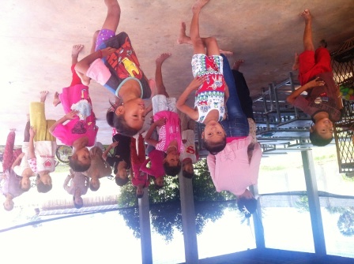

Children practicing dance styles inside SCC Community Centre at Siem Reap province

From the beginning until now, they come to practice and learn the skills at SCC-Community Centre regularly. Moreover, some of them are be able to perform more than 50 songs and 10 styles of Apsara Dance. Besides, some of them have a chance to perform music and dance at the Five Star SOKHA Hotel and Sofitel Angkor Hotel in Siem Reap town, at the wedding ceremony and at the various ceremonies. In this reporting period, 40% of the existing children have earned some income from the skills to support their family and themselves.

**HOST VISITING**

We are fortunate to have many visitors come to our music and dance school. Moreover, the visitors who are on a trip can visit the rice field nearby the SCC community Centre as well. We are very grateful to many people for spending their time to support SCC’s children. Our children warmly welcome visitors with the blessing dance (Robam Chun Por). In the reporting period, VBNK staff, Tem Sokchea and team of Protectkids Kambodscha from Germany visited the program and they wish to support and keep the program running.

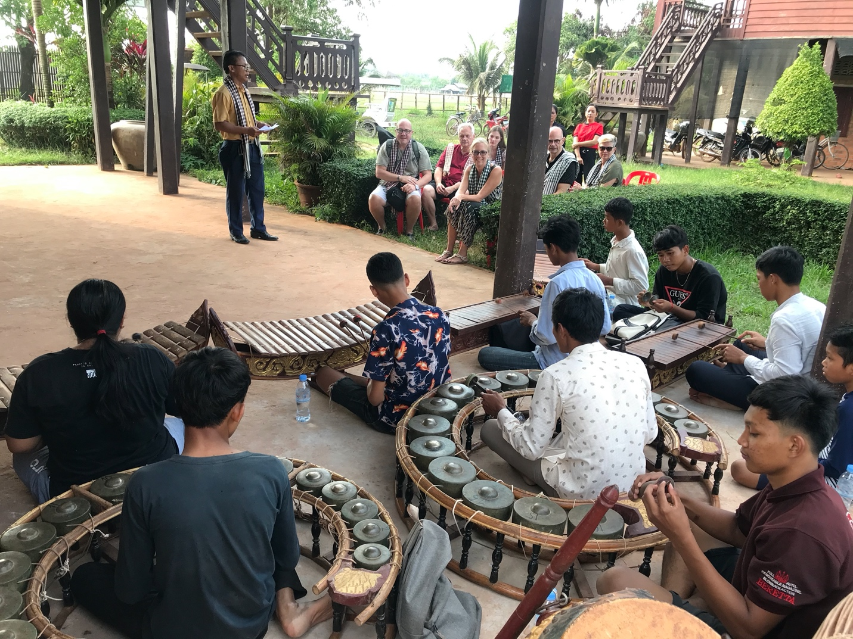

Protectkids Kambodscha team visited Khmer Transitional Music inside SCC Community Centre, November 2019, Siem Reap, Cambodia

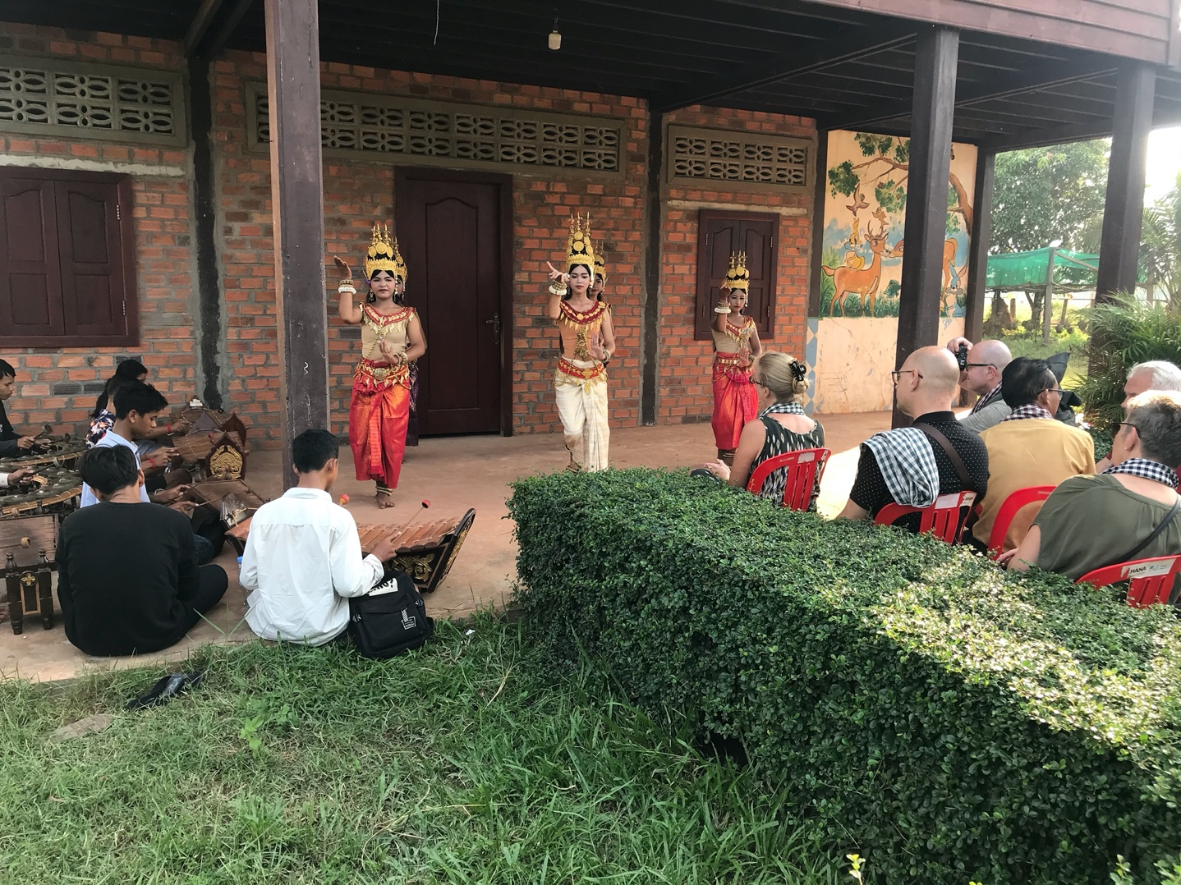

Protectkids Kambodscha from Germany visited Khmer APSARA dance inside SCC Community Centre, in November 2019 Siem Reap, Cambodia.

**ACKNOWLEDGEMENT**

On behalf of children, musician, and dancing instructor, we would like very much to take this opportunity to acknowledge thanking for generous supporters, Sadeep and Micheal who have supported the program through Global Giving. Their kind support made our musician, dancing instructor have job, and children gain skills for improving their lives both in present and in future and we hope all of you will share and continue to support us. I would like to appreciate the Governing Board, all of my colleagues and SCC’s volunteers for their hardship and energy in work so far.

**CHALLENGE**

* At present, music and dance classes, funding is insecure. It means we do not have a full budget package for running teaching and learning services. Therefore, SCC would like to ask all generous supporters to save these fruitful vocational skills.
* The administrative work of music and dance classes not well organized yet. Therefore, SCC needs more time and technical training to improve these.
* Beside a traditional musician and dancing instructor called “Kru Robam”, we do not have any responsible persons for coordinating this work yet. Therefore, we will coordinate to have a responsible staff with his/her job description in order to improve these vocational skills.
* Now, both music and dance classes lack of instruments for practicing and learning. For instance, dance class lacks of instruments such as Angre, Angrout, Tralaok, Chhneang and dance clothes for performing Apsara dance. In the meantime, musical class lacks of Sralai Thomm (Quadruple-reed shawm), Sralai Tauch and some musical instruments have broken, but have no budget to repair them.