Every year November 25 marks “Thank You , Donors” Day for Moqah Foundation. On this day our children thank our generous donors who makeit possible for these children to be in school.In their words:

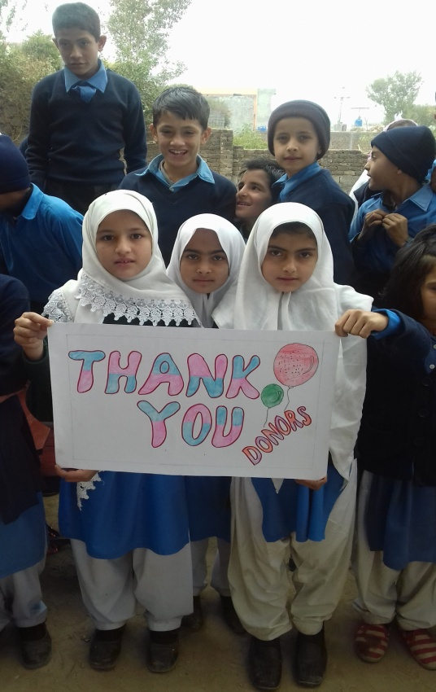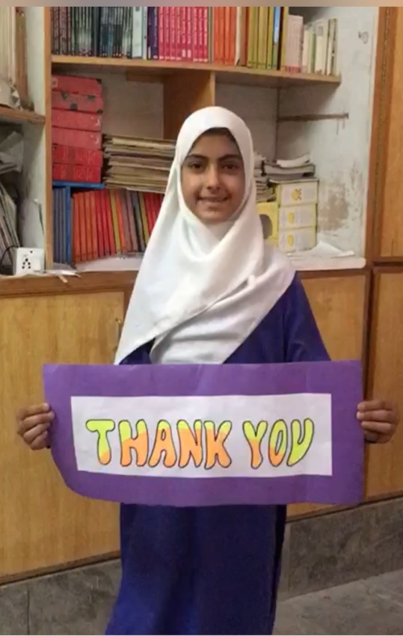
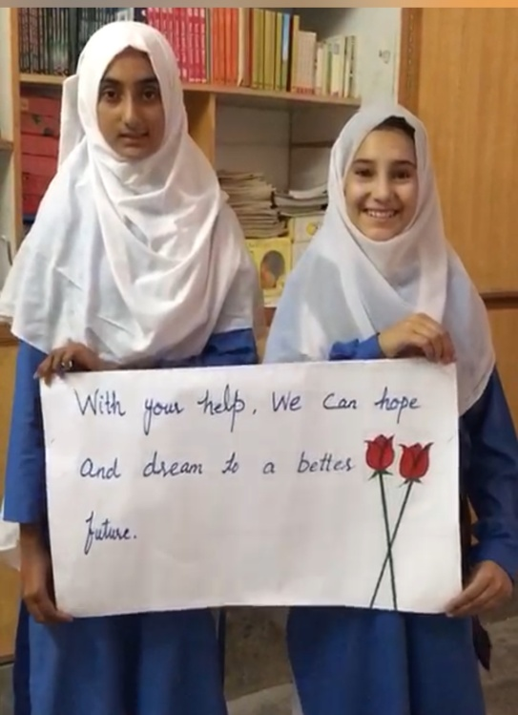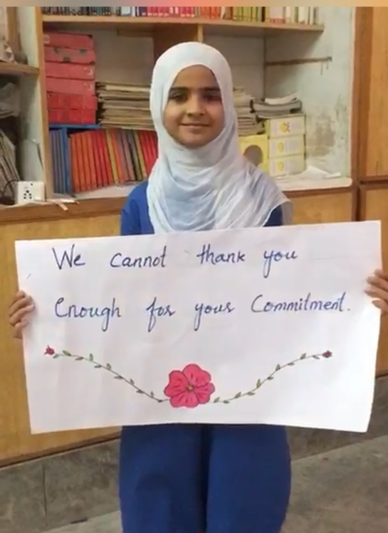

Changing gender biases : a great achievement for Moqah Foundation!
We are two months into the collaboration between Moqah Foundation and Girl Rising. Our students have been attending weekly sessions that has resulted in positive attitudinal change.For example, one of our 9th graders’ sibling, Senam, spoke about his two sisters Summaiya and Bushra who have never stepped out of their household other than coming to the school. Women in Senam, Summaya and Bushra’s family are mostly illiterate and live under highly traditional and conservative social structure, which is marked by its patriarchal male dominance and religious control. Now Senam talks about how he wants to help change the world for his sisters and believes that they have the right to determine their destiny. His first step in this direction was convincing his older brother to sign the permission letter for his sisters to join a school trip to another local school’s sports day event. It was a life time experience for the two girls!

