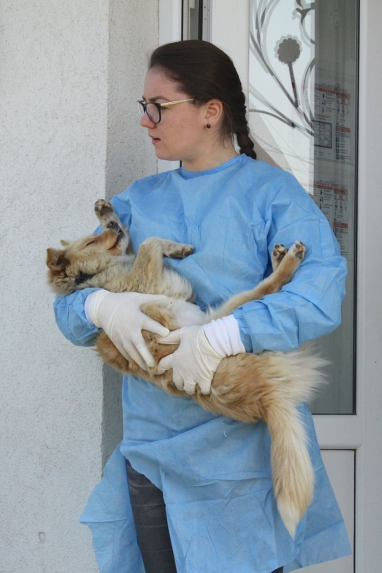
Spay means fewer strays.

STERILISATION AND MICROCHIPPING OF DOGS OWNED BY PEOPLE WITH LOW INCOME IN THE POOREST RURAL AREAS OF ROMANIA.

Coordinator: DVM Andrei Tudose
ROLDA website: https://rolda.org
Email: rolda@rolda.org

WHY ROLDA?
Romania has 2.5 million strays and to believe you can save them all is sadly utopic. Many of these dogs will suffer and die, hungry and alone - the victims of people's ignorance. ROLDA was born as a group of animal lovers determined to save as many animals in need as possible. Thirteen years have passed and we have already helped more than 18,000 animals - a rate of 3.3 new animals helped daily.

ROLDA rescues, shelters, rehabilitates and rehomes. Ultimately, our goal is to find a forever, loving home for every dog we shelter in our sanctuary. Each activity has its challenges: rescue is the most emotional, sheltering is most costly, rehabilitation is most time and skills demanding, rehoming is the most rewarding but also a very stressful mission for our team because we have only one chance to give a dog a perfect future and we can't afford to fail. ROLDA's rehoming program is targeted mostly to Western European animal lovers in search of a furry companion.

Having helped more than 18,000 animals since 2006, when we established as a nonprofit charity in Romania; with two private sanctuaries built from the ground-up where between 650 and 700 dogs are looked after to the highest standards, every day - you could say that ROLDA focuses on animals rescue, dogs in particular.

The ROLDA philosophy is to provide shelter and medical care for abused, homeless and abandoned animals - but equally, to work with poor communities, where families own pets or farm animals, but don't have the means or money to care for them responsibly.

We serve a community of approximately 300,000 people in the second largest urban agglomeration (Galati-Braila area), with Galati being the fifth largest city in Romania. This is one of the poorest regions of Europe, where the lack of infrastructure, high unemployment, lack of qualified personnel and lack of education, as well as extreme poverty, are just some of the extra challenges we're up against as we work to rescue animals.

Stray dogs reproduce fast. As studies from USA proof, an unneutered female and her offspring can produce 67,000 puppies in six years. In Romania at least 50 percent of these puppies will die a painful death from disease or starvation before reaching adulthood. In addition, a large proportion of these 67,000 puppies will die later in life from starvation, disease or in car accidents. The only humane thing to do is to prevent these innocent animals from ever being born.

Presently it is against Romanian law to release these strays back on the streets, so ROLDA spays and neuters street dogs when there's room for new dogs at our shelter. Dogs that have an owner are spayed or neutered at no cost to the owner and microchipped or recorded in the National Registry for Owned Dogs (aka RECS).

MEASURED RESULTS
Since ROLDA was launched in 2006, we have sterilised more than 15,000 dogs and cats. In the Galati industrial zone, where ROLDA intensively worked from 2008 to 2016, the number of stray dogs has fallen from 10,000 to 200.

WHY STERILISE DOGS THAT HAVE AN OWNER?
ROLDA works tirelessly to rescue homeless dogs in south east Romania. As part of our work, we proactively reduce the number of strays by running multiple sterilisation campaigns throughout the year.

After spending a number of years rescuing and caring for dogs in our two shelters, we started building a picture of where the most number of strays were originating from. We wanted to not only react to the huge problem Romania was facing (an estimated 2.5 million strays) but to find a way to tackle this problem at the cause.

In a bid to reduce the number of puppies born in the streets, we originally sterilised and returned homeless dogs. However, in 2016, it became illegal to return stray dogs to the streets, so we instead started running campaigns for pet owners living in disadvantaged communities.

Due to poor economic conditions, people from disadvantaged communities often find they cannot afford to care for their pets and the only option they have available to them is abandonment. Recently, the Romanian laws changed and dog owners face penalties if they don’t sterilise and microchip their dogs. To avoid penalties, people were getting rid of the “problem” and abandonment of dogs increased.

We realised from our rescue experience that many of the dogs we encountered had once lived in a home. So we began tackling the problem by offering families (especially from countryside) the opportunity to have their dogs sterilised and microchipped for free.

BENEFITS

The benefits of ROLDA’s campaign were three fold:

  - It prevented roaming pets from adding their offspring to the problem

  - It prevented families from abandoning their pets because they could now afford sterilisation and microchipping

  - Microchipping dog prevents future abandonment, because the owner is more likely to be identified and dealt with under Romanian law

We partner with a local vet, DVM Andrei Tudose, who provides a very cost effective service due to the high number of animals we bring to them.

BUDGET

One dog’ sterilization costs 130 RON = 23,5 GBP(27,4 EUR) (RON/GBP/EUR rate calculated on 06th of March 2019) It is a “common” price regardless if the dog is male or female, if the dog weights 5 or 60 kilos.
As a rule, ROLDA’s goal is to sterilize primarily female dogs.
The sterilization cost includes: preparation before surgery, IV anesthesia, surgery, post-surgery treatment.

One dog’ microchip costs 20 RON = 3,60 GBP (4,22 EUR) (RON/GBP/EUR rate calculated on 06th of March 2019)
Microchiping costs include the implantation of the microchip, as well as registering it in the RECS national dogs’ database.

If you have any further questions, please contact us at rolda@rolda.org

ROLDA STERILISATION PROGRAM FOR DOGS WITH OWNERS

The villagers are informed in the area where we plan the sterilization event about the importance of the sterilization and microchipping of their dogs.
They are also informed not to give food to the dogs with at least 4 hours before and after the surgery.
Once transported to the clinic, the vet examines the dogs thoroughly and the dogs are anesthetized before the sterilization.
After the operation the dogs are microchipped and recorded in the National Registry for Owned Dogs called RECS .The dogs are also medicated and the wounds carefully monitored. The stitches will dissolve in a fortnight.

ROLDA STERILISATION PROGRAM FOR STRAY DOGS

*Since 2016, it is illegal to capture a dog for sterilisation and then return the dog to their territory on the streets. So all dogs captured from streets are kept in our sanctuaries until we find them a home.

Our sterilisation program begins with our drivers and dog catchers searching for dogs in different areas. Usually, the dogs are fairly easy to catch with treats, but scared or aggravated animals have to be shot with an aesthetic gun for which ROLDA holds a valid permit. The dog falls asleep and is brought to the clinic of our veterinary collaborator, DVM Andrei Tudose. ROLDA’s dog catchers treat the dogs with care and respect, always trying to first win dog’s trust.

Then, the vet examines the dogs thoroughly and the dogs are anaesthetized before the sterilisation and ear marking.

After the operation, the dogs are medicated and any wounds are carefully monitored. We also treat the dogs for internal and external parasites, and vaccinate them against rabies.

Because these dogs are no longer allowed to be released back on the street, even when neutered, all dogs caught by ROLDA or that arrive at our shelter through other means, stay at our shelter.

The majority of these dogs enter our adoption program. But if they aren’t suitable (for example, due to severe shyness), they become sponsored dogs and live in our shelter forever. As a last resort extremely aggressive, seriously ill or severely injured dogs are euthanised.

These dogs undergo the following procedures:

- neutering /spaying
- ear marking
- routine veterinary examination
- deworming and external parasites control
- microchipping
- cleaning of ears and other basic treatments
- vaccinations against:
  - rabies
  - canine distemper
  - parvo
  - hepathisis
  - leptospirosis
  - parainfluenza

The dogs are kept in quarantine for 21 days as required by law.

