Dear Sir/Madam,
Introducing The Mlambe Project and our critical work building schools and education in Malawi
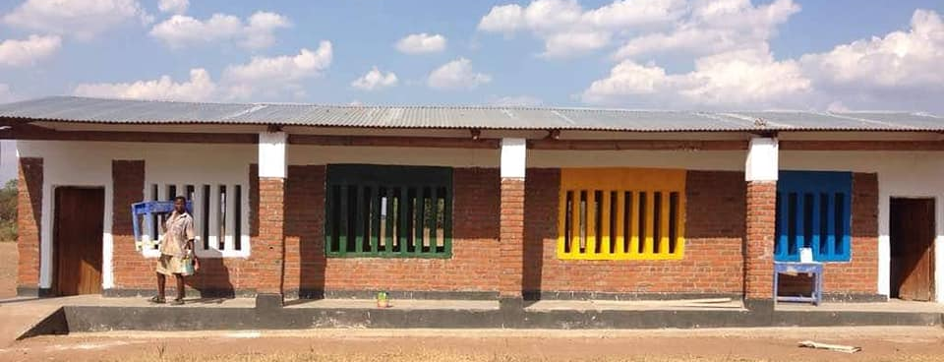
The Mlambe Project is a largely volunteer led international development charity working in the Balaka and Mangotchi Districts of Southern Malawi, which is the 19th poorest country in the entire globe and severely underdeveloped and lacking basic infrastructure such as schools, water, sanitation and power. Our work focuses on rural Malawi because other aid agencies and the Government focus their efforts on inner cities and densely populate urban areas for development. We focus our work on localities that may not have seen any international development investment for decades, or sometimes never.
An earthbag school we built
Our work focuses on building sustainable, locally driven solutions to development and this has been a huge driver in our work, that our staff are driving this work from the ground are largely Malawians, and that we focus on only supporting projects that can become self-sustaining in the long term, in all senses- ecologically, economically and rooted in local communities.
We are working to develop school blocks across the whole of Balaka over the next five years, where there is identified need for 86 school blocks, and 120 latrines. At the moment young girls in Balaka will rarely attend school whilst menstruating because there can be as many as 190 children using one latrine. In some schools, children have just one latrine for the entire school. 5160 children are currently being ‘educated under a tree’ in Balaka, that is that they have no formal classroom at school and are subject to intense weathers that can cancel their schooling for weeks at a time, for example in the recent Cyclone Idai which destroyed homes, crops and infrastructure across the District and left it flooded for weeks.
We are embarking on the nation’s biggest ever schools building programme, building on our experience developing the earthbag building technique. Earthbag building is hugely cost effective, and sustainable. It uses a mixture of compacted earth, sand and solution into a polythene bag to make bricks, which requires no firing and minimal wood to construct. What is amazing is that we can train local people to build with this technique and we have now trained a workforce of forty labourers, and for each new school block or latrine we build, we also train local people from the community in the building technique. We now have a team in Malawi that have over five years’ experience of building successive school blocks, supported by a UK based technical team of architectural and engineering experts.
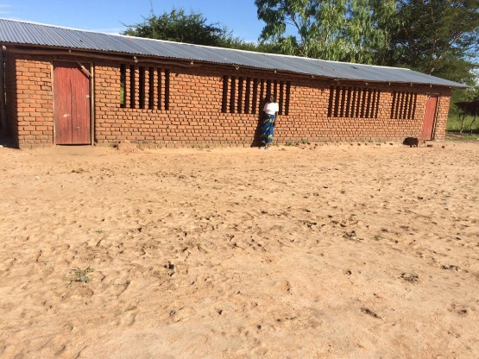
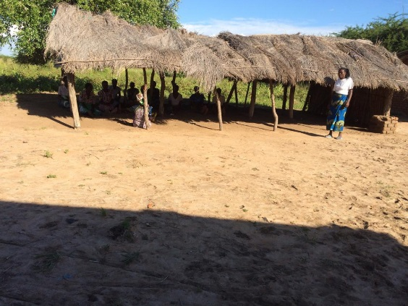
The makeshift school classroom @ Nankhono 1 School 'classroom' at Nankhono
Nankhono school urgently requires two school buildings and requires 6 latrines. There are no boys toilets at present which means boys have to go to toilet in nearby land which causes problems with sanitation. We have raised over £26000 towards the project so far which has allowed us to start building, but we need your help! We still need to raise a further £50,000 in the next 12 weeks so we can finish off the classrooms, some teacher homes and toilets.
A grant of just £10,000 could help us provide a classroom for 60 children a year over the next 30 years and ensure that some of our world’s poorest children get a basic and fundamental right to an education with the most basic of facilities. Whether you would like to give this, or a lesser amount, we would be tremendously grateful for any grant you could give us to help us ensure that children in Malawi get access to a basic education. We are a small charity with few overheads, and with only one part time paid staff member in the UK, you can be sure that your resources will be invested directly where they are most needed.
With your help, we can increase Nankhono’s pupil age range too- helping us move from educating children until they are 8 to when they are ten. This makes a huge difference as secondary school is a long way away and expensive. This means that most children, as their families are subsistence farmers can’t afford Secondary. By providing a longer primary school education we can try and ensure that children come out with the basic tenets of their literacy in place.
Help me help these children now, together we can make a long term impact in Malawi and lift children out of long term poverty.
Warmest wishes,

Anna Day FRSA
Chief Executive of The Mlambe Project
Winner #WISE2018 Top 100 women in Social Enterprise. Global Women’s Leadership Fellow.

