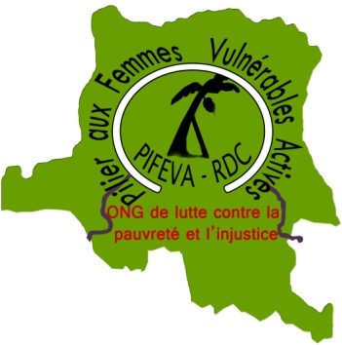
PIFEVA asbl
Pilier aux Femmes Vulnérables Actives en RD Congo
Pillar to Vulnerable Women Active in DR Congo
===========================================

Let's help Indigenous women of Mwenga

Introduction
PIFEVA(Pillar of Vulnerable Women Active in DR Congo) is a Congolese Non-profit Association created on 04 June 2004 in Bukavu in South Kivu and legally registered in DR Congo. She has specialized in women's adaptation and climate change, the promotion of gender and women's leadership, the fight against sexual and gender-based violence, the social and economic reintegration of women and girls in vulnerable situations and in the accompaniment of local communities prevention and peaceful conflict management, with a view to fighting against poverty and injustice in South Kivu in eastern DR Congo.
It is in this context that we set up this program called " Let's help indigenous women of Mwenga "

Main objective

The objective of this project is to contribute to the restoration of biodiversity of community forests by indigenous women through the planting of edible caterpillar trees in villages whose forests are overexploited and degraded in order to facilitate the empowerment of indigenous communities. indigenous women through the recovery and rational management of the production and sale of edible caterpillars as a source of food and income for indigenous women and households in Mwenga.

Specific objectives

1) Strengthen the capacity of indigenous nursery women in rehabilitation techniques for degraded ecosystems and the rational and sustainable management of community forests in Mwenga territory;

2) Establish seven fast tree nurseries (caterpillar hosts) by indigenous women trained and grouped into a local committee of nurseries of edible caterpillars in Mwenga territory;

3) Organize a campaign of planting edible caterpillar host trees by indigenous women over an area of 350 ha divided into seven community forest blocks of 50 ha each for the seven groupings bordering the Itombwe Nature Reserve (Basimweda 1st-Kalundu, Irangi-Ilibo, Kigogo, Bawandeme, Bingili-Bazala, Byonga and Kitutu) in the territory of Mwenga.

Amount requested: $ 5000

Donation options:

$10: will train an indigenous woman on biodiversity restoration techniques through reforestation;
$25: can train an indigenous nurserywoman on the production of edible caterpillar seedlings;
$50: will buy maintenance tools from a crawler tree nursery;
$100: can monthly pay a crawler tree nursery;
$200: will facilitate monthly monitoring 50 hectares reforested forests;
$500: can facilitate the construction and maintenance of a crawler tree nursery per village;
$1000: will support the organization of the campaign of planting host trees of edible caterpillars in a village;
$3000: can finance the reforestation of 50 hectares by planting caterpillars.

