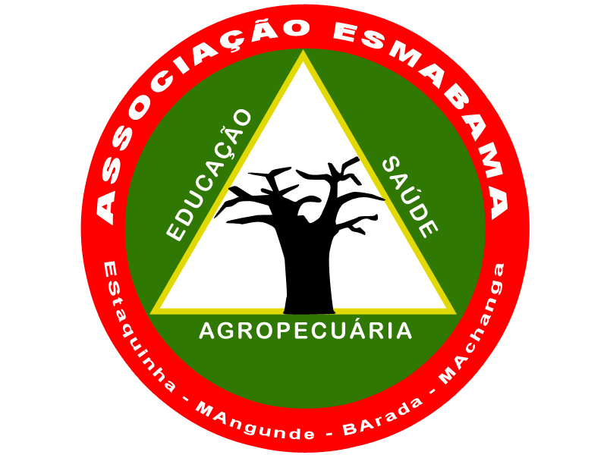**Cyclone Idai Emergency Relief (39849)**

**Report (4th quarter of 2021)**

**Summary**  
  
2021, and mainly the last quarter, was especially marked by the COVID context and the decisions taken by the PR on preventive measures. The classes reopened the 22 of March had to respect defined rules as intercalated classes (A class with 40 or more students should be divided into two groups, with the first group having classes on Monday, Wednesday and Friday in the morning and the second group classes on Tuesday, Thursday, Friday (afternoon) and/or Saturday in the mornings). In June/July, many cases have been met on urban areas such as Beira City, Dondo City and Nhamatanda and all the school in the urban areas were closed until September.

At the 28/12/21, the situation in Mozambique was the following: 20.642 active cases, 1.976 died, 175.648 case from the beginning of the pandemic and 4,9 millions of people completely vaccinated. In December the PR decided to close restaurants and bar from 9PM, to close the beach from 4PM to 5AM prohibiting the alcohol consumption during the day, allowing the organization of public events up to 30 persons inside and 50 persons outside and private event up to 20 persons inside and 30 outside.

During the last quarter, with the support of one of our partner some works are still ongoing in Mangunde (Chibabava District) as the rehabilitation of the General school, boarding schools, library, sanitary blocks and refectory (roofs, windows, walls, …). ESMABAMA rehabilitated also a water system of the agricultural school in Mangunde and the general boarding schools of Estaquinha and finally equipped the guest house of Barada. (*Please see pictures below*)

**Challenges**

Guarantee the functioning of 4 general schools with 6.400 students, 3 agricultural Institutes with 262 students and in total of 1.600 boarding students is a big challenge. Currently we are mainly fighting to ensure to the boarding students, food and hygiene material knowing that each student only pay / month 2€, just representing 10% of the monthly basic needs.

The other challenge we are facing were the rehabilitation of our damaged buildings (schools, boarding schools, health centres,….) during the school year. Work with the students around the building it was quite complicated and find available rooms and bedrooms to respect the preventive measures during the works was really challenging.  
  
**Results**

From July to December, ESMABAMA realized in Mangunde, 60% of the planned building works. Then, ESMABAMA prioritize the school infrastructure to allow to the students to study on the good way that’s why the buildings already ready to be used are classroom (A, B, C, D, E blocks), Laboratory/Library, Male boarding school and refectory, female boarding school and refectory. It’s just missing: administration office, Male and female sanitaries, guest house, Storage rooms, Doctor House and pigsty.

The rainy season slowed the planned works but the most part of the realized works will allow to the schools and boarding schools to attend the students from February 22 (*please see pictures in annex*).

In Mangunde, ESMABAMA rehabilitated also the water system access (Tower, electric pump, pipes,...) of the agricultural school damaged by the past cyclones ad storms. From January, more than 50 students and 10 teachers will finally have a water access.

In Estaquinha, ESMABAMA rehabilitated a water system access damaged by the past storms and cyclone, providing electric pump and pipes. From now, the sanitaries of the male and female boarding students have water for a better hygiene conditions of 365 students.

In Barada, one of the project of ESMABAMA supported the rehabilitation and equipment of the guest house (where all the visitors stay during their missions) repairing the water access system, doors, windows and providing equipment like bed, mosquito net, bed sheets and rod and curtains.

**Next step**

ESMABAMA will finish the current rehabilitation in Mangunde during the 1st or 2nd quarter of 2022. But ESMABAMA are seeking other partners to support the needs in the others intervention areas where ESMABAMA have works of rehabilitation to do, particularly for the technical school, primary school and maternity ward in Estaquinha and secondary and primary school, bathrooms and storeroom in Machanga.

**Pictures**

**Works done**  (10/01/22)

