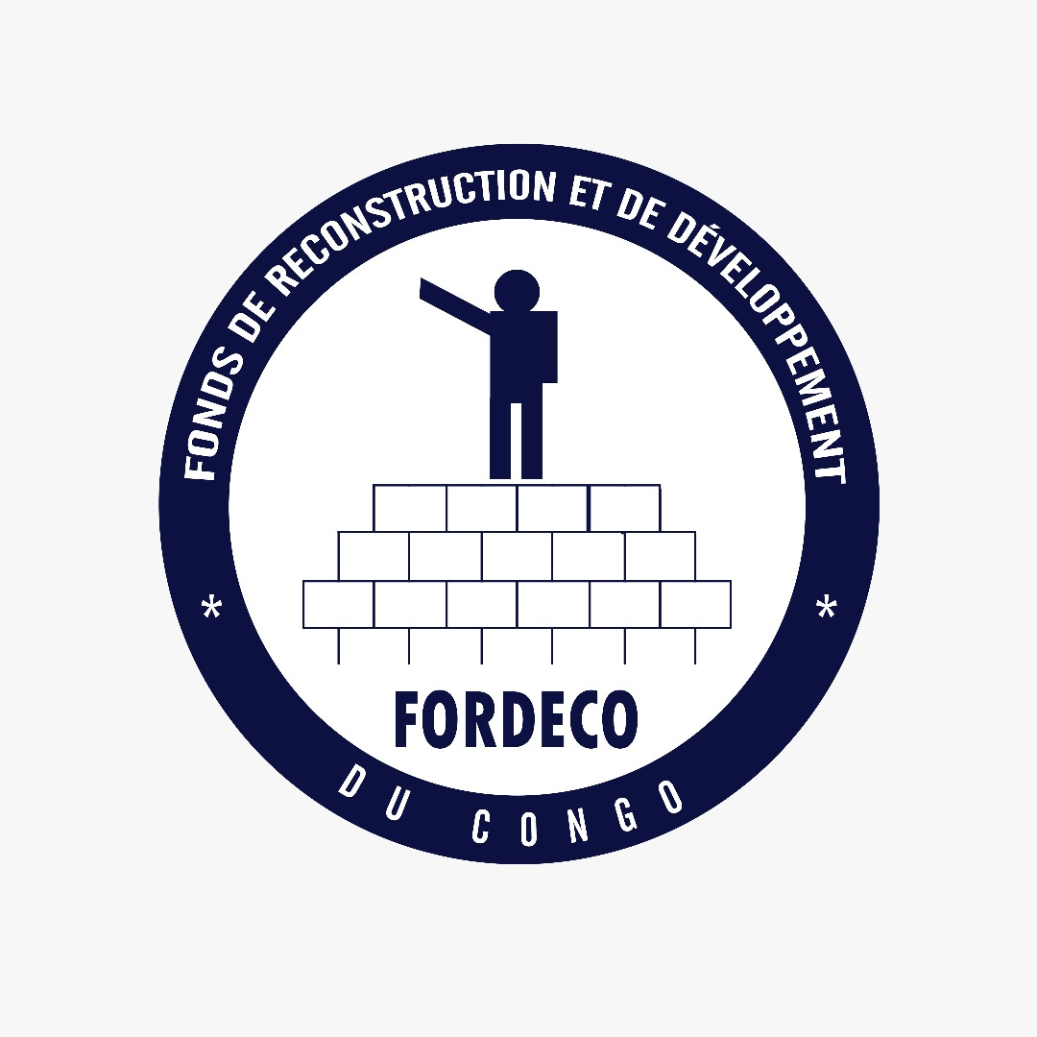

FONDS DE RECONSTRUCTION ET DE DEVELOPPEMNT DU CONGO
P.O.BOX 159 Nebbi, Ouganda, B.P. 452 Cyangugu, Rwanda Tel : +243990038624
Avenue des Martyrs Nº 8A, Vamaro, Bukavu, Sud Kivu. Bureau de Bunia Avenue Kibali, Quartier Bankoko, Ituri. Antenne de Kinshasa avenue des Universités nº77, Quartier Kauka, Commune Kalamu, e-mail : fordesk.rdc@live.fr www.fondsreconstruction.org
Registration N°JUSTICE/SG/20/1102/967/2018, Accusé Réception n°F.92/26.777
du 20 mai 2016. Account Bank N° 026-0262080000347/USD, FBNBank, Bunia, DR Congo.

Title of the Project: Self care of widows and orphans in the city of Bunia and Komanda through the production and marketing of ecological briquettes

- Who are you?
Le Fonds de Reconstruction et de Développement du Congo, in short « FORDECO », was created on August 20th 2003 to restore all things destroyed by the wars of 1994 and 1998 in the Democratic Republic of Congo (DRC.)

- What do you want to do:
We want to set up training programs for widowed women and adult orphaned children to teach them how to make charcoal briquettes. Stimulate and support various local charcoal producers to migrate to new green coal production, thus meeting ecological, health and environmental needs. This will reduce the bad environmental effect caused by charcoal use and will also give the women the financial power to satisfy their needs by their own efforts.
The number of targeted people is as follows:

- What and how:
  - Specific objective

3.1.1) Care for 1,023 widowed women and 4,218 orphaned children from the city of Bunia and Komanda, through supervision and training on the production of ecological coal.
3.1.2) Produce 36,000 briquettes of green coal based on vegetable biomass per month (banana peelings, corn cobs, peanut hulls and coconuts) and market it at a lower price than charcoal to meet needs of widows and orphans.
3.1.3) be a major player in nature conservation and the fight against deforestation through a strong awareness campaign on the benefits of nature;
3.1.4) Experiment with at least 3 other biomasses available for possible exploitation;
3.1.5) Create and strengthen the capacity of the environmental protection system.
3.1.6) Organize 12 sensitization sessions to engage the whole community (from the city of Bunia and Komanda) and local authorities on aspects of environmental protection using ecological coal.

  - GOAL OF THE PROJECT

    - Set up training programs for widowed women and adult orphaned children to teach them how to make charcoal briquettes. Stimulate and support various local charcoal producers to migrate to new green coal production, thus meeting ecological, health and environmental needs.

  - SUMMARY OR CONTENT OF THE PROJECT

This project aims to contribute to improving living conditions and reducing emissions from deforestation and forest degradation through self-help services. In this approach, the project wants to intervene in 4 interconnected activities:
1) Environmental protection
2) Health
3) Food security
4) Education
Action plans will be developed and implemented in the cities of Bunia and Komanda. These interventions or trainings will be implemented by the NGO FORDECO accompanied in some measures by other actors likely to play the partnership to the execution of some activities of the project.
Other areas of intervention will be defined as a result of participatory diagnoses of constraints and opportunities. The dissemination of the results will be presented through the various forums and through the participation of the various media (community radio), and some other slides, as well as the different community meeting outfits, etc.

  - DISSEMINATION OF THE PROJECT OR MEANS OF DISSEMINATION OF PROJECT RESULTS

As the lead agency of the project, FORDECO, to some extent, in collaboration with other partners, will be responsible for ensuring that project results are made accessible to all. In the sense that lessons learned from training and experience gained should be relevant even beyond the project area. Therefore, these lessons and experiences will be presented and disseminated through the various forums and through the media (community radios), regular project progress reports, cluster workshops, dialogues and information sessions. Community.
The project will also build on several other innovative dissemination techniques, including: slides. That is to say, FORDECO should take a lot of photographs of the key stages or film the progress of the project. These slides can be edited later to strongly illustrate the conditions encountered during the project, the perception of the project by the community and what it thinks of these results.

3.5 Innovation and original appearance of the project
While charcoal and other animal-based energy sources are the most widely chosen solutions for local people, the integration of coal that meets the ecological, health and environmental needs of communities should also be considered option for the future by FORDECO.

That is to say, energy sources other than those coming under charcoal and animal origin, remain neglected by strategies for environmental protection or the fight against climate change.

This strategy should note that not all communities in these targeted areas will be able or willing to accept this innovation for economic reasons.

This project is a response based on the results of an initial and comprehensive assessment of community needs, including:
The cutting of forest wood is one of the main activities and the prohibition of this first seems to be accepted because having no other activity to replace it.

Nevertheless, the training to be given to the communities in the framework of this project will, for this fact, be adapted to the level of each stakeholder. After of course having gone through the strategies of establishing clear criteria of beneficiary vulnerability and level of coal production and deciding what will be formed according to each of these criteria.

3.6. Evaluation method and means of verification

Monitoring and evaluation will be carried out by the PMT (Project Management Team), which has an activity monitoring and evaluation unit, based on objectively verifiable performance indicators.

Adequate budgetary allocation will be allocated for this task (missions); at the end of each mission, a report will be drawn up and sent to the FORDECO office.
The project will also be supervised by FORDECO, in particular through periodic supervision missions. The impact assessment will also be carried out periodically to determine the extent to which the project contributes to the goal of reducing the vulnerability of host communities in the project areas.
The evaluation of the beneficiaries as well as the impact of the impact will be carried out within the framework of a contract to be concluded with independent institutions. The project will finance the services of a specialist monitoring and evaluation consultant to assist the PMT in setting up and organizing the monitoring and evaluation mechanism.
The evaluation will review the achievements and the prospective impact of the project, and will, if necessary, take steps to facilitate the achievement of the objectives. The main concerns of the populations and their points of view concerning the activities of the project will be taken into account. To this end, arrangements will be made for conducting surveys and exchanges with beneficiaries during the mission.

3.7 Time Scale

Activity | MONTHS 2019
Activity | J | F | M | Ap | May | J | Jul | A | S | Oct | Nov | Dec.
Work Shop Rent
Acquisition of Production materials
Settlement of production sites
Capacity building for briquettes making
Monitoring and Evaluation
Reporting

- Why:
  - CONTEXT AND JUSTIFICATION OF THE PROJECT

At least 7 percent of global greenhouse gas emissions from human activities are due to the production and use of fuel wood and coal. According to a new FAO report released today, this is largely due to the fact that forests are managed in an unsustainable way, through inefficient coal production and wood burning.
In recent years, the DRC has been under severe pressure on its natural resources. High population growth, excessive cutting of wood for fuel, unsustainable agricultural practices and bush fires are the main causes. As a consequence, there is an irregularity and a delay of the rains as well as recurring droughts.

Charcoal and other energy sources of plant origin account for more than 95% of energy consumption in the Democratic Republic of the Congo. The industry consumes only 1% of the energy produced in the DRC. These figures contained in the annual report of the Energy Information System (EIS / 2010) of the Ministry of Energy contrast with the energy potential of the DRC.
This project is in line with the UN-REDD + program (the United Nations Collaborative Program on Reducing Emissions from Deforestation and Forest Degradation in Developing Countries).
In the Democratic Republic of Congo, almost all inhabitants use charcoal for cooking, which contributes to deforestation and the development of respiratory diseases.
For the past three years, the DRC has mobilized considerably in the REDD + readiness process and is currently a pioneer and leader in Africa. "Protecting the environment and combating climate change" is therefore one of the four pillars. of the Growth and Poverty Reduction Strategy. This principle is conceived in a vision of the country's transition to a green economy.
In Bunia, wood energy (firewood and charcoal) is mainly used for cooking food. The need for wood-energy supplies is such that its production, combined with slash-and-burn agriculture, is now a major cause of the degradation and deforestation of peri-urban woodlands. Phenomenon that leads to the disappearance of the various goods and services provided by these forest ecosystems and on which a large part of the rural population still depends.

This project aims to reduce deforestation and forest degradation, sustainably improve the incomes of local communities and reduce the vulnerability of widows and orphans to their financial problems. Concerned with respect for the environment, FORDECO wishes to produce clean organic (green) coal for which renewable energy resources are used and whose packaging is completely recyclable.

- Who: will do the work
The project will be implemented by FORDECO as it is the mandate of FORDECO to boost the development and keep the environment safe. FORDECO team is sufficient to give the expected result of this project. FORDECO has the skilled staff below:
  - Tuzza Alonda Victor: Coordinator of FORDECO. Tuzza has a bachelor degree in Administration Management, Financial and Accounting Management field. He has an experience of 20 years working with international NGOS: International Child Crae Ministries of North America in DR Congo, Action Against hunger USA, Save the Children UK, and with United Nations (WFP and UNICEF ) in development project. He is very well placed to monitor all activities at all levels.
  - Myra Sabina: Project Officer has a bachelor in sustainable development and has worked with FORDECO for 3 years now. She trains child rights ambassadors, teachers, parents, community leaders and other stakeholders in respecting Child Rights, Democracy, Global Friendship and No Litter Generation Project funded by the World’s Children’s Prize Foundation from Sweden (WCPF).
  - Sabina Tuzza Yedidia: Executive Secretary. She holds a bachelor degree in Project Management. She implements the WCPF project in South Kivu for 3 years now.
  - Mukanuna Tuzza Alain: has a bachelor degree in telecommunication. He is an engineer in telecommunication. He has been trained in financial matters and SAGE software in Nairobi. He is occupied with finance and all ICT matters.
  - Mchunga Ebengela: is a cashier of Bukavu Office. He has a diploma.
  - Mululi Mwesi Kayonga: a volunteer who is FORDECO internal auditor.
This means we have skilled and strong team to implement this project and produce the expected results.

- Impact.
  - The expected impact of the project is to contribute to the satisfaction of the basic needs of the people affected by the Komanda forest cutting ban.

  - It goes without saying that the project will not be able to solve the ecological problems linked to the emission of GHGs and deforestation, nor to meet the high demand for coal or permanently eradicate the vulnerability of communities. The project does not expect to achieve the stated impact, but rather to contribute with at least the expected effects that are presented according to these five objectives of sustainable development, namely:

6.2.1) No Poverty
6.2.1) Good Health and Well Being
6.2.3) Clean Energy and Affordable Cost
6.2.4) Relative action to fight against climate change
6.2.5) Terrestrial life
In the approaches piloted in the option of no poverty, this project will have a positive impact on the reduction of the vulnerability rate of the actors.

  - In the sanitary and hygienic framework, in the long term, there will be a reduction in respiratory pathologies linked to air pollution, a reduction of breeding areas for insects carrying diseases such as mosquitoes, which transmit diseases, namely malaria, dengue and Zika ...
  - In the long term, the recycling of waste will contribute to the respect of the principles aiming to preserve the health and the cleanliness in the private and public places.

  - Speaking of clean and affordable energy approaches, it should be noted that ecological briquettes being a reliable and modern energy will not have harmful effects when in use as it is a clean, climate-friendly energy and its price will be lower than that of charcoal on the market.
  - In the long-term climate and environmental change option, greenhouse gas emissions will be reduced and temperatures will decrease.

  - In the context of terrestrial life, in the long term, by protecting the fauna and flora we will also strengthen the management of natural resources and increase the productivity of the land

- BUDGET
Nº | Budget Items | Budget Code | Amount in USD | Annual amount in USD 140,730.00 | Expenditures 140,730.00
1. | Salaries | A | 4,350.00 | 52,200.00 | 52,200.00
 | Fordesk
 | Coordinator Salary | A.1 | 1,200.00 | 14,400.00 | 14,400.00
 | Other Satff Salaries | A.2
 | Programme Officer | A.2.1 | 500.00 | 6,000.00 | 6,000.00
 | Executive Secretary | A.2.2 | 500.00 | 6,000.00 | 6,000.00
 | Finances/HR Ressources Officer | A.2.3 | 500.00 | 6,000.00 | 6,000.00
 | Secretary at Coordination | A.2.4 | 450.00 | 5,400.00 | 5,400.00
 | Treasurer | A.2.5 | 300.00 | 3,600.00 | 3,600.00
 | Kinshasa Sub Office Chief | A.2.6 | 250.00 | 3,000.00 | 3,000.00
 | Supply Officer | A.2.7 | 150.00 | 1,800.00 | 1,800.00
 | Security staff and Watchmen (2*150*12 months) | A.2.9 | 300.00 | 3,600.00 | 3,600.00
 | Volunteers incentive by quarter (200*3*4) | A.2.10 | 200.00 | 2,400.00 | 2,400.00
 | S/Total Salaire Fordesk |  | 4,350.00 | 52,200.00 | 52,200.00
 | TOTAL SALAIRES | A | 4,350.00 | 52,200.00 | 52,200.00
2 | Administration & Travels | B | 12,690.00 | 20,337.00 | 20,337.00
 | Administration | B.1 | 8,767.00 | 14,694.00 | 14,694.00
 | Office Rent (Bukavu 150, Bunia 150 et Kinshasa 380*12=4560) | B1.1 | 380.00 | 4,560.00 | 4,560.00
 | Electricity (15*3bureux=45*12 months=540$) | B1.2 | 45.00 | 540.00 | 540.00
 | Water (20*2bureau=60*12=720$) | B1.3 | 60.00 | 720.00 | 720.00
 | Ordinateur (300*3bureaux=900) | B1.4 | 900.00 | 900.00 | 900.00
 | Imprimante (150*3bureaux=450$) | B1.5 | 450.00 | 450.00 | 450.00
 | Cartridge for computer (50*3 offices =150*4 quarters =600$) | B1.6 | 150.00 | 600.00 | 600.00
 | Paper (10*3 offices =30*4 quarters =120$) | B1.6 | 30.00 | 120.00 | 120.00
 | Pens (10*3 boxes =30$) | B1.7 | 10.00 | 30.00 | 30.00
 | Staples (5*2 =10*3 offices =30$) | B1.8 | 10.00 | 30.00 | 30.00
 | Staplers (5 boxes *3$=15$) | B1.9 | 3.00 | 15.00 | 15.00
 | Classeur (5$*40=200$) | B1.10 | 200.00 | 200.00 | 200.00
 | Office Chairs (150*7 people) | B1.11 | 1,050.00 | 1,050.00 | 1,050.00
 | Table (100*7 people =700$) | B1.12 | 700.00 | 700.00 | 700.00
 | Cupbaord (120$*7 people=840$) | B1.13 | 840.00 | 840.00 | 840.00
 | Holers (5*10$=50$) | B1.14 | 50.00 | 50.00 | 50.00
 | Audit Fordesk | B1.15 | 1,667.00 | 1,667.00 | 1,667.00
 | Audit JCRT | B1.16 | 2,222.00 | 2,222.00 | 2,222.00
 | S/Total | B1 | 8,767.00 | 14,694.00 | 14,694.00
 | Travels | B.2 | 3,923.00 | 20,337.00 | 20,337.00
 | Ticket et visa Bunia-Kampala-Bunia(taxi Bunia-Kampala-Bunia, 100$+visa50$=150*3 quarters) | B.2.1 | 150.00 | 450.00 | 450.00
 | Hotel (30$*7 days*3 quarters) | B.2.2 | 30.00 | 630.00 | 630.00
 | Restauration (10*3*7 days*3 quarters) | B.2.3 | 210.00 | 630.00 | 630.00
 | Turns in the city (10*7 days*3 quarters) | B.2.4 | 70.00 | 210.00 | 210.00
 | Loading training materials (100*3 quarters ) | B.2.5 | 100.00 | 300.00 | 300.00
 | Laundry, white dent and ironing clothes (30*3 quarters) | B.2.6 | 30.00 | 90.00 | 90.00
 | Field Visit JRCT | B.2.7 | 3,333.00 | 3,333.00 | 3,333.00
 | S/Total voyages |  | 3,923.00 | 5,643.00 | 5,643.00
 | Total Administration & Travels |  | 12,690.00 | 20,337.00 | 20,337.00
3 | Training | C | 6,710.00 |  | 0.00
 | Fordesk staff Training (50*10staff=500$) | C1 | 500.00 | 500.00 | 500.00
 | Women's Training (250 widows*11$*12 months) | C2 | 2,750.00 | 33,000.00 | 33,000.00
 | Chidren's Training (girls), 45*11$*12months | C3 | 495.00 | 5,940.00 | 5,940.00
 | Children’s Trainig (boys), 40*11$*12months) | C4 | 440.00 | 5,280.00 | 5,280.00
 | Trainig men (200*11$*12 months) | C5 | 2,200.00 | 26,400.00 | 26,400.00
 | Total Training | C | 6,385.00 | 71,120.00 | 71,120.00
4 | Project Implemention | D
 | Workshop Rent | D1 | 1,050.00 | 1,050.00 | 1,050.00
 | Pay the carpenter (1700$) | D2 | 1,700.00 | 1,700.00 | 1,700.00
 | Transport & logistics (33$*60 turns=1980$) Bunia | D3 | 1,980.00 | 1,980.00 | 1,980.00
 | Transport & Logistics (33$*60 turns=1980$) Komanda | D4 | 1,980.00 | 1,980.00 | 1,980.00
 | Total Project Implementation | D | 6,710.00 | 6,710.00 | 6,710.00
5 | Production of briquettes | E | 17,160.00 | 17,160.00 | 17,160.00
 | Production Komanda site (18000 copies*0.44$=8000$) | E1 | 7,920.00 | 7,920.00 | 7,920.00
 | Produaction Bunia site (18000 copies *0.44$=8000$) | E2 | 7,920.00 | 7,920.00 | 7,920.00
 | Distribution Cost (22$*60=1320$) | E3 | 1,320.00 | 1,320.00 | 1,320.00
 | S/Total E | E | 17,160.00 | 17,160.00 | 17,160.00
 | Reporting (postage, attaching papers etc). Forfait | G | 250.00 | 250.00 | 250.00
 | S/Total G | G | 250.00 | 250.00 | 250.00
 | Total Budget |  | 28,145.00 | 140,730.00 | 140,730.00
 | Bunia, 14/04/2019
 | Tuzza ALONDA Victor
 | Coordinator

