PROGRAM TITLE:

Water, Sanitation and Hygiene (WASH)

PROJECT NAME

Increasing menstrual hygiene management, edification and service delivery to adolescent school girls

SUBMITTED TO:

Global Giving

IMPLEMENTING AGENCY

SIAFU AND UPENDO WOMEN DEVELOPMENT ORGANIZATION (SUWODE)

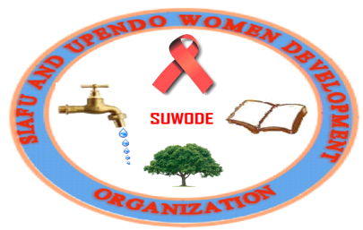

CONTACT PERSON.
Mrs. Ruth Simba
Chairperson SUWODE
Phone. No. + 255 754 974 483
P.O. Box 45534
Yombo Mwinyi street
Dar es salaam-Tanzania
Email: siafupendo2003@yahoo.co.uk
siafu.upendo@gmail.com

Table of content
Table of content……………………………………………………………….. 1
List of abbreviation……………………………………………………………. 2
Project summary………………………………………………………………. 3
Statement of need……………………………………………………………… 4
Call for action massage………………………………………………………… 7
Project activities with objective……………………………………………….. 7
Identification of stakeholder………………………………………………....... 9
Project goal and objective……………………………………………………… 10
Result, output and outcome……………………………………………………. 11
Monitoring and evaluation method……………………………………………. 12
Project budget………………………………………………………………….. 12
Project sustainability…………………………………………………………… 13
Project beneficiary………………………………………………………………` 13
Project location…………………………………………………………………. 13
Population………………………………………………………………………. 14
Risk and mitigation measure……………………………………………………. 14
SUWODE profile……………………………………………………………….. 14

List of abbreviation
MHM Menstrual Hygiene Management
WASH water, Sanitation and Hygiene
SUWODE Siafu and Upendo Women Development Organization
RTIs Reproductive Tract Infections
BV Bacterial Vaginosis
WSP Water, Sanitation Program
RSV Respiratory Syncytial Virus
LGA Local Government Authority

PROJECT SUMMARY
The inter-relationship between gender, poverty, education and health, demonstrates the need for all sectors address gender equity as a central part of their efforts to attain the SDGs intervention plus international efforts to confront gender inequity. Since the 1979 adoption of the UN Convention on the Elimination of All Forms of Discrimination against Women, the status of girls and women has improved. In many regions, girls and women increasingly have access to education, the labour market, and governmental structures. Legal and economic reforms have also begun to remove some of the structural barriers to women’s full social, cultural and economic participation
Menstrual Hygiene Management (MHM) proposal reflects an ambitious vision of Government republic of Tanzania and Sustainable Development Goal (SDG) number 4 indicators 4.5 and number 5 indicator 5.2 and also for greatly expanding Siafu and Upendo Women Development Organization (SUWODE). SUWODE seek to strength and contribute positive change to the community and school society concern to improve WASH sector development as well as health and education development plus provide more value to the social welfare service delivery. SUWODE seek collective social actions, which is long term commitment by group of important actors to a common agenda for solving a social problem facing school society. In this case the common agenda is contribution of sustainable development to menstrual hygiene management facilities and service delivery plus availability of sanitary pads and privacy room for adolescent girls.
Be familiar with that the effectively availability of sufficient, reliable water, sanitation and hygiene facilities for human use is a major factor limiting the economic and social development outcomes for the target population SUWODE has been carrying some effort to endorse access to safe and sufficient water for livelihoods and promote sanitation and hygiene through investing in water service provision, strengthening community WASH resource management structure and the issue of menstrual hygiene management (MHM) in school society, increase rights to WASH service.
The MHM strategy/proposal will be initially implemented as a pilot in the four primary schools of Kigunga and Kilakala in Kilakala ward and Yombo Vituka and Ukombozi primary schools in Yombo Vituka ward. The central part problem that the programme seeks to address is to combat poor menstrual hygiene management and negative impact purposely improves school attendance, participation and performance among the adolescent girl who experience adolescent period without proper menstrual hygiene service and education. Encourage all WASH project/programs implementing in schools by Government institution or development partners should not only consider average/number of drop holes between girls and boys but also considered privacy rooms and MHM facilities.
SUWODE need to see every stakeholders participate fully to design, plan and implement menstrual hygiene management issue within their areas and community have enough knowledge to manage WASH issue by achieving this obvious will stimulate good sanitation and hygiene behaviours as a result communicable diseases totally will be trail off. extremely weak livelihood, education and health upshot currently faced by target school society and communities of Kilakala and Vituka ward due to insufficient and on shaky ground water, sanitation and hygiene facilities and practice. By addressing these WASH issues alongside its work to address other core problems within the sectors

1.0 STATEMENT OF NEED
Basically this project designed for the improvement and development of health and learning performance to the adolescent school girls who are vulnerable to poor menstrual instruction, and service delivery. SUWODE search for address issue that undermine their good health plus WASH enhancement such as MHM advocacy and improve WASH facilities. Also increase the capacity of intended schools to effectively and efficiently manage and sustain Water, Sanitation and Hygiene (WASH) specifically good menstrual hygiene practice. There is a need for capacity development to teachers, pupils as well as other schools society purposely having knowledge to deal with menstrual hygiene management in all WASH issue.
Normally WASH stand for water, sanitation and hygiene and As we know also advocacy can be a process of speaking, acting, writing with minimal conflict of interest on behalf of the sincerely perceived interests of a disadvantage person or group to promote, protect and defend their welfare by being on their side and no one else, the effect of poor water, sanitation and hygiene (WASH) seep into every aspect health development, economic and social development. Perpetuate an intergenerational cycles of poverty and deprivation to meet country water, sanitation and hygiene challenges.
Poor menstrual hygiene leads to bacterial vaginosis (BV) an increase risk of reproductive tract infections (RTIs) which can in term lead to maternal issue, such as preterm birth, sexually transmitted infections, post partum infection complication after abortions or caesarian section urinary tract infection are also commonly caused by poor hygiene. Basically children learns some of their most important sanitation and hygiene skills during schooling and use this skills to their home practice, technically teachers of all level can be effective advocate for hygiene through formal and informal education as well as acting as acting as role models for school life among the children such as hand wash with soap after toilet use and accurate use of latrines.
Furthermore, poor sanitation and hygiene contribute strongly challenges to school society and for schools girls are more vulnerable due to the fact that environment that may be acceptable for boys may be hostile to girls. Girls and women living per urban and rural areas setting and particularly in school society suffer most from stigma and lack of appropriate service delivery and facilities to support them cope with the physical and psychological pain they undergo during the menstrual period, inadequate preparation for the period of children to adolescent, privacy space and wash room as well as disposal of the material for those who use sanitary pads.
When women/girls can’t afford or access absorbent sanitary product, they may use improvised materials such as improperly clean garments or other materials such as even grass, this may cause reproductive tract infection such as bacterial vaginosis or vulvovaginal candidiasis which is turn can increase susceptibility to HIV infection. Its fact that poor sanitation and hygiene resulting of millions of infants, Childs death, poor sanitation and hygiene stalls social and economic development, according to economic impacts on poor sanitation in Africa report under Water, Sanitation Programme (WSP). The study reveal that poor sanitation cost Tanzanians 301 billion Tsh each year and 28 million Tanzanian use unsanitary or shared latrines, 5.4 percent have no latrine at all and defecate in the open poorest quintile is 41 times more likely to practice open defecation than the richest.
SUWODE appreciate a goodwill of the Government to improve social welfare service to all citizen, however the total cost of 301 billion Tsh, which Government republic of Tanzania spent yearly for treatments and sometime seem as a need to increase Government budget to cover treatment cost. Obvious 301billion shilling its much money but this might not only solution to overcome this challenges, there is a need to put more efforts and financial for awareness creation and promotion at the grassroots level as well as capacity development and provide stakeholders participation to bring positive changes. Basically when community of all level have enough skills with passion to protect ecosystem and capacitated to a large extent involved to solve Water, Sanitation and Hygiene (WASH) challenges, apparent Government will use little money for covering treatments and further financial will be used for other development activities such as education development program, social welfare service plus delivery and mentored.
Naturally girls in each months truant to school about five (5) days or more due menstrual periodic and greater awareness and understanding of, and appreciation for Menstrual Hygiene Management that links water, sanitation hygiene programme. Menstruation is a natural process; however, if not properly managed it can result in health problems. The impact of poor menstrual hygiene on the psycho-social wellbeing of women and girls should also be considered. Menstrual hygiene management (MHM) aims to ensure that young girls and women are able to manage their periods hygienically.
The menstrual hygiene process is different for every girl and woman. It is very specific, because it relates with the organism of the person, with the health situation and mostly with the inner feelings and emotions. When this stage of life comes to a young girl she doesn’t know what she has to do and what is she going to face up to through all her. It is very important young girls from 7-9 years old to talk freely with their families on this topic, especially with their mothers and sisters. There are many girls that grow faster than others and they should be prepared and know how to react, because the first time the menstruation comes they may be alone and they should know what to do.
There is an urgent need to focus on triggering the demand to build latrines and ensuring quality and standard, use and maintained this as achieved by creating a culture of social sanction that challenges acceptance of open defecation for all. Open defecation is an socially accepted traditional behaviours and many household and community consider latrine unclean and availability of open defecation of such of belief, the major challenges is to change behaviours established over country which have resulted on open defecation and being considered socially, acceptable, it is not. Ownership or having latrines does not always mean to better adoption of good sanitation and hygiene practices habitually few design with lack of proper maintenance, lack of knowledge concerns proper latrine usage.
Basically the immediate need for communities of all group of age and gender to change existing perception concerns the importance of good sanitation and hygiene practice to achieve a promote change to individual practice attached with a change in the positive change in the social norm. SUWODE believe that transformation it’s about process and change cannot occur overnight but strong collaboration from different actors plus sustainable planning and participatory approach need to be proper considered to ensure communities have opportunities to bring change as well as have knowledge and best technique to combat WASH challenges to their society.
The unexpected doorway of children into primary schools arising from the bold move by the Tanzania government to implement the free primary education compounded the sanitation situation in schools. The available sanitation facilities could not adequately serve the children. With reference to WASH guideline set standard concerns to latrines build and usage, the standard direct that one drop hole should serve 20 girls and for boy one drop hole shall save 25boys. So due to high number of children observable waste invention is far above the ground and the standard of using latrines unsuccessful. So it’s better in the implementation of free education programs also should consider or goes part and parcel to hygiene and sanitation programs.
Water, sanitation and hygiene in school will focus on the fact that school is one of agent of socialization so it’s have special and important roles in protecting children and school society from diseases and illness due to eruption of communicable diseases caused by poor water, sanitation and hygiene and through best practice of hygiene education, awareness creation. Basically involvement of difference actor s in solving WASH challenges in school society and having intervention programs it might improve participation and behaviour change from bad to good beheaviours among the communities. Also WASH interventions programs in school guarantee performance and fully participation among the children.
Many pit-latrine constructed in school society always considered the toilet use by number of drop holes between boys and girls. SUWODE seek Local Government Authority and Central government consider all constructs latrine should have room for privacy to adolescent girls in WASH guideline and their construction design, because WASH issue goes in pare with menstrual hygiene management. Poor menstrual hygiene management mostly hinder girls to participate well in learning activities because without proper service most of them when they reach in the period feel inferior to appear front of others pupils as a result decide to stay at home until the period finished
Diseases spread through fecal-oral transmission. Infections that may be transmitted through this route include salmonellosis, shigellosis, hepatitis A, giardiasis, enterovirus, amebiasis, and campylobacteriosis. Because these diseases are spread through the ingestion of even the tiniest particles of fecal material, hand washing after using the toilet cannot be over-emphasized. Diseases spread through indirect contact with respiratory secretions. Microorganisms that may be transmitted through this route include influenza, Streptococcus, respiratory syncytial virus (RSV) and the common cold.
Hands contaminated by respiratory discharges of infected people may spread these diseases indirectly, illness may be avoided by washing hands after coughing or sneezing and after shaking hands with an individual who has been coughing and sneezing. In addition, diseases are spread when hands are contaminated with urine, saliva or other moist body substances. Microorganisms, which may be transmitted by one or more body substances, include cytomegalovirus, typhoid, staphylococcal organisms, and Epstein-Barr virus.
Keeping the hands away from the face will prevent transfer of germs to the mucous membranes. Frequent and pro Originally Menstrual Hygiene Management (MHM) advocacy plan/proposal targeted four and SUWODE develop this MHM advocacy plan in the aspect to achieve a positive change and bring sustainable development of WASH issue. Basically children considered as future parents and if well build in hygiene practice form the beginning and given a chance to participate fully at initial stage to learn about the important of best hygienic behaviours/practice he/she will be agent of change at family level as well as in social groups to solving social problem, each person have responsible to ensure environment conserve in sustainable way and comply with policy, laws and guideline and it is important to recognize that individual behaviours is complex to water, sanitation and hygiene.
per hand washing reduces the chance of germs getting into the body and prevents the spread of germs to others. Hand washing is the best way to stop the spread of infections. Because the hands can spread eighty percent of common infections, frequent and proper hand washing will reduce absenteeism and keep staff and communities healthy.
Originally Menstrual Hygiene Management (MHM) advocacy plan/proposal targeted four and SUWODE develop this MHM advocacy plan in the aspect to achieve a positive change and bring sustainable development of WASH issue. Basically children considered as future parents and if well build in hygiene practice form the beginning and given a chance to participate fully at initial stage to learn about the important of best hygienic behaviours/practice he/she will be agent of change at family level as well as in social groups to solving social problem, each person have responsible to ensure environment conserve in sustainable way and comply with policy, laws and guideline and it is important to recognize that individual behaviours is complex to water, sanitation and hygiene.
Human behaviours is determine by close social network, so this WASH advocacy plans focus on the safe disposal and management of sold and squashy waste, promoting hand washing with soap after defecation and before food safe storage and handling drinking water and influence build the conducive latrines which comprise privacy girls to manage menstrual hygiene as well as WASH education. Raising awareness is importance mechanism to adopt best Water, sanitation and hygiene behaviours, and influence attitude from bad to good among the communities.
SUWODE seek to influence positive change through organize WASH stakeholder meeting which will participated by political leaders, religious leaders, media, communities, adolescent girls from the targeted schools, business person who doing business around Yombo Vituka and Kilakala wards with local government leaders. At the closing stages participants will get opportunity to develop wards level water, sanitation and hygiene strategic plans as working tools to WASH issue. WASH strategic plan will identify potential stakeholders and their contribution/commitment to construct pit-latrine in schools with privacy room.
Also through increasing access to WASH appropriate facilities and MHM in school society plus advocacy SUWODE want district executive director and their teams considers menstrual hygiene management in district plans along with all WASH issue performed in schools, mean that all pit-latrine constructed in schools areas have privacy room with full sanitary pad and related gears for adolescent girls as well have trained teacher to educate adolescent girls continuously.
Basically schools administrators or decision maker officers who are not aware about Menstrual Hygiene Management (MHM) including service delivery, obvious failed or feel not imperative to provide supportive environmental for adolescent having privacy room and sanitary pad the only thing consider its about number of latrine. Poor menstrual hygiene in schools society obvious contribute poor performance and poor attendance among school girls, so to constructs pit latrines without privacy room, materials for emergency incidents and WASH education always challenges will be incessant, the only thing needed is about provide supportive environment and menstrual hygiene management friendly
SUWODE also want to establish school health club in all targeted primary school to promote best hygiene practice within schools, as well as school girls (adolescent) have the forum to discuss their challenge and address the challenges. This team will acquire capacity development training as well as facilitated sanitation and hygiene protection gears to make easy day to day cleaning and environment protection issue. For having sustainability of club subsistence wards councilors will be custodian of all formed school health clubs.
The proposed project also will offer capacity development to 240 adolescent of Kilakala and Kigunga as well as Ukombozi and Vituka primary schools purposely have basic education/knowledge about menstrual hygiene management. This project design to facilitate school girls(adolescent) to stay at school throughout the months without fear or psychological pain, we hope by accomplish this obvious school attendance, participation and performance will be improve as well as increase the number of school girls who complete primary education.

1.1 CALL FOR ACTION MASAGE FOR WASH ADVOCACY IN FOUR SCHOOL AT KILAKALA AND VITUKA WARDS
- amplify sustainable mechanism to increase water, sanitation and hygiene (WASH) in school, and mobilizing resource to secure children health

- Demonstrate sustainable, quality and standard WASH facilities in school programs
- PROJECT STRATEGY/ACTIVITIES
2.1 Community mobilization /Awareness creation to introduce project goal

Specific objective
- Increasing community participation in project implementation and solving WASH challenges face school society/pupils

  - Conducting need assessment
Specific objective
- To understand the real and perceived needs of the proposed project beneficiary communities.

- Communities themselves might have strong opinions about the main problems they are facing and their desired interventions, however these perceived needs may not be consistent with needs

  - Capacity building training, SUWODE will organize in each of intended program schools. The capacity development training will conducted for five days for one program school and will have four female facilitators. During the training should facilitate training participant and made brief introduction and overview that participants expected to transfer the knowledge acquire to others students and community generally
Specific objective
- Schools society/participants understand meaning of menstruation
- Participants having know-how about the menstrual process, the age which menstrual start and stops, and when you experience which thing require to do and how to keep clean during menstruation
- To understand how can prevent from diseases caused by poor menstrual hygiene management
- Learn about how to use sanitary pads effectively
2.4 Prepare and develop IEC promotion materials
Specific objective of IEC materials
- IEC materials develop to facilitate management and to cascade information to the communities
- Improve community understands through simplify and translate into local language to make understandable at all age of people
  - WASH key stakeholder meeting
Specific objective
- influence district plans and development partners consider and implemented menstrual hygiene as a part and parcel to Water, Sanitation and Hygiene (WASH) projects at grassroots level

- Encourage ministers of WASH sector related to consider WASH issue as first priority to Government plans

- Use moral authority to encourage behavioral change and technological input

- Act as agent of social changes within their areas to ensure community and schools society have appropriate WASH facilities plus service delivery

- Develop Water, Sanitation and Hygiene strategy plans that can guide WASH program at ward level

2.6 Facilitate construction of privacy room
Specific objective
- Increase access to menstrual hygiene management service and hand washing facilities
- Improve classroom participation, attendance and performance among the adolescent
- Combat WASH circumstance that contribute highly drop-out to schools
2.8 follow up, monitoring and evaluation
Specific objective
- Achieving projected results and quality control.
- Monitoring indicators of project activities will be reviewed during the planning meeting at the beginning of the project and reviewed/adjusted during annual planning workshops. Activity monitoring will take place as project interventions occur. Monitor project outputs and risks as part of the quarterly discussion and reporting to the Steering Committee.

3.0 IDENTIFICATION OF PROJECT STAKEHOLDER
SUWODE understand the important to all stakeholders participate full to the community based projects. Therefore will arrange WASH stakeholder identification workout

3.1 Stakeholder who will involve influencing change and achievement to wash programs

S/N | STAKEHOLDER | ESTEEMED SUPPORTS
1 | Politician | - Lobby with Government of various level of WASH in targeted program schools  - Encourage ministers of WASH sector related to consider WASH issue as first priority to Government plans  - Speak to municipal/district forum and meeting session in favour of WASH program
2 | Media | - Interview children, school society and record their experience with WASH issue in school  - Build forum for discussion, willing and broadcasting success stories  - Use their professional to disseminate WASH key massage in public
3 | Religion leader | - Help congregation understand the health benefit of better WASH by describing the relationship  - Use moral authority to encourage behavioral change and technological input
4 | Civil Society Organization (CSO) | - Documentation and dissemination by prepare, publish and  - distribute simplified WASH advocacy materials  - Facilitate formation of WASH club and open dialogue on MHM  - Capacity development through organize and arrange strategic consultative meeting with District Executive Director and District Education Officer at District level
5 | Teacher | - generate greater awareness and understanding of, and appreciation for WASH issue to school society  - participate fully to demonstrate conductive environmental to implement WASH program within their school
6 | Local Government Authority (LGAs) | - establish relationship of WASH actors to increased collaboration between district extension workers, policy maker  - influence district plans consider and implemented Water, Sanitation and Hygiene (WASH) projects at grassroots level  - allocate essential funding for operational and maintenances of school WASH programs  - providing space and time for children and teacher to engage in WASH issue promotion  - Plans and design sanitation model which consider menstrual hygiene management (MHM) to the WASH program implemented in the schools
7 | Community | - build consensus to eliminate open defecation for better health of children and all who are being in the community  - participate fully in WASH school programs and contribute financial, manpower and skills

- PROJECT GOAL AND OBJECTIVE
4.1Project goal
To strength the capacity of WASH stakeholder and school society in managing menstrual hygiene in Kilakala ward and Yombo Vituka wards primary schools. This will be achieved through the following objective:-

- to strength and increase community awareness on proper sanitation and hygiene practice among school society ( girls and teacher)

- to influence decision maker and politician leaders to advocate for improved water, sanitation and hygiene standard with appropriate privacy room for adolescent

- Religion leaders as stakeholder participate to facilitate congregation understand the health benefit of better WASH by describing the relationship

- inspirational on the sympathetic of the key concepts in the WASH advocacy

- To expand scientific know how on the development of the WASH advocacy strategy/plan

- Ensure school society and community have enough knowledge about the linkage between WASH and human health development to increase public demand of social welfare service delivery

4.3 Specific objective
Increase population wide and community awareness about the importance of having menstrual hygiene management program and encourage using latrines effectively and practicing best hygiene in positive impact

4.4 Purpose
To generate greater awareness and understanding of, and appreciation for Menstrual Hygiene Management that links water, sanitation hygiene programme

5.0 RESULT: OUTPUT AND OUTCOME
Outcome
- District executive Director and Council Water and Sanitation Team(CWST) considered Menstrual hygiene management in WASH program as fundamental mechanism to combat poor performance and poor attendance to school among school girls as well as consider MHM as policy issue

- Decreased risk of diarrhea, dysentery and other waterborne gastrointestinal diseases

- Individuals in communities especial teenager girls are able to access good menstrual hygiene practice and service delivery

- Classroom attendance and performance among the girls improved

- Water, sanitation and hygiene ward plans develop to watch over WASH issue to the streets institute in Kilakala ward
Output
- Increased collaboration between district extension workers, policy maker, implementers and communities in WASH project implementation

- Capacity of District task force team improved to provide active and relevant learning environment for poor community.

- Local Government leaders has clearly defined responsibility for overseeing Water, Sanitation and Hygiene and considered part and parcel to Menstrual Hygiene Management.

Expected Results
- Local Government Authority(LGA) and WASH stakeholders supports program schools have privacy room for adolescent girls and provide sanitary pads as well as service delivery
- Improved school society and household in personal hygiene practices enhance the living environment and thus, have direct effect on improved health.
- District plans consider Menstrual Hygiene Management in all implemented Water, Sanitation and Hygiene (WASH) projects

Project indicator
Menstrual Hygiene and Management clearly define and articulated in natural WASH, health and education policy

Means of verification
- Natural WASH policy has reference to menstrual hygiene and management infrasture and awareness
- Menstrual Hygiene Management infrastructure is a part of standard WASH design as advocated at the national and district level
- Natural education policy include menstrual hygiene within natural curriculum

Indicator
- 75% of institutional and public Water, Sanitation and Hygiene (WASH) facilities constructed with consideration for Menstrual Hygiene Management

Mean of verification
- Hygienic space for Menstrual Hygiene Management
- Security and privacy for Menstrual Hygiene Management
- Hygienic option for disposal of used sanitary materials

Indicator
- 80% of girls and women with improve menstrual Hygiene management(MHM)

Mean of verification
- Able to identify myths related to menstrual hygiene management as myths
- Able to describe positive change in attitude to award menstrual hygiene management

Timeline
The implementation of this project will cover twelve months from 1st of June 2019 to 31st of May 2020

- LOGICAL FRAMEWORK
Impact (long-term) |  | Indicator | Mean of verification | Assumption
 | Improve gender equality | High degree of girls completing primary school and join high school | Natural and record data | NA
Impact (short term) | Girls are able to take full advantage of the education | - The number of school absentees reduce  - Reduce retention of the girls/school achievement | - Record from school engage in menstrual hygiene management  - Survey data from girls involve in MHM health education | - Girls who miss less school and perform better are more likely to complete school and subsequently secure opportunities for high level education
Outcome | Girls are able to manage their menstrual dignity | Improve knowledge of menstruation and reproductive health | Data from social impact assessment | Good education of reproductive health and accessing family planning
Output | Girls received menstrual health education and sanitary pads | - Number of trainers  - Number of girls received education  - Number of girls received sanitary pads | Social enterprises record  Report from other firm | Access to reliable sanitary product and menstrual health instruction
Key activity | - Menstrual hygiene advocacy  - Key stakeholder meeting  - Construction of pit latrine with privacy room | - Number of workshop participants  - Number of training course | Charity record | NGO are interest and integrated MHM into the program and addressing the issue

7.0 MONITORING AND EVALUATION METHOD
The work plan will be used to measure the progression of the project. Using the participatory approach, specific monitoring tools will be developed for each objective and used to collect information. This approach involves data collection from interviews with key informants, feedback from community discussions as well as the local council and water committees.

8.0 PROJECT BUDGET
S/N | ACTIVITIES | THEMATIC FOCUS | TIMEFRAME |  |  |  | BUDGET
S/N | ACTIVITIES | THEMATIC FOCUS | QI | Q2 | Q3 | Q4
 | Awareness creation
1 | Community mobilization meeting to introduce project goal and objective | Resource development |  |  |  |  | 450,000/=
2 | Conduct Social Impact Assessment on WASH issue at wards level | Policy, research and advocacy |  |  |  |  | 2,000,000/=
3 | Key stakeholder meeting at wards level and community facilitation to form ward level WASH technical committee to watch-over WASH issue | Coordination and networking |  |  |  |  | 3,050,000/=
4 | Prepare and publish simplified advocacy materials (400 posters and 200 booklet) for stakeholder and community advocacy at the community level | Documentation and dissemination |  |  |  |  | 3,950,000/=
5 | Facilitate formation of 4 schools WASH club and capacity development | Advocacy |  |  |  |  | 1,600,000/=
 | Subtotal |  |  |  |  |  | 11,050,000/=
 | Capacity development
6 | Organize and arrange strategic advice-giving meeting with wards councilors of Kilakala and Yombo Vituka wards, ward executive officer, streets executive officers and ward Education Officers and street chairperson | Capacity development |  |  |  |  | 1,500,000
7 | Capacity development training to the intended program schools | Capacity development |  |  |  |  | 2,000,000
 | Subtotal |  |  |  |  |  | 3,500,000/=
 | Resource development
8 | Construction of 4pit-latrines with privacy rooms and hand washing facilities in four primary schools | Resource development |  |  |  |  | 75,000,000
9 | Lunching ceremony of the project completion( the amount will cover hire loud speaker, theater groups and other logistic arrangement) | Networking |  |  |  |  | 2,500,000
10 | Monitoring and evaluation | Advocacy |  |  |  |  | 3,800,000
11 | Handover, Report preparation and submission | documentation |  |  |  |  | 400,000
12 | Stationeries for office work | documentation |  |  |  |  | 610,000
 | subtotal |  |  |  |  |  | 82,310,000
 | Total project cost |  |  |  |  |  | 99,860,000
 | Overhead cost |  |  |  |  |  | 12,200,000/=
 | Grand total |  |  |  |  |  | 112,060,000
 | Community contribution 10% |  |  |  |  |  | 11,206,000
 | Funds request |  |  |  |  |  | 100,854,000
 | One Tsh is equal to U$ 2,300 |  |  |  |  |  | 43,849.56

9.0 PROJECT SUSTAINABILITY
For the aspect of programme sustainability, SUWODE will offer opportunity of dynamic participation to media/journalist, community, local government leaders, and ward councillors as well as wards executive officers and influential people/religious leaders in targeted ward. Also subsequent to completion of the project implementation, Temeke District council through department of education, health, Community development and social welfare plus District planning officer will be accountable to supervise daily activities as well as supporting technical staffs and materials including ensure through capital grant provide 5% to support water, sanitation and hygiene issue in schools. Also ward WASH committee will be responsible to watch over WASH issue in ward level as well as ensure WASH facilities managed in sustainably way.

10.0 PROJECT BENEFICIARIES
Basically MHM and WASH advocacy strategy plans contain direct beneficiaries and indirect beneficiaries, the total direct beneficiary stands of 1,200 people and indirect beneficiaries stand for 2,450people this total figure include school society, communities, political leaders and local government leader(street and ward), even though SUWODE consider that after projects completion we respect to have high volume of indirect beneficiaries from WASH education provided but also the number of other communities who seek to begin establish WASH groups in other area.

10.1 Project approach
Always top down approach in implementation of community project failed to bring positive change, so the proposal action will adopt bottom to top approach to ensure school society participate fully to support intended school MHM program.

10.2 project design
SUWODE technical team will constructs four pit-latrines in four primary schools, the pit-latrine will comprise eight chambers, with privacy room for adolescent school girls, separate part to people with disability facilities and part to teachers (female and Male). Construction of those pit-latrines will consider sanitation guideline (see attached sketch)

11.0 PROGRAMME LOCATION
Kilakala and Vituka wards previously were one ward and both located in southern part of Dar es Salaam region approximately 10 kilometre from Dar es salaam city center. Fundamentally the MHM advocacy program targeted school society which bordered by five street of Kigunga, Kilakala, Barabara ya Mwinyi, Magengeni and Kiembe samaki. and after finishing point of the menstrual hygiene management project, Water, sanitation and hygiene ward level plans will developed to guide WASH issue. Both street found in targeted ward will consider and adopt ward WASH plan to prepare street WASH plans and committed to create community sensitization at grassroots level.

11.1 Historical background
Temeke district was first established as a district in 1977 following the introduction of the decentralization policy in Tanzania. The Government decides to restore local Government Authorities in late seventies henceforth service provision responsibilities were best owed to Local authorities. Temeke Municipal Council was establishing on 10th of November 1999 under the local Government (urban authorities) Act, 1982. Prior that time Dar es Salaam city and coast region constituted a single region known as coast region.
The coast region were constituted Mzizima, Kilwa, Rufiji, Kisarawe, Bagamoyo and coast district. Later on, the region was further subdivided into two regions namely coast (Pwani) and Dar es Salaam. While the former including Kisarawe, Bagamoyo, Rufiji, Mafia, Mkuranga and Kibaha districts. The later comprise Ilala, Kinondoni and Temeke districts. Of recent, a portion of land was apportioned from Mkuranga district and added to the present municipality of the city of Dar es salaam, has three municipality with 656sq km and the largest of the 3municipalities of the city Dar es salaam has three of divisions of Chang’ombe, Mbagala, and Kigamboni with 30ward and 180streets

12.0 POPULATION
Dar es Salaam Region currently comprises of five Administrative Districts: Temeke, Kigamboni, Ilala, Kinondoni, and Ubungo. According to the 2012 National Census, the population is at 4,364,541 with an annual growth rate of 5.6% and for targeted population of targeted ward the population stands for 44,948 people. And for the targeted wards the population of 44,949 people( male 22,568 and female 22,381) of Kilakala ward, and 76,999 ( male 37,638 and female 39,361) of Yombo Vituka ward

12.1 RISK AND MITIGATION MEASURES
- The programme will test the premise of whether primary school children are effective agents of change for their families. If proven the concept it evidently and creates further opportunities for the effective use of children in awareness creation to inspire social development within their communities.

- WASH school club will start and leave the scheme as attrition is inevitable. It is assumed that the profit potential and subsequent reality, combined with careful targeting of promoters, will limit this risk.

- Local Government Authority, development partners (local/international NGOs) and WASH stakeholders are looking for new ways to support MHM school program and engage children in water, sanitation and hygiene, and to enhance the link between schools and the broader community. Growth potential it will demonstrates a new model for sustainable sanitation services in a sector nervously looking for innovative and successful models that are not subsidy-dependent. If successful and creatively covered in the media, it will show the way to calls for similar work in other parts of the country. It will potentially inspire other Districts/ donors/CSOs to expand the work, and will not require the continual involvement

13.0 ORGANIZATION PROFILE
Siafu and Upendo Women Development Organization (SUWODE), is non-profitable organization establish in 1st January 2003, and being registered under non-Governmental Organization Act, 2002 with registration number OONGO/1141 year 2007. The organization formed by 12 women activist of Yombo Mwinyi Street, in Temeke municipal, Dar es Salaam city for the aims empower and encourage women for active participation in the social and economic development to combat all form of violence and discrimination hinder women development socially, economically and politically. The organization also established purposely facilitates and provide supportive environment for poor communities have access to appropriate water, sanitation and hygiene. Moreover build community capacity to use their resources to design, own and manage community development program within their areas consecutively improve social welfare service delivery.

13.1 Organization experience
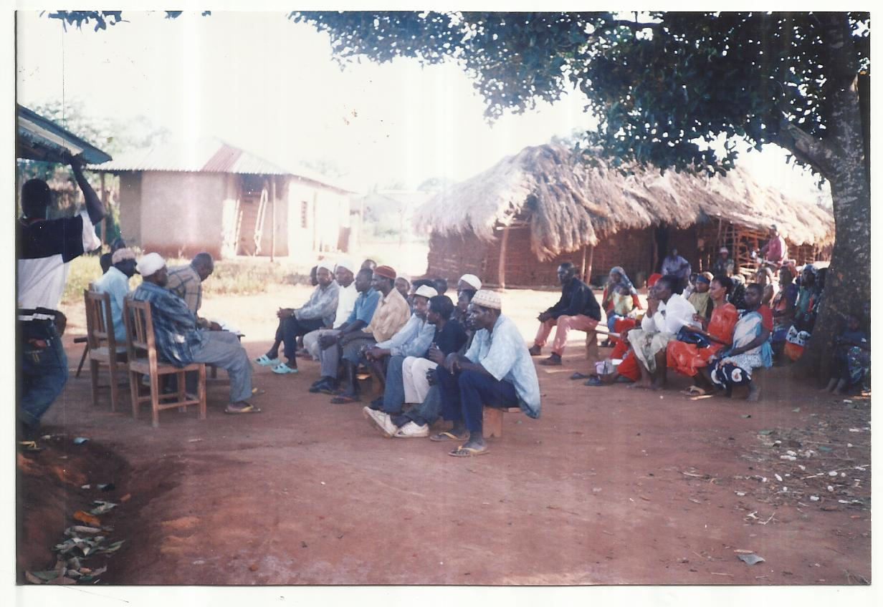
Picture illustrate Kwankonje villagers and her village leaders of Handeni District as well as SUWODE field staffs during community mobilization meeting and formation of water user groups.
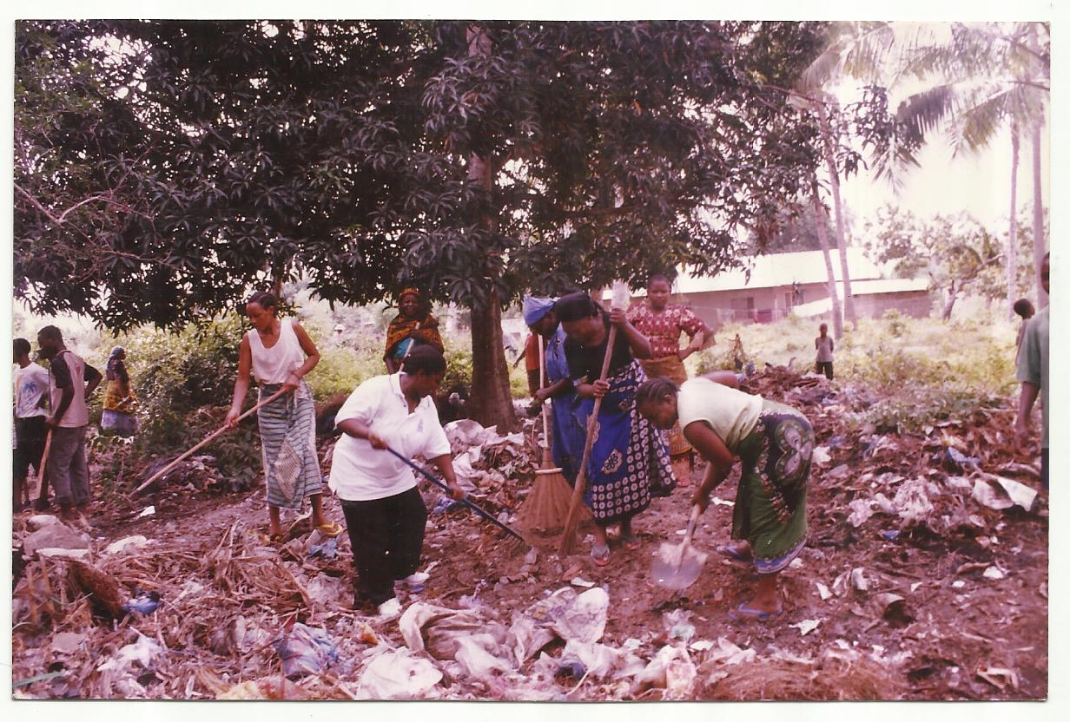
SUWODE organization member with communities during the lunching ceremony of health cleaning campaigne

- 2017 Carried WASH advocacy to Yombo Mwinyi street of Kilakala ward for the aim to create positive change in water, sanitation (WASH) issue specifically improve management of menstrual hygiene (MHM) to adolescent girls of Yombo Kilakala primary school and Kigunga primary school

- 2012-2016 Formation of women small entrepreneur at Nyarukongogo village,Biharamulo District of Kagera region, the task comprise capacity building training on fundraising skills, project management and manufacture of liquid soap

- 2012 Staff capacity building on home based care to the HIV/AIDS victim people as well as provides humanitarian assistance to orphan, widow and elders at Yombo Mwinyi streets.

- 2012 Extend Water supply and sanitation project through construction of three domestic water points purposely reduced workload of women and children

- 2010-2011 SUWODE in partnership to Temeke District council through department of education carryout feasibility study to 150 primary school of Temeke District, the study were based on water, sanitation and hygiene situation of Temeke per urban primary school.

- 2009-2011 in partnership to PEVODE ,Free World and Prime ministry office through Water Sector Development Programme (WSDP) provision of technical and facilitation to ten villages at Babati district.

- 2009-2010 Some staffs in affiliate to Environmental conservation, Water supply and AIDS Control Organization (EWACO) in partnership to Concern worldwide-Tanzania implement water and environmental health programme in thirty six villages of Biharamulo district council, the villages namely katoke,Kabukome,Kasuno,Katahoka,Rusabya,Kabindi,Kagondo,Rwekubo,Kikomakoma,Isambara,Nemba,Nyabusozi,Mbindi,Nyantakara,Kasilo,Mubaba,Mavota,Kaniha,Nyakanazi,Kasato,Lusahunga,Ntumagu,Nyamigere,Kalenge,Mihongora,Mabare,Nyarugombe,Ruganzu,Rukora,Nyamahanga,Nyarubungo,Ntungamo,Kisuma, Nyakahura, Rusenga and Karuguyu.

- 2007/2008 SUWODE project manager with other key staffs, in partnership to Peoples Voice for Development (PEVODE) has been implement the task on formation of women water user groups, capacity building training as we as assist women water user groups on registration procedure in five villages In Handeni District Tanga region, the village namely Komkole, Kwanjonje,Mazingara,Amani and Msasa

- 2007-2008 SUWODE in collaboration with American Embassy-Tanzania, through Ambassador Special Self-Help program. Supporting the task of extension of water supply scheme at Yombo Mwinyi, the task involve construction of three domestic water points, construction of panel house (tower) purchasing plumbing materials and plastic water storage tank. After finishing point of the project, the project was opened officially with American ambassador wife Mrs. Susan Mark Green on 4th December 2008.

- 2005/2006 SUWODE project manager with other key staffs in partnership to Peoples Voice for Development (PEVODE) has been implementing the task on formation of women water user groups, capacity building training as well as assist women water user groups on registration procedure in eight villages in Handeni district Tanga region village namely Magamba,Chang’ombe,Taula, Kwenkwale,Suwa, Tuliani Kwachaga,Kwedzinga and Ugweno

- Since WaterAid international Organization, has been working in seven streets at Temeke District, Dar es Salaam city, the year 1998, the street namely Yombo Mwinyi, Yombo Kilakala, Kurasini Mianzini, Kurasini Zamcargo, Ferry, Tuamoyo and Kigamboni. Some of organization members have been involved to implement water and sanitation projects, from the initial stage up to the finishing point. Also SUWODE chairperson has been attended to the workshop of strategic planning on water and sanitation program, the event held at Bangladesh on the year 2000, and organized by Water Aid Bangladesh, facilitated by WaterAid program manager Bangladesh.

- During the water drought crisis, faced Tanzania in the year 1997, communities was suffered and walking long distance to fetch water, and communicable diseases affected most of them due to the shortage of safe and clean water supply services. As a result SUWODE organization members from the own contribution, organized our self to come up with a solution for fighting against drought. On 1st January 2004, from the own fund of Tsh 6,200,000/=, managed to drilling 60meters borehole, which produced 1134litre per hour, installation of submersible water pump, construction of the two domestic water points and provide safe and clean water supply service at Yombo Mwinyi street and neighboring streets.

- 15th September 2005, some of organization member participate in community auditing research at seven streets, in the street that have supported by Water Aid-Dar program. The major aim of the research were to check out achievement, problem/constraints and challenge faced in the water project, at some stage in the research, communities and project team leaders interviewed were able to identify the community basic needs which demand water Aid to carry out, in order to be sustainable and have a strongly management of water project.
Vision
To contribute to poverty mitigation by increasing accessibility to clean and safe water supply services, environmental protection and reducing gender violence.

Mission
Involving of women, youth and other stakeholders to take active roll to improve water networking, human health care, through rooted advocacy networking, capacity building to the communities in order to ensure accessibility to safe water and hence sustainability of water and environment health scheme.

