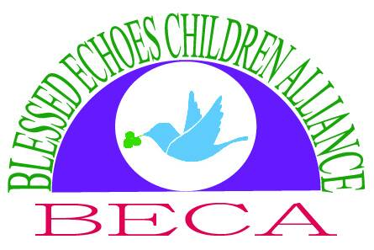
community transportation and empowerment
BLESSED ECHOES CHILDREN ALLIANCE ANNUAL REPORT 2018
Blessed Echoes Children Alliance was established and registered first as a Community Based Organization (CBO) on 7th November, 2016. It was registered (Under section 18(3) of the Companies Act 2012) as an NGO on the 24th day of August the year 2017.

Registration Number: 80020000430414.
Registered Address: P. O. Box 2126, JINJA, UGANDA.
E-MAILS : blessedechoes2016@gmail.com
info@blessed-echoes.org
director@blessed-echoes.org
WEBSITE : www.blessed-echoes.org
PHONE CONTACT: +256 706 313 414/+256700536725
Project Link: https://www.globalgiving.org/projects/educate-500-girls-in-uganda/

Governing Board/ Management Committee
No |  | Name | Designation | Qualification | Contact
1 | Michael Dyope |  | Chairman | Bcom/Banker | +256753415922  dyopem@yahoo.com
2 | Paul Nandhubu |  | Vice Chairperson | BSc/ Engineer | +256701568940  nandhubupaul@yahoo.com
3 | Rev. Dr. Macben Enock |  | Member | PhD/Pastor | +256774500054  enochmacben@yahoo.com
4 | Agatha Baliddawa |  | Member | PhD Mgt/Director | +19293320033  baagatha@yahoo.com
5 | Evt.Henry Baliddawa |  | Executive Director | IAB(London)  Accountant | +256706313414  muyodibaliddawa@gmail.com

Objectives:
1. To increase access to services essential to ensuring healthy lives, coping with emergencies and creating resilient livelihoods – with a particular focus on maternal and child mortality, and preventable diseases such as malaria, TB and HIV/AIDS.
2. To transform unjust and unsustainable economic policies and practices so that poor and vulnerable people in rural households and communities with emphasis to women, children, youths, disabled, orphans and other specialized groups of people to be able to gain thriving livelihoods, and face disasters more effectively while protecting the natural resources on which all our future depends.
3. To help to reduce structural and gender-based inequality and create a more inclusive world, where identity – gender, ethnicity, caste, religion, class, sexual orientation – is no longer a barrier to equal treatment.
4. To help protect the vulnerable people (children and women) from violence, identify and challenge its causes, and transform conflict peacefully.
5. To Promote and provide access to quality non-formal and formal basic education for children and school dropouts within deprived rural communities and by that, contributing to bridging the urban-rural, gaps in basic education in Uganda and also as long-term means to poverty reduction.
6. To strengthen the capacity of small-scale farmers and households in value added agro-enterprise Technologies for increased income, improved nutrition, food security, availability and strength of seed chain.
7. To increase access to safe and clean drinking water and sanitation so as to ultimately reduce water related and faucal-based diseases.
8. To affirm the enduring values of peace, social justice, human dignity and integrity in settings where these values are not always taken for granted.
9. To promote, encourage and protect the environment and its conservation within Blessed Echoes Children Alliance Limited geographical scope of operation.
Membership
Blessed Echoes Children Alliance [BECA] is open to the public for participation in its charitable activities in helping the poor, vulnerable and marginalized community. Community meetings, home visitation are also conducted for the public in pursuing of the objects of the Charity.
Vision:
“A society in which the local population is empowered and has access to equitable whole spectrum of quality social services”

Mission:
“To work in a holistic manner towards improving the quality of life through interventions that reduce vulnerability to illiteracy, ignorance poverty, disease, hunger, environmental degradation and gross abuse of human rights.”

MESSAGE FROM THE EXECUTIVE DIRECTOR
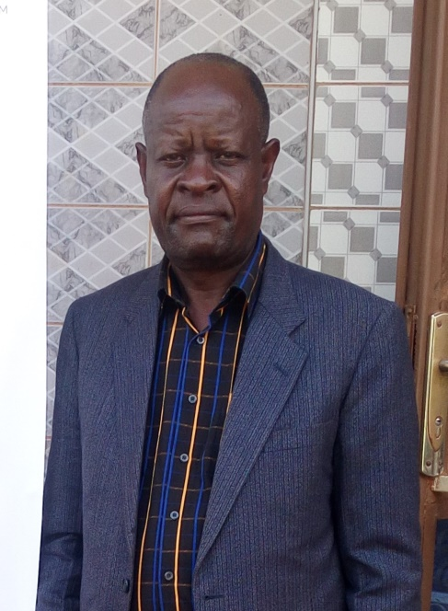
I am proud to present the 2018 annual report, reporting on activities that were undertaken in the year we found reasons to celebrate as we moved forward with our work in the world’s poorest communities. All the activities were implemented from resources generated locally from the members of the organization, its well wishers and from the international community under the globalgiving organization through its fundraising strategy.
BECA was born out of desire to help those clinging to survival in a war, AIDS and poverty. Our mission to work in a holistic manner towards improving the quality of life through interventions that reduce Vulnerability to Illiteracy, Ignorance, Poverty, Disease, Hunger, Environmental degradation and gross Abuse of Human Rights-to be agents of change within their communities. We work in 6 villages in Mayuge district namely: Namago, Nsango, Ivugunyu, Kikubo Lwabala, Luwanula and Imanyiro respectively. But most of our work seeks long term improvement in people’s lives by cutting down the root causes of poverty as specifies in our mission statement.
We look forward to serving as a voice for people living in poverty and as a steward of the plans in the future and ensuring that services reach our communities. In all these endeavors, we require both the local and international community support through donations and any other form of collaboration to achieve our objectives. I look forward to working with Blessed Echoes Children Alliance partners around the world and I would like to thank all our supporters, staff, volunteers and well-wishers for their contributions without which Blessed Echoes Children Alliance wouldn’t have reached this far. Wishing each partner, staff, Board members and volunteers a blessed 2019 a year of hard work.
Evangelist Baliddawa Henry Muyodi
The Executive Director

About Blessed Echoes Children Alliance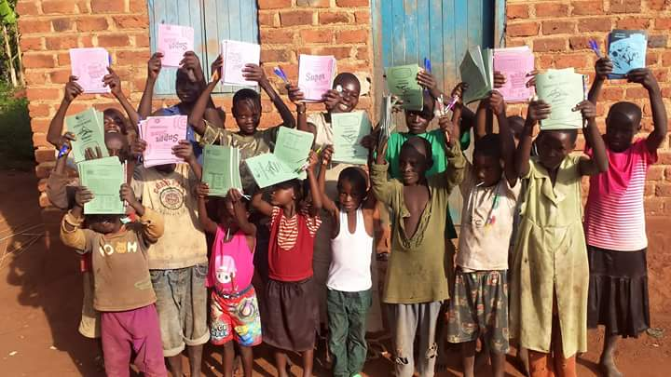

Blessed Echoes Children Alliance (BECA) is a national Non- Governmental Community Development Organization registered in Uganda in 2016 and works to reach out to vulnerable children, families and communities with various needs as a result of HIV/AIDS epidemic in all our areas of operation. The organization was formed to address five major themes deliberately to focus on: (1) Children education with emphasis to the girl child, (2) Child Protection, Governance and Advocacy, (3) Agriculture, Food Security, Livelihood and Humanitarian relief; (4) Health and Nutrition, (5) Water, Sanitation, Hygiene and Environment ( WASHE).
Staffing
There are two full-time, one part-time administrative staff employed and two volunteers
Volunteers
Volunteers are the backbone of our services; we rely on their services provided. We appreciate the services of those who volunteered over the past year, for their effort to helping our staff achieve the organization goals and objectives.

Funding sources
Blessed Echoes Children Alliance is financially supported by the members of the organization and well-wishers and rely on the local resources available. Their financial assistance comes in very many forms such as taking part in the fundraising events. BECA works harder than ever to raise funds for its work locally. We believe in the approach of working with others in partnership to empower the marginalized communities and this is one of our future plans. We welcome all those who would like to partner with us to assist the marginalized groups of our community as the work ahead of us is very big and requires concerted efforts. In 2018, Blessed Echoes Children Alliance presented a project proposal to Globalgiving Organization in September 2018 and got $ 229 in the fundraising. These funds were received during the end of the year and were not utilized during the period. The funds were kept and have been utilized during the 2019 fiscal year to support the poor and other vulnerable children by paying school fees for the first quarter of the year.

ESSENTIAL SERVICES
EDUCATION
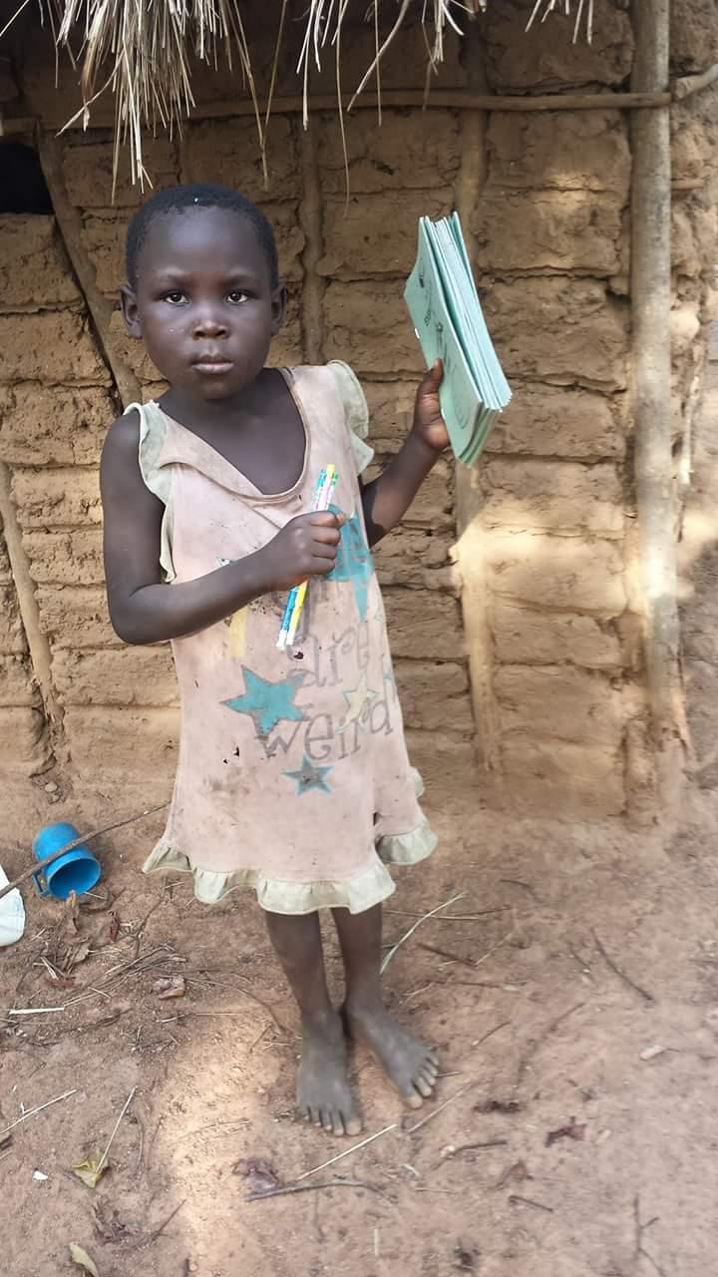
Over sixty-one million children are not in primary schools and to get them there and ensure all children receive equitable good quality basic education BECA needs financial support to ensure that at least in every household a child attends school. Young people have no choice but to drop out of school especially girls who are given out to early marriage. Other children are used in communities as child labor because in most areas, children also are used to baby sit their siblings. This has kept this area backward as most children cannot gain any qualifications that can enable them to train in different jobs.
BECA together with the well-wishers and supporters are engaged in the ongoing campaign of EDUCATION FOR ALL that aims to ensure that every child has greater access and better education especially for a girl child. The campaign is aimed at mobilizing of the young people to make them well informed citizens who can claim their rights, and this involve communities and educational officials who have been in the fore front in fighting for all the needs of the children in schools.
BECA supports over 500 children boys and girls and plans to support more children to ensure that the task of keeping these children in school is achieved. We hope these children if given an opportunity to access education, will go a long way in transforming them into better citizens who will participate in future economic activities in their communities.

GENDER JUSTICE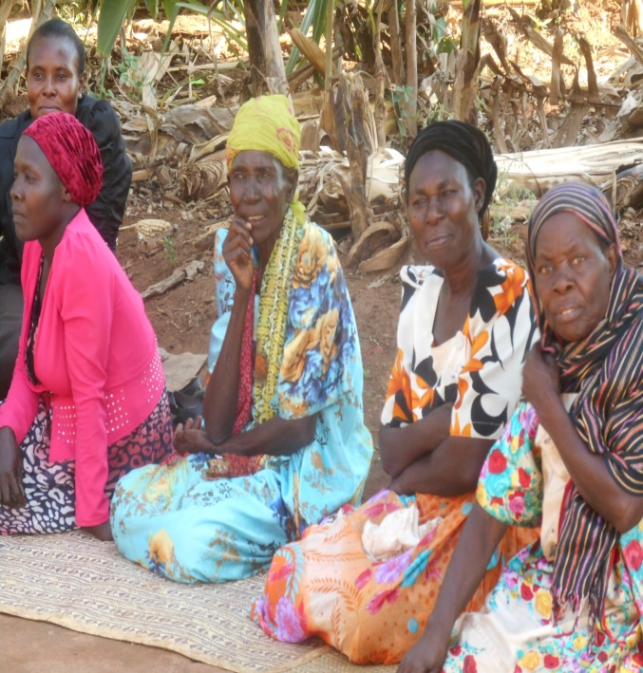
Blessed Echoes Children Alliance ensures that poor and marginalized women are empowered to claim their rights against domestic violence, globally women and girls are exposed to many forms of violence and they are denied a voice, women’s work is not recognized and undervalued. Women lack opportunity to represent themselves.
BECA has been involved in community mobilization meetings and sensitization on issues such as childlabour,domestic violence and children rights so that marginalized communities are able to speak out and their voices to be heard. We seek to connect local issues to the global agenda and acting as a bridge by bringing together likely and unlikely parties to cover domestic violence, more young women, to exercise their rights in order to influence decision making in their respective communities. Our hope is to see poor and marginalized women claim and advance their rights through engagement in leadership roles of women in their communities which helps them fight against domestic violence.
The mobilization meetings about gender issues has helped women who are normally marginalized to rely on each other for support and solidarity. BECA will continue to focus on supporting women to develop their own vision to achieve that change. BECA looks forward to engage them in economic activities where they will be able to meet
their needs and take care of their families through activities such as agriculture, beads making, chicken and goat rearing. BECA has been blessed through their partners Hope Seeds, a nonprofit organization from USA which has donated vegetable seeds to BECA and seeds will be distributed to women to improve on their children diet.

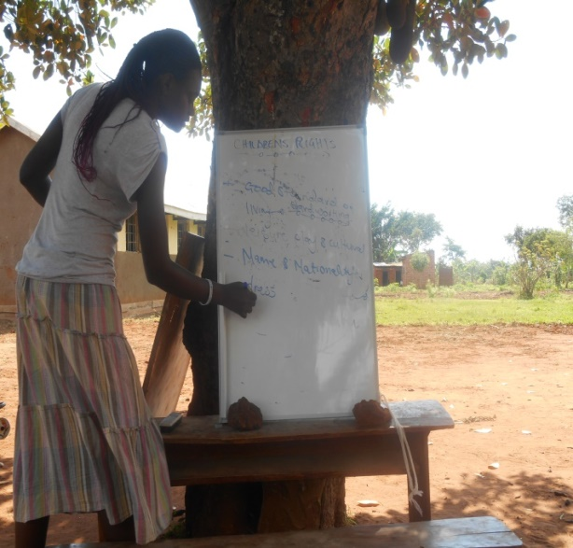
FOOD SECURITY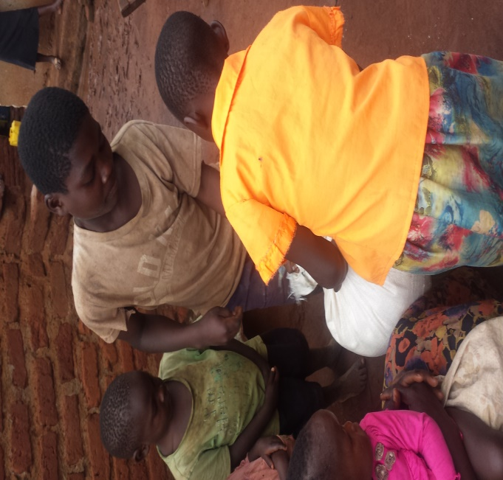
BECA believes that we can change the world. We also work with the local people to make changes to practices to the level that support food security and to end hunger. Mayuge district is one of the areas with food insecurity regions in Uganda, farmers struggle to grow enough food for their families and another big challenge is that most of the areas have been put under sugarcane growing living little space for food growing. Through our efforts, we have been able to provide food to unstable homes. We aim to see more people in rural areas enjoy greater food security. Last year homes in Lwabala village experienced drought leading thousands of people going hungry.BECA plans to build a future where on planet everyone has enough to eat, we have seen changes that people can achieve when working together.
Majority of women and men have no knowledge and are ignorant about the importance of family planning methods and.most people in the rural areas have given birth to many children, they cannot afford providing food, health services. Most times women are the victim due to the fact they are beaten by their husbands for using family planning methods. We look forward in the near future to have an orphanage for the vulnerable children.

HOME VISITATION AND COUNSELLING AND GUIDANCE
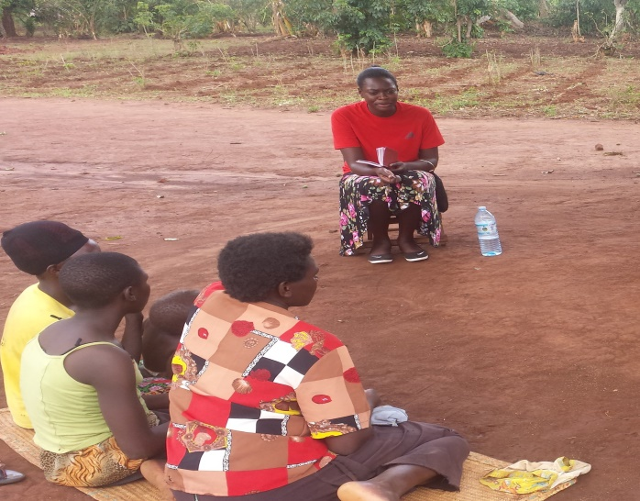
Blessed Echoes Children Alliance has been actively engaged in home visiting and sharing with them the word of God through the evangelism program. There are many people in the community going through many challenges and cannot handle stress alone but through our programs of outreach and evangelism, people’s hopes have been restored after sharing with them the word of God. We intend to put more efforts in home visitation on a regular basis. Blessed Echoes Children Alliance has also began on offering counselling services to people living with HIV/AIDS, widows, orphans and street children. It is our plan also to establish health services like a clinic where patients will be accessing treatment of various diseases.
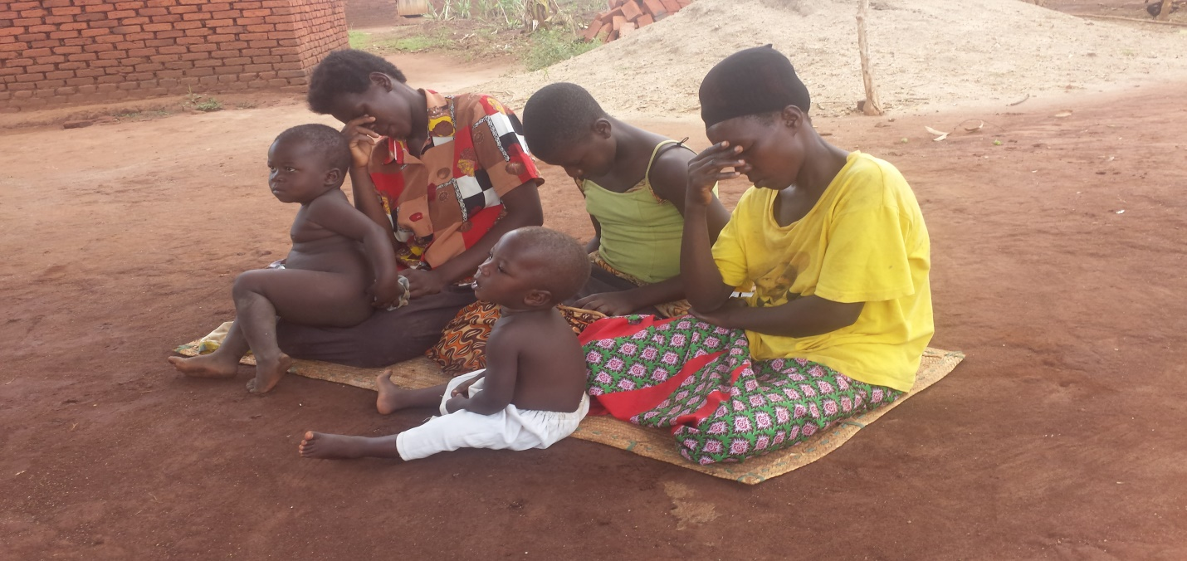
BECA does not only visit but proclaim the word of God to the marginalized community who have never had an opportunity to hear the good news of Jesus Christ. During our home visitation we pray for the sick for healing and encouraging them in times of trouble as they seek God who hears their inner troubled hearts. Through proclaiming the gospel we have seen testimonies and people glorifying his works in their lives.
THE ORGANISATION ASSETS
Land: 7 acres of were purchased in 2016 by Blessed Echoes Children Alliance to provide a place for the organization to conduct charitable activities.
Pick up: It was purchased to ease on the transportation going to the field because most the places are in the remote areas.
Laptop and desk top: Blessed Echoes Children Alliance bought a laptop and desktop to quicken the office work and as well as to use it to access internet for the update information of the organization.
Other assets that were bought during the year include two desk tables and two chairs.

FURTHER PLANS AND COMMITMENT
The Blessed Echoes Children Alliance plans to build an orphanage in order to provide shelter, food and education to the poor and vulnerable children. It will also embark on the project of women empowerment through engaging women in economic activities such as beads making, soap making and agriculture.
BECA will be working more and more to seek and solicit support and partnership for purposes of raising funds to meet its targets of reaching out more people in the community.
TO GOD BE GLORY------------AMEN.
.

