OVERALL REPORT GIVING ENVIRONMENTAL EDUCATION PROGRAM.
During the months of April, May, and June, we continued with the celebrations of the traditional Fiestas de la Tierra. These are cultural events with the purpose of rescuing and promoting the roots and traditions of the mountain region, as well as consolidating the environmental culture, but especially as a tribute of respect and love for Mother Earth. These events were held in schools and communities in the different municipalities of the Sierra Gorda, with the support of teachers, educational networks, and local authorities.
The GESG team of environmental educators presented a play entitled "Waves of Action for Mother Earth" to raise awareness among the school population about the environmental crisis of the planet, climate change and water scarcity, and above all to propose solutions, maintain and protect the common goods. This message was addressed to 2,539 attendees at the 23 earth festivals, we also had the participation of 55 schools, with 1,285 students, 1,087 adults, 220 non-school children and 167 teachers. Likewise, mothers and grandmothers presented 495 typical regional dishes in the gastronomic fairs, which they generously shared with those attending the festivals.
On International Water Day, a "Water Forum" was held at the Centro Tierra facilities, attended by 35 young students from two universities in the region and personnel from the state water commission. A working agenda was developed around the topics that were presented by GESG and CEA: Water sanitation, wastewater treatment plants, hydrological recharge of the basins that supply water to the state of Queretaro, the environmental services provided by forests as part of the solutions, the construction of rainwater catchment tanks, the separation of solid waste.
Similarly, to continue raising environmental awareness, we distributed 850 stickers and 440 posters on the separation of solid waste, 723 posters on forest fire prevention, 1,300 newspaper stickers from the "Our Earth" series with the themes of "My Participation" and 1,350 with the theme of "Ecological Panorama" and 420 coloring books on the flora and fauna of the mountainous region, which were given to school principals and parents.
We held 23 community meetings, which were attended by 1,087 adults, to raise awareness about minimizing and separating solid waste and preventing forest fires.
During this period, we continued with the "Diploma in sustainable development, educational tools for climate action". As a result, 300 teachers participated online and virtually and developed a school and community intervention project, applying the lines of action of the green protocol.

Photographic Evidence
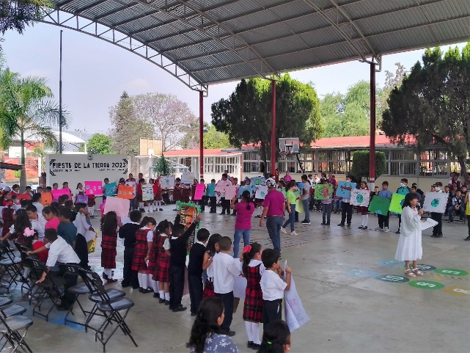
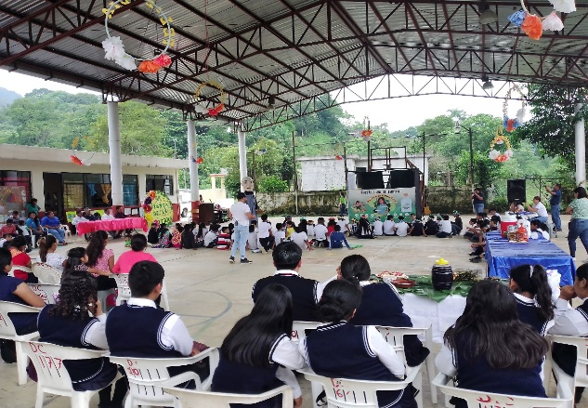
Tlaletla, Xilitla
Arroyo Seco, Arroyo Seco

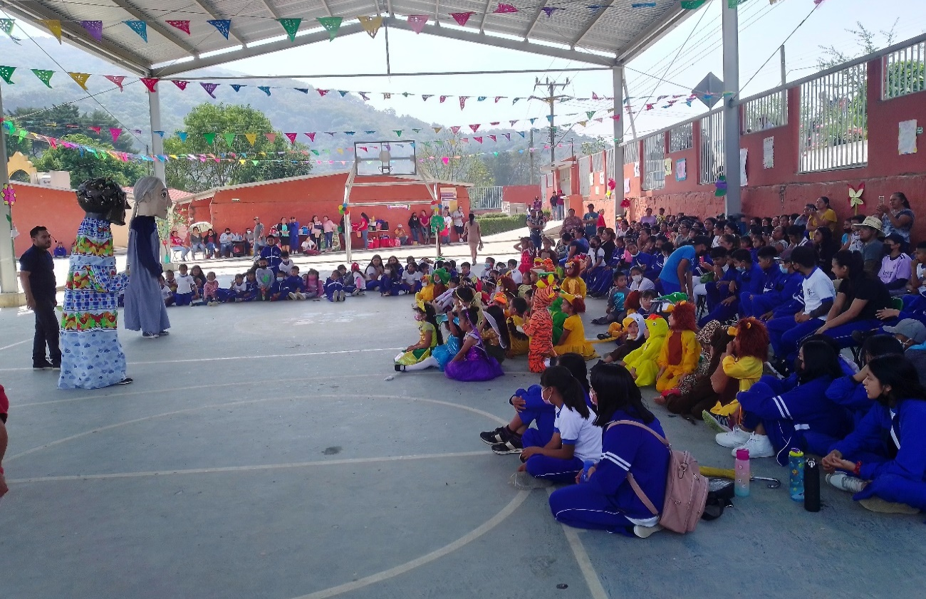
San Pedro el Viejo, Pinal de Amoles

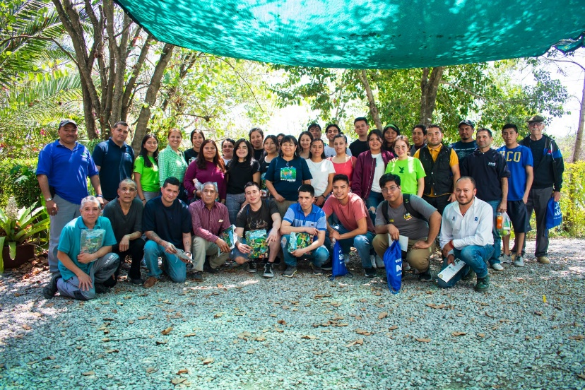
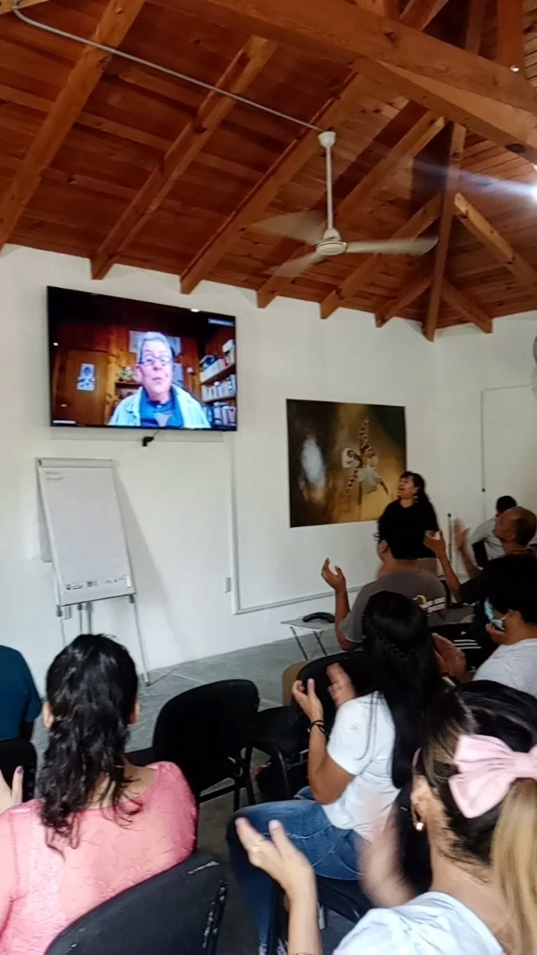
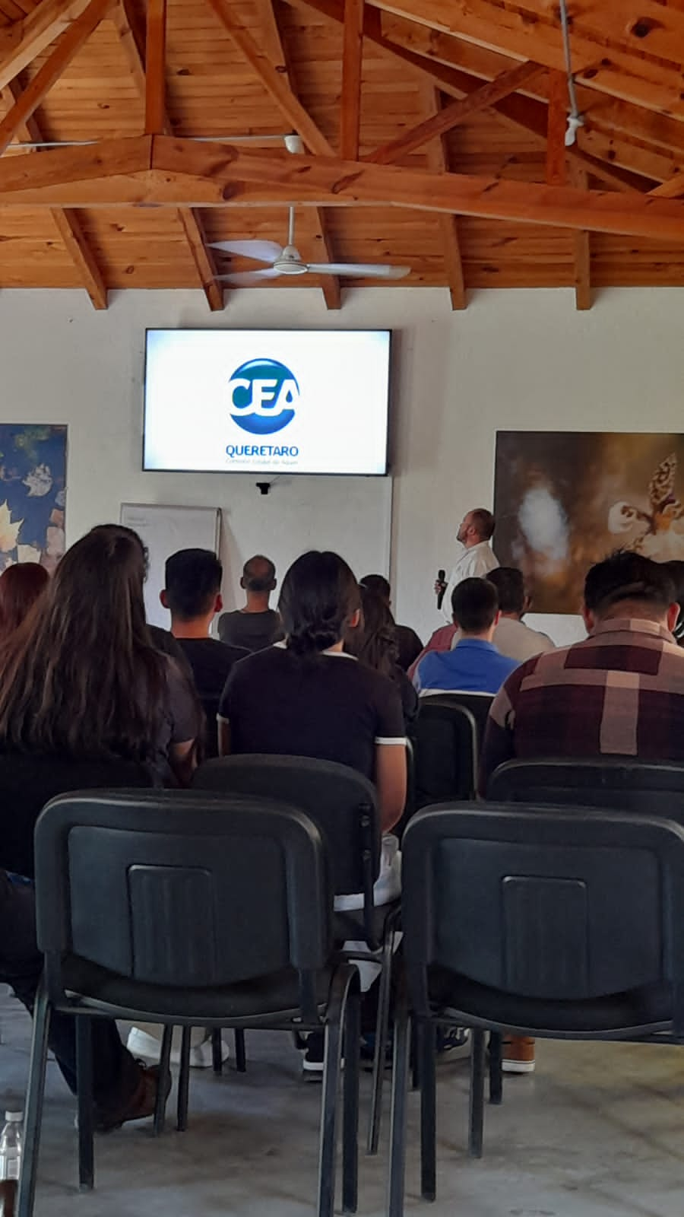
Foro del Agua
Foro del Agua/ Mtra. Pati Ruiz
Foro del Agua / CEA
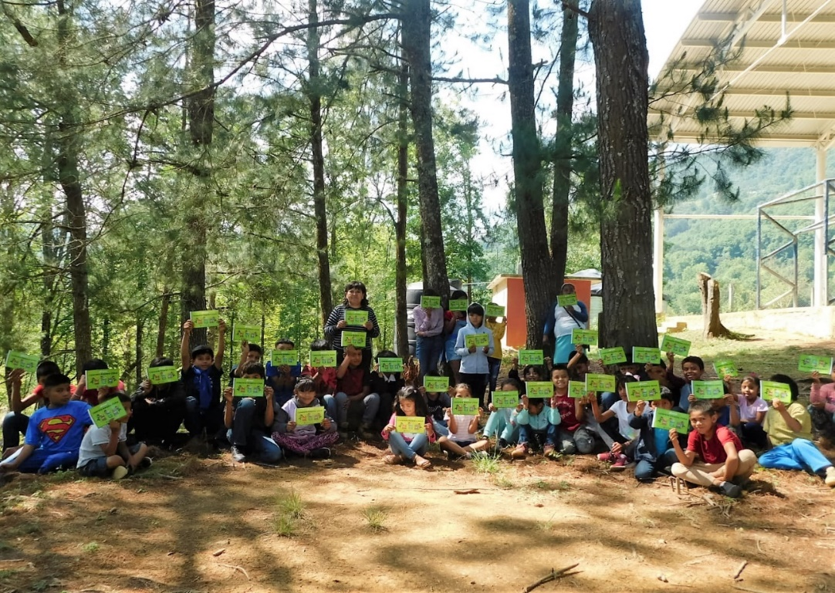
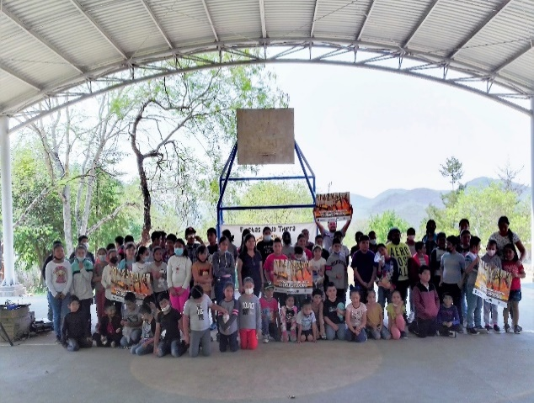
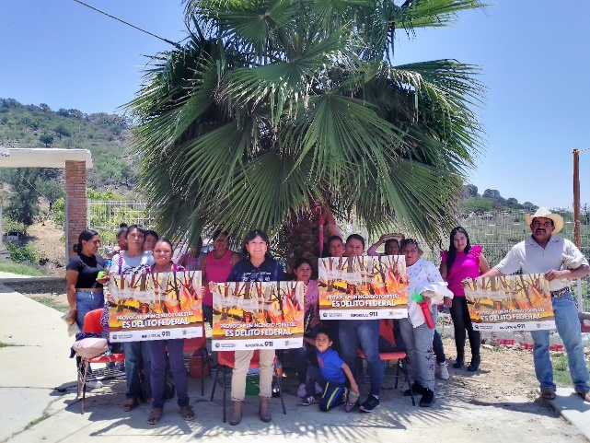
Agua del Maíz, Pinal de Amoles
Encino Solo, Landa de Matamoros
Adjuntas de Ahuacatlán, Pinal de Amoles

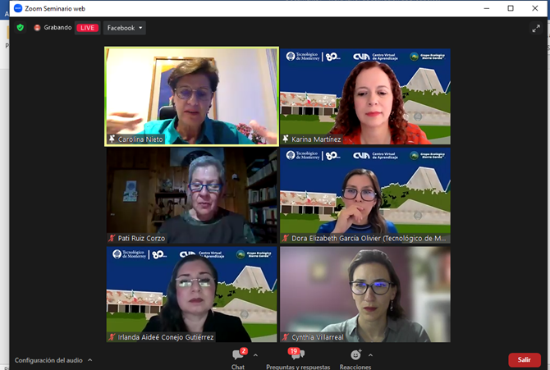
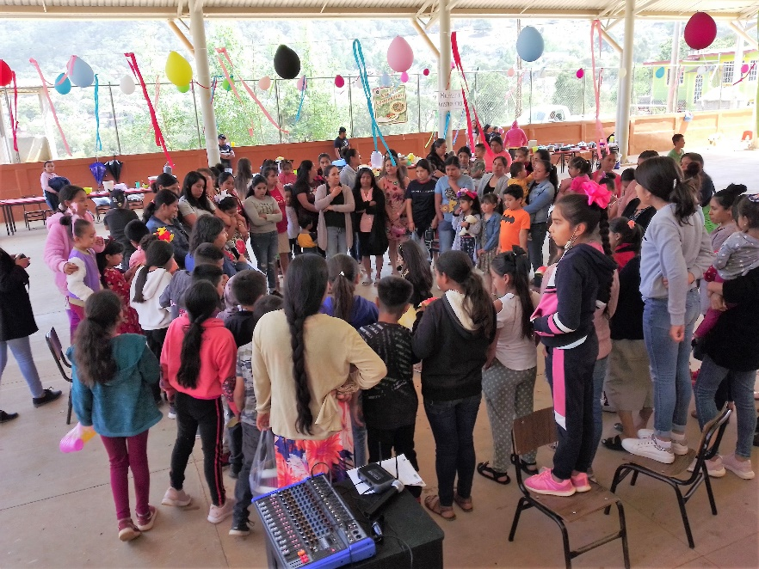
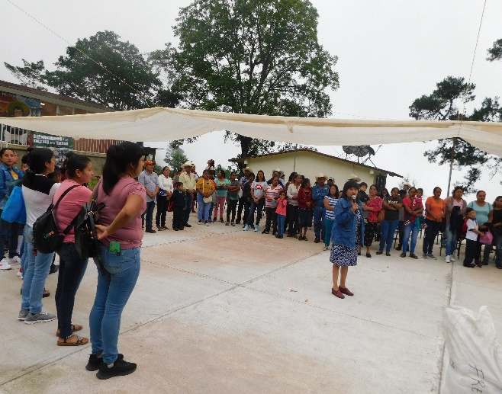
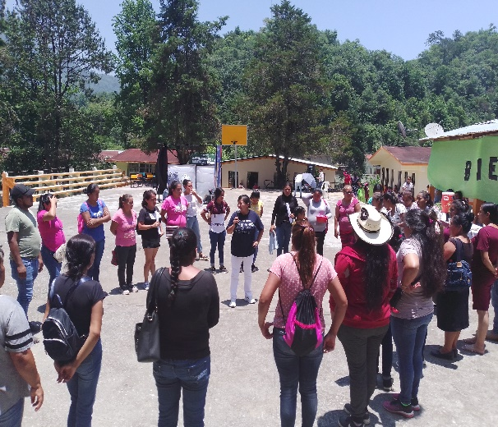
Pinalito de la Cruz, Landa de Matamoros
Ollita del pino, Xilitla
Diplomado en desarrollo sostenible
Soledad de Zaragoza
Diplomado en línea

