Save the victims affected by STORM an unexpected Disaster in Nepal
by Multi-Dimensional Resource Center, Nepal (MRC Nepal)

Story Reports Photos Share

Summary
Massive winds accompanied by hailstorms and rain struck Bara and Parsa late on 31 March 2019. A freak storm battered several places in Southern Nepal killing 31 people and injuring more than 700 others as high speed wind tore down houses, flipped vehicles and toppled trees and electricity poles. Villagers at Purainiya in Bara district search for belongings in the rubble after the storm brought down their homes . The storm swept through villages in a farming region of Bara and Parsa district of Nepal.A 30-knot wind storm known as gale, probably the first in Nepal, according to the Department of Hydrology and Meteorology. At 30 knots, gale, a classification of wind speed according to the Beaufort scale, blows at 15 meters per second or 55.56 kilometre per hour.According to the Home Ministry, the devastating rainstorm that battered Bara and Parsa for 30 minutes – from 7:45 pm to 8:15 pm on 31 March,2019 Sunday evening.
$70,000
total goal
$70,000
remaining
0
donors
0
monthly donors
Coming
soon

Challenge
Houses have been reduced to rubble. Trees, utility poles and even underground water pumps have been uprooted. People are facing difficulty finding food, medicine, shelter and drinking water and crops have been damaged, threatening people’s livelihood. The estimates of infrastructural damages incurred in the disaster are yet to be ascertained as the storm has damaged hundreds of houses, electric pylons, while uprooted trees have obstructed the roads and highways.The storm also damaged over 12 passenger buses that were parked along the roadside during the incident, police added. The natural disaster also led to a power outage last night while the internet services have resumed in the affected districts.
Many affected people have been facing problem of housing, fooding, medicine, clothing and treatment. Just they are waiting for the relief support. In some of the villages 80 % houses are swept away. Some of the Government and non government organizations have been providing supports but that is not sufficient.
District | Death toll | Injured persons | Damaged houses | Remarks
Bara and Parsa | 55+ | 700+ | 1500+ | Affected people Around 6,000

Solution
This is urgent need to support to affected families on the spot. MRC Nepal as a social and humanitarian organization should stand with relief support in such painful situation.
Project will be supported on coordination of victim community people towards adopting the friendly environment with social harmony for distributing foods, medicines, safe drinking water, sanitation and transit shelter. Strong coordination and linkage will be carried out with Government bodies and other relevant agencies to be involved in the disaster relief.For the immediate support, food, medicinal, transit shelter and sanitation will be provided to cover more victim families as much as possible based on resources.

Long-Term Impact

The long term impact of the project will be suggested to relevant agencies for prior information of occurring disaster in the areas. So that maximum losses could be minimized to some extent.There will be built good social harmony among victims through motivation and counselling, So that victim families could forgot any type of shocks as they feel. Health and hygiene among victims will be improved. Along with these,victim will be able to back for their works and business to maintain livelihood of the families.

Additional Documentation
This project has provided additional documentation in a DOCX file (changed_projdoc.docx).

Resources
http:/​/​www.mrcnepal.org.np

Organization Information

Multi-Dimensional Resource Center, Nepal (MRC Nepal)
Location: Hetauda, Makwanpur - Nepal
Website: http:/​/​www.mrcnepal.org.np

Project Leader:
Bharat Bahadur
Chief Executive officer (CEO)
Hetauda, Makwanpur, Nepal

Some of Glimpses
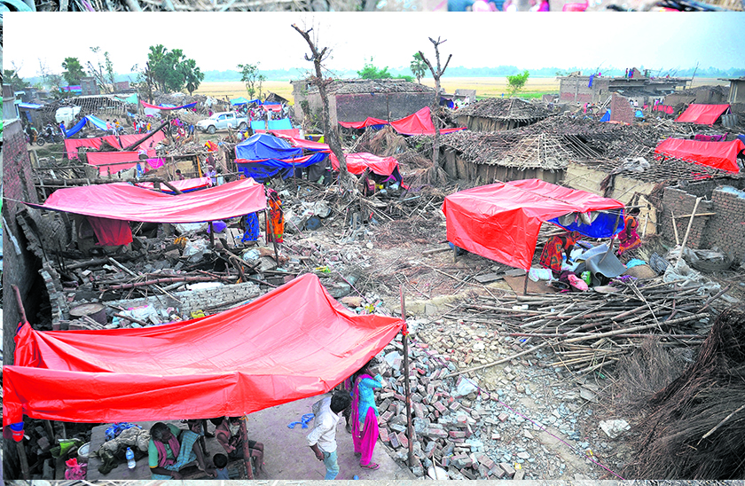
Losses in different Villages
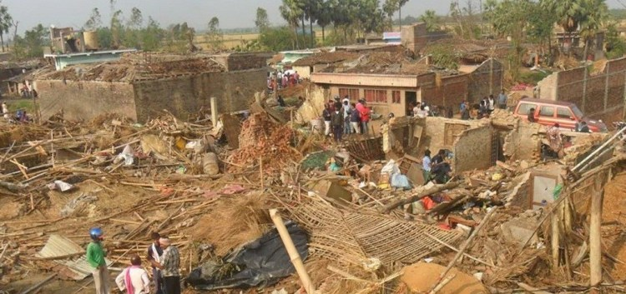
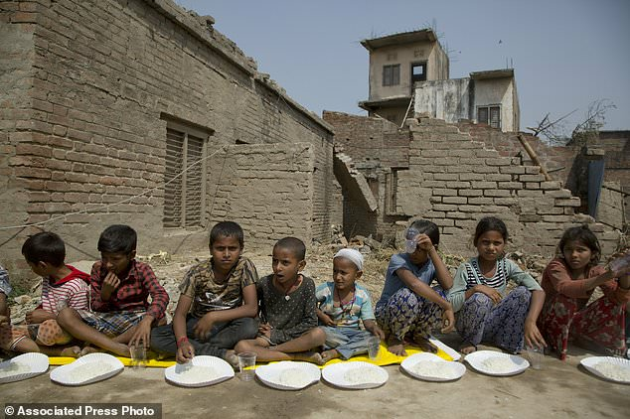
Children victims
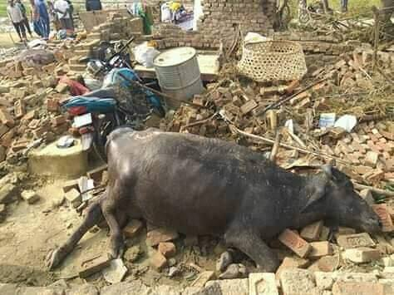
Dead Animals
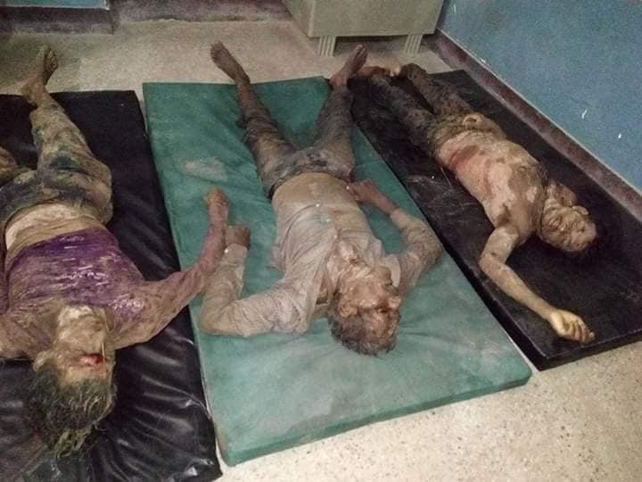
Death
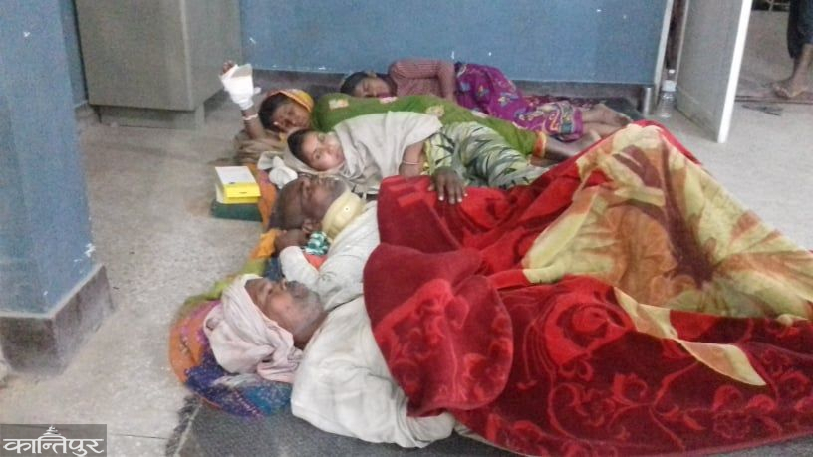
Injured in local Hospital

