**Monthly Performance Report - Local Partner(SORD)**

**Project report saving the lives of 3,025 children under the age of five and 1,360 pregnant and lactating women in Yemen**

**April - June 2023 / AD**

**The author of the report: Muhammad Abu Haidar**

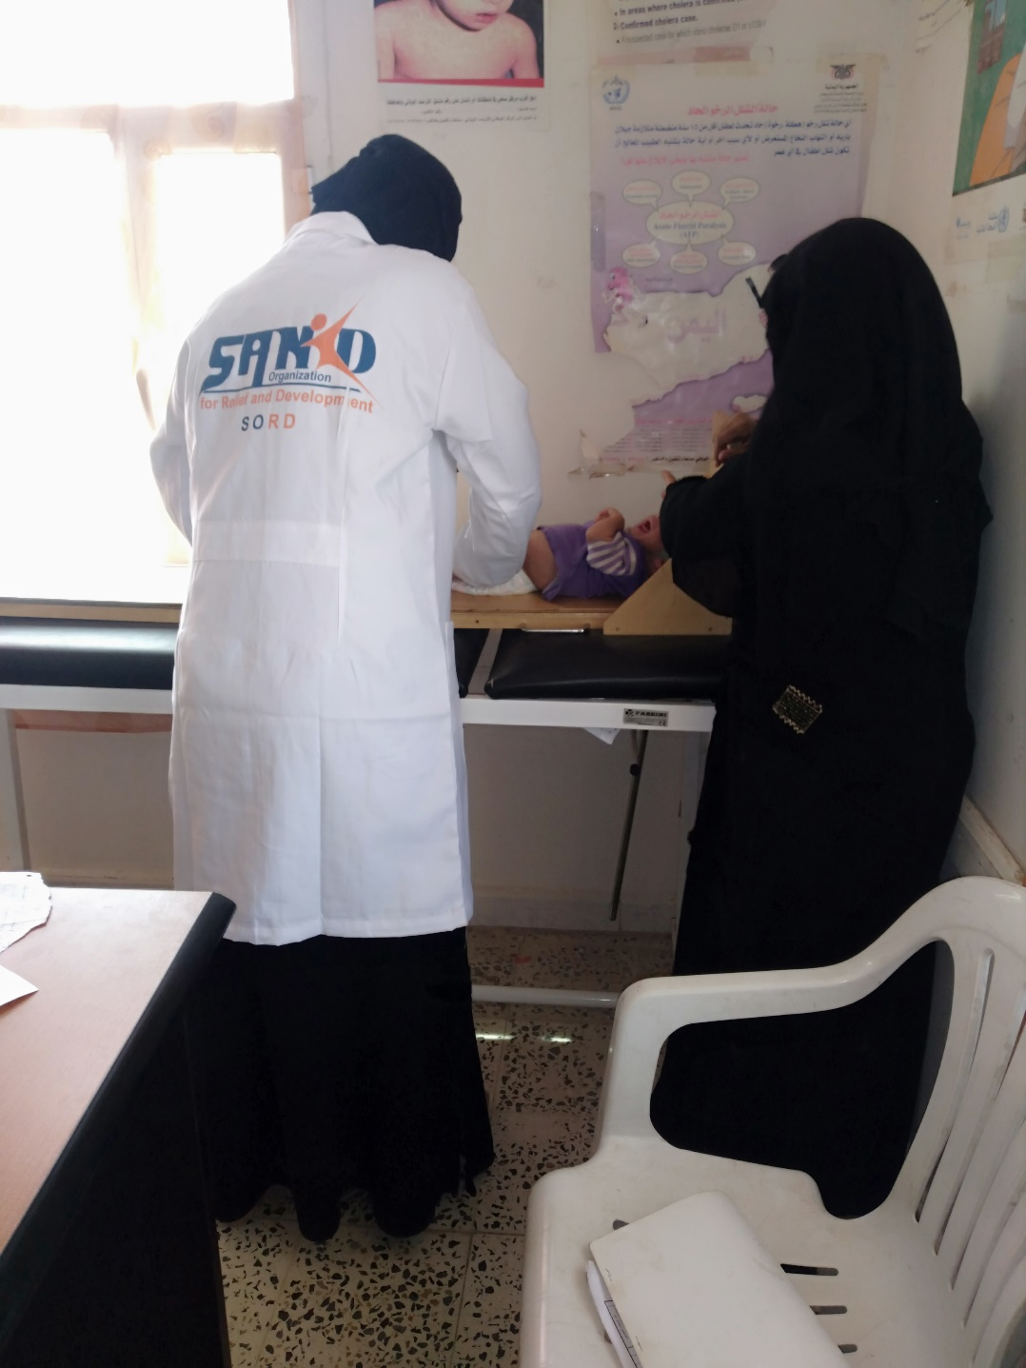

|  |  |  |  |
| --- | --- | --- | --- |
| **Project Name** | **Addressing malnutrition for children under the age of five, lactating women, and pregnant women among the displaced and the host community in Yemen.** | | |
| **The project Location** | **Yemen** | | |
| **The name of the organization applying for the scholarship** | SANID Organization for Relief and Development (SORD) | | |
| **Report duration** | 90 days | | |
| **starting date** | **1/4/2023** | **Expiry date** | **6/30/2023** |
| **Organization address** | **Capital Municipality - Directorate of Shoub - Al Habari** | | |
| **phone number** | ***0096701205757*** | | |
| **Prepared the report** | **Muhammad Abu Haider** | | |
| **Current Position** | **project manager** | | |
| **E-mail** | **Programs.officer@sanid.org** | | |
| **mobile number** | ***00967 775907606*** | | |
| **Organization's website** | **www.sanid.org** | | |

**Project's Data**

**An overview of the tragic situation in Yemen**

# It was very inspiring to see the work you doget upwith it globalgivingAndhuman societySANID organization.She expresses her gratitudehighly to allSupportersIn the humanitarian field who do their best to helpYemeni society and alleviate its suffering inAmid an escalating global food insecurity crisis, there is little hope for millions already suffering from extreme hungerSo it wasglobalgivingIt is the hope to save him from the specter of famine that has reached him

Hajjah is one of the Yemeni governorates with a high prevalence of acute malnutrition

.They need a projectEmergency health and nutrition projectand projectemergency human capital

toVital nutrition services are provided to the most vulnerable communities. There are eight therapeutic feeding centers

It lacks sufficient support to cover the needs of malnourished people, whether nutritional supplements, the most important of which is therapeutic milk.

It is also badly neededRehabilitation, furnishing, equipment and supplies.

# According to the analysis,The safest directorate isthe most vulnerableYemen in general And ingovernorHargumentespecially, where food insecurity and acute malnutrition converge to extremely high levels. For acute malnutrition, the degree rangeswhz inThis directorate , a measure of wasting for children under five, ranged from 17% to 26%, well above the emergency thresholdFor those interestedamounting to 15%, while for acute food insecurity, theThis directorate (Aslam) scooped higherPrevalence rates with more than 65 percent of the population in the third stage of classificationOfficial authorities and follow-up of the situationFor food insecurity and above at the moment. It is also expected that a large number oftarget directorateto higher IPC stages, with significantly reduced levels of humanitarian food assistance.

Also, during the months of April and May of the year 2023 AD, many diseases spread in Yemen, as many children were infected, which led to the death of approximately 32 children. The number of infections and deaths continues to rise in light of the poor health situation in those areas affected by this disease.

There has also been a recent increase in the number of polio infections. Where UN reports and appeals for rapid intervention to provide the necessary vaccines for these creditors, who are killing children.

Yemen suffers from the spread of diseases and epidemics among children, especially with the absence of interventions to save their lives.

**Overall Performance**

In turn, raisedSORD's project is entitled: "Saving the lives of 3,025 children under the age of five and 1,360 pregnant and breastfeeding women in Yemen." The proposed project aims to contribute to reducing deaths and diseases associated with acute malnutrition for children under the age of five, pregnant women and nursing mothers in targeted areas with high rates of acute malnutrition. During the second quarter of the year 2023, children under the age of five and pregnant and lactating women who suffer from acute malnutrition were provided with appropriate complementary feeding. Community awareness has been raised among pregnant women, nursing mothers, and girls of childbearing age regarding the prevalence of malnutrition, both for the child and the mother, the importance of good nutrition for mental and physical health, and how to use available resources in order to overcome or reduce malnutrition. More details about the project's achievements can be found on our side, and based on the available capabilities, we have made remarkable progress compared to the percentage of cases recorded by the team in the field. During the second quarter of the year 2023 in Hajjah Governorate, Aslam region, as follows:

**Activities carried out during November and December:**

According to what was determined in the October report, an indicator has been set that will be achieved during April to June 2023

|  |  |  |  |
| --- | --- | --- | --- |
| Activity | Pointer | Period | Port |
| Receiving and assisting malnourished children under the age of 5 (new), including examination, examinations and complementary treatment. | 250 | April, June | 146 |
| Receiving and assisting nursing and pregnant mothers (new). Comprehensive examination, examinations and complementary treatment. | 250 | April, June | 133 |
| Follow-up and help malnourished children under the age of 5 who have been previously admitted. Comprehensive examination, examinations and complementary treatment. | 314 | April, June | 214 |
| Follow-up and assistance to nursing and pregnant mothers (hesitating). Those who have previously been accepted, including examination, examinations and complementary treatment. | 361 | April, June | 241 |
| Activating external referrals by communicating with service providers in the centers of neighboring regions. | 50 | April, June | 37 children and 14 women |
| Activating and sharing a map of similar services in the district's health centers and units | 1 | April, June | Coordination has been made with the competent authorities |
| Educating a woman about malnutrition prevention measures, hygiene methods, and proper healthy nutrition.through awareness sessions | 500 | April, June | 417 |

These indicators are for the objectives of the program, which began to be implemented from April to June 2023

SANED has worked to implement the activities according to its available capabilities and in accordance with the support and donations it received from Global.

the reportActivities listing:

**The total number of beneficiaries during the months of November and December:1202A woman and a child distributed over the services** **Which is implemented by SANID distributed as follows**: .

* Coordination was made with the health center to receive 146 cases of malnourished children (new). They were presented to the specialized doctors within the malnutrition program at the health center in Aslam district.

Where approximately 218 cases of malnourished children were recorded, and as we mentioned that due to the lack of resources, Sanad was unable to help this number of injured people. It was able to provide aid (examination, examinations and disbursement of therapeutic supplements to 146 children under the age of 5 years who suffer from toxic and poor malnutrition.

Immunization was carried out through vaccinations for children under the age of five, for 122 children, from infectious and deadly diseases.

* A number of 214 children under the age of five who were assisted were received in January-March, and they continue to follow up on their cases until recovery. Their cases were followed up through examination and nutritional supplements.
* After coordination with the health center, the Maternity and Childhood Department, to receive 133 cases of malnourished mothers, pregnant and lactating women (new), and they were presented to the specialized doctors within the motherhood and childhood program at the health center in Aslam district.

About 197 pregnant and lactating women with malnutrition were registered. As we mentioned, due to the lack of capabilities, Sanad could not help this number of pregnant and lactating women in need of health care and follow-up. Sanad was able to provide assistance (examinations, examinations, and disbursement of therapeutic supplements to 133 women (pregnant and lactating).

Immunization procedures for 98 pregnant women against tetanus.

* Also, 152 women who attended the center were received for follow-up, who were assisted in the month of January-March, especially from pregnant women in the last months and newly breast-feeding women.
* 37 cases (children under the age of five and those with toxic malnutrition who were targeted by SANID, whose cases have become difficult and require intensive care, have been referred to some of the governorate’s hospitals, which have special capabilities and care, where they were assisted with the costs of transportation, accommodation, supplementary feeding, and intensive care room fees in private hospitals.
* Referring 14 cases of pregnant women suffering from chronic diseases and needing special care to hospitals in the governorate center. A case, including a heart patient, was referred to the capital, Sana'a.
* Implementation of 24 awareness sessions on aspects of reproductive health, measures to prevent malnutrition, hygiene methods, and proper healthy nutrition. 286 pregnant and lactating women were targeted by volunteer midwives.
* Coordinating with the local authority and the competent authorities in the Aslam district in order to obtain a map of services for the agencies working in the same field within the district and neighboring areas in order to exchange experiences and refer some cases that need other services that are not available to us.

Where 41 cases of transition to recovery from malnourished children were recorded, including 24 females and 17 males.

**Challenges:**

* The deterioration of the health situation in the health centers in the targeted areas.
* Unavailability of salaries for workers in health centers.
* Poor capabilities to cover the visitors to health centers.
* lackSupport and donations.
* to riseThe number of malnourished people.

**Lessons learned:**

* Get to know the conditions of the target area closely.
* Tangible cooperation by the health authorities represented by the health center in the Aslam district, the health department in the directorate and the competent authorities.
* Society's love, appreciation, respect, and thanks to the implementing organization and to the supporting parties for the implementation of these activities.
* Identifying many areas in Hajjah Governorate, in which people with malnutrition, German measles and polio are increasing.

**Recommendations:**

* Redoubling efforts to provide support and assistance to save the largest number of children and women who are on the brink of death.