|  |  |
| --- | --- |
|  |  |

**Performance Report - Local Partner (SORD)**

**Treating Malnutrition in Children Under Five, Pregnant and Lactating Women**

**Yemen - Sana'a**

**November 2024**

**Report Preparer:**

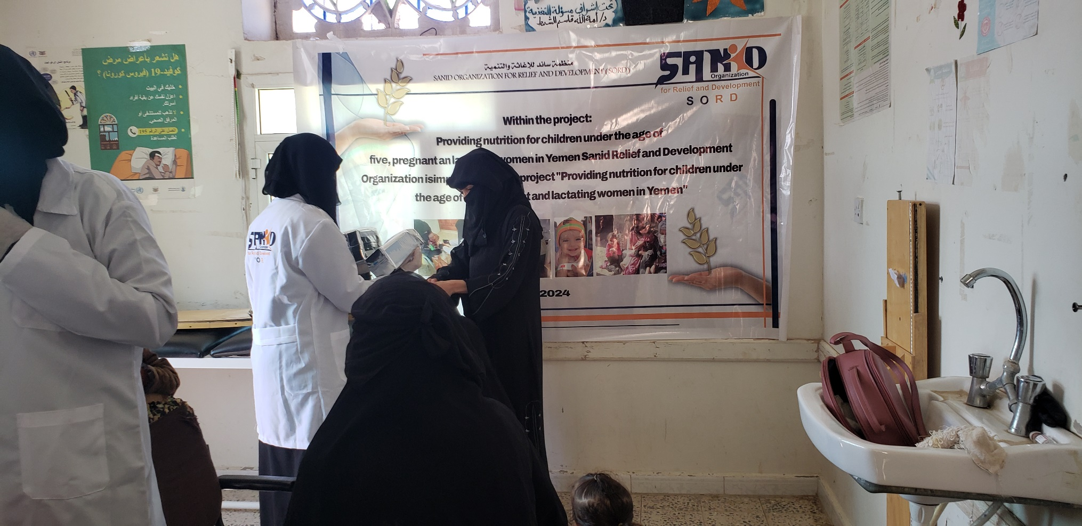

**Project Data :   
-------------------**

**Project Name :**[**Providing nutrition children U5yr & PLW in Yemen (39682)**](https://u31235.ct.sendgrid.net/ls/click?upn=u001.nXcXiZhglRfjdN-2FkjXr4cf8Mpfu7k9OiY1m-2F05Gx7zZF-2FyGTclMYeiGAEJdKTfeE3-2BWEd0D8OacgVU8Dq7Q644XOvHHsGrYGmkBaIBwkK-2BL-2B318w4Y0lVtnekKkrFKwTX2grSeRr-2F65qa8ZHsZcBEo6gMe8d3FGpfPf6Ajp0X612a-2BzAK5-2FHPyXXb0t9jGqDa-2FzR8W5TE9enCbsifAFuIhJ9DK-2F8NHgOSEHJKYSGEpvSHt1F9q982Sb4bYDEai3VE-2Fu-2FRQagk7IDr73iCdcmmxKiiqg7rX9oTN3jlvCKv0IzEHHeLgzSq63Kol-2FwYR5Hw8Zdoikrd7p1Gnyo-2FTdEsHC5JW127asg1JSmXg4eZB8-3DCD76_M-2BkB2cCeehDELLwg1wej3jD-2FIF1ubiraOHYAk1fGDWZ0vkoqoXtSuEHurWdmf6IAA6imUeuKEUJhxdcdOln8UiMhoOCYf-2B27l3jzyI0UWanOasba4F1-2FJhQOCOr-2Bbfp-2BMwPwEaP-2F1vMsXLAcuvmPFoYb4r3thMnqdgxYpotokrfbR-2F-2Bmb5-2Fmm9Y9zgFE2-2B7YkcBNxKsWMNGgFAilkvYQ2dlLO9HBMLgPuy5Da8Y-2BTHizcYyyFTt16ZSd9WhXt-2BcoMhJOomiYDh4VVl45ASVSuWWbRtbl2BWZJXmrJhLs3Vpo7pscpvX-2FI-2BZAc1Fl1XK-2F)

**The project Location:  Yemen**

**Name of the organization applying for the scholarship:**Sanid Organization for Relief and Development

**Report duration: My quarter**

**Starting date   01-09-2024       Expiry date         15-11-2024**

**Organization address:  Municipality of the Capital - People's District - Al-Habbari**

**Phone Number:   0096701231744**

**Report preparer : Shaif Ahmed Ali Ezadeen**

**Current Position:  Project Manager**

**E-mail: programmes. officer@sanid.org**

**Mobile Number: 00967778515105**

**The organization's website:**[**https://sanid.org**](https://sanid.org)

**General situation**

**Conflict, Hunger** and **Disease** are daily concerns for the Yemeni people. Two-thirds of the population – 17 million people – do not know where their next meal will come from; another 5,000 Yemenis are infected with cholera or acute watery diarrhea every day.   
  
The country has faced massive levels of humanitarian need, leaving the Yemeni people in dire need of some form of humanitarian assistance or protection.   
  
The massive humanitarian needs have always been a direct result of poverty, sporadic conflict and weak rule of law – including widespread human rights abuses.   
  
The conflict has made the situation worse, causing a significant deterioration in the country’s economic and social conditions.   
  
The deterioration of living conditions has been greatly accelerated by the collapse of the Yemeni economy, the deterioration of the local currency, the shortage of liquidity in the currency, and the near-bankruptcy of the Central Bank of Yemen, unable to meet its obligations, all affected by the ongoing conflict.  
  
 All of these factors and more have negatively affected all aspects of people’s lives, leading to increased rates of malnutrition in many areas of Yemen, warning of the possibility of a coming famine, according to the 2017 Humanitarian Needs Overview.  
  
 “An estimated 18.8 million people in Yemen require some form of humanitarian or protection assistance, including 10.3 million people in acute need. An estimated 14 million people are currently food insecure, including 7 million who do not know where their next meal will come from.  
  
 This represents a 33 percent increase since late 2014. The escalation has put affected people – including displaced people and affected communities – on the frontlines of the conflict. Yemen is beyond the critical level of severity of acute malnutrition.   
  
Acute malnutrition rates are highest in the densely populated northwest of the country, along the Red Sea coast and along the Arabian Sea coast up to Abyan Governorate.   
  
Available data and reports show that 4 of the country’s 22 governorates are experiencing critical nutrition conditions, either in the entire governorate or partially exceeding the WHO classifications of critical (Global Acute Malnutrition > 15 percent).   
  
Due to the deteriorating health, food security, water, sanitation and hygiene (WASH) situation, the nutrition situation is expected to deteriorate further given the ongoing conflict, particularly among vulnerable groups such as children under 5 and women of reproductive age (15-49 years).   
  
The Integrated Food Security Phase Classification (IPC) released on 17 March indicates that an estimated 17 million (60 percent of the population) are food insecure, including 6.8 million who are severely food insecure and require urgent humanitarian assistance to save lives and protect livelihoods. Some 10.2 million people are in IPC Phase 3 (Crisis) and 6.8 million in IPC Phase 4 (Emergency), a 20 percent increase since the June 2016 IPC analysis.   
  
Taiz and Ibb governorates are classified in IPC Phase 4 and IPC Phase 3, respectively.   
  
The global acute malnutrition rate in Taiz governorate has exceeded the critical level while Ibb governorate is at a serious level compared to the WHO crisis classification criteria.   
  
The latest figures from the Nutrition Cluster show that some 3.3 million children and pregnant and lactating women are acutely malnourished, including 462,000 children. Children under five are suffering from severe acute malnutrition, a 57 percent increase since late 2015, threatening the lives and life prospects of those affected. Violence has engulfed most districts of Taiz governorate and caused extensive damage to infrastructure. Since 17 January, airstrikes have been ongoing Violent and intense fighting and armed confrontations in Taiz, leaving people in deadly living conditions that have led to people fleeing to safer areas.   
  
The targeted areas in Ibb and Taiz governorates are reported to be suffering from malnutrition and the worst living conditions and are among the most urgent priority areas for intervention. 17.4 million people in Yemen now need food assistance, and an increasing proportion of the population is dealing with emergency levels of hunger, while 2.2 million children across Yemen are suffering from acute malnutrition. •   
  
**The project targets** the governorates with the highest levels of acute malnutrition (Sana’a, Hodeidah, Taiz and Aden) based on the Yemen Humanitarian Needs Overview 2023 and the latest nutrition cluster reports.   
  
The project ensures the provision of therapeutic and preventive nutrition services by implanting the community-based management of acute malnutrition program among vulnerable people with a focus on children under 5 years of age and pregnant and lactating women.   
  
SANID will support existing health facilities by operating and providing OTP/SFP/IYCF services including capacity building, incentives, screening and treatment of SAM/AAM and referral of SAM/AAM cases to the nearest SC/TFC as per the national guidelines for community management of acute malnutrition in Yemen.  
  
 In addition to community outreach services by deploying a network of community health volunteers and conducting health services and nutrition awareness campaigns in targeted areas to enhance preventive aspect and community awareness. In order to ensure the most cost-effective intervention, targeted health facilities will be supported with a minimum monthly support for operating cost (incentive for health workers and community health volunteers, stationery, cleaning materials/IPC kits, utilities, water, etc.).

**sAchievement:**

**Statistics** of those treated and educated during the reporting period of children under the age of five, as well as pregnant and lactating mothers:

The Table below shows the primary health services for women and children in the targeted area.

|  |  |  |  |  |  |  |  |  |  |
| --- | --- | --- | --- | --- | --- | --- | --- | --- | --- |
| **SAM without Complications Transferred from the previous reporting period Under treatment** | | | | | | | | | |
| **Total Acceptance** | | **Total** | **Total admissions** | | **Total** | **Total discharges** | | **Total** |  |
| **Males** | **Females** |  | **Males** | **Females** |  | **Males** | **Females** |  |
| **2** | **4** | **6** | **1** | **5** | **6** | **1** | **3** | **4** |  |
| **Summary of children treated during the reporting period Summary of screening at the target community level** | | | **Summary of screening at the target community level** | | |  |  |  |  |
| **Males** | **Females** | **إجمالي** | **Males** | **Females** | **Total** |  |  |  |  |
| **86** | **78** | **164** | **75** | **72** | **147** |  |  |  |  |
| **Screening of pregnant and lactating mothers of children from 0 to 24 months who received awareness counselling on infant and young child feeding** | | | **Number of pregnant and lactating mothers who received iron and folic acid tablets** | | | **Screening of mothers, pregnant women and lactating women at the target community level (volunteers)** | | | |
|  | **Females** | **Total** | **Awareness** | **Referral** | **Total** |  | **Pregnant** | **Lactating** | **Total** |
|  | **60** | **60** | **141** | **4** | **145** | **Awareness** | **26** | **19** | **45** |
|  |  |  |  |  |  | **Referral** | **12** | **7** | **19** |
| **Number of MAM Cases benefited during the reporting period** | | | | | | | | | |
| **Single Entry** | **46** |  | | | | | | | |
| **Double Access** | **46** |
| **Total** | **92** |  | | | | | | | |
| **Total beneficiaries of children under five and pregnant and lactating mothers from the program** | | **688 beneficiaries** | | | | | | | |

**Challenges and lessons learned:**

**•** Deterioration of the health situation in health centers in the targeted areas.

• Lack of salaries for health center workers.

• Weak capabilities to cover those who visit health centers.

• Lack of support and donations.

**Lessons learned:**

Preliminary coordination with the relevant authorities (Ministry of Social Affairs - Health Office - Local Community).

Identifying many areas in Sana'a Governorate where malnutrition cases are increasing.

Continuous communication with donors through GobalGiving and clarifying the situation of children and women in Yemen, who are considered among the most vulnerable cases in Yemen and are at risk.

People with special needs who suffer from malnutrition face difficulty in reaching health centers.

**Next period activities:**

Continue to receive and assist malnourished cases for 500 children and women.

Activate the external referral service (outside the targeted directorate).

• Work on the service provider map will begin during December 2024 in the neighboring

