**SORD Nutrition Project**

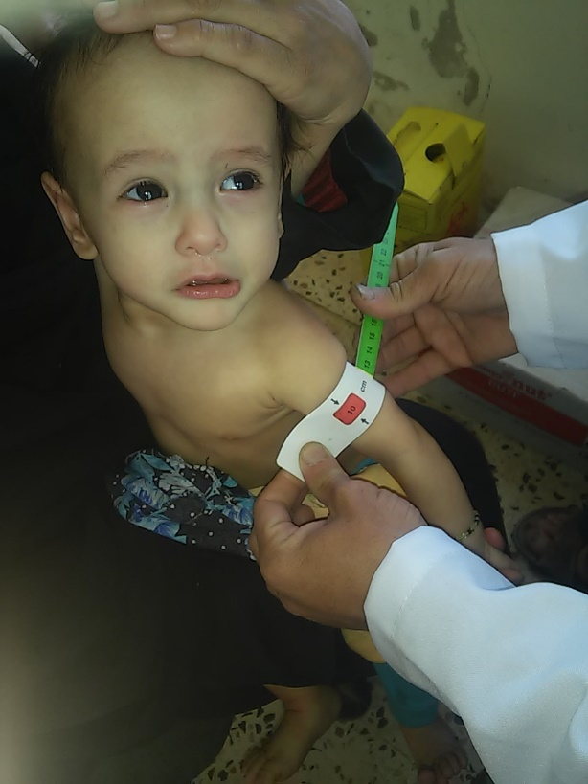In the eyes of the children we see our future our dreams our hope, but in the eyes of the children in Yemen we see the struggle and the fight to survive, hunger have excocted their energy suppressed their dreams making their only wish is to live another day, yet the unfortunate truth that lays behind the second day, is another story of struggle. Mothers covering their pain and worries, unable to give their infants basic nutrient as hunger have dried their milk.

Day by day we find more and more children with several cases of malnutrition, health facilities empty of medication, houses with no food and others with no roof. Children as old as seven years thinking that life is this way, as they have no seen it before the war.

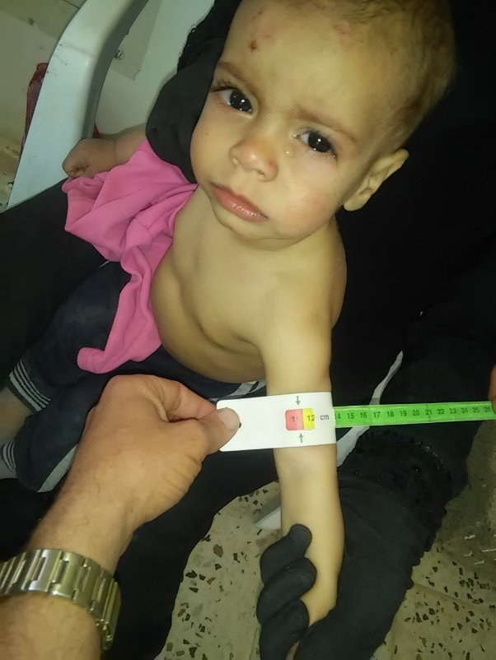In our efforts to stand with the forgotten once, we give our all to provide with everything is in our hands, yet nothing seems enough, with your generous help during august we were able to aid 123 children suffering with severe malnutrition, by providing nutrition supplements along with vitamins to help strength their meagre body to see another day only 9 out of the 123 were cured and transferred to the second stage which is the moderate malnutrition, unfortunately as we are still in the process of rising funds we are still unable to provide the full service, It was also noted that during August and the Eid Holidays, many others were not able to attend. Yet another 80 child 42 of them males and 38 females, were screened and given awareness sessions to their care givers on the danger of malnutrition as some have no background of the indirect causes. Also 42 pregnant and lactating mothers. Those children were admitted to Qa’a Al Era Health facility which is supported by Sanid Organisation, both UNICEF and WFP are also participating in the fight against malnutrition, but as the need is massive in the world’s worst humanitarian crisis, priority districts have been allocated due to the displacement caused by the war clashes, leaving many others in desperate need.

We would like to thank you all for the generous donations, and give our assurance that it will not be in vain, we also like to give our gratitude for all those who supported the implementation of the project, specially the field team and the health workers who still stand no matter what challenges stand ahead

We will continue to stand along with those in need, and wit your help, hope can be restored in the eye of the future.