Monthly Performance Report - Local Partner (SORD)

A project to save the life of a child under the age of five in Yemen

July 2024/AD

Report prepared by: Muhammad Abu Haider

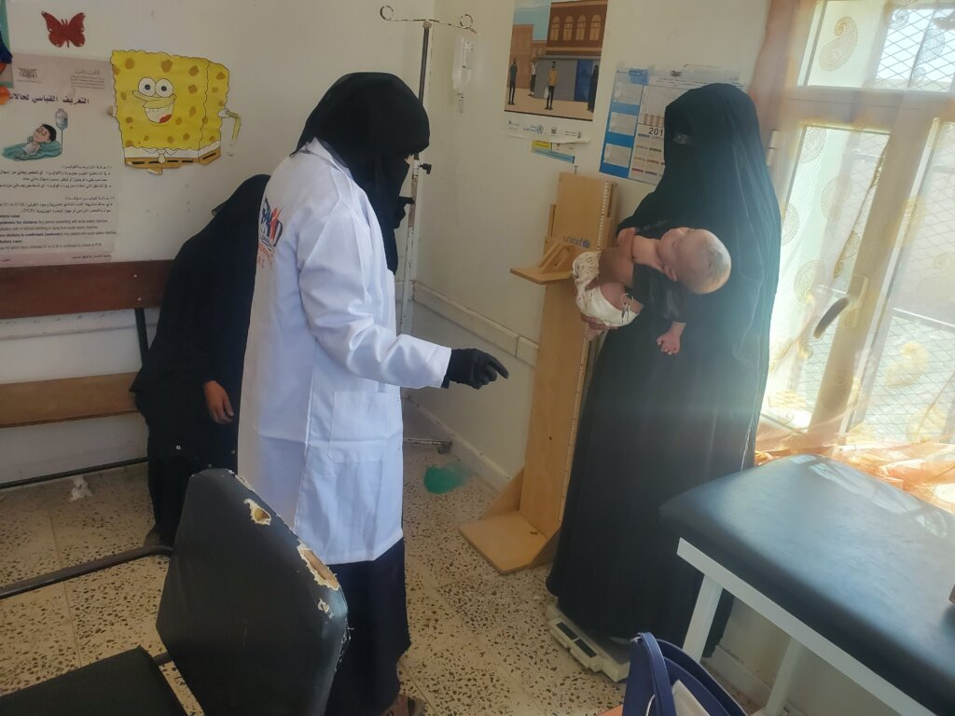

|  |  |  |  |
| --- | --- | --- | --- |
| project name | project rescue life child Without age Fifth in Yemen | | |
| The project Location | **Yemen** | | |
| Name of the organization applying for the scholarship | Sanid Organization for Relief and Development ( SORD ) | | |
| Report duration |  | | |
| starting date | **May 1 , 2024** | **Expiry date** | **July 2024 1 5** |
| Organization address | Municipality of the Capital - People's District - Al-Habbari | | |
| phone number | *0096701205757* | | |
| Report preparer | Muhammad Abu Haider | | |
| Current Position | project manager | | |
| E-mail | programmes.officer@sanid.org | | |
| mobile number | *00967 775907606* | | |
| The organization's website | www.sanid.org | | |

**project's data**

**An overview of the tragic situation in Yemen**

# It's been so inspiring to stand up for the work you do Globalgiving and the humanitarian community , Sanad Organization . It expresses its profound gratitude to all supporters in the humanitarian field who are doing their utmost to help the Yemeni community and alleviate its suffering. In the midst of an escalating global food insecurity crisis, hope is fading for millions who already suffer from extreme hunger. Globalgiving was It is the hope to save him from the specter of famine that has reached him.

In the first quarter of 2024, the percentage of people suffering from malnutrition reached 51%, according to government reports and international organizations.

Cholera also spread widely among children and women, especially pregnant and breastfeeding women

Yemen is one of the countries with high rates of acute malnutrition

. It needs an emergency health and nutrition project and an emergency human capital project

l Vital nutrition services are provided to the most vulnerable communities. There are eight therapeutic feeding centers

It lacks sufficient support to cover the needs of people with malnutrition, whether nutritional supplements, the most important of which is therapeutic milk.

It is also in urgent need of rehabilitation, furnishing, equipment and supplies .

# According to government reports and international organizations, Yemen ’s districts, the rural ones in particular, are the most vulnerable , where food insecurity and acute malnutrition converge to extremely high levels . It also has the highest prevalence rates, with more than 65 percent of the population in the third stage of the official classification and monitoring of the situation for food insecurity and above at the present time . A large number are also expected to move To higher stages of the IPC, with levels of humanitarian food assistance declining significantly .

**Overall performance**

In turn , SORD submitted its project entitled: “ Project rescue life child Without age Fifth in Yemen

. The proposed project aims to contribute to reducing deaths and diseases associated with acute malnutrition for children under the age of five, pregnant women, and breastfeeding mothers in targeted areas with high rates of acute malnutrition. During the second quarter From 2024 , children under five years of age and pregnant and lactating women suffering from acute malnutrition are provided with appropriate complementary feeding. Community awareness has been increased among pregnant women, breastfeeding mothers and girls of reproductive age regarding the prevalence of malnutrition, both for the child and the mother, the importance of good nutrition for mental and physical health, and how to use available resources in order to overcome or reduce malnutrition. More details about the project achievements can be found on our side, and based on the available capabilities, we have achieved remarkable progress compared to the percentage of cases recorded by the team in the field. During the second quarter of the year 2024 AD as follows:

**Activities that were implemented during the month of September to November**

SAND worked to implement the activities according to its available capabilities and in accordance with the support and donations it received from Global

report on activities for MATM Implement it

* Coordination was made with the health center to receive 225 cases of malnourished children (new) and they were presented to specialist doctors within the malnutrition program at the health center.

Approximately 354 cases of malnourished children were recorded, and as we mentioned, due to the lack of capabilities, Sanad was unable to help this number of afflicted people. It was able to provide aid (inspection, examinations, and dispensing of therapeutic supplements to 225 children under the age of 5 years who were afflicted with toxic and severe malnutrition. .

328 children under the age of five were immunized with vaccines against infectious and deadly diseases.

* A number of 225 children under the age of five who were helped were received during the month of September and November, and their cases continue to be followed up until recovery. Their cases were followed up through examination and obtaining nutritional supplements.
* After coordination with the health center, the Maternity and Childhood Department received 209 cases of mothers, pregnant and breastfeeding women suffering from malnutrition (new), and they were presented to specialist doctors within the motherhood and childhood program at the health centre.

Approximately 289 pregnant and lactating women suffering from malnutrition were registered. As we mentioned, due to the lack of capabilities, Sanad was unable to help this number of pregnant and lactating women in need of health care and follow-up. Sanad was able to provide aid (examinations, examinations, and dispensing therapeutic supplements) to 209 women (pregnant and lactating women). .

Immunization procedures for 123 pregnant women against tetanus.

* In addition, 340 women who frequented the center were received for follow-up who were helped in the month of October, especially those who were pregnant in the last months and newly breastfeeding women, and their cases were followed up through (examination, weighing, and dispensing nutritional supplements).
* 27 cases (children under the age of five and suffering from toxic malnutrition who were targeted by Sanid, and whose cases became difficult and needed intensive care) were referred to some hospitals in the governorate that have special capabilities and samples, where they were helped with the costs of transportation, accommodation, supplementary nutrition, and fees for intensive care rooms in private hospitals .
* 7 cases of pregnant women suffering from chronic diseases and needing special care were referred to central hospitals.
* Implementing 32 awareness sessions on reproductive health aspects, malnutrition prevention measures , hygiene methods, and healthy nutrition. 320 pregnant and breastfeeding women were targeted by volunteer midwives .
* Coordinating with the local authority and the competent authorities in order to obtain a map of services for entities working in the same field within the targeted areas and neighboring areas in order to exchange experiences and refer some cases that need other services that are not available to us.

32 cases of malnourished children moving to the recovery stage were recorded, including 20 females and 12 males.

**Challenges .:**

* The deterioration of the health situation in health centers in the targeted areas.
* Weak capabilities to cover people visiting health centers.
* Lack of support and donations.
* Increase in the number of people suffering from malnutrition.

**Recommendations :**

* Redouble efforts in providing support and aid to save the largest number of children and women who are on the verge of death.

.