Monthly Performance Report - Local Partner (SORD)

**Addressing malnutrition for children under five, lactating women and pregnant women among the displaced and the host community, Hajjah Governorate**

**October 2022/AD**

**Producer : Muhammad Abu Haider**

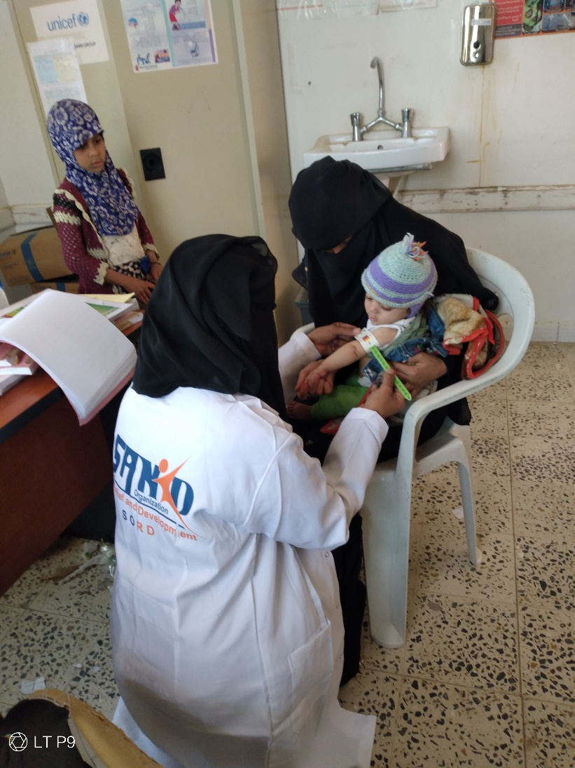

**Project's Data**

|  |  |  |  |
| --- | --- | --- | --- |
| **Addressing malnutrition for children under five, lactating women and pregnant women among the displaced and the host community, Hajjah Governorate** | | | Project Name |
| **Aslam District - Hajjah Governorate** | | | The project Location |
| Sand Organization for Relief and Development ( SORD ) | | | Name of the organization applying for the scholarship |
| Month | | | Report Duration |
| **1/10/2022 AD** | **Expiry date** | : **6/11/2022** | starting date |
| Capital Secretariat - Shu'ub District - Al-Habari | | | Organization address |
| *0096701205757* | | | phone number |
| Mohammed Abu Haider | | | Report preparer |
| Project manager | | | Current job |
| Programs.officer@sanid.org | | | E-mail |
| *00967 775907606* | | | mobile number |
| www.sanid.org | | | Organization's website |

**An overview of the tragic situation in Yemen**

After the collapse of the declared truce in Yemen and the renewed confrontations, the suffering of Yemenis has doubled and the living situation has become very difficult, as according to official and UN statistics and reports, 17 million Yemenis live below the poverty line and the level of living security has become at its lowest, as Yemenis lack the simplest means of livelihood, which is what made them in Extreme difficulty in obtaining adequate food to preserve their lives and the lives of their children from the specter of famine, which has become widespread in all regions of Yemen.

17.4 million people in Yemen now require food assistance, a growing proportion of the population is dealing with emergency levels of hunger, while 2.2 million children across Yemen are suffering from acute malnutrition .

Yemen is on the brink of disaster..according to UN agencies reports , The humanitarian situation in the country worsened between June and December 2022, with the number of people who may not be able to meet their minimum food needs to reach a record 19 million in this period .

Following today's new release [of the Integrated Food Security Phase Classification](https://learning.ipcinfo.org/mod/scorm/view.php?id=609) (IPC) analysis , as warned by the United Nations Children's Fund ( [UNICEF](http://unicef.org/ar) ) and the [World Food Programme ,](http://ar.wfp.org/) And the Food and Agriculture Organization of the United Nations ( [FAO](https://www.fao.org/home/ar/) ) from the intensification of the hunger crisis in Yemen, which makes the country teeter on the brink of inevitable disaster . .

According to the UN Resident and Humanitarian Coordinator in Yemen: “The new IPC analysis confirms the deterioration of food security in Yemen. The bottom line is we need to act now. We need to sustain the integrated humanitarian response for millions of people, including support Food and nutrition, clean water, basic health care, protection and other necessities.An additional 1.6 million people in the country are expected to decline to emergency levels of hunger, bringing the total number to 7.3 million by the end of the year .

Alarming data indicate that the number of people suffering from catastrophic levels of hunger ( stage 5, IPC5 starvation conditions) is expected to increase fivefold: from 31,000 currently to 161,000 over the second half of 2022 .

According to these catastrophic data and indicators , only more than half of the health facilities are functioning. The workers face severe shortages of medicines, equipment, and personnel. Health systems are on the verge of collapse if they are not supported .

# It was so inspiring to see the work you do globalgiving and the humanitarian community, Sanid . She expresses her deep gratitude to all the donors in the humanitarian field who are doing their best to help the Yemeni community and alleviate its suffering. In the midst of the escalating global food insecurity crisis, the hope of the millions already suffering from extreme hunger is fading . Globalgiving It is the hope to save him from the specter of starvation that has reached him.

# And the [According to the Yemen Humanitarian Needs Overview document (HNO) for the year 2022](https://reliefweb.int/report/yemen/yemen-humanitarian-needs-overview-2022-april-2022)

* About 23.4 million people will be in need of humanitarian assistance in 2022, of which 12.9 million will be in acute need .
* 19 million people suffer from food insecurity .
* 17.8 million people lack access to safe drinking water and adequate sanitation .
* About 21.9 million people lack basic health care .
* About 4.3 million people have been displaced from their homes since the beginning of the conflict, including about 3.3 million people who are still displaced, and one million of them have returned .

In the governorate of Hajjah, which is diverse in climate and terrain, where its population is distributed in the coastal plains adjacent to the Red Sea, plateaus and mountains, and being a border area with neighboring countries, which has become, as a result, an arena of wars and continuous conflicts, which has led to depriving it of the simplest services and suffering from an applied siege and making it a military zone in which the humanitarian conditions have worsened, the most important of which is famine. Which led to malnutrition among children under the age of five and pregnant and lactating women, as the statistics reached last February about 4,000, four out of a total of 400,000, four hundred thousand children at risk, a thousand children and women suffering from malnutrition. These most sick children struggle every day for their lives and need To immediate specialized care to save their lives in order to survive . . A child with severe acute malnutrition is 9 times more likely to die than a well-nourished child. For this reason, the ambition of the organization's work is to continue life-saving care for the child in more than 8 therapeutic feeding centers throughout Hajjah governorate. .

Hajjah is one of the Yemeni governorates with a high prevalence of acute malnutrition

. They need a project Emergency health and nutrition project and emergency human capital project

l Vital nutrition services are provided to the most vulnerable communities. There are eight therapeutic feeding centers

It lacks sufficient support to cover the needs of malnourished people, whether nutritional supplements, the most important of which is therapeutic milk.

It is also in dire need of rehabilitation, furnishing, equipment and supplies ..

# The United Nations also warned of dire consequences of the continuation of the conflict in Yemen on food security and malnutrition, which witnessed a further deterioration in 2022 compared to 2021 . According to the latest analysis of food insecurity, there are 86 Yemeni regions that have become in a state of very severe food insecurity since the beginning of this year, of which 82 regions have moved from the third stage of the Integrated Phase Classification of Food Security (crisis) to the fourth stage, which is the emergency stage in the classification. It consists of five stages, the top of which is the famine stage, bringing the number of regions classified in the fourth stage to 233 regions . According to the analysis, the most vulnerable districts are in the governorates of Hajjah and Al Hudaydah, where food insecurity and acute malnutrition are converging to very high levels . For severe malnutrition, the WHZ score in these two governorates, a measure of wasting for children under five, ranges from 17% to 26%, well above the WHO emergency threshold of 15%, while for severe food insecurity, these two governorates have The highest prevalence rates with more than 65 percent of the population in the third stage of the international classification of food insecurity and above at the present time . The analysis projects that approximately 2.2 million children aged 6-59 months will continue to suffer from acute malnutrition throughout the year, including 538,000 children with severe acute malnutrition . A total of 17.4 million people or 54 percent of the population faced acute food insecurity (phase III and above) from January to May 2022, with 31,000 people classified as ICD Phase V (famine) and 5.6 million (18 percent). ) in the fourth stage of the international classification (emergency) and 11.7 million people (37 percent) in the third stage of the international classification (crisis) between June and December 2022 . The analysis states that the number of people likely to face high levels of acute food insecurity (ICF insecure stage III or higher) is expected to rise to 19 million (60 percent of the total population) . It is also expected that a large number of districts in these two governorates will move to higher stages of the IPC, with significantly reduced levels of humanitarian food assistance .

**overall performance**

role ha SORD raised its project entitled: "Saving the lives of 3025 children under the age of five and 1360 pregnant and lactating women in Yemen." The proposed project aims to contribute to the reduction of deaths and diseases associated with acute malnutrition for children under five years of age, pregnant women and nursing mothers in targeted areas with high rates of acute malnutrition. During the third quarter of 2022 , children under five and pregnant and lactating women suffering from severe acute malnutrition were provided with appropriate supplementary feeding. Community awareness was raised among pregnant women, nursing mothers and girls of childbearing age regarding the prevalence of malnutrition, both for the child and the mother, the importance of good nutrition for mental and physical health, and how to use available resources in order to overcome or reduce malnutrition. More details about the achievements of the project can be found on our side and based on the available capabilities we have made significant progress compared to the percentage of cases recorded by the team in the field. During the third quarter of 2022 AD in Hajjah Governorate, as follows:

The table below shows the primary health services for women and children in the target area ( Hajjah Governorate ) .

<https://sanid.org/content/uploads/2022/11/table-of-save-chillds-nov2022.png>

|  |  |  |  |  |  |  |  |
| --- | --- | --- | --- | --- | --- | --- | --- |
|  | Nutrition Program | Immunization Program | | | | | |
| Screening for pregnant and lactating women | to *immunize* | toxic | MAM | Pregnant | Breastfeeding | Sorting for kids | Services |
|  | 438 | 101 | 213 | 145 | 216 | 314 | number of case |

**Total number of beneficiaries: 2402 Individuals distributed on**

|  |  |  |  |  |  |
| --- | --- | --- | --- | --- | --- |
| child health program | reproductive health program | | | list of diseases | checkups |
| Children under five years old | family planning | Pregnant Care | Childbirth and postpartum services |  |  |
| 314 | 135 | 213 | 99 | 1482 | 418 |
|  |  |  |  |  |  |

Where 46 cases of recovery from malnourished children were recorded, including 29 females and 17 males. 314 malnourished boys and girls were registered , of which 79 were SAM and 235 were MAM.

While primary health services were provided to 213 women A pregnant woman, in addition to educating 466 women about measures to prevent malnutrition , hygiene methods and proper healthy nutrition.

Also, the necessary examinations were carried out and conducted for 418 cases of various diseases that were treated and transferred to the stage of recovery and recovery. Of the 1482 sick cases that visited the center during the month of October and the first week of November 2022 AD.

**Challenges and lessons learned :**

* The deterioration of the health situation in the health centers in the targeted areas.
* Unavailability of salaries for workers in health centers.
* Poor capabilities to cover the frequent visitors to health centers.
* Lack of support and donations.

**Lessons learned :**

coordination with the competent authorities (the Supreme Council for the Coordination of Humanitarian Affairs - the Health Office - the local community.

Identifying many areas in Hajjah Governorate, in which malnutrition cases are increasing.

Continuous communication with donors through **globalgiving and clarifying the situation of children and women in Yemen, who are considered among the most important cases of vulnerability in Yemen are at risk.**

Malnourished people with special needs have difficulty accessing health centers To benefit from medical aid and referrals .

• located The health center in Aslam district, Hajjah governorate, which is considered the district most affected and affected by cases of malnutrition and other diseases such as malaria and typhoid, is considered a remote area , which leads to a significant increase in frequency to the health center And take advantage of the services provided by Sand organization and given To the large number of hesitant people who were not able to obtain treatment and awareness assistance because of the scarcity of resources in the health facility , . Coordination will be made to reach a map of similar services in the Directorate and the nearby nearby areas, in order to activate the referral service to similar facilities in the neighboring areas. To cover the largest number of beneficiaries in Aslam district .

**Next month 's activities :**

Continuing to receive and assist malnourished cases for 500 children and women.

Activating the external referral service (outside the target directorate).

• The activation of work on the map of service providers will start during the month of November in the accessible areas .

.