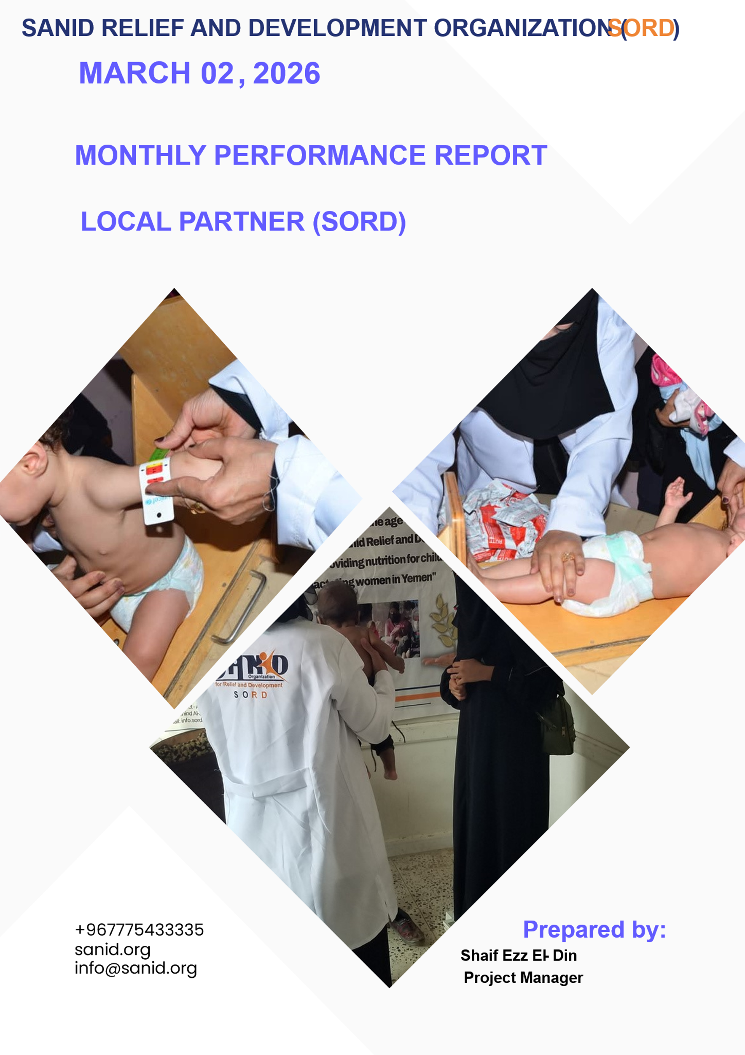
Monthly Performance Report – Local Partner (SORD)
Project Title: Addressing Malnutrition in Children Under Five
Project Location: Yemen
Reporting Period: Quarterly (December 2025 – February 2026)
Prepared by: Shaif Ezz El-Din – Project Manager
Organization: Sanid Relief and Development Organization (SORD)
Address: Capital Secretariat – Shu’ub District – Al-Habari
Phone: +967 1205757
Email: shaief.izzudin.yemen@sanid.org
Mobile: +967 778515109
Website: www.sanid.org

1. Context Overview
Yemen continues to face one of the world’s most severe humanitarian crises, marked by widespread poverty, famine, disease, and ongoing conflict. The country suffers from a near-total collapse of basic services and infrastructure. Malnutrition remains one of the most critical challenges, especially among children under five, pregnant women, and lactating mothers. These vulnerable groups face life-threatening conditions daily, with severely malnourished children being nine times more likely to die than well-nourished peers.
In this context, GlobalGiving and the humanitarian community have been a beacon of hope. SORD expresses deep gratitude to all donors and partners working tirelessly to alleviate suffering and save lives.
2. Project Objective
To reduce mortality and morbidity associated with acute malnutrition among children under five in targeted high-prevalence areas.

3. Activities Implemented
Activity | Target | Period | Achieved
Screening and treatment of new cases (children under 5) | 150 | Dec 2025 – Feb 2026 | 52
Screening and treatment of new cases (pregnant/lactating women) | 150 | Dec 2025 – Feb 2026 | 70
Follow-up for previously admitted children | 150 | Dec 2025 – Feb 2026 | 52
Follow-up for previously admitted women | 150 | Dec 2025 – Feb 2026 | 70
External referrals to nearby health centers | 50 | Dec 2025 – Feb 2026 | 8 children, 12 women
Mapping of similar services in the district | 1 | Dec 2025 – Feb 2026 | Completed
Awareness sessions on nutrition and hygiene | 500 | Dec 2025 – Feb 2026 | 187 women
4. Beneficiary Summary
- Direct Services: 122 children and women received medical screening and supplementary treatment.
- Awareness Sessions: 187 women (pregnant/lactating) participated in nutrition and hygiene education.
5. Challenges
- Deteriorating health infrastructure in targeted areas.
- Lack of salaries for health workers.
- Limited resources to meet growing demand.
- Insufficient donations and funding.
- Rising rates of acute malnutrition.
6. Recommendations
- Intensify efforts to secure funding and resources to reach more vulnerable children and women.
- Strengthen partnerships with donors and humanitarian actors.
- Support health workers with incentives to ensure service continuity.
- Expand awareness campaigns to promote preventive practices.

