**Monthly Performan Addressing Malnutrition for Children Under Five and Pregnant and Lactating Women among IDPs and Host Communities   
Report prepared by: Shaif Ahmed Ali Ezz El-Din**



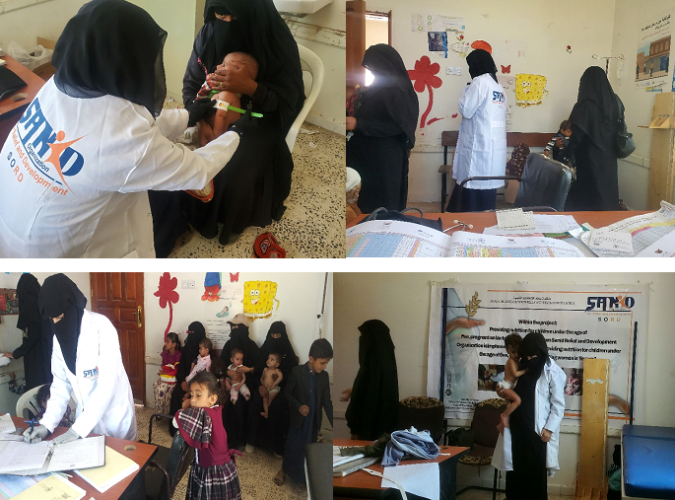

**Mar 2025/AD**

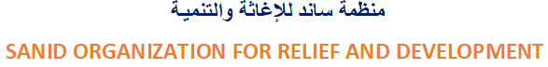**Author : Shaif Ahmed Ali Ezadeen**

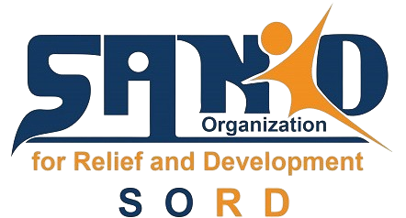

**Report Overview**

**Project Name:** Addressing Malnutrition for Children Under Five and Pregnant and Lactating Women among IDPs and Host Communities   
**Location:** Sana'a, Yemen  **Reporting Period:** March 2025  **Report Prepared by:** **Shaif Ahmed Ali Ezadeen**

**Contact Information:** Programs.officer@sanid.org, **00967778515105**

**Project Highlights**

* **Target Areas:** Sana'a, Hodeidah, Taiz, and Aden
* **Services Provided:**
  + Outpatient Therapeutic Program (OTP)
  + Supplementary Feeding Program (SFP)
  + Infant and Young Child Feeding (IYCF)
* **Community Outreach:** Through volunteers, health services, and nutrition awareness campaigns

**Achievements**

* **Children Treated and Mothers Assisted:**
  + **Community Screening:**
    - **Boys:** 56 screened, 48 treated
    - **Girls:** 57 screened, 49 treated
  + **Pregnant and Lactating Women:**
    - **Nutritional Advice:** 112 received advice
    - **Iron and Folic Acid Supplements:** 44 received supplements
    - **Community Outreach:** 19 provided with awareness, 16 referred
* **Total Beneficiaries:** 514 children under five and pregnant and lactating women

**Challenges**

* Deteriorating health conditions in targeted areas
* Lack of salaries for health center workers
* Insufficient resources for high footfall at health centers
* Limited support and donations

**Lessons Learned**

* Pre-coordination with relevant authorities (Ministry of Social Affairs, Health Office, local communities)
* Identification of high-malnutrition areas in Sana'a
* Continuous communication with donors to highlight the situation of children and women in Yemen
* Access issues for people with special needs affected by malnutrition

**Upcoming Activities**

* Continue assisting 500 malnourished children and women
* Activate external referrals (beyond target directorate)
* Implement service provider mapping in nearby accessible areas starting April 2025

**Based on the above,** the following interventions were the most effective:

1. **Outpatient Therapeutic Program (OTP):** This program focused on treating children with severe acute malnutrition (SAM) without complications. The support provided by OTP facilities played a crucial role in managing and reducing SAM cases.
2. **Supplementary Feeding Program (SFP):** This initiative targeted children and women who needed additional nutritional support. The provision of supplementary foods helped in improving their nutritional status.
3. **Infant and Young Child Feeding (IYCF):** This program focused on providing nutritional advice and support to pregnant and lactating women, ensuring the health and proper development of their children.
4. **Community Outreach and Awareness Campaigns:** The project included a significant effort in raising community awareness through health services and nutrition campaigns. Community health volunteers were instrumental in spreading knowledge and encouraging preventive measures.
5. **Capacity Building and Incentives:** By building the capacity of health workers and providing incentives, the project ensured that health facilities could operate effectively and sustainably.
6. **Screening and Referrals:** Regular community screenings and referrals to specialized care centers helped in early detection and timely intervention for malnutrition cases.

***Overcoming the challenges*** identified above requires both innovative and pragmatic approaches to ensure sustainable impact. Here are some strategies tailored to each challenge:

1**. Improving Healthcare Infrastructure**

Resource Mobilization: Partner with international donors, NGOs, and local businesses to secure funds for renovating health centers and acquiring necessary equipment.

Public-Private Partnerships: Collaborate with private sector entities to co-fund infrastructure improvements.

2. **Addressing Staff Salary Issues**

Performance-Based Incentives: Work with donors to establish a system of incentives tied to service delivery milestones.

Advocacy: Engage government agencies and international bodies to prioritize healthcare workers' salaries in humanitarian aid packages.

Volunteer Programs: Train and mobilize community health volunteers to support understaffed centers.

3. **Enhancing Support for Health Center Visitors**

Community Outreach Programs: Increase awareness about available health services to manage visitor flow more effectively.

Resource Optimization: Use digital tools to monitor and allocate resources based on demand patterns in various centers.

**4. Boosting Support and Donations**

Storytelling for Fundraising: Share compelling success stories and visuals from the project to attract donors via platforms like GlobalGiving.

Networking: Strengthen relationships with existing donors and explore partnerships with non-traditional funding sources, such as philanthropic organizations.

**5. Reaching Vulnerable Groups**

Mobile Health Clinics: Deploy mobile teams to visit remote areas and cater to those unable to access health centers.

Barrier Reduction: Provide transport vouchers or organize community transport systems for individuals with mobility challenges.

***This project*** is a vital component of broader humanitarian efforts in Yemen, specifically targeting malnutrition, which remains one of the most critical challenges in the region. Here's how it contributes to larger efforts:

**1. Addressing Immediate Needs**

By providing nutritional treatment and preventative care to vulnerable groups—children under five, pregnant women, and lactating mothers—the project directly tackles acute malnutrition, reducing the risk of severe health complications and mortality. This aligns with national and international goals to improve child and maternal health in Yemen.

**2. Enhancing Healthcare Capacities**

The project strengthens existing healthcare facilities by supplying essential resources and implementing training programs for healthcare workers. This capacity-building approach ensures sustainability and enhances the overall healthcare infrastructure, contributing to long-term resilience.

**3. Coordinating with Broader Frameworks**

The implementation of this project is integrated with guidelines from key organizations like UNICEF, WFP, and Yemen's Ministry of Health. This coordination ensures alignment with larger national nutrition strategies and international humanitarian frameworks.

**4. Community Engagement**

Through community outreach, education campaigns, and the involvement of community health volunteers, the project raises awareness and fosters local participation. This not only increases the program’s reach but also empowers communities to adopt preventive measures against malnutrition.

**5. Data Collection and Insights**

The project identifies high-need areas and collects valuable data on malnutrition trends, which can inform and influence other humanitarian interventions in Yemen, ensuring resources are directed to where they are most needed.

**6. Addressing Broader Vulnerabilities**

By targeting malnutrition, the program indirectly supports broader humanitarian priorities such as reducing child mortality, improving maternal health, and building resilient communities. The focus on vulnerable groups ensures that marginalized populations are not left behind.

This project represents a crucial piece of the puzzle in the collective effort to address the severe humanitarian crisis in Yemen

**Certainly!** The statistical outcomes presented in the report carry significant value, as they illustrate both the impact of the project and its alignment with broader goals. Here's a breakdown of their significance:

**1. Demonstrating Project Reach**

* **514 beneficiaries** (children and mothers) indicate the tangible impact the project has achieved in the short reporting period. This highlights the program's ability to address malnutrition effectively among high-risk groups.
* These numbers reflect the coverage of services, including screening, treatment, and counseling, showcasing the project's extensive outreach efforts.

**2. Identifying Gender Equity**

* The data shows a balanced distribution of support across genders (e.g., male and female children) and focuses on vulnerable women (pregnant and lactating mothers), emphasizing inclusivity and equitable service delivery.

**3. Tracking Progress**

* The **104 children and 116 women served** signal a measurable contribution to mitigating malnutrition. Such granular data can be used to compare against previous reporting periods, aiding in performance evaluation and demonstrating improvements.

**4. Highlighting Community Engagement**

* Screening efforts that reached **106 individuals** at the community level reflect active involvement and mobilization of resources. This indicates the project's success in integrating preventive care measures alongside treatment.

**5. Evidence for Advocacy**

* These statistics provide solid evidence to advocate for continued funding and support. Donors and stakeholders can see clear results and understand the project's critical role in combating malnutrition.

**6. Informing Future Planning**

* The identified service gaps, such as follow-up visits (76 cases), reveal areas for improvement and help in planning future activities. The outcomes also underline the importance of sustained engagement for long-term impact.