School For Peace Wins Major Award

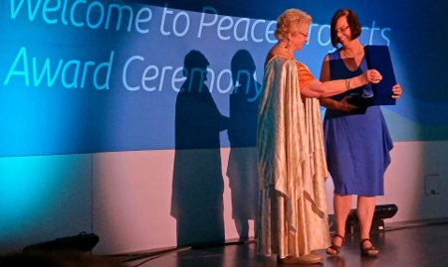
In June, Dr. Nava Sonnenschein was invited to Turkey to take part in the competition for the prestigious Journalists Writers Foundation award. The School for Peace was one of 1,179 organizations, from 107 countries, competing for the 10 prizes that were awarded.

The foundation has set its goal as promoting the idea of coexistence through understanding among the masses. JWF is a non-governmental organization in general consultative status with the United Nations Economic and Social Council (ECOSOC).
The prize is intended to “support innovative conflict resolution and peace building projects focused on preventing, managing and resolving violent conflict and promoting post-conflict peace building”. It will fund a joint project of the School for Peace and Tawasul in Ramallah which will teach 60 Palestinian and Jewish literature teachers to teach the literature of the “other”.

Congratulations Dr. Nava Sonnenschein!

