Parents and kids live together in the hotel next to rehabilitation center.
One rehabilitation course duration is 1 week. Normally one course needed in 3-4 month, i.e. 3 courses per year. The cost of one year rehabilitation (3 weeks courses) is RUB 165,000 (about USD 2,500). Normally it is sufficient for kids under 3 years.

The schedule of a week rehabilitation course
№ | Lessons | Quantity
1 | Speech therapist | 5
2 | Fitting session | 2
3 | Psychologist | 2
4 | Free sound field audiometry | 1
5 | Game therapy | 2
6 | Art therapy | 2
7 | ENT doctor consultation | 1
8 | Logopedic | 3
9 | Physical education instructor | 3
10 | Music education instructor | 2
11 | Neurologist consultation | 1

Set of rehabilitation materials
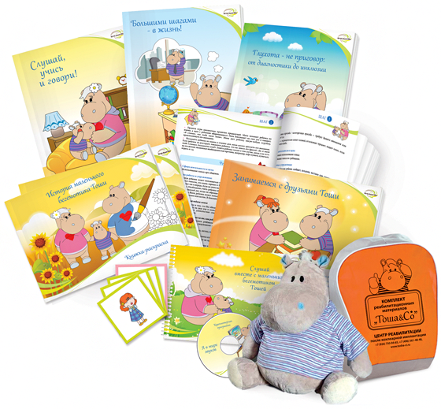

Structure:
- “History of Tosha-the-Hippo”
- “Listen, Learn and Talk”
- “Sound foundation for babies”
- “Listen together with Tosha-the-Hippo!”
- “Deafness is not a sentence: from diagnostics to inclusion”
- Flashcards
- Loudness scale
- Subject pictures
- Tosha-the-hippo soft toy
- Nice package

