SPECIAL TALENTS
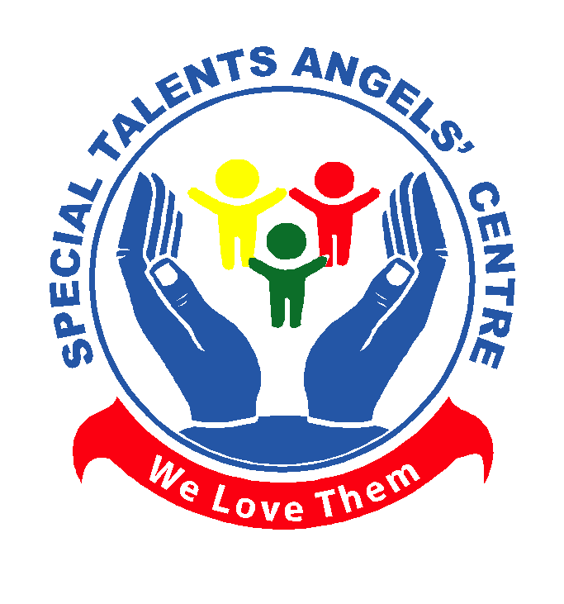

ANGELS' CENTRE
(STAC)

BRIEF CENTRE PROFILE

GENESIS OF THE CENTRE.

The Genesis of this Centre runs back to 2006 when the challenged and hopeless parents met at a certain point as they were looking for a future for their stuck children.

These three parents almost shared the same cross as one of them by the names of Mr. Sseguja Henry had struggled for more than five years with his child who was intellectually impaired due to the absence of any effective, accessible and affordable Special needs centre in his locality.

Not forgetting the second traumatized parent by the names of Nakate Juliet
Mubiru who almost lost her marriage. Her daughter was struggling
with academics due to her specific learning difficulties, she could transfer her from school to school but without great improvement.

As if that was not enough, even another parent had landed on a village couple that had divorced due to their four years old girl who had proved deaf.

Part of our Staff
Fortunately out of this dilemma one member decided to enroll for a special needs course to find out the would be causes of increasing disabilities and the possible interventions. Later after the course fellow members
were mobilized and formed an outreach task force to create public awareness about the differences in humanity at both homestead and school level.

Due to the increased demand, the concerned members decided to come up with a project. "A community initiative for disability awareness and prevention and possible interventions for persons with disabilities" being funded by one member for two years.

Following the created awareness, parents started identifying the nature of their children but couldn’t find special schools for them to cater for their needs.

Amidst the above dilemma parents started entrusting us with their children through home based programmes and ordinary schools programmes.

Until recently in 2013 when we decided to set up a centre to manage children for rehabilitation, academics and skills development.

Under rehabilitation we have children with autism, intellectual impairment, down’s syndrome, delayed speech and for children with specific learning

difficulties –dyslexia. Our classes range from nursery to
primary seven. Our learners reciting a poem on a talents day competition
VISION

A society in which children with special needs can grow and develop to their full potential for independent living.

MISSION

To promote a God fearing, equal rights and equitable opportunities for special needs children through assessment, rehabilitation, capacity building and advocacy.

MOTTO

Our motto is “We Love Them”.

OBJECTIVES
Our Children enjoying a balanced
diet as a Nutritional Therapy

• Conducting community mobilization for sensitization, child psycho- Educational assessment for intervention as regards rehabilitation for child growth and development.
• Acting as a model centre for hands on training of students from higher
institutions of learning.
• Development of basic vocational skills in affordable and manageable fields like music dance and drama, modern agriculture, food preparation, art and craft, etc.
• Promotion of children`s health and nutrition, and advocating for their
rights.
• Promotion of environmental conservation strategies and practices for
a sustainable environment.

CORE VALUES

• God first
• Empathetic service
• Tolerance and passion
• Result oriented service
• Professionalism
• Work and life balance

ACTIVITIES AT THE CENTRE

• Child Psycho-Educational Assessement. This involves the testing of the child for suitable internations/recommendations.
Special classes. Our classes run from pre class to primary seven that being ran on wave based systems.
• Rehabilitation or behavioural management and therapy. this involves communication and language therapy, Occupational Therapy, Physio therapy, Nutritional therapy e.t.c
• Public sensitization. We create public awareness and sensetazition through centre vists, talk shows, radio programmes about disability as a concept, its types and possible intervations as regards health living and advocacy.
Skills development. We equipe our children with basic vocational skills like
home management, food preparation and management, art and craft, ceramics,
liquid soap making e.t.c.
• Environmental protection. We participate in community activities like regular
voluntary community cleaning, tree planting and community sensetazition
about environmental protection.

Some of the basic

Skills at the Centre Children Enjoying Acqua-Therapy

CENTRE ACHIEVEMENTS

• Children enrolment. our enrolment is growing day and night to the extent that our capacity is over whelmed by the demand.
Centre Upgrading. we have upgraded and advanced the oﬀered services due to the fact that we do hire exparts in communication and language Therapists from prominent institutions like Mulago hospital, we have extended our classes from primary four (4) to seven (7).
• Centre registration. our centre is now legaly registered by the government of uganda.
Public awareness. Several media channels have been accessed with an aim of creating public awareness and advocacy on the areas of disability issues. The cases in point are bekedde T V, NBS T V, Delta T V, UBC-Star T V, UBC radio,
Radio Mama etc.
• Skill development. Some of our learners have acquired basic skills that can let
them live an independent life and earn a living.
Religious strengthening. we have promoted all religious aﬃllaitions to the
extent that some learners completed religious renewal, Baptism renewal,
Religious comfirmation etc and for the moslems islamic classes are on our time
table.

Religious Upgrading party

The Principal exhibits learners work

Religious Confirmation

CHALLENGES

• Over whelming numbers of special needs children
Increasing rental bills
• Irresponsible parents
• Inadequate funds to run the centre
• Inadequate instructional materials
• Limited space
• Fluctuating prices of food stuﬀs and devices
Expensive human resource as regards experts.

FUTURE PLANS

• Massive community sensitisation and capacity building.
• Advocacy for children with disabilities rights.
• Having our own home.
• Extension to a secondary section.
• Setting up a vocational institute.

CONCLUSION

Looking for well wishers and partners for support.

A joyful Parent testifying a success story

Our children at the parliament A winner of the

talents day competition

