RURAL ECONOMIC WOMEN EMPOWERMENT PROGRAM-FEB 2022
Background
One of the major highlights of Hope for Children’s Health Foundation will be the sharing of experiences and achievements on working on the Joint Programme on “Accelerating Progress towards the Economic Empowerment of Rural Women, a project jointly implemented by Kyangwali Subcounty. Furthermore, we collaborate with many partners to explore the universe of rural women all over the 8 villages in Hoima and create an engendered rural development agenda, with a dedicated look at creating gender-responsive economic opportunities for the women in rural communities.
The programme is designed around the following four outcome areas:
Outcome 1: Improved food and nutrition security, deals with increasing the productive potential of women smallholder farmers.
Outcome 2: Rural women’s increased income to secure their livelihoods focuses on supporting rural women’s livelihood strategies, enhancing their income opportunities along the food value chain, supporting women-led entrepreneurship and promoting their linkages to high value markets.
Outcome 3: Rural women’s enhanced leadership and participation in their communities and in rural institutions, and in shaping laws, policies and programmes promotes it with other organizations and local governance.
Outcome 4: Gender responsive policy environments for the economic empowerment of rural women catalyzes legislative and policy reforms for the effective enforcement of rural women’s land rights and their access to decent wage employment and social protection, and infrastructure.
Achievement
The resources generated on this Global Giving forum helped us to reach 34 rural women and empower them economically and supply them with farm inputs and with more funding we can achieve more.
Appreciation.
We thank our Donors for the continued support to our projects.
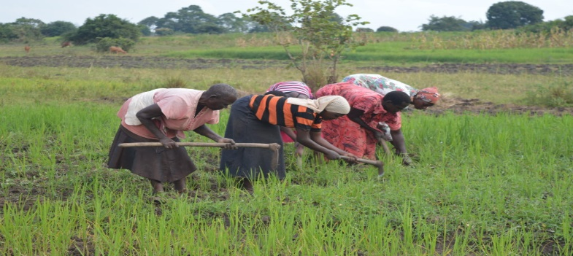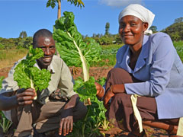
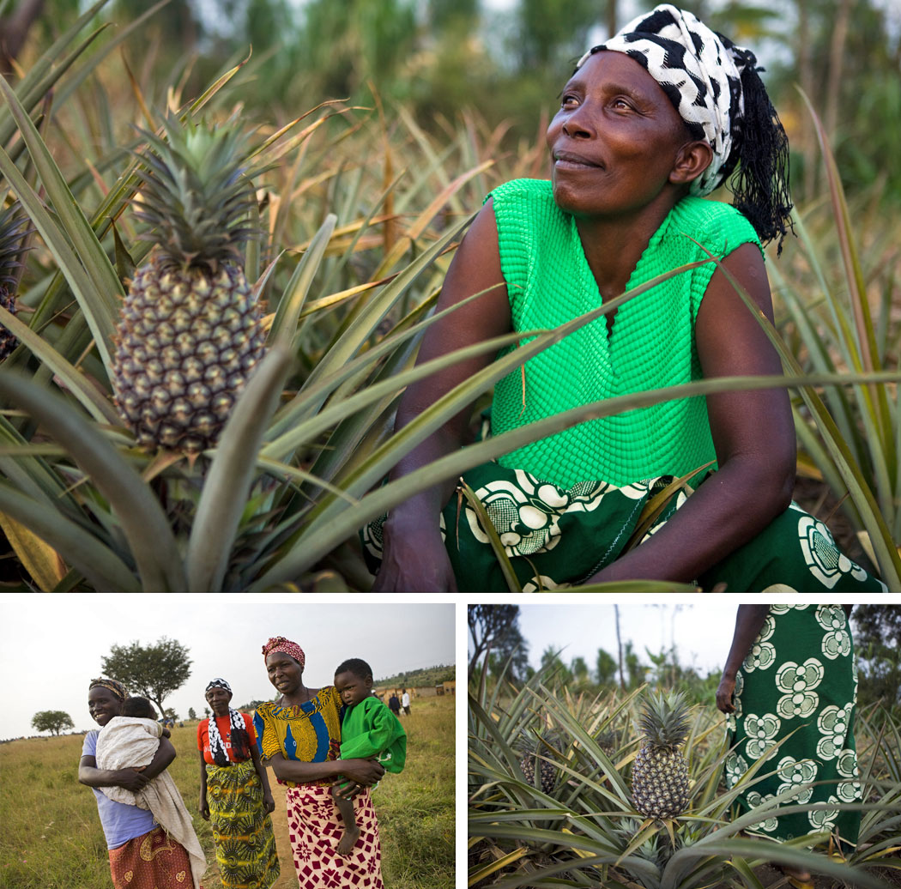
Prepared by John Mwesigwa-Project Leader

