“All I want to do is go outside on my own.”

We all take for granted something so simple as going outside, but Ms. Lina doesn’t. This homeowner’s biggest wish in applying to WARM was having the ability to go outside by herself.

As an 85-year-old widow living alone battling Parkinson’s Disease, she is limited to using her walker. With only steps to enter or exit her home, she is unable to walk alone down steps without fear of falling.

When volunteers arrived from Illinois State University, they were determined to help Ms. Lina. Building a new wheelchair ramp with hand rails and adding grab bars in her tub, it dramatically improved the safety of her home and gave Ms. Lina a new-found confidence she has lost.

Walking side by side down the new ramp for the first time, Ms. Lina and the volunteers started to cry tears of joy. You helped give this special memory they will never forget.
Ms. Lina and the volunteers from Illinois State University
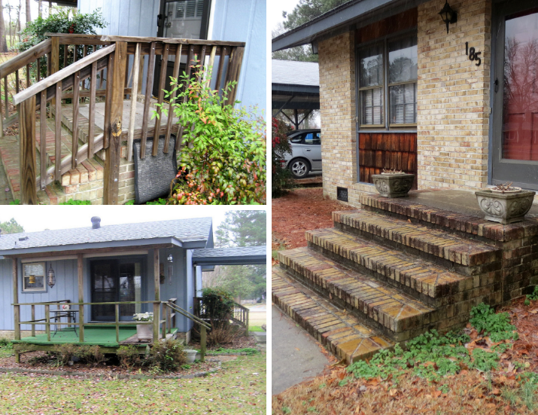
Ms. Lina’s home before the wheelchair ramp

