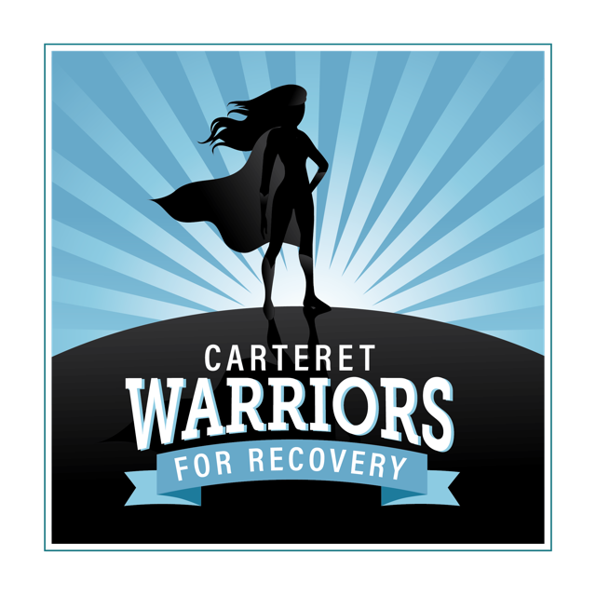

Carteret Warriors for Recovery started with a crazy idea on September 28th, 2018. We had hoped to collect items needed and store until families were able to repair or rebuild and move back into clean and beautiful homes. We had no idea how devastating, widespread and long lasting the process would be. We have since learned that the realistic timeline is projected to be 3-5 years.

Our collection of clothing, supplies, household items and furniture gained momentum and quickly filled a need since the local Salvation Army was a casualty of the storm. Before long, we were getting calls from across the county, the state and out of state. People wanted to help. Churches and businesses rented trailers and headed to our area with truck loads of donations. At first, we packed boxes with clothes and cleaning supplies and included a nice note and usually a gift card. When students were finally able to return to schools, we were called by a friend and extraordinary teacher from East Carteret looking for shoes for a student that couldn’t return to school because he had lost everything and couldn’t find a pair of size 14 shoes. When we put out a call for help, about 6 pair of gigantic shoes appeared! This has truly been a community effort!

To date, Carteret Warriors for Recovery has helped over 400 Families in 6 counties, 3 states. Our focus is to help our neighbors replace essential items lost in the storm. We have had countless community members, businesses and volunteers take part along the way. People ask us all the time what is our “end game”. I honestly don’t think that any of us know. Right now, five months after the storm, we still have people finding damage, living in hotels, worried about where to go. At this point, most people drive around and think everything is “back to normal”. The people we are meeting lately are almost paralyzed due to lack of options. At this point, volunteers have gone back to work, donations have dried up and money has run out.

Our current efforts are focused on helping those in our community that were displaced look forward to moving into a safe home with basic life necessities. We have decided for us, a clean bed is essential.
We have been trying to give bedding and towels, basic household items, a dresser or chest of drawers, a place to eat like a family and a start to a living room. We have worked closely with the Long Term Recovery Alliance, Hope4NC and many churches and schools to identify true “needs” in our area. Several low income housing developments were damaged to the point management sent letters giving residents only a few short days to evacuate with few options for living or storing possessions. Many of these people had small children or were elderly. In the next few months, we are focused on helping in any way we can as these residents are allowed back in.

Currently, we have shifted our priorities to mattresses and box springs, dressers or chests, dining table sets, sofas or loveseats and linens. We have been fundraising and searching for grants or other funding to help purchase these items. We are also accepting great condition used furniture when offered. Volunteers to help sort, distribute and pick up items are always welcome and appreciated. On a few occasions, we have tried to help with clean-up or demo when needed. We always post hours, needs and requests on our CW4R Facebook page.

