Final Project Report
The help 500 families in Zimbabwe affected by Cyclone Idai is a project that is implemented by Hope for a Child in Christ (HOCIC) under global giving online crowd funding platform. To date, the project has assisted 700 girls with sanitary wear, stationery and with the rebuilding of infrastructure such as roads. During the project, HOCIC partnered with Fountain of Hope Foundation and Higher Life Foundation.

In 2019 after the aftermath of the Cyclone, HOCIC partook in the helping of families in Zimbabwe affected by the Cyclone Idai. During the first visit, the program implementers’ objectives were to assess and evaluate the extent of the damage caused by the cyclone, to carry out a needs assessment, to partner with like minded organizations working in the areas to provide psycho-social support, reconstruction of infrastructure such as roads damaged by the cyclone and distribute stationery and clothing to the survivors. The team toured Ngangu area in order to assess the socio economic, environmental and psychological damage caused by the Cyclone. HOCIC and Fountain of Hope Foundation partnered with Higher Life Foundation who had mobilised community volunteers and provided materials to use such as wheelbarrows, shovels, picks and protective clothing to clear the debris and reconstruct the roads using available resources such as rocks and soil. The team also conducted psycho social support and counselling of children and families affected by the cyclone. The trip was fruitful as the team managed to note a number of needs in the area such as ablution facilities for the school, school uniforms, stationery, housing, sanitary ware, essentials for new born babies and psycho-social support for the school going children.
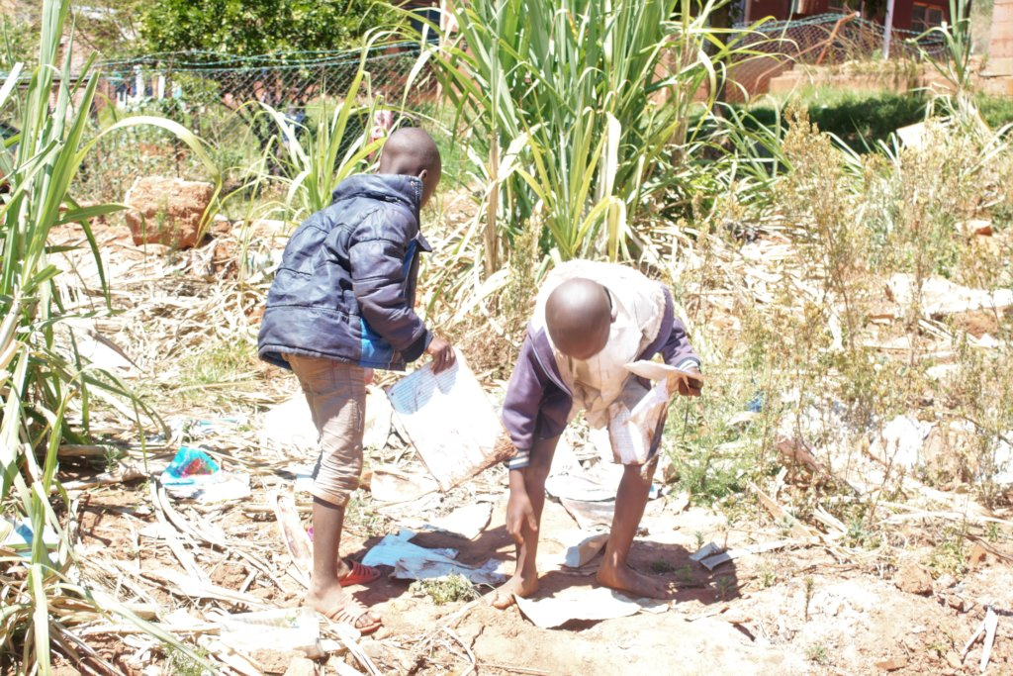
Fig1. Children picking up remains of their books after the disaster
Despite having failed to raise enough funds on the Global Giving platform for the project the team conducted a visit to Chimanimani in mid September 2019. The objectives of the visit were to increase access to sanitary ware that is safe for adolescent girls and young women affected by Cyclone Idai to ensure sustainable menstrual hygiene through the provision of training on the production and management of reusable sanitary pads to adolescent girls and young women and to improve uptake of education through the provision of stationery to children affected by Cyclone Idai. The team managed to distribute one thousand five hundred 32 page exercise books, 1200 pens, 750 book covers, 750 plastic covers 600 sellotapes to 292 children at Tilbury Primary School in ward 12 of Chimanimani District. The team also managed to distribute 400 dignity packs to girls at Chimanimani High school; the dignity pack constituted of packet of 4 reusable sanitary pads, one cotton panty and one face towel. The girls were also trained on menstrual hygiene and how to use reusable sanitary wear.The team found that the district was still in recovery and due to economic challenges in the country the survivors of the disaster were still finding it difficult to put their lives together. Hence HOCIC pledged to continue with the initiative to support families on their recovery.
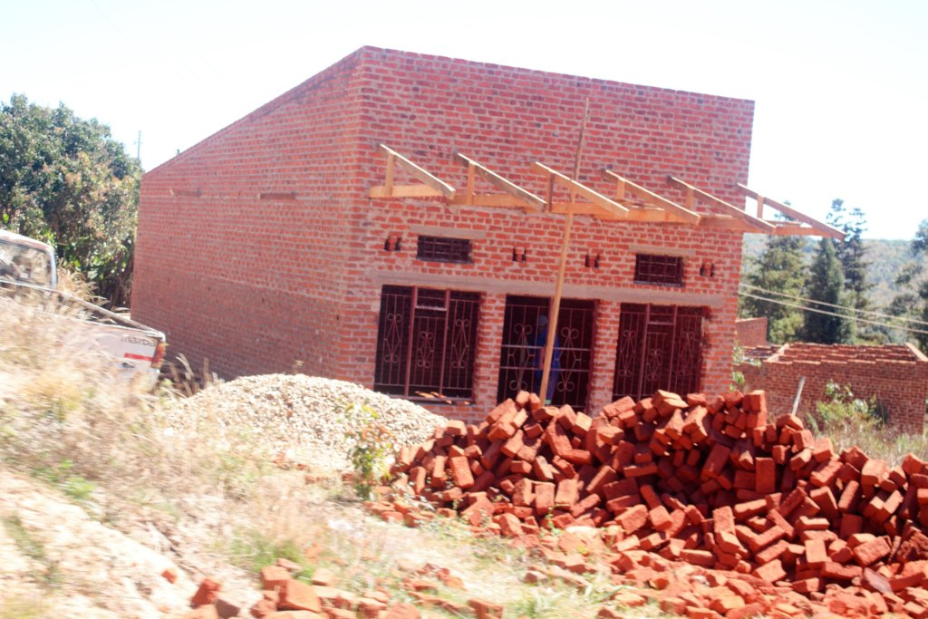
Fig2. Rebuilding of infrastructure in progress in the affected areas.

In the following quarter, the program assistant conducted monitoring visits and calls to the beneficiaries of the reusable sanitary wear and stationery. Feedback received was positive and encouraging. The adolescent girls who received the dignity packs stated that they were now able to attend school even on days when they are on their periods as they have proper panties and sanitary pads that prevent leakage. Leakage during periods causes embarrassment and girls would rather miss school if they do not have proper panties and sanitary wear. This means that girls used to miss out on school and this affected their uptake of the education they received. The girls also stated that the dignity packs helped increase their confidence levels, hence they were enabled to take part in activities at school such as sports, drama and debate. The headmaster at Tilbury primary school, which received the stationery stated that the school attendance during the third term of 2019 was high that the second term and the children participated actively because they all had stationery which enabled them to do their school work properly. He stated that most children at the school were severely affected by the Cyclone. Parents and guardians were struggling to put their lives and homes back together, hence the stationery had helped them a lot. However, the stationery was only enough for the third term of 2019 and a bit of the first term of 2020.
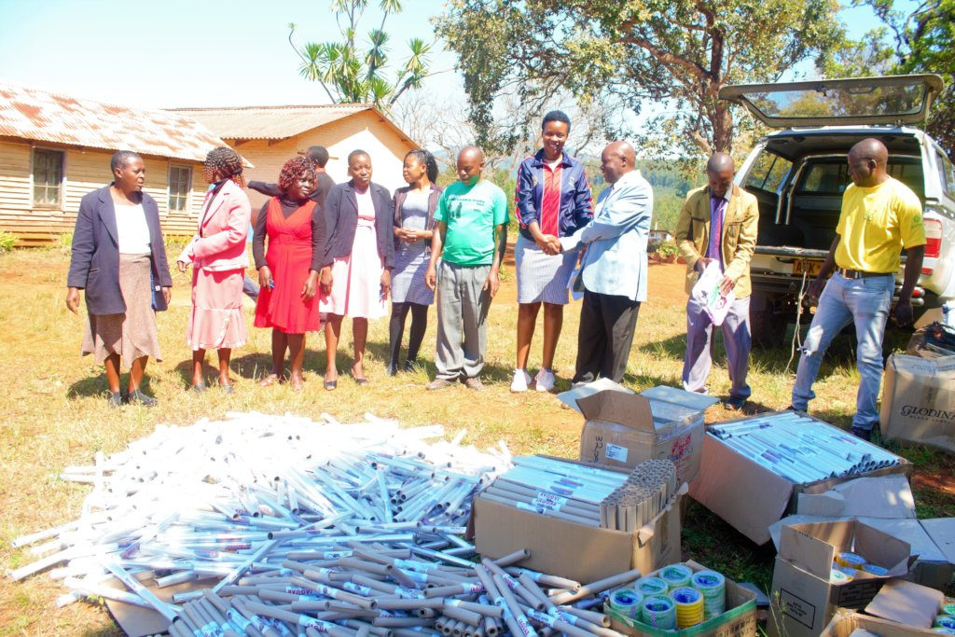
Fig3. Distribution of stationery by HOCIC global giving team at Tilbury Primary School in Chimanimani.
The program was quite fruitful and partly achieved its goals though there were financial hiccups that hindered its progress thus leading to some plans failing to go through for example being able to go for more monitoring visits in Chimanimani to assist the people affected by the cyclone.

HOW THE PROJECT HELPED PEOPLE
- The project helped to improve the psycho social well-being of children as a response to the effects of Cyclone Idai in Chimanimani.
- It ensured sustainable menstrual hygiene through the provision of training on the production and management of reusable sanitary pads to adolescent girls and young women.
- Improved uptake of education through the provision of stationery to children affected by Cyclone Idai.
- Increased access to sanitary ware that is safe for the adolescent girls and young women affected by Cyclone Idai.

CHALLENGES FACED
- The project faced financial challenges which led it to it being discontinued
- The COVID-19 lockdown made it impossible to move around for project members to monitor the program on the ground

