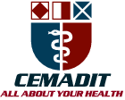
Research Center for Analytic Diagnosis and Imaging Trends (RECEADIT)
School of Health, Biomedical and Computer Sciences (SHBCS)
2021-2022 Academic Year
P.O. Box 19, Belo-Kom, Belo Sub-Division, Boyo Division, Cameroon, North-West Region,
West Africa - Tel: (237) 6 83 41 86 00 or (237) 6 77 68 99 32
CEMADIT@yahoo.com http://www.meditech-group.org

Motto: Health Care Research and Education for Services to Humanity

MEDITECH GROUP
CEMADIT
ALL ABOUT YOUR HEALTH

MEDITECH GROUP
RECEADIT
ALL ABOUT YOUR HEALTH

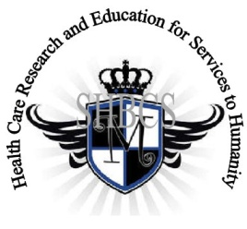

Ministry of Higher Education Ministry of Public Health Registration No. 3342 of August 31, 2011 Registration No. 4042 of August 31, 2011

GlobalGiving RECEADIT Drug Assistance for Internally Displaced People (39386) Project
Twelfth Project Report of Saturday, October 29th, 2022
On behalf of our RECEADIT Humanitarian Team, I take this opportunity to thank you so very much for your generosity and willingness to join us and to partnership with us on our journey of serving humanity through the Guidance, the Blessings, the Love, and the Grace of God Almighty.
We are glad to provide you with the following progress report and updates for our “Drug Assistance for Internally Displaced People Project (39386)” thanks to your generosity:
1) As we indicated in our Eleventh Project Report of Saturday, July 2nd, 2022, we must still point out and emphasize with a lot of regret and frustration that because of the threat posed by Covid -19 and the intensification of the war in the English speaking part of Cameroon where our RECEADIT Clinics at Kitchu, Mbam, Muteff, and Ngemsibo remote rural communities are located, RECEADIT has turned its attention to and its focus on drugs/medication for the Internally Displaced People (This explains why most of the Illustration Photos are about drugs/medication, drug/medication transportation and distribution to Our four Clinics (See First, Second, Third and Fourth Illustration Photos);

2) This Twelfth Project Report still focuses on our continued concern for and the horrible and deplorable living conditions of some of the Internally Displaced People within the Kitchu, Mbam, Muteff, and Ngemsibo rural communities where our RECEADIT Clinics are located (See Fifth, Sixth, Seventh, Eighth, Ninth, Tenth, Eleventh, Twelfth, Thirteenth and Fourteenth Illustration Photos);

3) We are very glad to report that, through the efforts and initiative of our RECEADIT Medical Team at our RECEADIT-GlobalGiving Partnership Community Health Center at Mbam, we now have a New Partnership Program with the Njinikom General Hospital Medical Outreach Team, which is now providing medical services, dental and eye care to patients at our Kitchu, Mbam, Muteff and Ngemsibo, remote, rural Communities where our RECEADIT Clinics are located (See Fifth, Sixth, Seventh, Eighth, Ninth and Tenth Illustration Photos); and

4) We are very glad and proud to report that our four RECEADIT Motor Bikers are doing an excellent job of rushing Internally Displaced People and families to our RECEDIT Clinics at Kitchu, Mbam, Muteff and Ngemsibo for needed, urgent medical treatment (See Fifteenth, Sixteenth, Seventeenth and Eighteenth Illustration Photos)

We will continue to provide you with monthly reports and updates of our other projects, activities, accomplishments, and challenges.
We hope that you will continue with us on this our journey of serving humanity through the Guidance, the Blessings, the Love and the Grace of God Almighty, a journey which has now taken us to this our “Drug Assistance for Internally Displaced People (39386)” through our new link: https://goto.gg/39386

Jilly M. Ngwainmbi, RECEADIT Project Leader

Illustration Photos

First Illustration Photo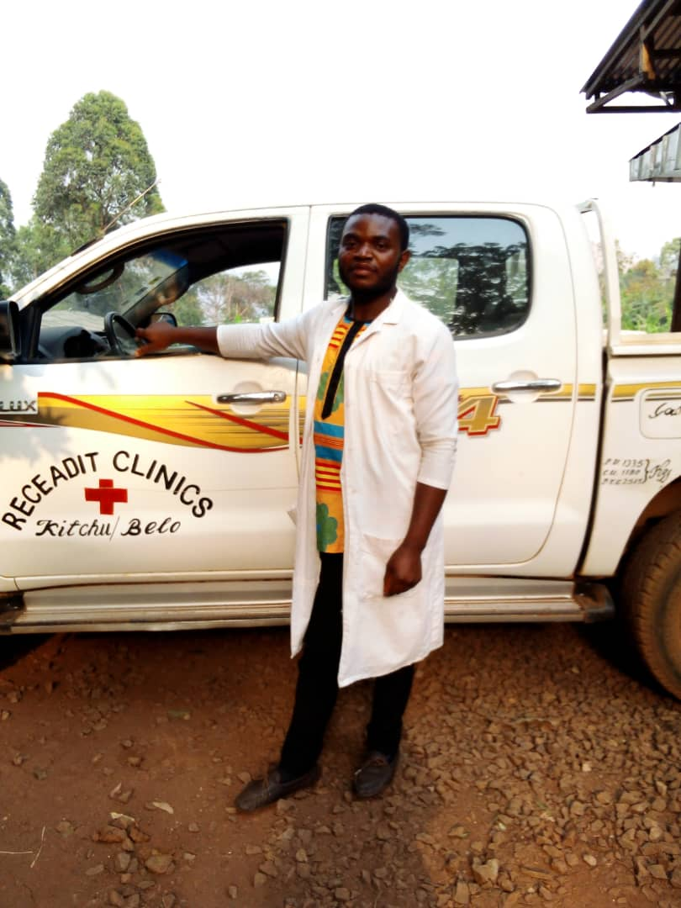
RECEADIT Male Nurse who has just arrived RECEADIT-GlobalGiving Partnership Community Health Center at Mbam from Bamenda City with Drugs and Medical Equipment

Second Illustration Photo

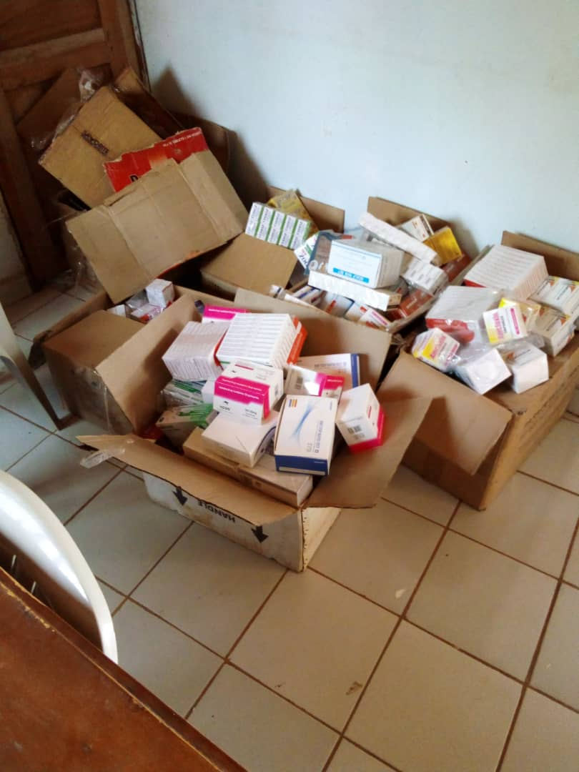

New Stock of Drugs and Medical Equipment at the RECEADIT Central Pharmacy at the RECEADIT-CEMADIT Clinic at Kitchu

Third Illustration Photo

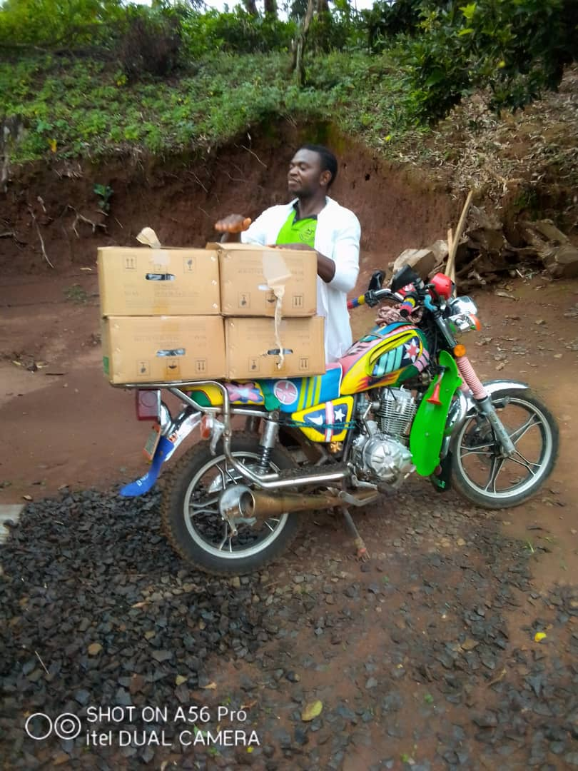
RECEADIT Male nurse at our RECEADIT-GlobalGiving Partnership Community Health Center at Mbam, getting ready to transport Drugs and Medical Equipment to our RECEADIT-GlobalGiving Partnership Community Health Center at Muteff

Fourth Illustration Photo

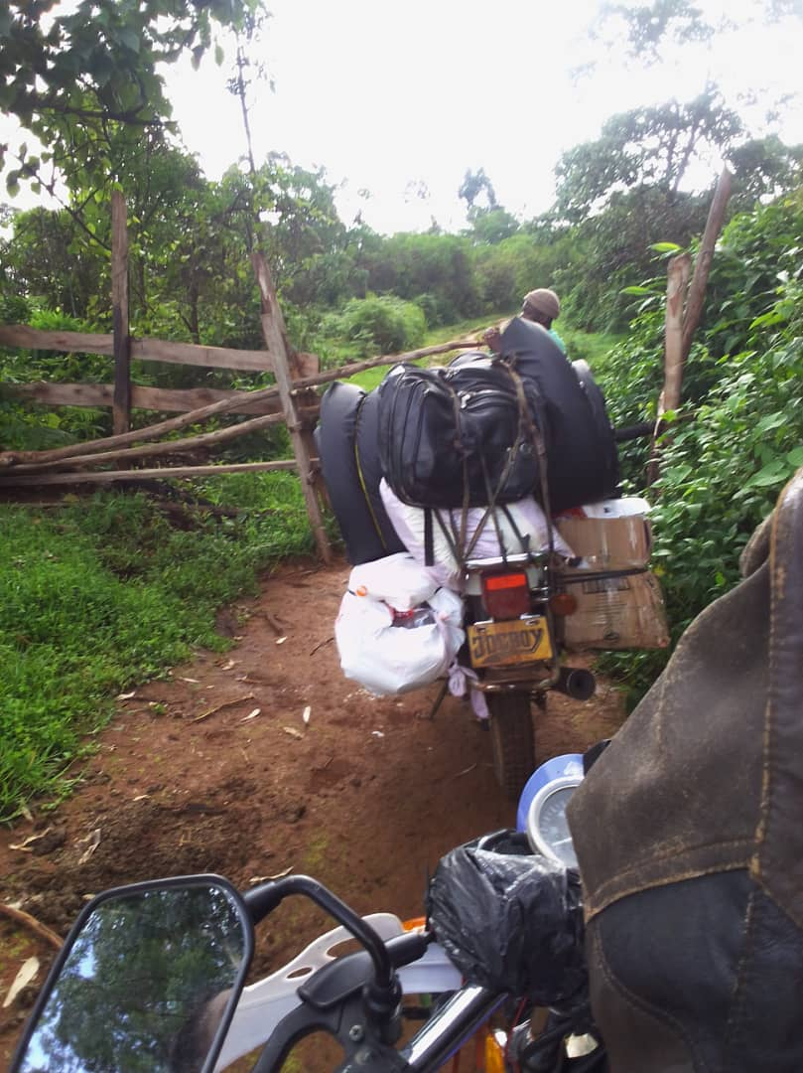
RECEADIT Motor Bikes transporting Medication/Drugs and Medical Equipment from RECEADIT-CEMADIT Kitchu Clinic at Belo to our RECEADIT-GlobalGiving Partnership Clinic at Ngemsibo.

Fifth Illustration Photo

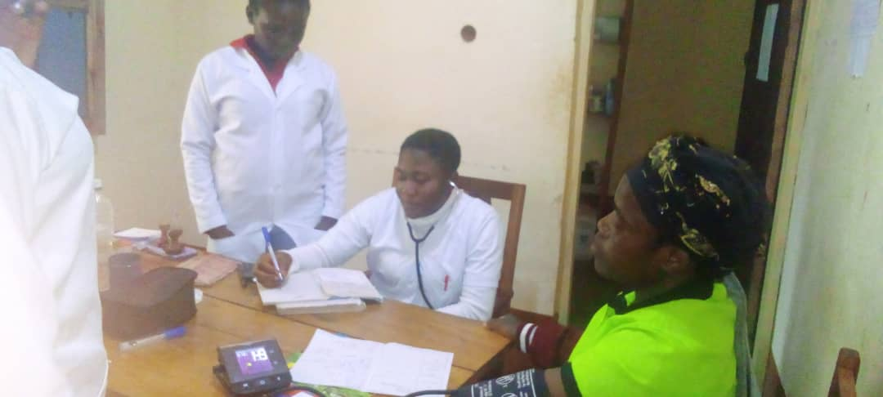

RECEADIT Female Nurse and In-Service training nurses attending to Patients at our RECEADIT-GlobalGiving Partnership Clinic at Ngemsibo.

Sixth Illustration Photo

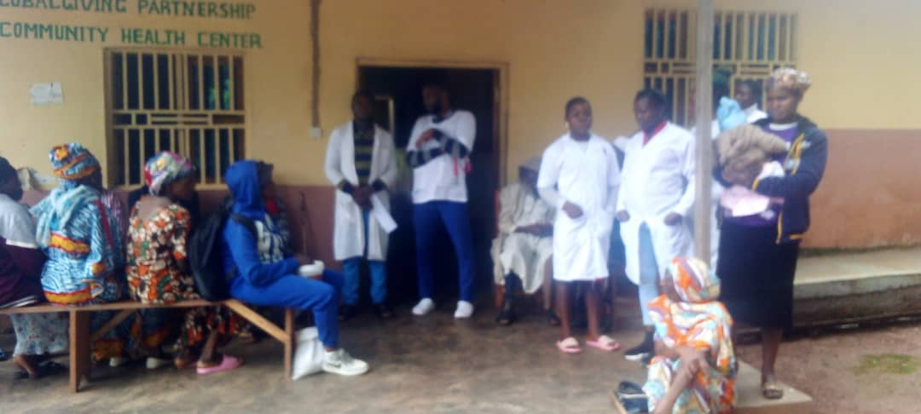

RECEADIT-Njinikom General Hospital New Outreach Program: Medical Doctor, Dentists, Eye specialists and nurses from Njinikom Hospital waiting to start their consultation and treatment of patients at our RECEADIT-GlobalGiving Partnership Community Health Center at Mbam

Seventh Illustration Photo
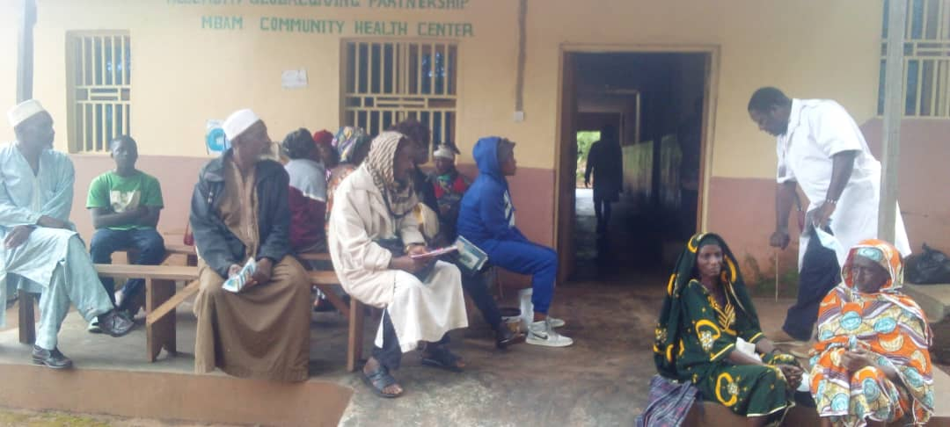
RECEADIT-Njinikom General Hospital New Outreach Program: Medical Doctor from the Njinikom Hospital attending to patients at our RECEADIT-GlobalGiving Partnership Community Health Center at Mbam

Eighth Illustration Photo
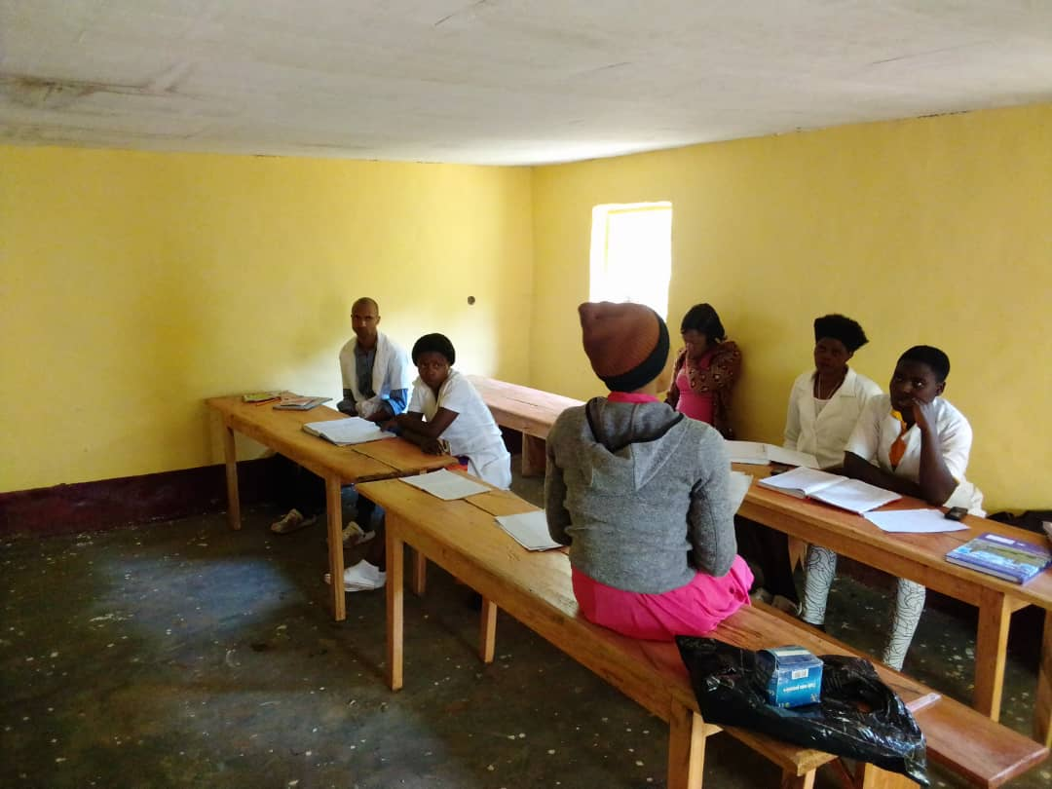
New Students in our RECEADIT New In-Service Training Program at our RECEADIT-GlobalGiving Partnership Community Health Center at Muteff

Ninth Illustration Photo

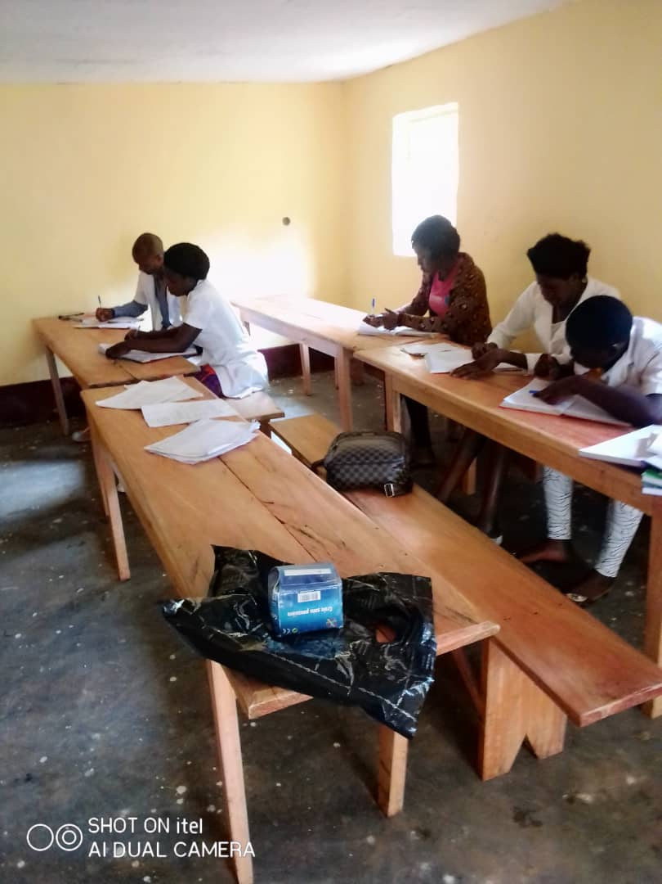

New Students in our RECEADIT New In-Service Training Program at our RECEADIT-GlobalGiving Partnership Community Health Center at Muteff

Tenth Illustration Photo

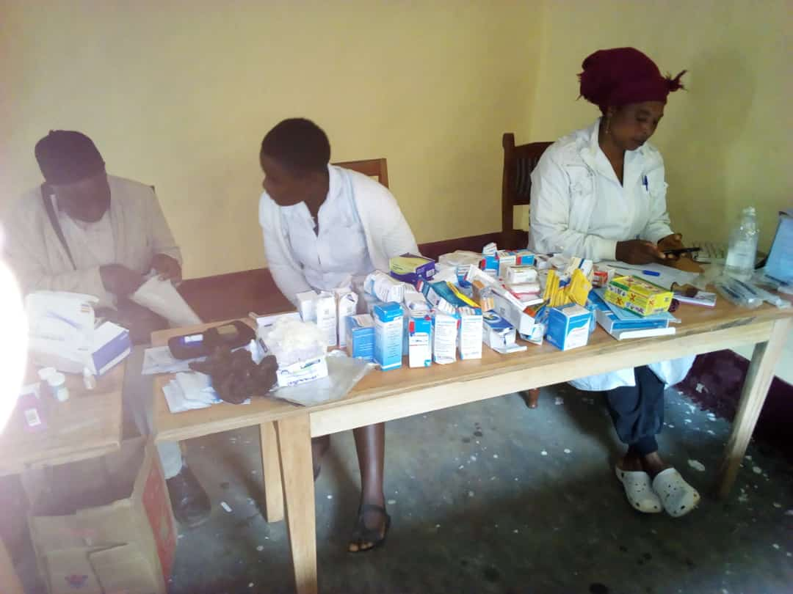

Female Nurses attending to patients after their medical consultations at our RECEADIT GlobalGiving Partnership Community Health Center at Muteff

Eleventh Illustration Photo

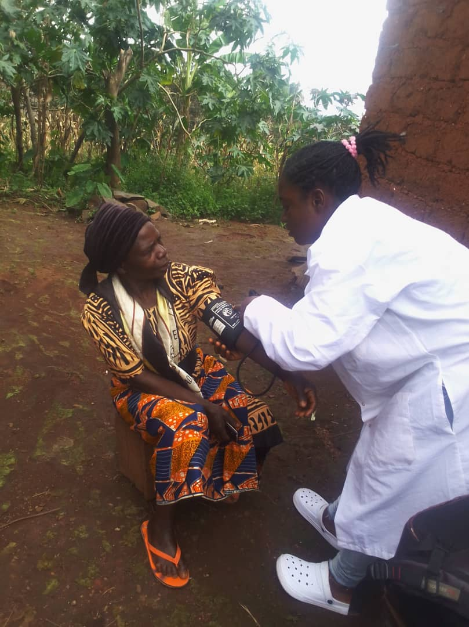

RECEADIT Female Nurse, from our RECEADIT-GlobalGiving Partnership Clinic at Ngemsibo, attending to a patient at home during her Home Visits Program.

Twelfth Illustration Photo

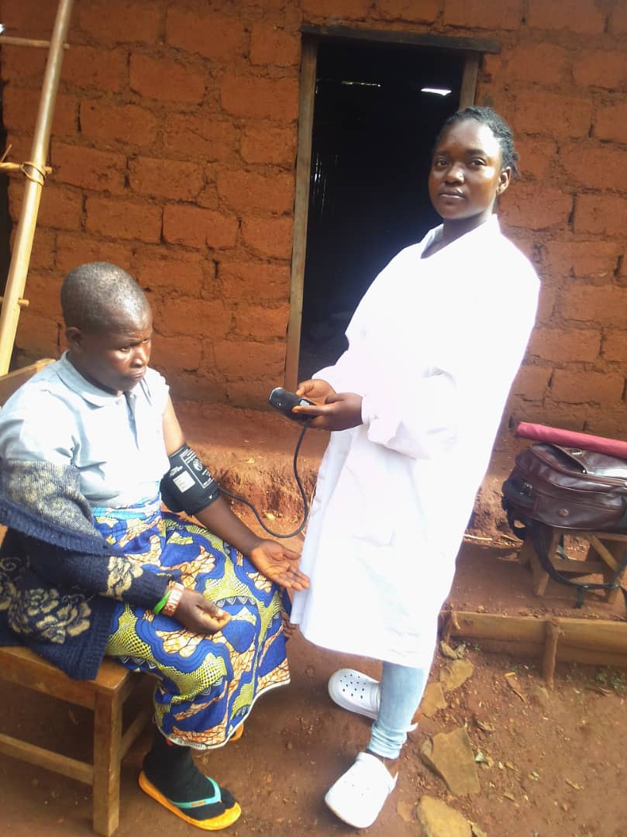
RECEADIT Female Nurse, from our RECEADIT-GlobalGiving Partnership Clinic at Ngemsibo, attending to a patient at home during her Home Visits Program.

Thirteenth Illustration Photo

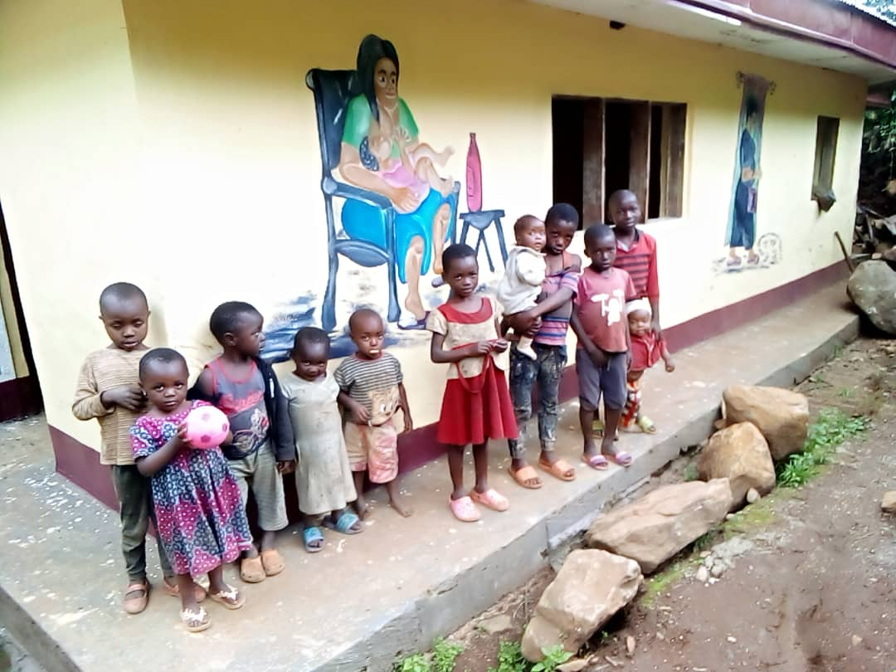

RECEADIT New School Building and Shelter for Internally Displaced People in the Muteff Remote, Rural Community with Children waiting for their vaccination.

Fourteenth Illustration Photo

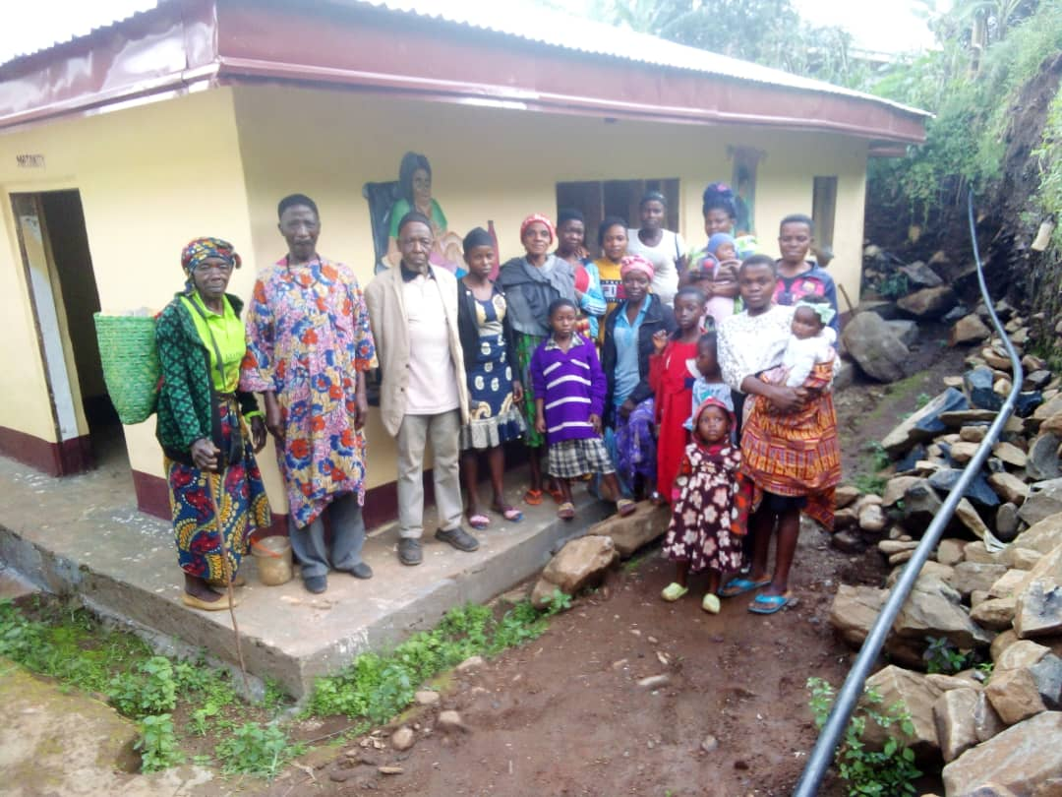

RECEADIT New School Building and Shelter for Internally Displaced People in the Muteff Remote, Rural Community with Community Members after Receiving Medical Services at Our RECEADIT-CEMADIT Community Health Center at Muteff.

Fifteenth Illustration Photo

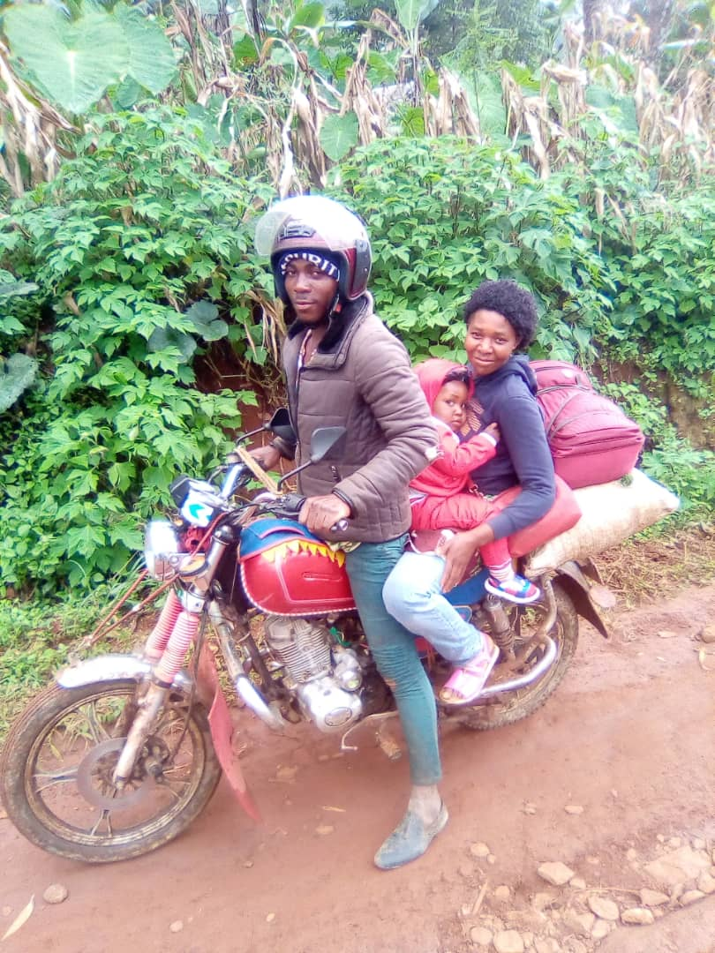

RECEADIT Biker Returning to RECEADIT Mbam Community Health Center with one Internally Displaced Patient and Her Child

Sixteenth Illustration Photo

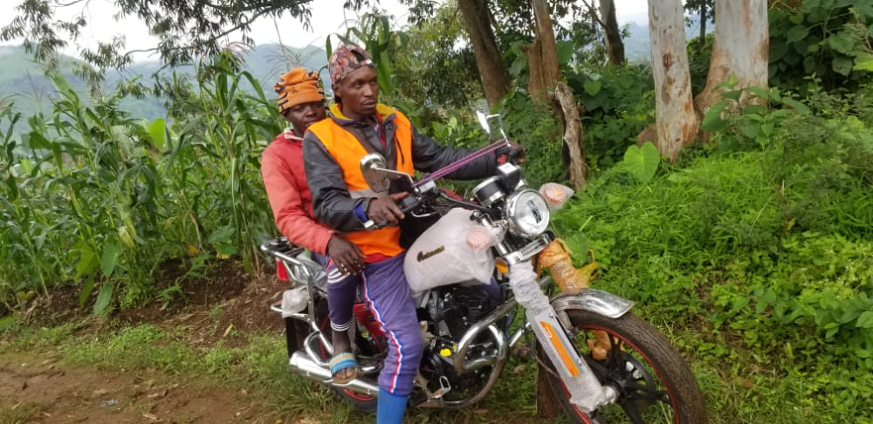

RECEADIT Biker Returning to RECEADIT Mbam Community Health Center with one Internally Displaced Patient

Seventeenth Illustration Photo

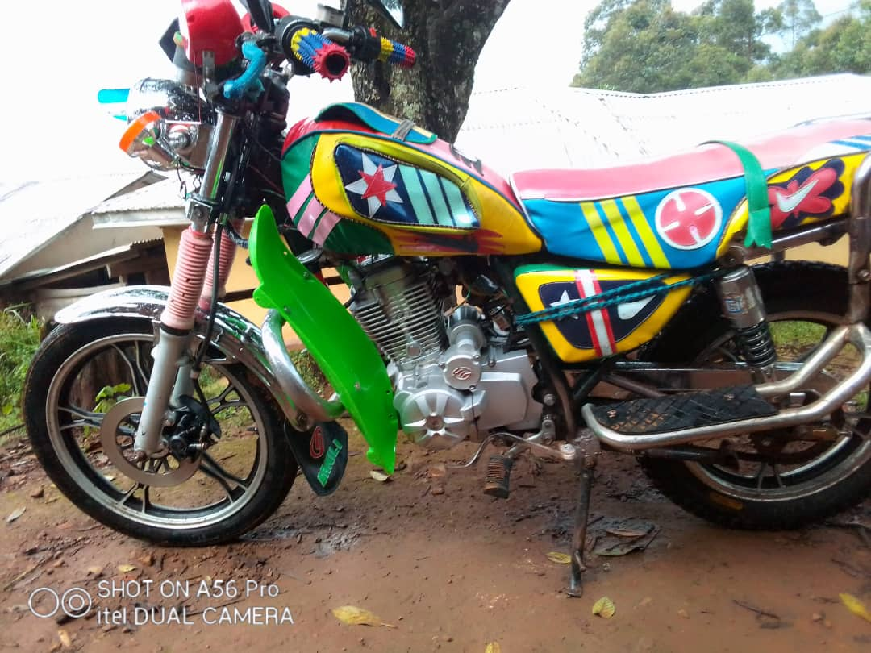

RECEADIT Bike Ready to Go Pick Up Internally Displaced Patients

Eighteenth Illustration Photo

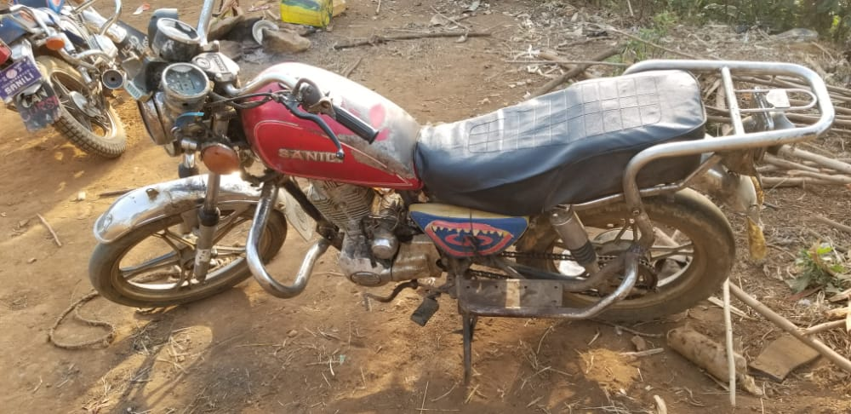
RECEADIT Bike Ready to Go Pick Up Internally Displaced Patients

