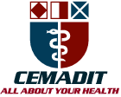
Research Center for Analytic Diagnosis and Imaging Trends (RECEADIT)
School of Health, Biomedical and Computer Sciences (SHBCS)
2022-2023 Academic Year
P.O. Box 19, Belo-Kom, Belo Sub-Division, Boyo Division, Cameroon, North-West Region,
West Africa - Africa - Tel: + 1(910) 261-7785 or +237 6 52 49 78 82 or + (237) 6 77 68 99 32
RECEADIT-CEMADIT Clinic Authorisation no/A/MINSANTE/SG/DOSTS/SDOS/SFSP
CEMADIT@yahoo.com http://www.meditech-group.org

Motto: Health Care Research and Education for Services to Humanity

MEDITECH GROUP
CEMADIT
ALL ABOUT YOUR HEALTH

MEDITECH GROUP
RECEADIT
ALL ABOUT YOUR HEALTH

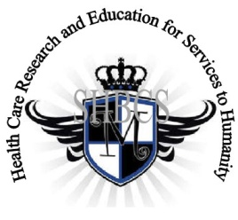

Ministry of Higher Education Ministry of Public Health Registration No. 3342 of August 31, 2011 Registration No. 4042 of August 31, 2011

GlobalGiving RECEADIT Drug Assistance for Internally Displaced People (39386) Project
Thirteenth Project Report of Friday, February 24th, 2023
On behalf of our RECEADIT Humanitarian Team, I take this opportunity to thank you so very much for your generosity and willingness to join us and to partnership with us on our journey of serving humanity through the Guidance, the Blessings, the Love, and the Grace of God Almighty.
We are glad to provide you with the following progress report and updates for our “Drug Assistance for Internally Displaced People Project (39386)” thanks to your generosity:
1) As we indicated in our Twelfth Project Report of Saturday, October 29th, 2022, we must still point out and emphasize with a lot of regret and frustration that because of the threat posed by Covid -19 and the intensification of the war in the English speaking part of Cameroon where our RECEADIT Clinics at Bassamba, Kitchu, Mbam, Muteff, and Ngemsibo remote rural communities are located, RECEADIT has turned its attention to and its focus on drugs/medication for the Internally Displaced People (This explains why most of the Illustration Photos are about drugs/medication, drug/medication transportation and distribution to Our five Clinics (See First, Second, Third, Fourth and fifth Illustration Photos);

2) This our Thirteenth Project Report still focuses on our continued concern for and the horrible and deplorable living conditions of some of the Internally Displaced People within the Bassamba, Kitchu, Mbam, Muteff, and Ngemsibo rural communities where our RECEADIT Clinics are located (See Sixth, Seventh, Eighth, Ninth, Tenth and Eleventh Illustration Photos);

3) We continue to be very glad and proud to report that now our six RECEADIT Motor Bikers are doing an excellent job with our six RECEADIT Bikes of rushing Internally Displaced People and families to our RECEDIT Clinics at Bassamba, Kitchu, Mbam, Muteff and Ngemsibo for needed, urgent medical treatment (See Second, Third, and fifth Illustration Photos);

4) With the increase in mosquitoes and malaria fever between December 2022 and January 2023, our RECEADIT Medical Team had to turn its attention to its RECEADIT Home Visits Program to provide medical assistance to patients within the remote, rural communities of Bassamba, Kitchu, Mbam, Mutef and Ngemsibo where our RECEADIT Clinics are Located (See Sixth, Seventh, Eighth, Ninth, Tenth and Eleventh Illustration Photos); ; and

5) As we reported in our Twelfth Project Report of Saturday, October 29th, 2022, we are still very thankful for the efforts and initiative of our RECEADIT Medical Team at our RECEADIT-GlobalGiving Partnership Community Health Center at Mbam, for our New Partnership Program with the Njinikom General Hospital Medical Outreach Team, which continues to provide medical services, dental and eye care to patients at our Bassamba, Kitchu, Mbam, Muteff and Ngemsibo, remote, rural Communities where our RECEADIT Clinics are located.

We will continue to provide you with monthly reports and updates of our other projects, activities, accomplishments, and challenges.
We hope that you will continue with us on this our journey of serving humanity through the Guidance, the Blessings, the Love and the Grace of God Almighty, a journey which has now taken us to this our “Drug Assistance for Internally Displaced People (39386)” through our new link: https://goto.gg/39386

Jilly M. Ngwainmbi, RECEADIT Project Leader

Illustration Photos

First Illustration Photo
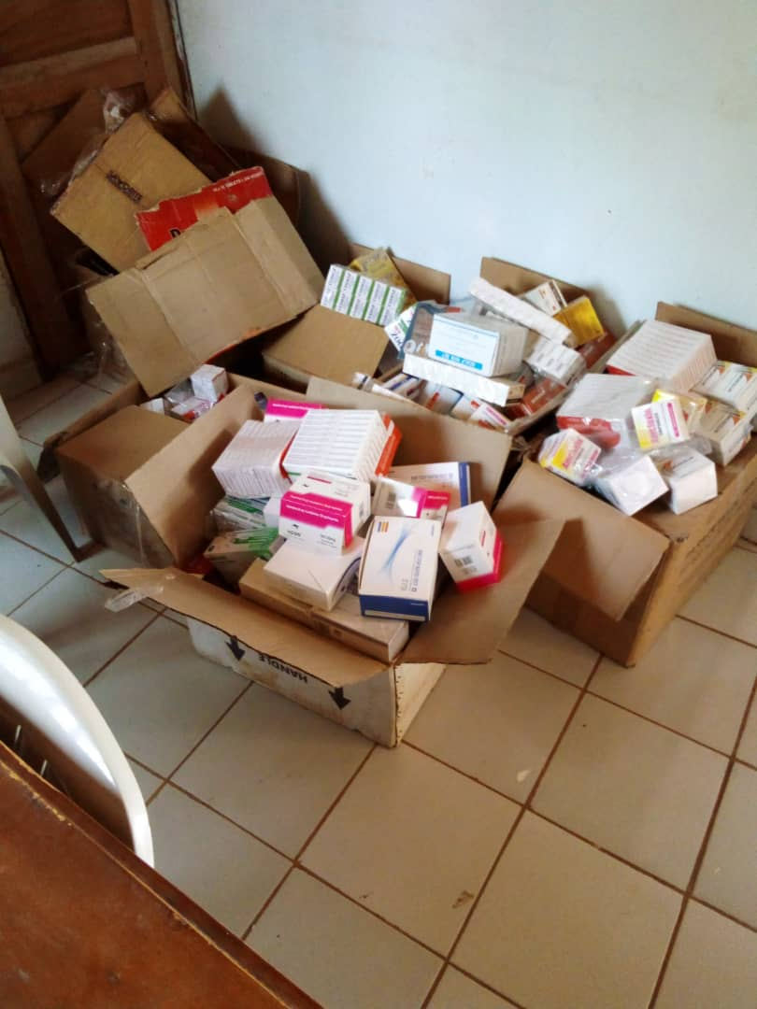
December 2022 New Stock of Drugs and Medical Equipment at the RECEADIT Central Pharmacy at the RECEADIT-CEMADIT Clinic at Kitchu

Second Illustration Photo

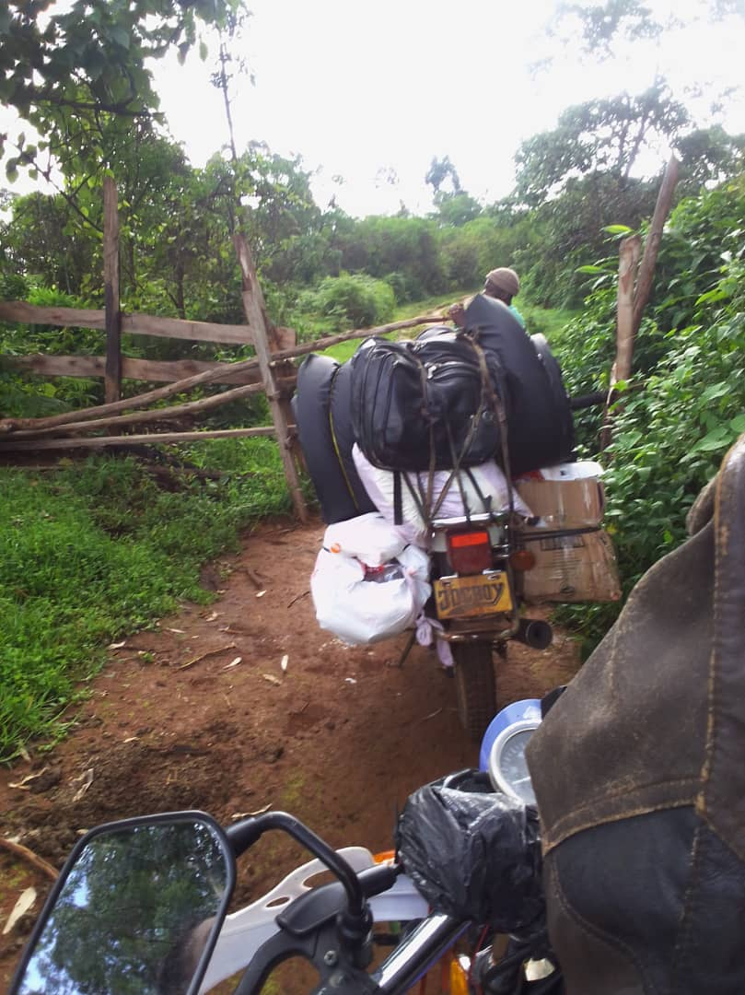
RECEADIT New Motor Bikes transporting Medication/Drugs and Medical Equipment from RECEADIT-CEMADIT Kitchu Clinic at Belo to our RECEADIT-GlobalGiving Partnership Clinic at Ngemsibo on December 28, 2022

Third Illustration Photo

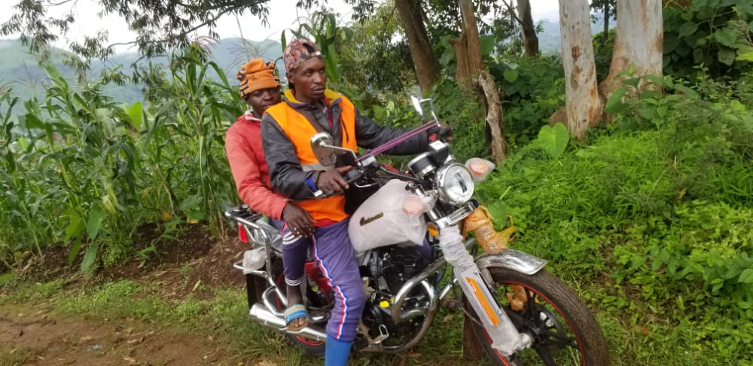

RECEADIT Biker Returning to RECEADIT Kitchu Community Health Center with one Internally Displaced Patient who needs follow up medical care.

Fourth Illustration Photo

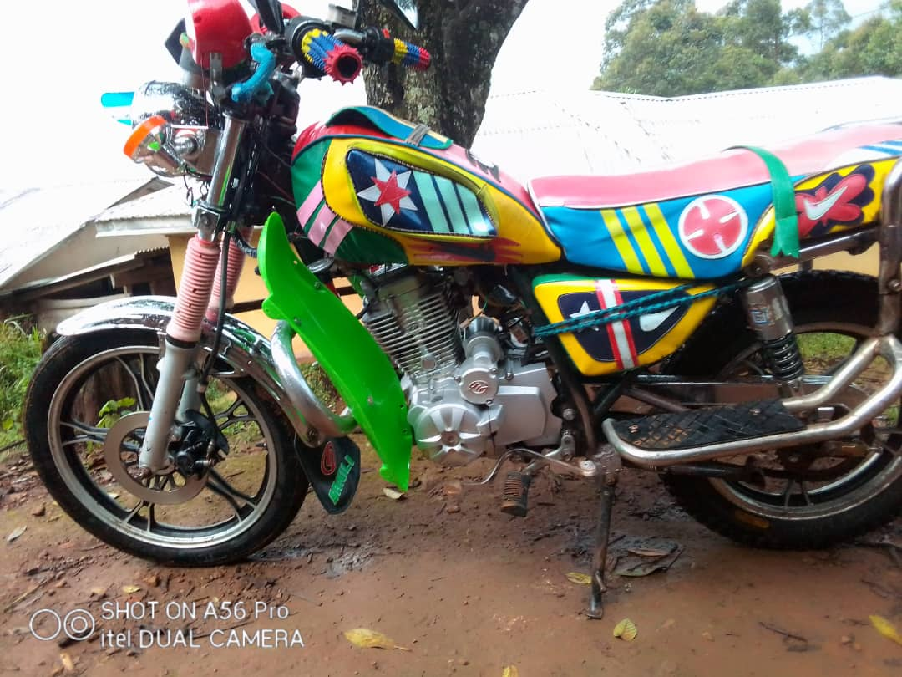

RECEADIT New Bike Ready to Go Pick Up Internally Displaced Patients at Muteff

Fifth Illustration Photo

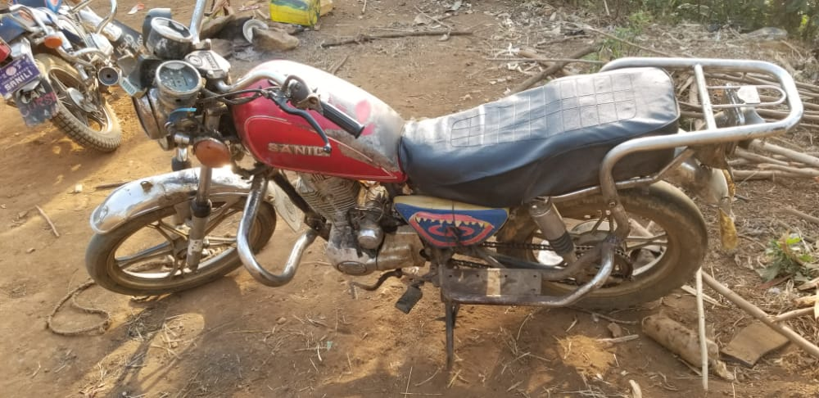

RECEADIT Bike Ready to Go Pick Up Internally Displaced Patients at Muteff

Sixth Illustration Photo

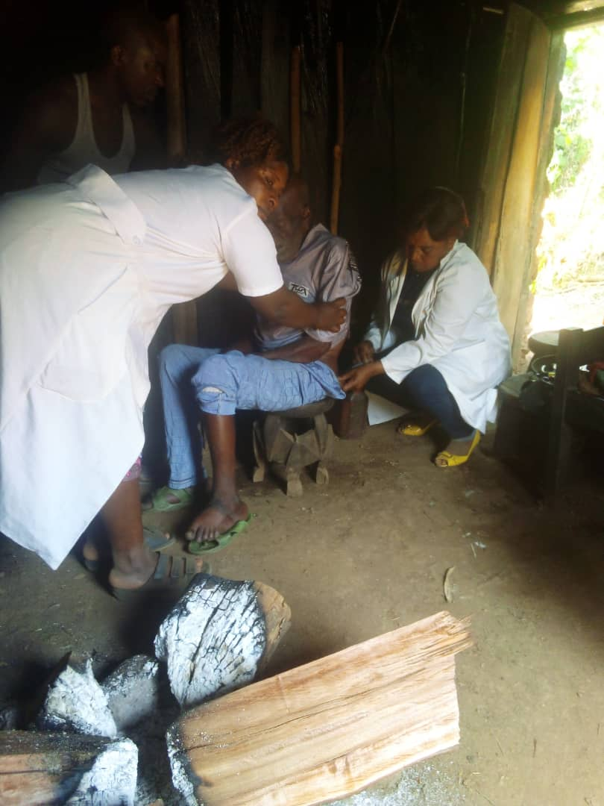
RECEADIT Female Nurses Attending to a Male Patient at the patient’s home during their Home Visits Program at our RECEADIT-GlobalGiving Partnership Community Health Center at Muteff Remote, Rural Community.

Seventh Illustration Photo

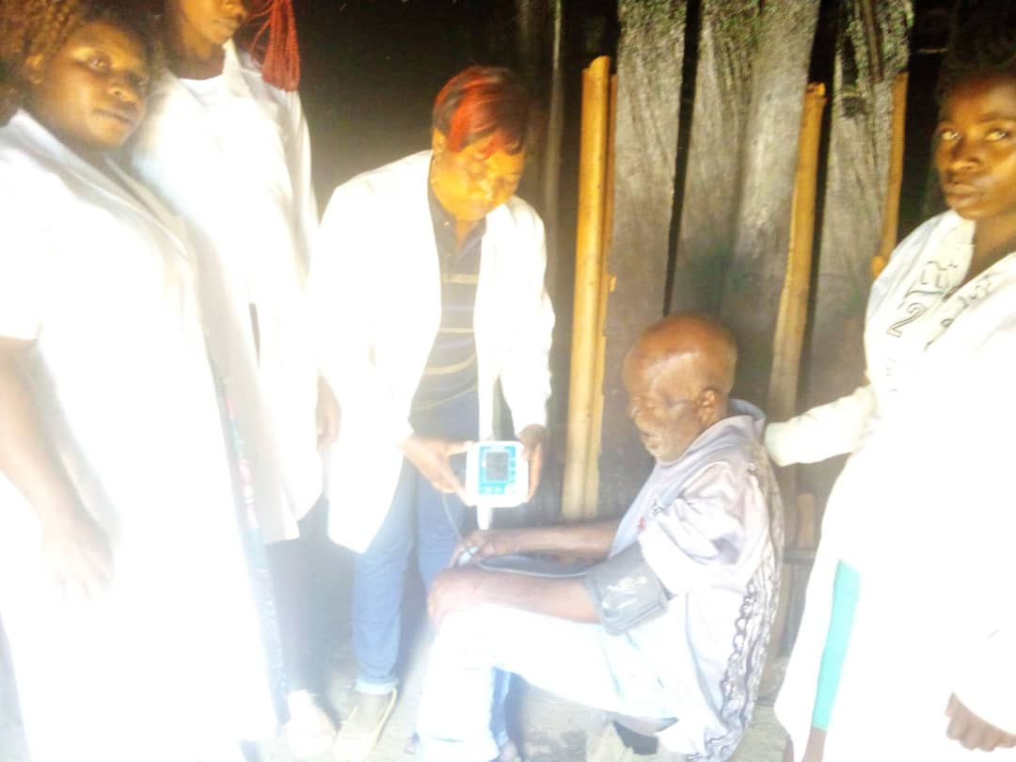

RECEADIT Female Nurses Attending to a Male Patient at the patient’s home during their Home Visits Program at our RECEADIT-GlobalGiving Partnership Community Health Center at Muteff Remote, Rural Community.

Eighth Illustration Photo

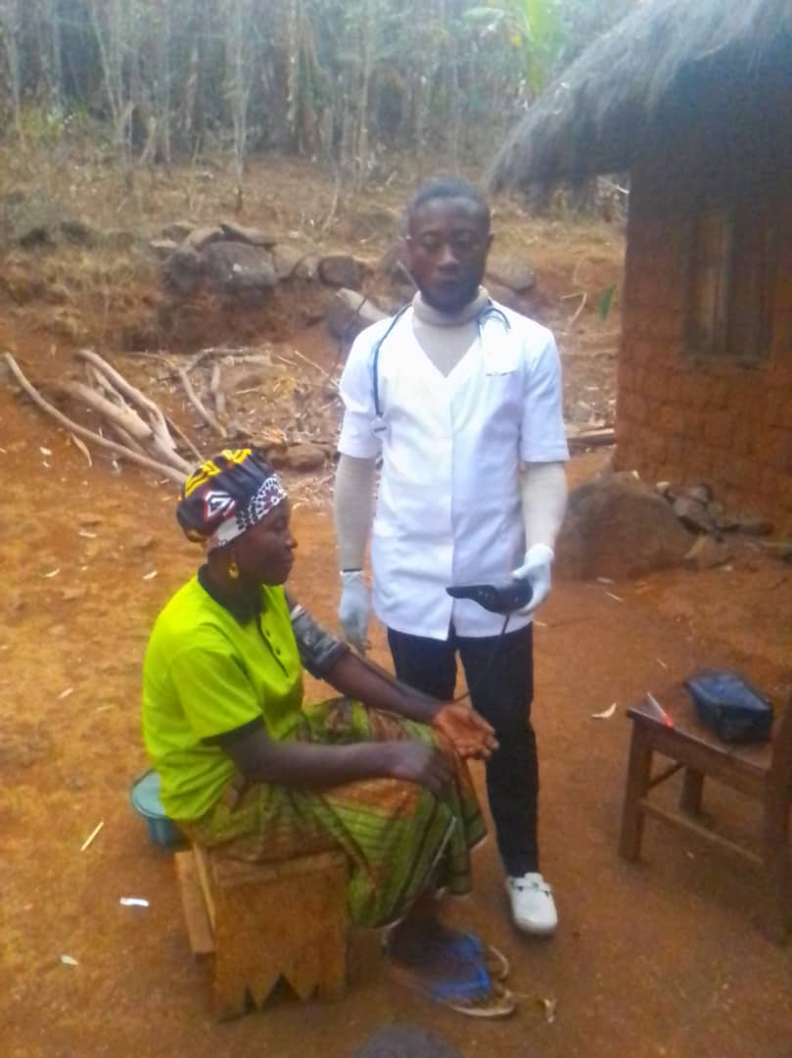
RECEADIT Male Nurse Attending to a Female Patient at the patient’s home during his Home Visits Program at our RECEADIT-GlobalGiving Partnership Clinic at Ngemsibo Remote, Rural Community.

Ninth Illustration Photo

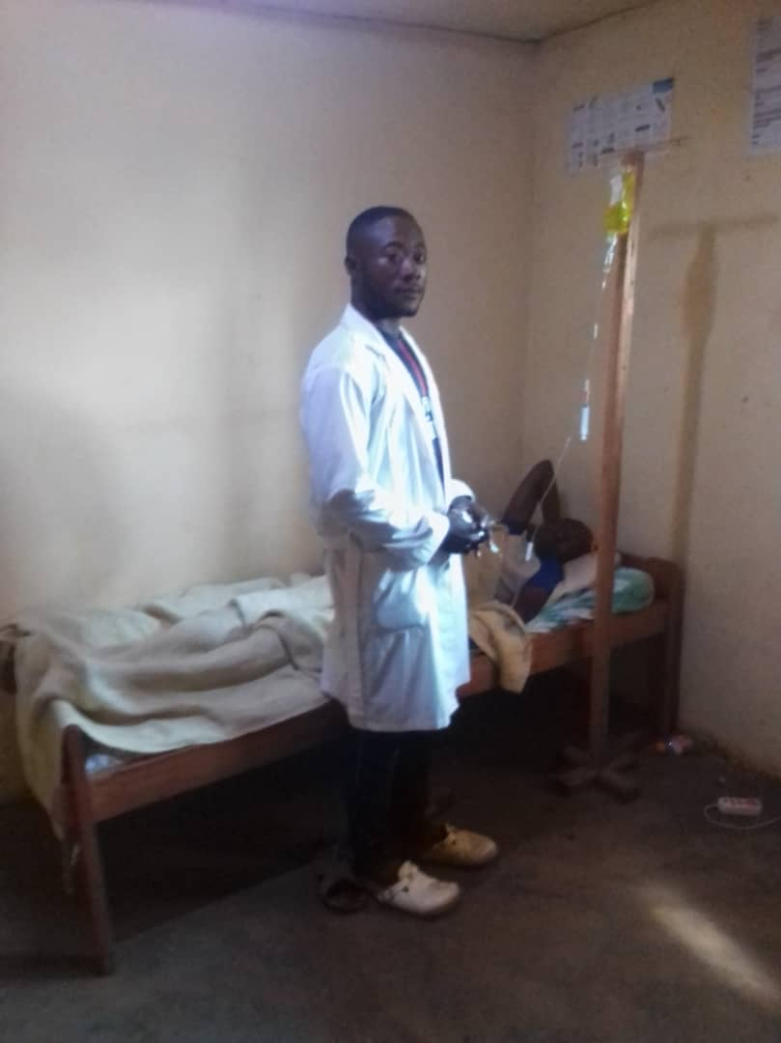
RECEADIT Male Nurse Attending to a Male Patient at the patient’s home during his Home Visits Program at our RECEADIT-GlobalGiving Partnership Clinic at Ngemsibo Remote, Rural Community.

Tenth Illustration Photo

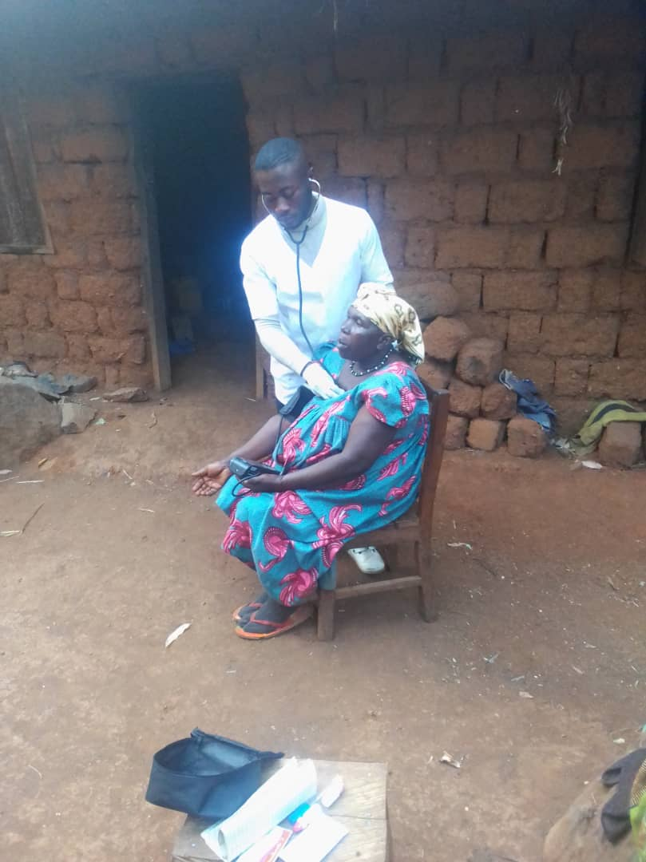
RECEADIT Male Nurse Attending to a female Patient at the patient’s home during his Home Visits Program at our RECEADIT-GlobalGiving Partnership Clinic at Ngemsibo Remote, Rural Community.

Eleventh Illustration Photo

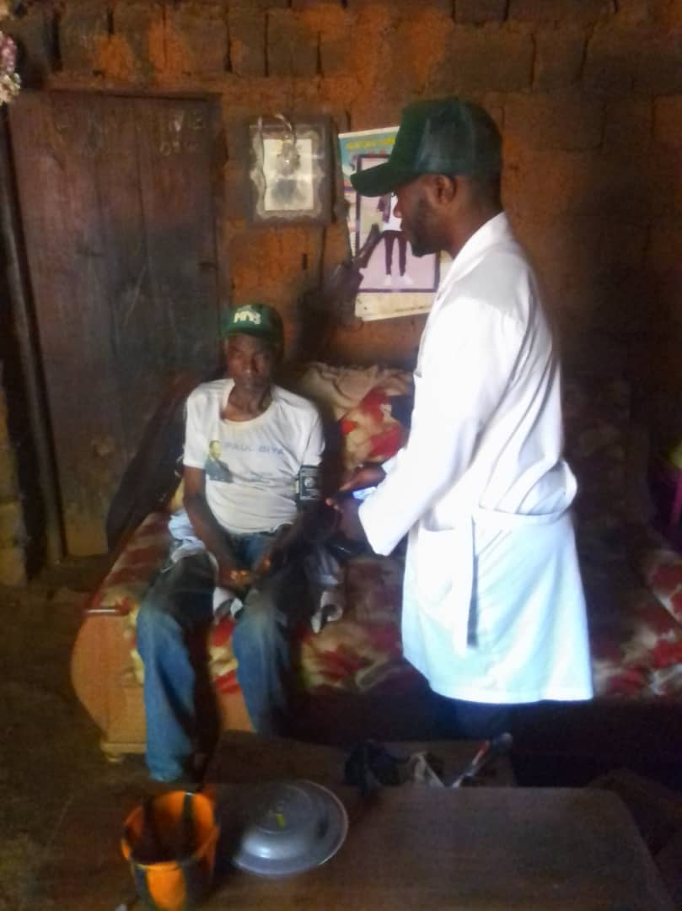
RECEADIT Male Nurse Attending to a male Patient at the patient’s home during his Home Visits Program at our RECEADIT-GlobalGiving Partnership Clinic at Ngemsibo Remote, Rural
Community.

