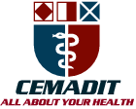
Research Center for Analytic Diagnosis and Imaging Trends (RECEADIT)
School of Health, Biomedical and Computer Sciences (SHBCS)
2022-2023 Academic Year
P.O. Box 19, Belo-Kom, Belo Sub-Division, Boyo Division, Cameroon, North-West Region,
West Africa - Africa - Tel: + 1(910) 261-7785 or +237 6 52 49 78 82 or + (237) 6 77 68 99 32
RECEADIT-CEMADIT Clinic Authorisation no/A/MINSANTE/SG/DOSTS/SDOS/SFSP
CEMADIT@yahoo.com http://www.meditech-group.org

Motto: Health Care Research and Education for Services to Humanity

MEDITECH GROUP
CEMADIT
ALL ABOUT YOUR HEALTH

MEDITECH GROUP
RECEADIT
ALL ABOUT YOUR HEALTH

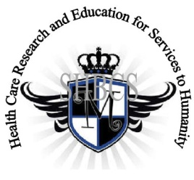

Ministry of Higher Education Ministry of Public Health Registration No. 3342 of August 31, 2011 Registration No. 4042 of August 31, 2011

GlobalGiving RECEADIT Drug Assistance for Internally Displaced People (39386) Project
Fourteenth Project Report of Thursday, June 22nd, 2023
On behalf of our RECEADIT Humanitarian Team, I take this opportunity to thank you so very much for your generosity and willingness to join us and to partnership with us on our journey of serving humanity through the Guidance, the Blessings, the Love, and the Grace of God Almighty.
We are glad to provide you with the following progress report and updates for our “Drug Assistance for Internally Displaced People Project (39386)” thanks to your generosity:
1) As we reported in our Thirteenth Project Report of Friday, February 24th, 2023, we must still point out and emphasize with a lot of regret and frustration that because of the threat posed by Covid -19 and especially the intensification of the war in the English speaking part of Cameroon where our RECEADIT Clinics at Bassamba, Kitchu, Mbam, Muteff, and Ngemsibo remote rural communities are located, RECEADIT has turned its attention to and its focus on drugs/medication for the Internally Displaced People. This explains why most of the Illustration Photos are about drugs/medication, drug/medication transportation and distribution to Our five Clinics (See First, Second, Third and Fourth Illustration Photos);

2) This our Fourteenth Project Report still focuses on our continued concern for and the horrible and deplorable living conditions of some of the Internally Displaced People within the Bassamba, Kitchu, Mbam, Muteff, and Ngemsibo remote, rural communities where our RECEADIT Clinics are located (See Fifth, Sixth, Seventh, Eighth, Ninth and Tenth Illustration Photos);

3) We continue to face a major challenge posed by the deplorable conditions of some of our Internally Displaced People, especially in the Muteff remote, rural community. We are glad and very proud of our six RECEADIT Motor Bikers who continue to do an excellent job with our six RECEADIT Bikes by transporting our nurses to the various locations where our Internally Displaced People are located so that they can provide them medical treatment and food assistance (See Fifth Illustration Photo);

4) With the difficult and challenging conditions of our Internally Displaced People, especially in the Ngemsibo remote, rural community where our RECEADIT-GlobalGiving Partnership Community Health Center is located, we have decided to build a new structure, designed specifically for: a) The provision of lodging and accommodation for our Internally Displaced People and our medical workers; and b) Our Clinic Canteen/Food Store, designed to provide our medical workers and our Internally Displaced People food and other needed items (See Ninth Illustration Photo); and

5) As we reported in our Thirteenth Project Report of Friday, February 24th, 2023, we continue to be very thankful for the efforts and initiative of our RECEADIT Medical Team at our RECEADIT-GlobalGiving Partnership Community Health Center at Mbam, for our New Partnership Program with the Njinikom General Hospital Medical Outreach Team, which continues to provide medical services, dental and eye care to patients at our Bassamba, Kitchu, Mbam, Muteff and Ngemsibo, remote, rural Communities where our RECEADIT Clinics are located.

We will continue to provide you with monthly reports and updates of our other projects, activities, accomplishments, and challenges.
We hope that you will continue with us on this our journey of serving humanity through the Guidance, the Blessings, the Love and the Grace of God Almighty, a journey which has now taken us to this our “Drug Assistance for Internally Displaced People (39386)” through our new link: https://goto.gg/39386

Jilly M. Ngwainmbi, RECEADIT Project Leader

Illustration Photos

First Illustration Photo

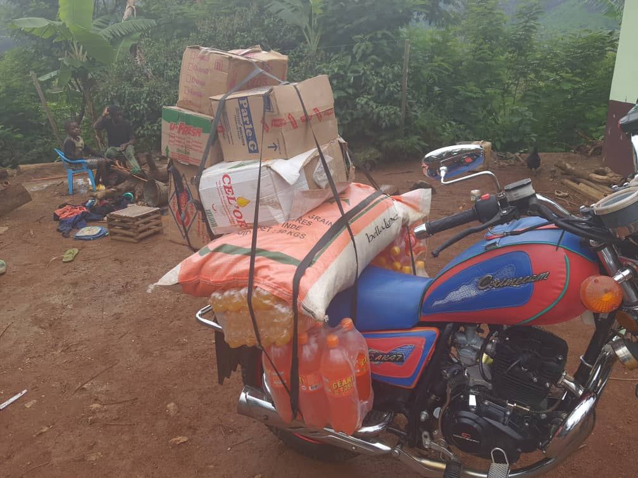

Our New RECEADIT Bike loaded with Drugs, Food Items, Medical Equipment at the RECEADIT Central Pharmacy at the RECEADIT-CEMADIT Clinic at Kitchu, ready to take these items to Our RECEADIT-GlobalGiving Partnership Clinic at Ngemsibo Remote, Rural Community.

Second Illustration Photo

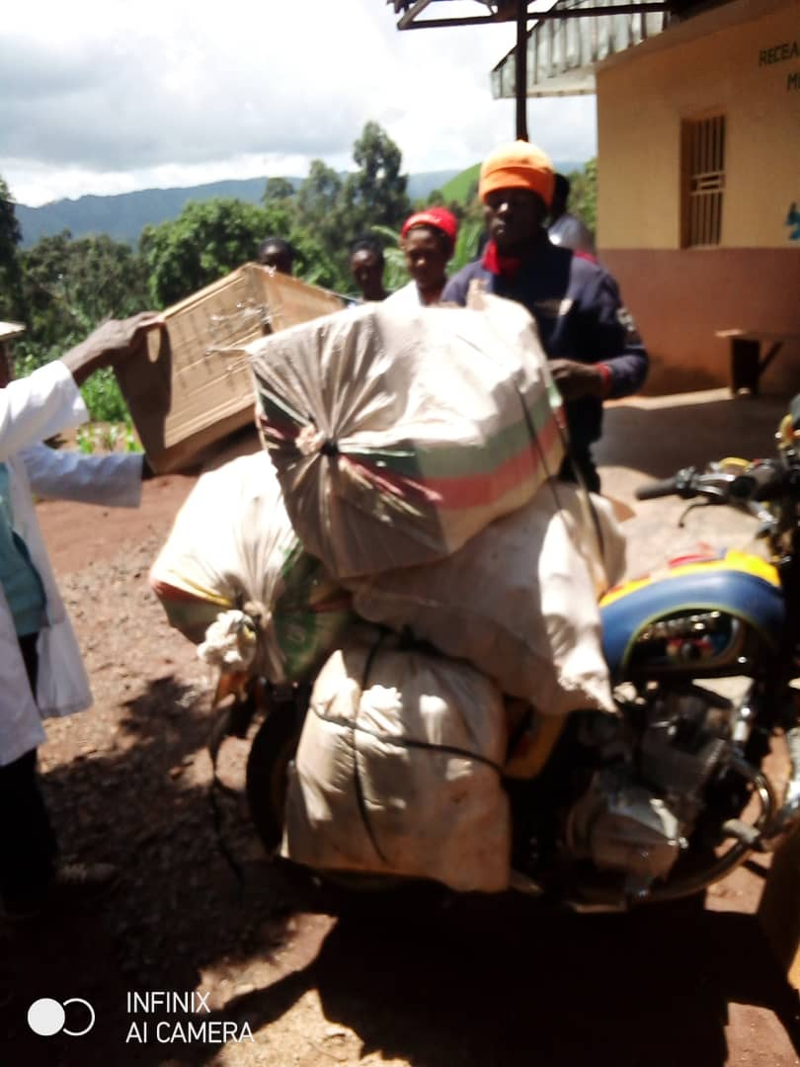

RECEADIT New Motor Bike transporting Medication/Drugs and Medical Equipment from RECEADIT-CEMADIT Kitchu Clinic at Belo to our RECEADIT-GlobalGiving Partnership Clinic at Mbam on May 30, 2023

Third Illustration Photo

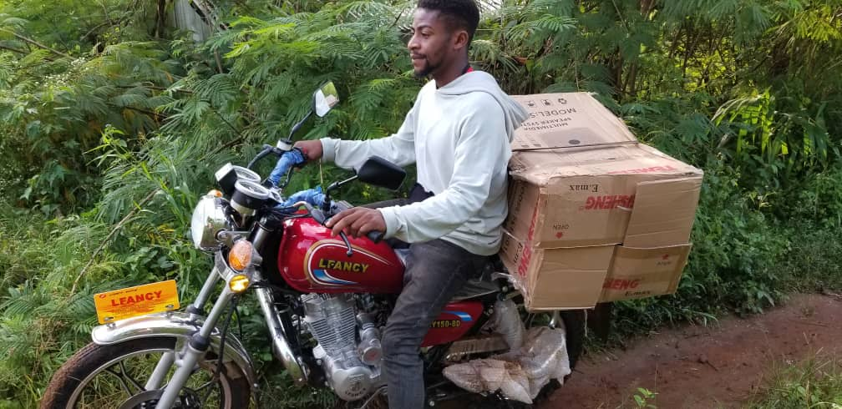
RECEADIT Biker Transporting Drugs/Medication from Our RECEADIT-GlobalGiving Partnership Community Health Center at Mbam to Our RECEADIT-GlobalGiving Partnership Health Center at Muteff.

Fourth Illustration Photo

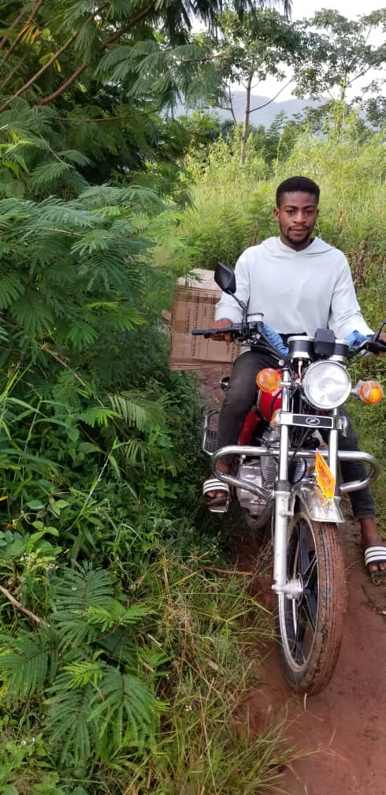

RECEADIT Biker Transporting Drugs/Medication from Our Central Pharmacy at Our RECEADIT-GlobalGiving Partnership Community Health Center at Kitchu to Our RECEADIT-GlobalGiving Partnership RECEADIT’s CEMADIT Clinic Annex at Bassamba.

Fifth Illustration Photo

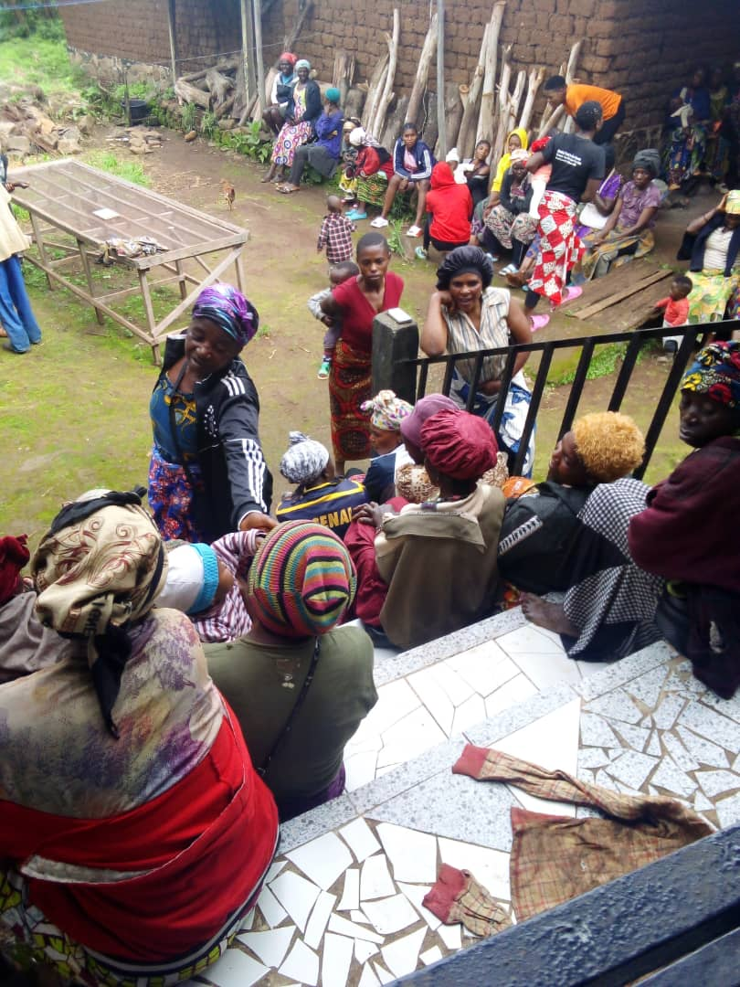

Our Internally Displaced People within the Muteff Remote, Rural Community where Our RECEADIT-GlobalGiving Health Center is located, waiting for medical examination and food assistance from our RECEADIT Medical Team at Muteff

Sixth Illustration Photo

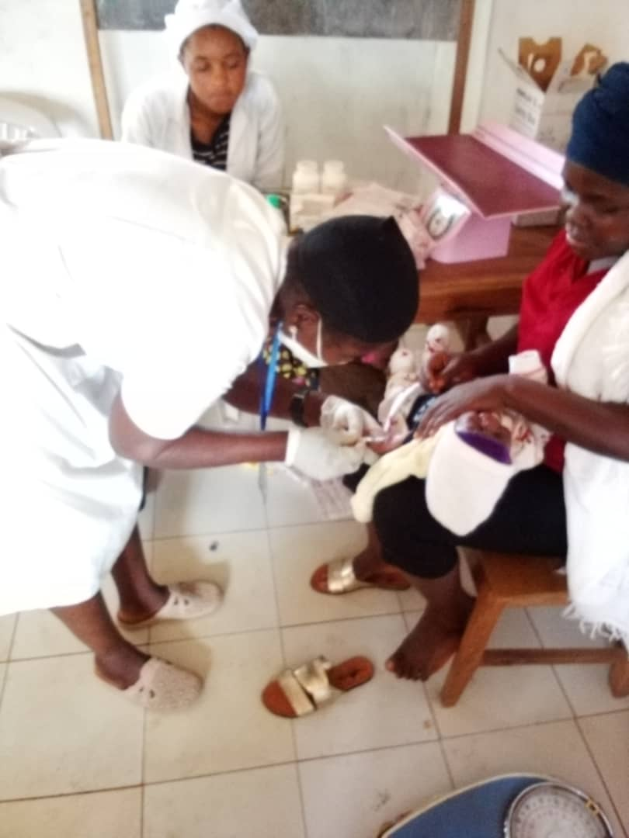

RECEADIT Female Nurses Vaccinating Children at Our RECEADIT-GlobalGiving Partnership Community Health Center at Ngemsibo remote, rural Community.

Seventh Illustration Photo

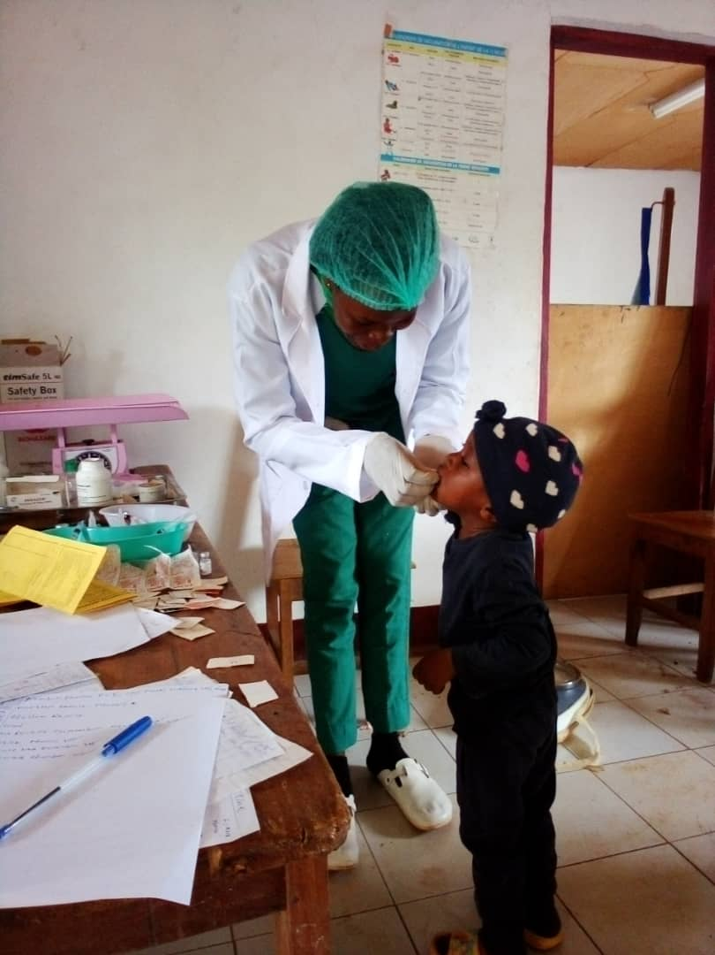

RECEADIT Female Nurse Attending to a Child immediately after her vaccination at Our RECEADIT-GlobalGiving Partnership Community Health Center at Kitchu, Belo.

Eighth Illustration Photo

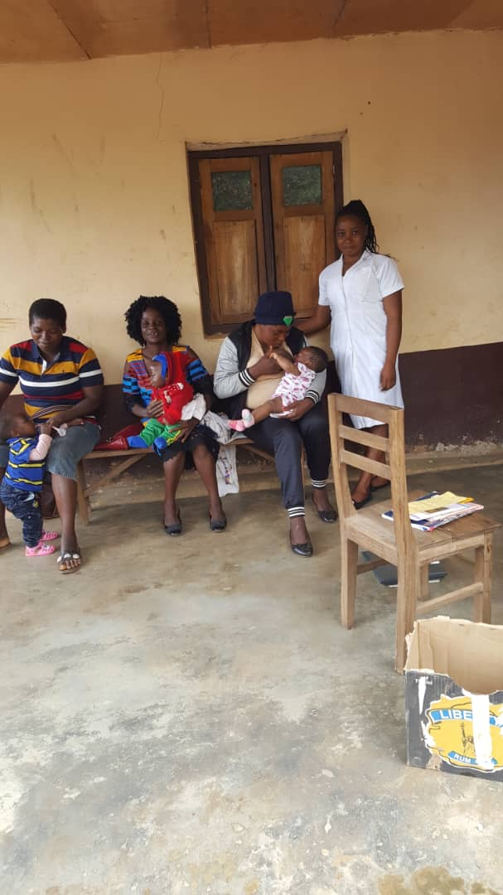
RECEADIT Female Nurse Ready to start vaccinating Children at our RECEADIT-GlobalGiving Partnership Community Health Center at Ngemsibo Remote, Rural Community on Tuesday, March 28, 2023.

Ninth Illustration Photo

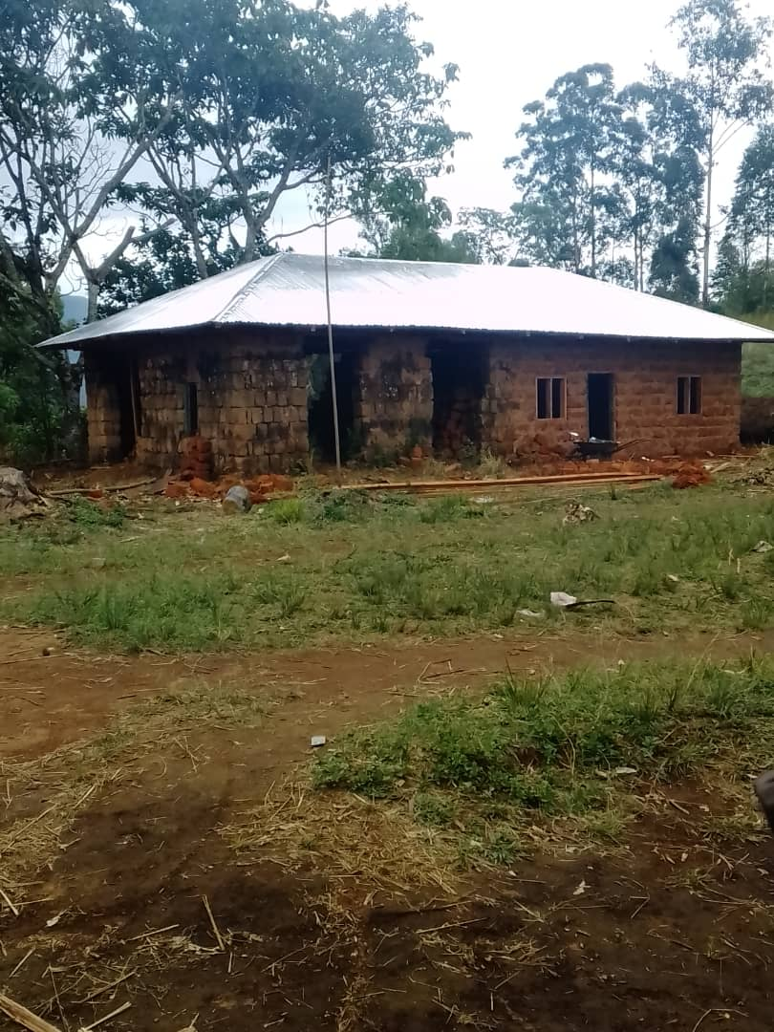

RECEADIT New Building under Construction for the lodging of the Internally Displaced People, RECEADIT Medical workers, Clinic Canteen and Food Store for both the Ngemsibo Community members and our Clinic medical Workers

Tenth Illustration Photo
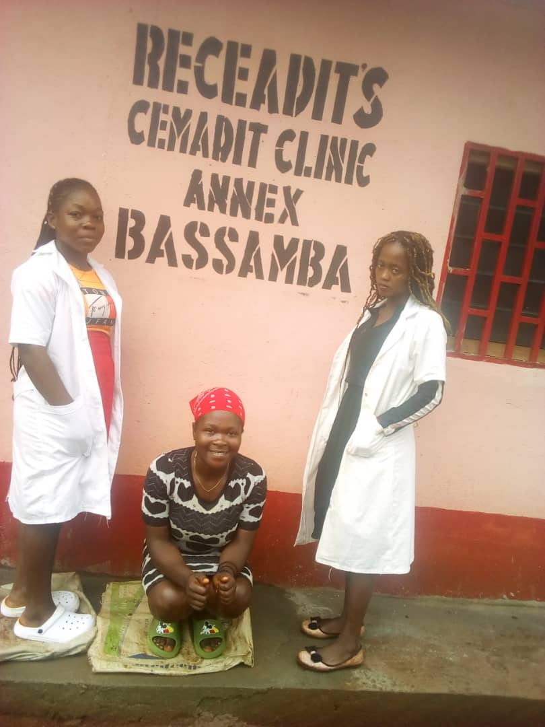

RECEADIT Two Female Nurses With one of their Internally Displaced Peoples who has just received medical treatment and has fully recovered at our RECEADIT’s CEMADIT Clinic Annex-at Bassamba Remote, Rural Community.

