Research Center for Analytic Diagnosis and Imaging Trends (RECEADIT)
School of Health, Biomedical and Computer Sciences (SHBCS)
2021-2022 Academic Year
P.O. Box 19, Belo-Kom, Belo Sub-Division, Boyo Division, Cameroon, North-West Region,
West Africa - Tel: (237) 6 83 41 86 00 or (237) 6 77 68 99 32
CEMADIT@yahoo.com http://www.meditech-group.org

Motto: Health Care Research and Education for Services to Humanity

MEDITECH GROUP
CEMADIT
ALL ABOUT YOUR HEALTH

MEDITECH GROUP
RECEADIT
ALL ABOUT YOUR HEALTH

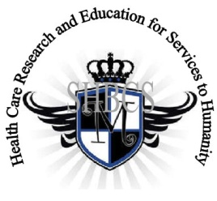

Ministry of Higher Education Ministry of Public Health Registration No. 3342 of August 31, 2011 Registration No. 4042 of August 31, 2011

GlobalGiving RECEADIT Drug Assistance for Internally Displaced People (39386) Project
Eleventh Project Report of Saturday, June 2nd, 2022
On behalf of our RECEADIT Humanitarian Team, I take this opportunity to thank you so very much for your generosity and willingness to join us and to partnership with us on our journey of serving humanity through the Guidance, the Blessings, the Love, and the Grace of God Almighty.
We are glad to provide you with the following progress report and updates for our “Drug Assistance for Internally Displaced People Project (39386)” thanks to your generosity:
1) As we indicated in our Tenth Project Report of Monday, March 8th, 2022, we must still point out and emphasize with a lot of regret and frustration that because of the threat posed by Covid -19 and the intensification of the war in the English speaking part of Cameroon where our RECEADIT Clinics at Kitchu, Mbam, Muteff, and Ngemsibo rural communities are located, RECEADIT has turned its attention to and its focus on drugs/medication for the Internally Displaced People (This explains why most of the Illustration Photos are about drugs/medication, drug/medication transportation and distribution to Our four Clinics (See First, Second, and Third Illustration Photos);

2) This Eleventh Project Report focuses on our continued concern for and the horrible and deplorable living conditions of some of the Internally Displaced People within the Kitchu, Mbam, Muteff, and Ngemsibo rural communities where our RECEADIT Clinics are located (See Fourth, Fifth and Sixth Illustration Photos).

3) As a result of another threat to our Internally Displaced People stemming from mosquitoes and malaria fever, Our RECEADIT Medical Team has increased its Home Visits, aimed at distributing mosquito nets, masks and malaria drugs/medication to our Internally Displaced People and Families (See Second, Third, Fourth, Fifth, Sixth, Ninth and Tenth Illustration Photos); and

4) We are very glad and proud to report that our four RECEADIT Motor Bikers are doing an excellent job of rushing Internally Displaced People and families to our RECEDIT Clinics at Kitchu, Mbam, Muteff and Ngemsibo for needed, urgent medical treatment (see Seventh and Eighth Illustration Photos)

We will continue to provide you with monthly reports and updates of our other projects, activities, accomplishments, and challenges.
We hope that you will continue with us on this our journey of serving humanity through the Guidance, the Blessings, the Love and the Grace of God Almighty, a journey which has now taken us to this our “Drug Assistance for Internally Displaced People (39386)” through our new link: https://goto.gg/39386

Jilly M. Ngwainmbi, RECEADIT Project Leader

Illustration Photos

First Illustration Photo
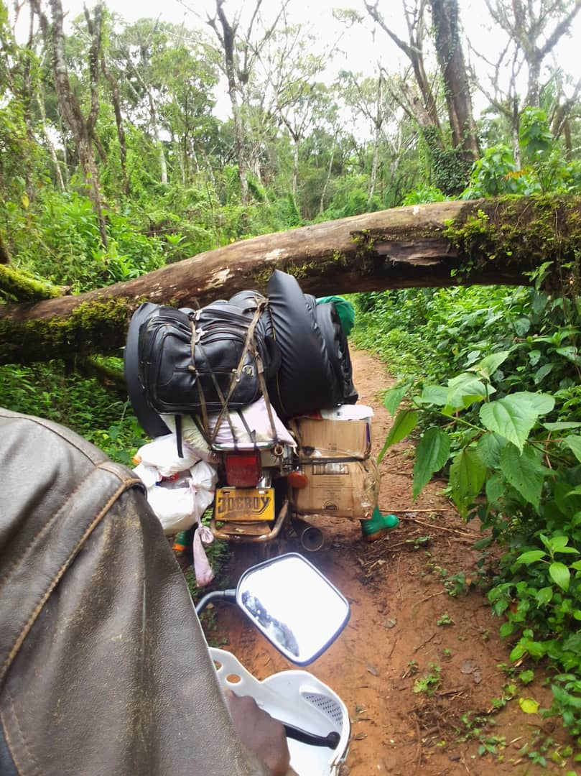
RECEADIT Motor Bikes transporting Medication/Drugs and Medical Equipment from RECEADIT Kitchu Clinic at Belo to our RECEADIT Clinic at Ngemsibo.

Second Illustration Photo

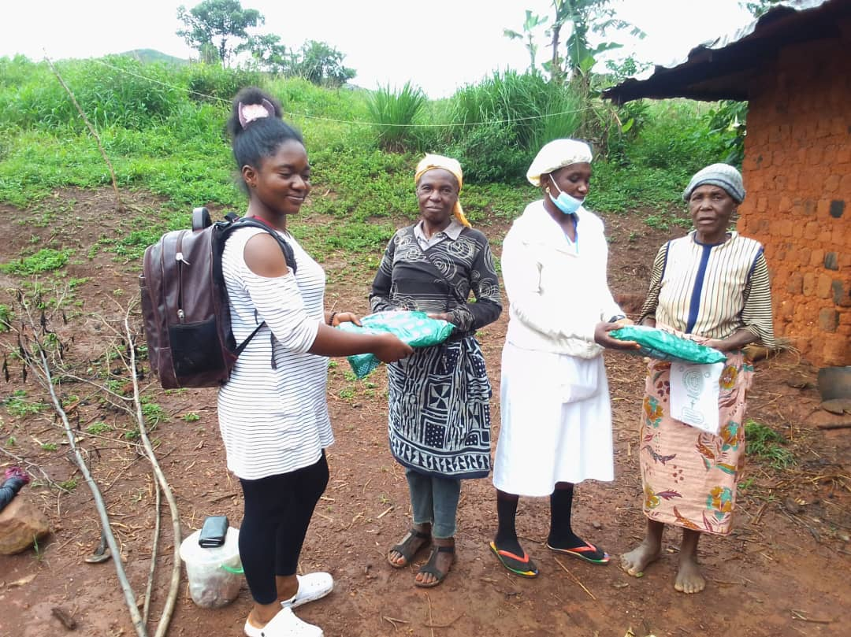

Two RECEADIT Female Nurses Distributiong Mosquito Nets to the Internally Displaced People within the Ngemsibo remote, rural Community.

Third Illustration Photo

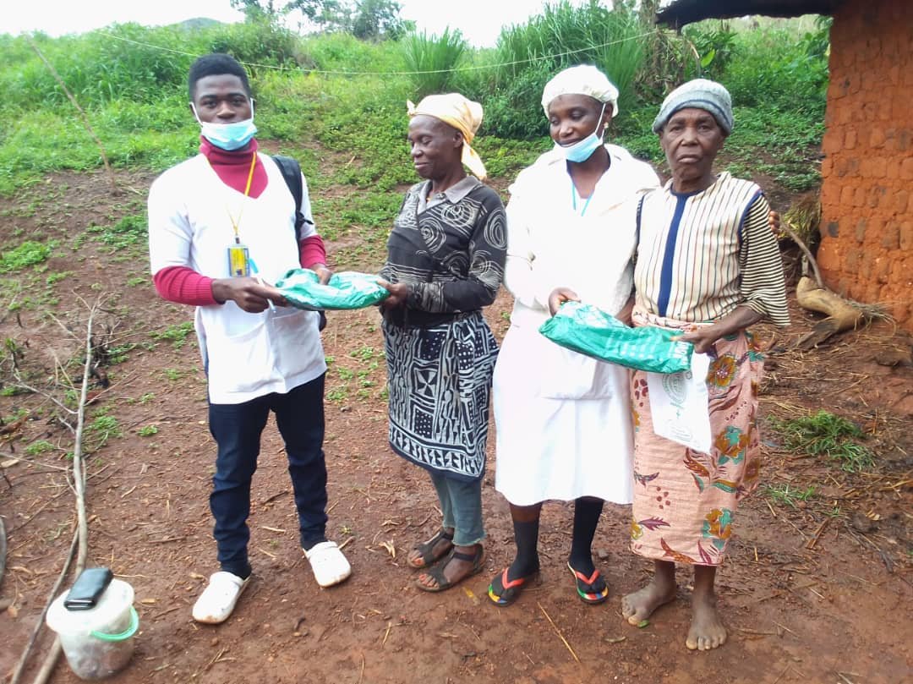

Two RECEADIT Nurses (Female and Male) Distributiong Mosquito Nets to the Internally Displaced People within the Ngemsibo remote, rural Community

Fourth Illustration Photo

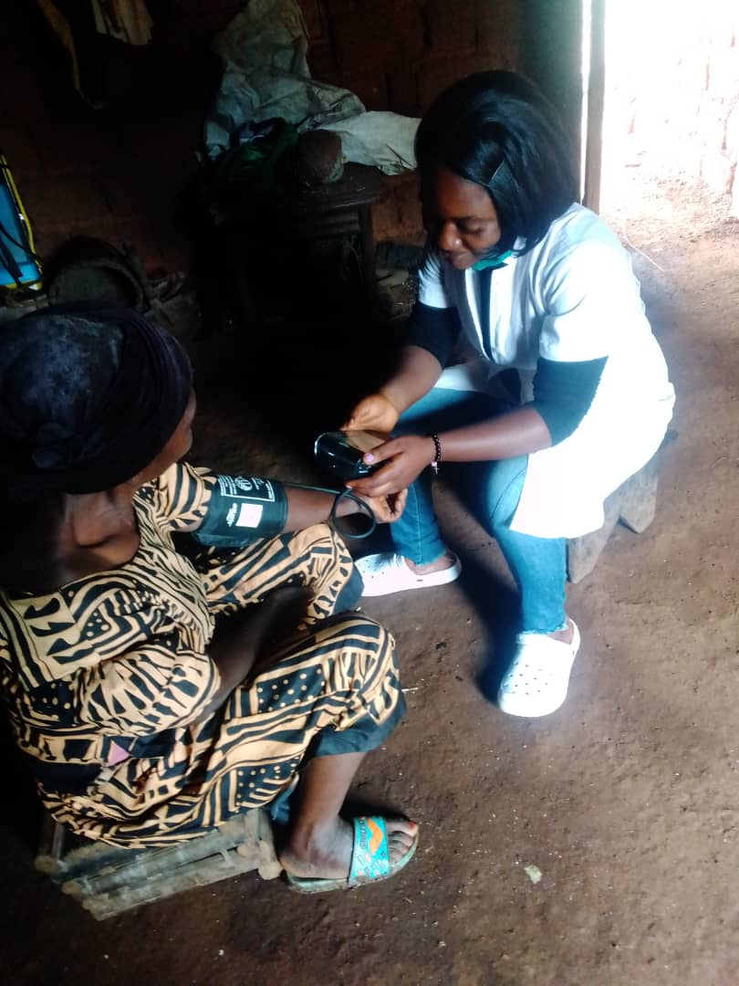

RECEADIT Female nurse attending to an Internally Displaced Family within the Ngemsibo remote, rural Community

Fifth Illustration Photo

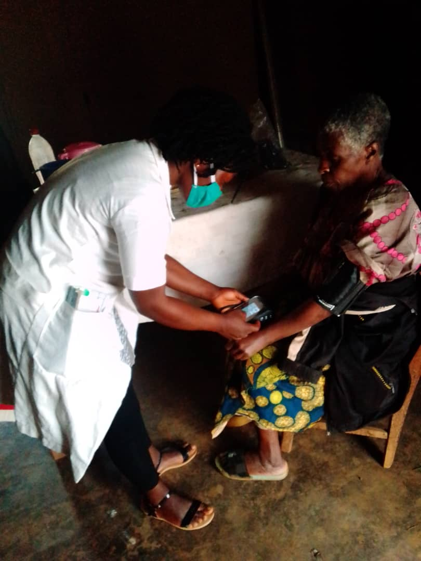

RECEADIT Female nurse attending to another Internally Displaced Family within the Ngemsibo remote, rural Community

Sixth Illustration Photo

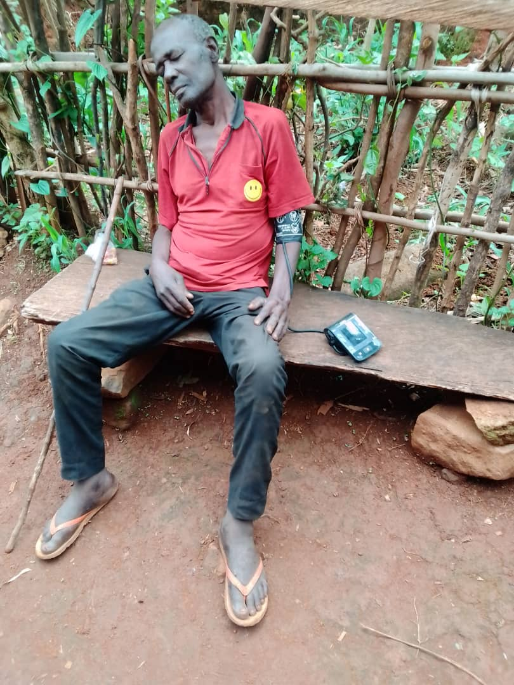

RECEADIT Female nurse attending to an Internally Displaced and abandoned Fellow Human Being within the Ngemsibo remote, rural Community

Seventh Illustration Photo
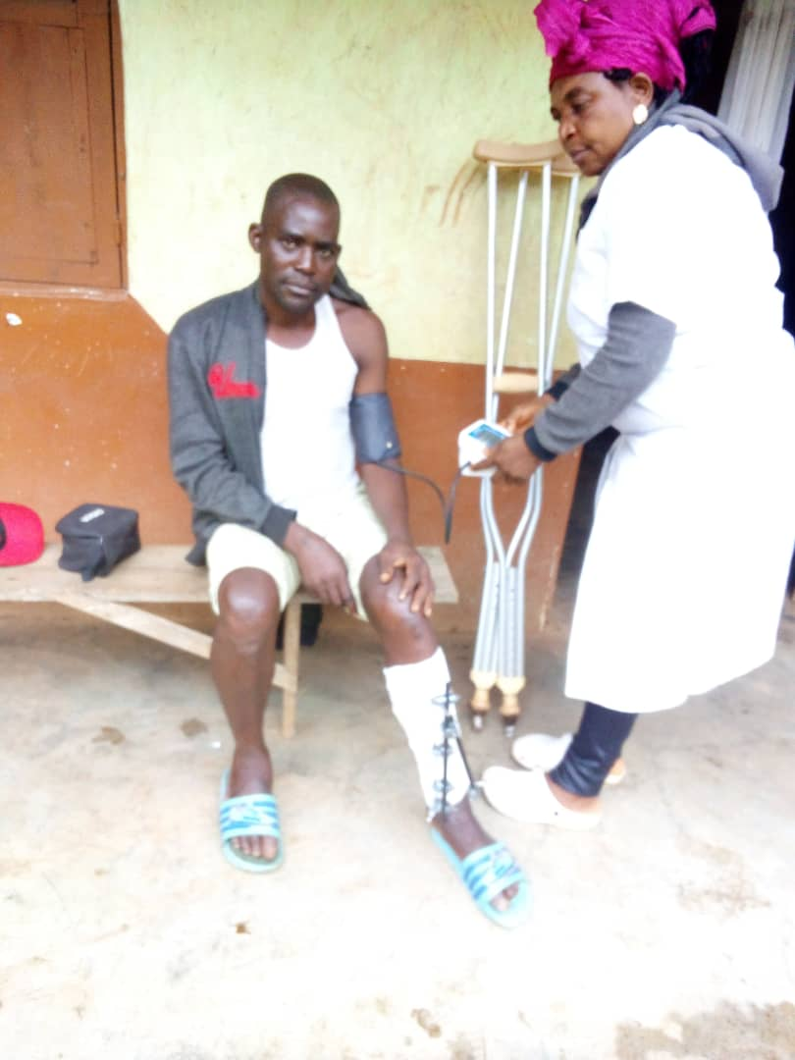

RECEADIT Female nurse attending to an Internally Displaced, wounded Person that RECEADIT Bikers found and rushed him to RECEDIT Clinic at Muteff remote, rural Community

Eighth Illustration Photo

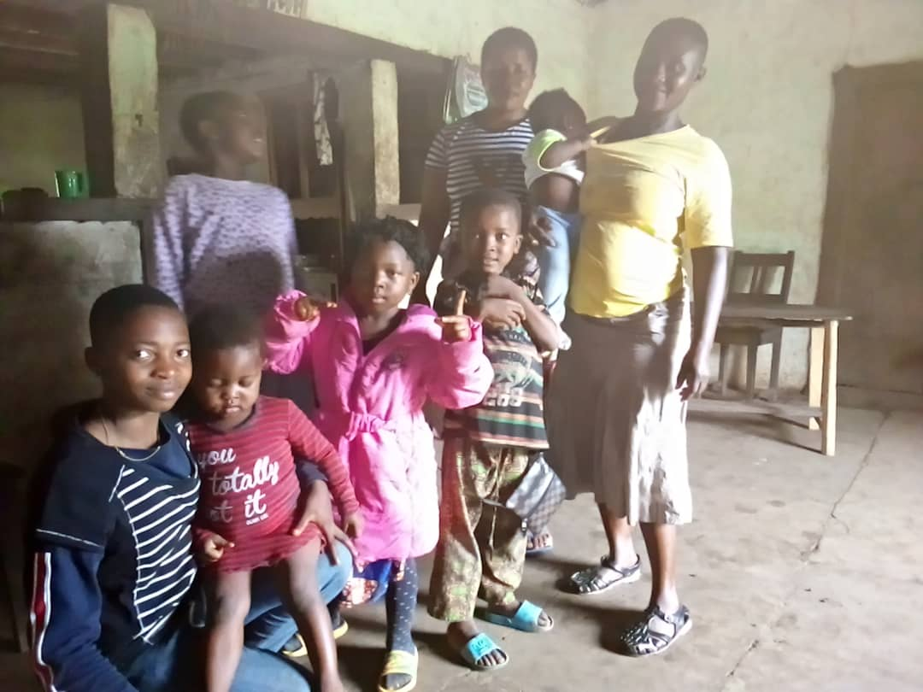

An Internally Displaced Family within the Muteff remote, rural Community brought to RECEADIT Clinic at Muteff for medical assistance.

Ninth and Tenth Illustration Photos Below: RECEADIT Female Nurse and Male Nurse during their separate medical assistance/check up visits of an Internally Displaced Family of a blind mother, her child and grand child at Mbam.

