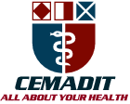
Research Center for Analytic Diagnosis and Imaging Trends (RECEADIT)
School of Health, Biomedical and Computer Sciences (SHBCS)
2020-2021 Academic Year
P.O. Box 19, Belo-Kom, Belo Sub-Division, Boyo Division, Cameroon, North-West Region,
West Africa - Tel: (237) 6 83 41 86 00 or (237) 6 77 68 99 32
CEMADIT@yahoo.com http://www.meditech-group.org

Motto: Health Care Research and Education for Services to Humanity

MEDITECH GROUP
CEMADIT
ALL ABOUT YOUR HEALTH

MEDITECH GROUP
RECEADIT
ALL ABOUT YOUR HEALTH

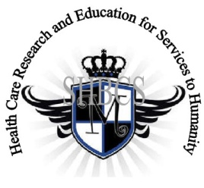

Ministry of Higher Education Ministry of Public Health Registration No. 3342 of August 31, 2011 Registration No. 4042 of August 31, 2011

GlobalGiving RECEADIT Drug Assistance for Internally Displaced People (39386) Project
Tenth Project Report of Monday, March 8th, 2022
On behalf of our RECEADIT Humanitarian Team, I take this opportunity to thank you so very much for your generosity and willingness to join us and to partnership with us on our journey of serving humanity through the Guidance, the Blessings, the Love, and the Grace of God Almighty.
We are glad to provide you with the following progress report and updates for our “Drug Assistance for Internally Displaced People Project (39386)” thanks to your generosity:
1) As we indicated in our Ninth Project Report of Monday, November 8th, 2021, in order to improve upon its Drug/Medication Assistance Program, RECEADIT has added a Reserved Pharmacy Section to each of its Clinics within the Kitchu, Mbam, Muteff, and Ngemsibo rural communities, with the New Central Distribution Pharmacy located on the Fourth Floor of the RCEADIT Main Building at Kitchu (See Second Photo);

2) Again, we must point out and emphasize with a lot of regret and frustration that because of the threat posed by Covid -19 and the intensification of the war in the English speaking part of Cameroon where our RECEADIT Clinics at Kitchu, Mbam, Muteff, and Ngemsibo rural communities are located, RECEADIT has turned its attention to and its focus on drugs/medication for the Internally Displaced People . This explains why most of the Illustration Photos are about drugs/medication, drug/medication transportation and distribution to Our four Clinics (See First, Second, Third, and Fourth Photos);

3) The living conditions of some of the Internally Displaced People are truly horrible and deplorable, as demonstrated by those of this family of a father, mother, and their children (See Fifth Photo).

4) Our RECEADIT Medical Team has suggested that RECEADIT should assist such Internally Displaced Families, such as the one presented in the Fifth Photo by constructing shelters, such as the six rooms Shelter under construction at Muteff (See Sixth Photo).

We will continue to provide you with monthly reports and updates of our other projects, activities, accomplishments, and challenges.
We hope that you will continue with us on this our journey of serving humanity through the Guidance, the Blessings, the Love and the Grace of God Almighty, a journey which has now taken us to this our “Drug Assistance for Internally Displaced People (39386)” through our new link: https://goto.gg/39386

Jilly M. Ngwainmbi, RECEADIT Project Leader

Illustration Photos

First Photo

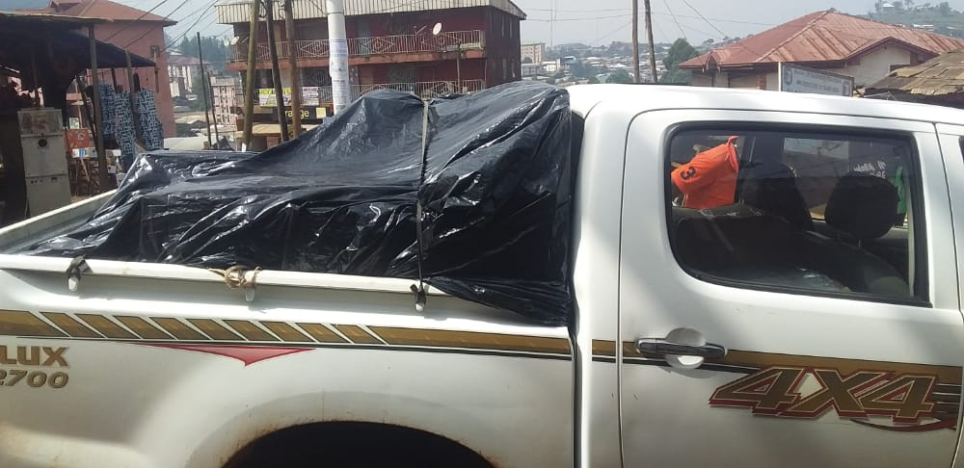

RECEADIT Truck on its regular trip to Kom to deliver Drugs/Medication and other medical equipment from the city of Bamenda to our Four Clinics in Kom.

Second Photo

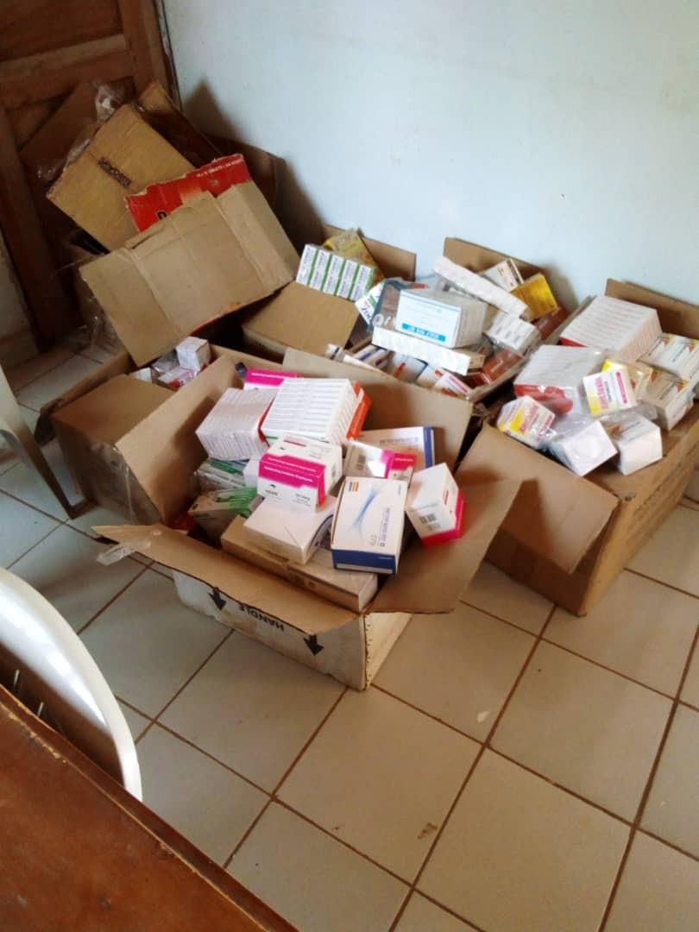

Stocks of Drugs in the RECEADIT New Central Pharmacy at our RECEADIT Clinic at Kitchu

Third Photo

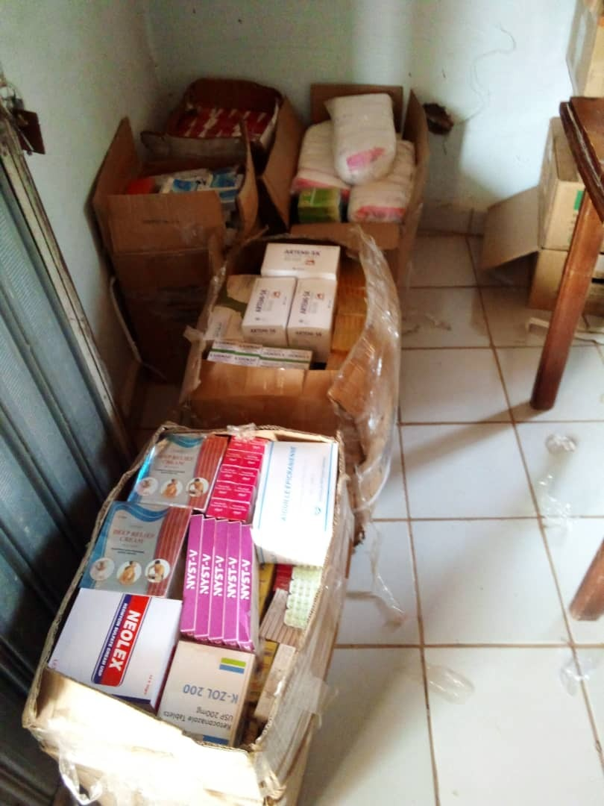

Stocks of Drugs in the RECEADIT New Central Pharmacy at our RECEADIT Clinic at Kitchu ready to be transported to our RECEADIT Clinic at Mbam

Fourth Photo

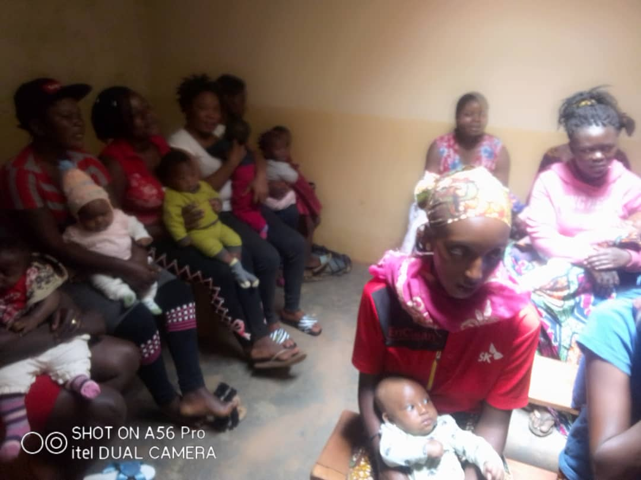

Mothers and their Babies waiting for Vaccination and malaria Drugs at our RECEADIT Clinic at Mbam

Fifth Photo

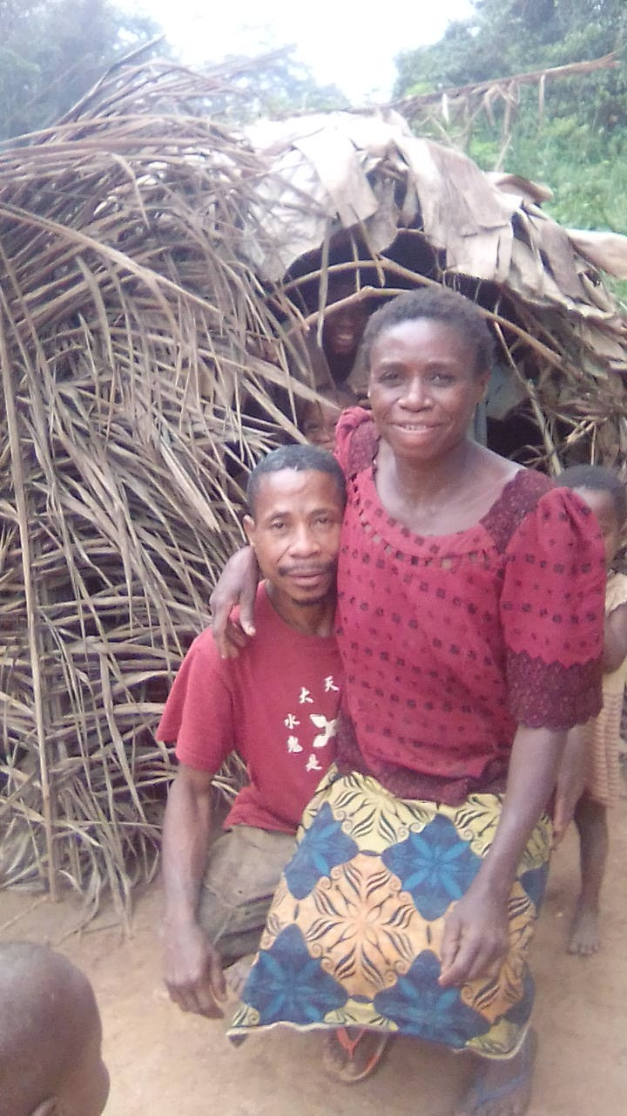

Internally Displaced Family: Husband, Wife, and Children

Sixth Photo
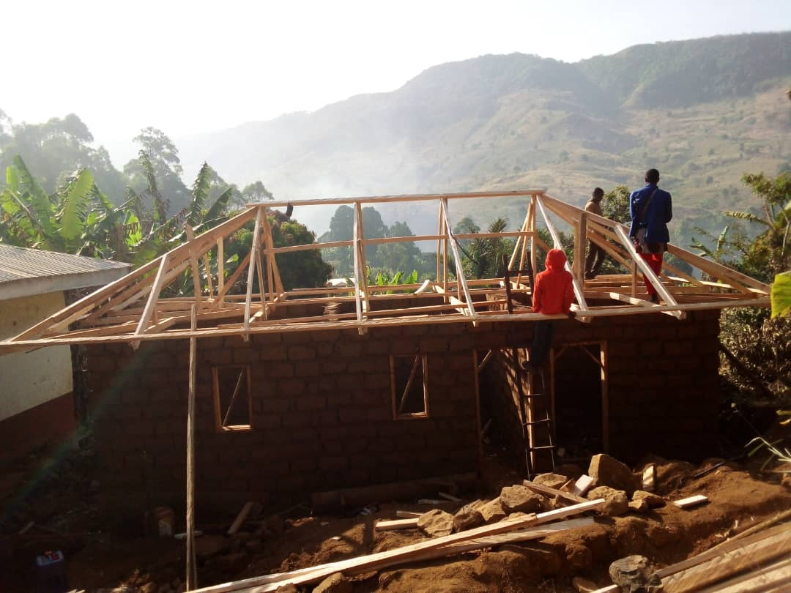

Construction of a Six rooms Shelter for the Internally Displaced People at Muteff

