Research Center for Analytic Diagnosis and Imaging Trends (RECEADIT)
School of Health, Biomedical and Computer Sciences (SHBCS)
2019-2020 Academic Year
P.O. Box 19, Belo-Kom, Belo Sub-Division, Boyo Division, Cameroon, North-West Region,
West Africa - Tel: (237) 6 83 41 86 00 or (237) 6 77 68 99 32
CEMADIT@yahoo.com http://www.meditech-group.org

Motto: Health Care Research and Education for Services to Humanity

MEDITECH GROUP
CEMADIT
ALL ABOUT YOUR HEALTH

MEDITECH GROUP
RECEADIT
ALL ABOUT YOUR HEALTH

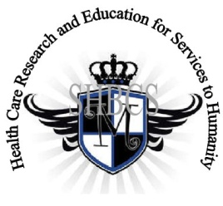

Ministry of Higher Education Ministry of Public Health Registration No. 3342 of August 31, 2011 Registration No. 4042 of August 31, 2011

GlobalGiving RECEADIT Drug Assistance for Internally Displaced People (39386) Project
Sixth Project Report of Monday, November 16th, 2020
On behalf of our RECEADIT Humanitarian Team, I take this opportunity to thank you so very much for your generosity and willingness to join us and to partnership with us on our journey of serving humanity through the Guidance, the Blessings, the Love, and the Grace of God Almighty.
We are glad to provide you with the following progress report and updates for our “Drug Assistance for Internally Displaced People Project (39386)” thanks to your generosity:
1) As we reported in our Fifth Project Report of Monday, July 20th, 2020, we then had two female nurses and one male nurse for this project, all graduates of our School of Health, Biomedical and Computer Sciences (SHBCS). Now, unfortunately, the male nurse left due to the threat posed by the war. Now we only have the two female nurses. They continue to provide medical assistance to our Internally Displaced People (See First and Second Photos);

2) Our Face Masks Wearing and Distribution Campaign among the Internally Displaced People within the Mbam, Muteff, and Ngemsibo remote, rural communities continue (See First Photo). However, recently Internally Displaced People do not yet have masks due to intensified war activities, which make it extremely difficult to reach them (See Second, and Third Photos);

3) The burning down of villages by the army, usually at night, is making it very difficult for our female nurses to provide medical assistance for Internally Displaced People (See Second, Third, and Fourth Photos) which is resulting in tragic deaths, especially the elderly (See Fifth Photo); and

4) We have intensified our struggle to find and recruit two more female nurses and two male nurses for this Project, since the displacement of people is increasing and the elderly particularly are not able to escape for their lives (See First and Second Short YouTube Video Links).

We will continue to provide you with monthly reports and updates of our other projects, activities, accomplishments, and challenges.
We hope that you will continue with us on this our journey of serving humanity through the Guidance, the Blessings, the Love and the Grace of God Almighty, a journey which has now taken us to this our “Drug Assistance for Internally Displaced People (39386)” through our new link: https://goto.gg/39386

Jilly M. Ngwainmbi, RECEADIT Project Leader

Illustration Photos and Videos

First Photo
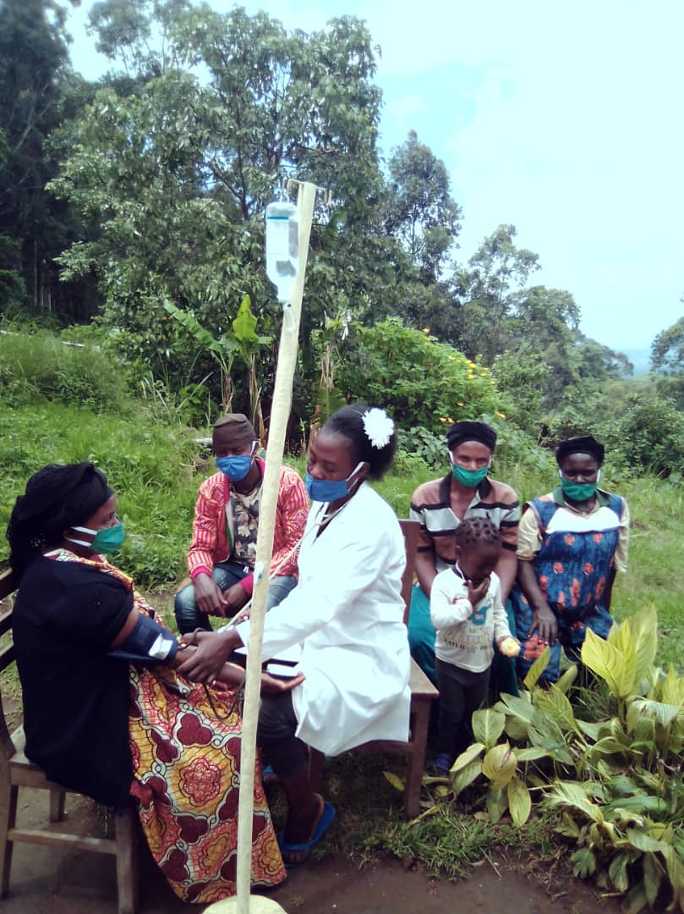

RECEADIT Clinic Annex Ngemsibo’s Female Nurse Attending to Internally Displaced People at one of RECEADIT’s temporary Health Care Facility locations.

Second Photo

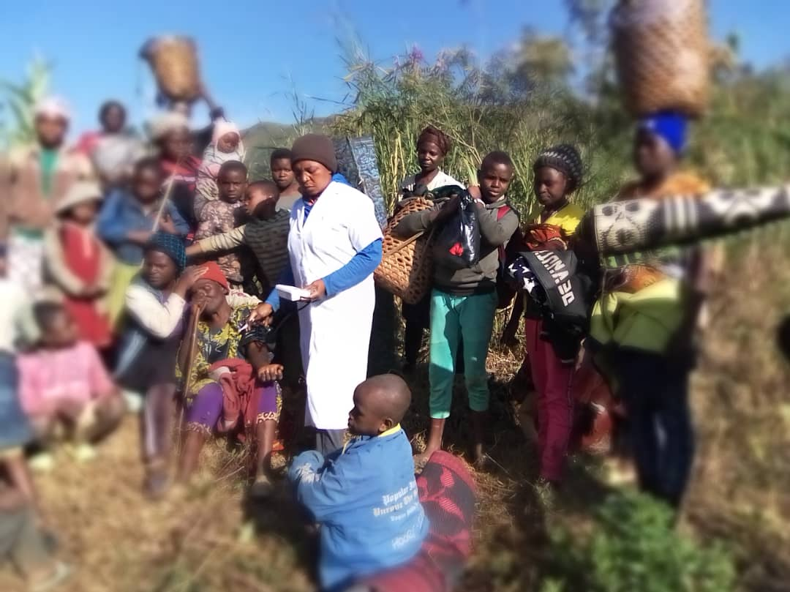

RECEADIT Clinic Annex Muteff’s Female Nurse Attending to Internally Displaced People at one of RECEADIT’s temporary Health Care Facility locations.

Third Photo
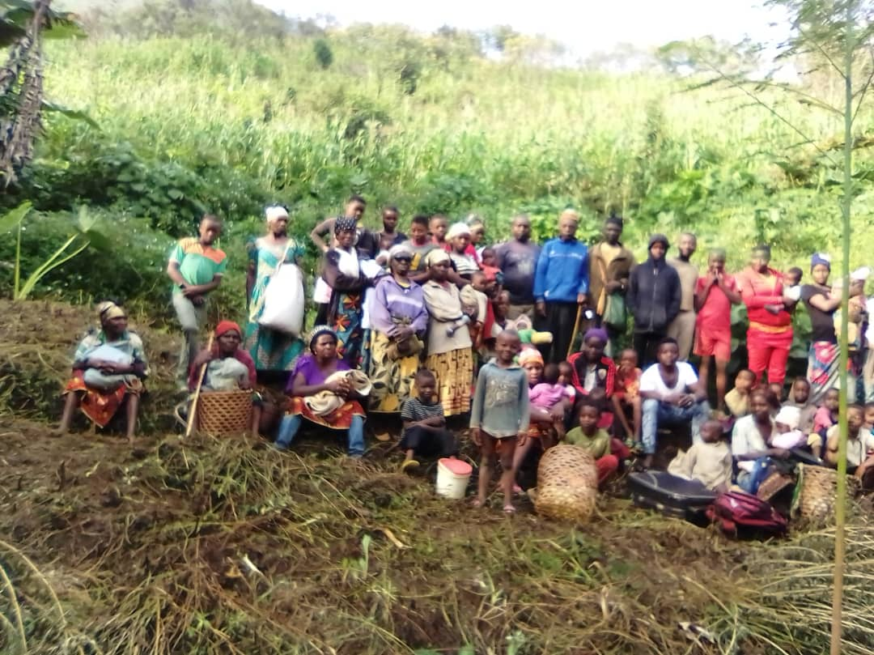

Internally Displaced People at one of RECEADIT’s temporary Health Care locations at Muteff, waiting for medical care Assistance from a Female Nurse of the RECEADIT Clinic Annex at Muteff.

Fourth Photo
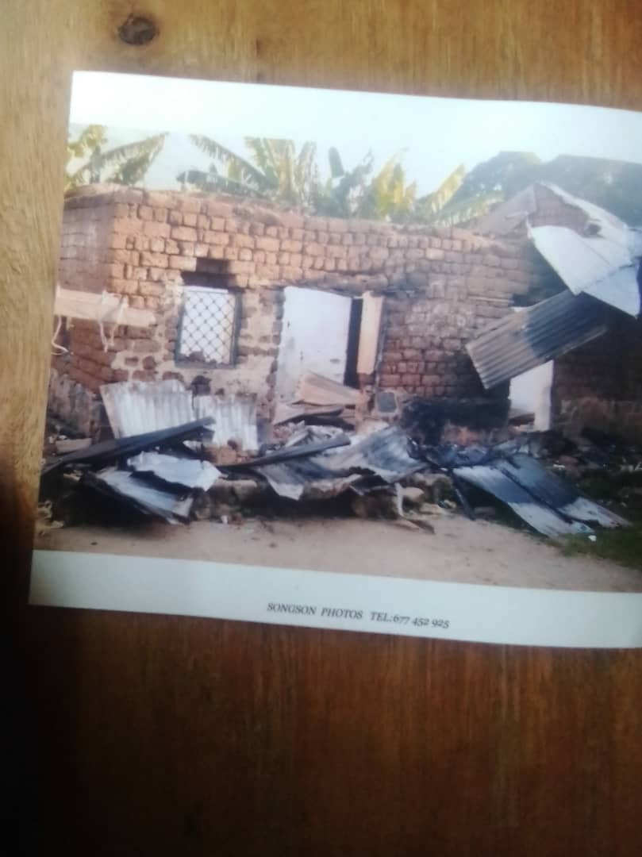
One of the Burnt Down Houses in the village which was set on fire by the army

Fifth Photo

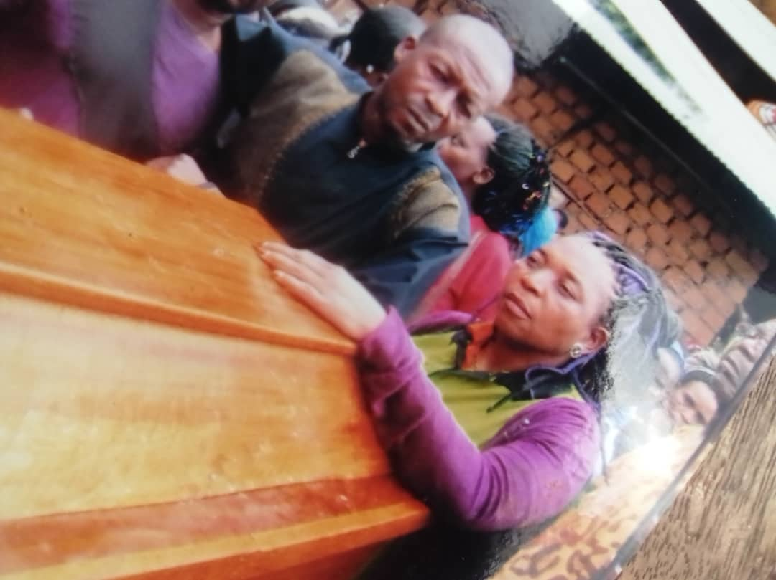

The Funeral of a Rural Community Member who died for lack of Medical care when the Army invaded the Village and set it on fire.

YouTube Video Links

First YouTube Video Link

https://www.youtube.com/watch?v=CoIZPJJvLdU&feature=youtu.be ->

Short YouTube Video of Children and Adults carrying Boxes and escaping from the Army Burning Down their villages.

Second YouTube Video Link

https://www.youtube.com/watch?v=z5rJcdqlvx4&feature=youtu.be ->

Short YouTube Video with Handicapped Children and Adults escaping from the Army Burning Down their villages.

