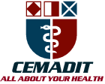
Research Center for Analytic Diagnosis and Imaging Trends (RECEADIT)
School of Health, Biomedical and Computer Sciences (SHBCS)
2020-2021 Academic Year
P.O. Box 19, Belo-Kom, Belo Sub-Division, Boyo Division, Cameroon, North-West Region,
West Africa - Tel: (237) 6 83 41 86 00 or (237) 6 77 68 99 32
CEMADIT@yahoo.com http://www.meditech-group.org

Motto: Health Care Research and Education for Services to Humanity

MEDITECH GROUP
CEMADIT
ALL ABOUT YOUR HEALTH

MEDITECH GROUP
RECEADIT
ALL ABOUT YOUR HEALTH

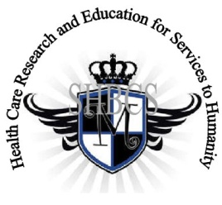

Ministry of Higher Education Ministry of Public Health Registration No. 3342 of August 31, 2011 Registration No. 4042 of August 31, 2011

GlobalGiving RECEADIT Drug Assistance for Internally Displaced People (39386) Project
Seventh Project Report of Monday, March 15, 2021
On behalf of our RECEADIT Humanitarian Team, I take this opportunity to thank you so very much for your generosity and willingness to join us and to partnership with us on our journey of serving humanity through the Guidance, the Blessings, the Love, and the Grace of God Almighty.
We are glad to provide you with the following progress report and updates for our “Drug Assistance for Internally Displaced People Project (39386)” thanks to your generosity:
1) We identified three young males within one of the remote, rural locations, where some of the Internally Displaced People are hiding, to build a shelter for the Internally Displaced People and they are currently working on this project (See First Photo);

2) Government terrorist soldiers found one of the camps where Internally Displaced People are hiding and they started shooting randomly at unarmed fellow English speaking Cameroonians and killing them. Some of the wounded were rushed to our RECEADIT-CEMADIT Community Health Center at Muteff rural Community where they received medical treatment (See Second Photo).

3) We have acquired new medical equipment to be used in providing medical treatment for the Internally Displaced People and also bought bags of rice and other food items for them (See Third Photo);

4) In addition to our two female nurses and one female laboratory technician, recruited recently in January, who are all graduates of our School of Health, Biomedical and Computer Sciences (SHBCS), we have also found and recruited one male pharmacy technician. Most importantly, we have found and recruited a former World Health Organization (WHO) trained personnel who is an eye specialist and a dentist. He has organized training programs for all our RECEADIT workers (See Fourth Photo); and

5) Our RECEADIT Medical Team continues to provide medical services for the Internally Displaced People and for their Community members (See Fifth and Sixth Photos).

We will continue to provide you with monthly reports and updates of our other projects, activities, accomplishments, and challenges.
We hope that you will continue with us on this our journey of serving humanity through the Guidance, the Blessings, the Love and the Grace of God Almighty, a journey which has now taken us to this our “Drug Assistance for Internally Displaced People (39386)” through our new link: https://goto.gg/39386

Jilly M. Ngwainmbi, RECEADIT Project Leader

Illustration Photos

First Photo

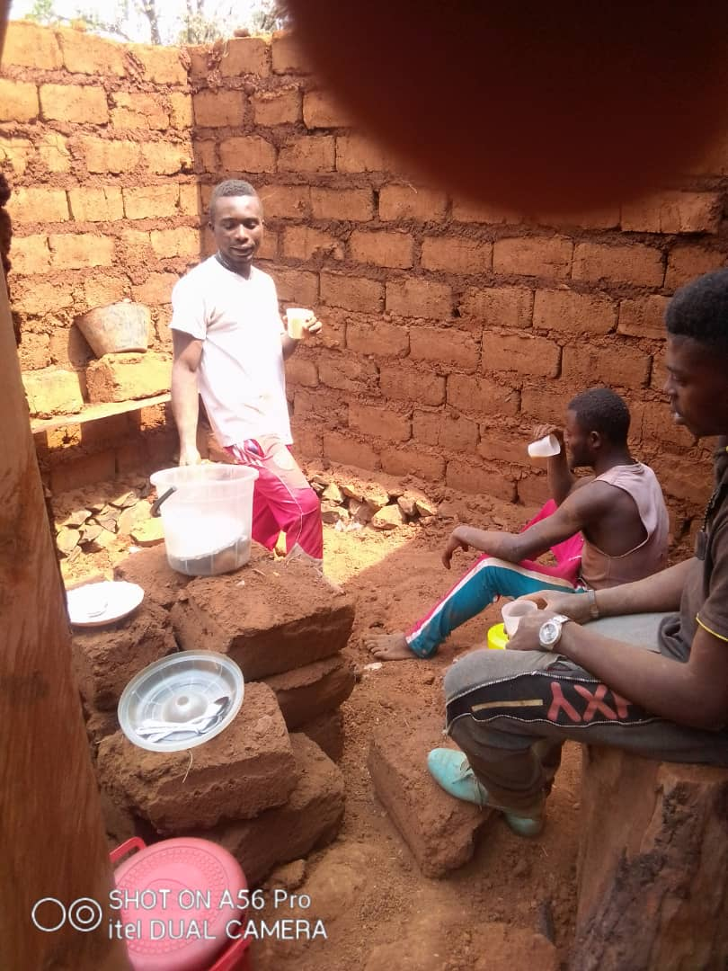

Young Males constructing a shelter for the Internally Displaced People

Second Photo

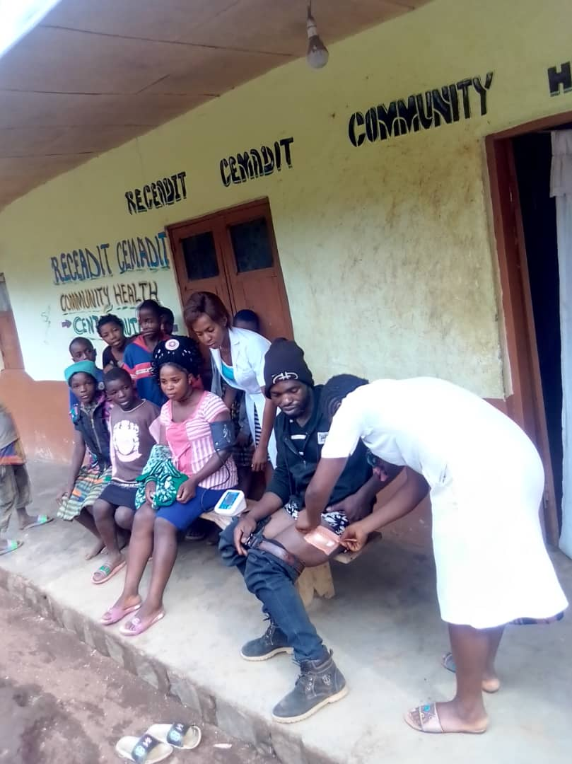

Female nurses Attending to Wounded Internally Displaced People at our RECEADIT-CEMADIT Community Health Center at Muteff

Third Photo

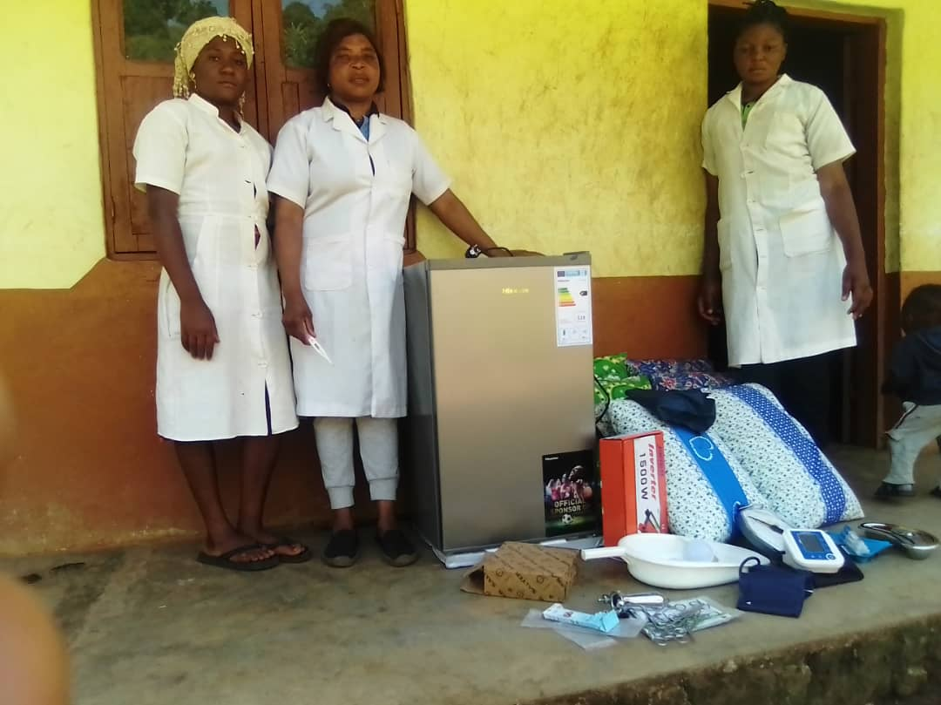

New Medical Equipment and Food for the Internally Displaced, RECEADIT-CEMADIT Community Health Center at Muteff

Fourth Photo

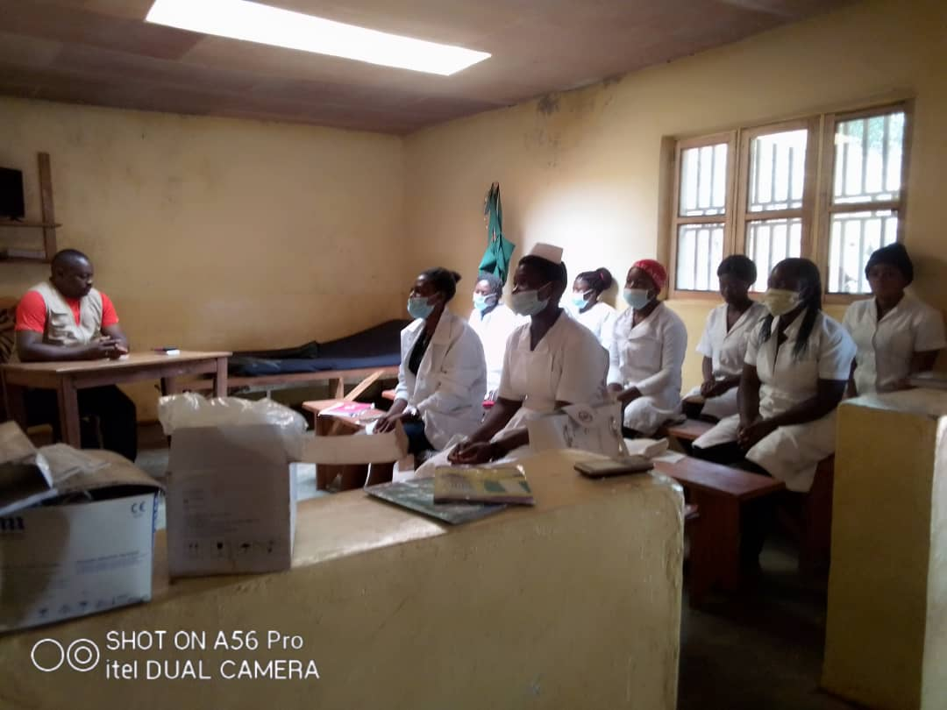

Organized Medical Training at RECEADIT Mbam Community Health Center for all RECEADIT Health Care Workers

Fifth Photo

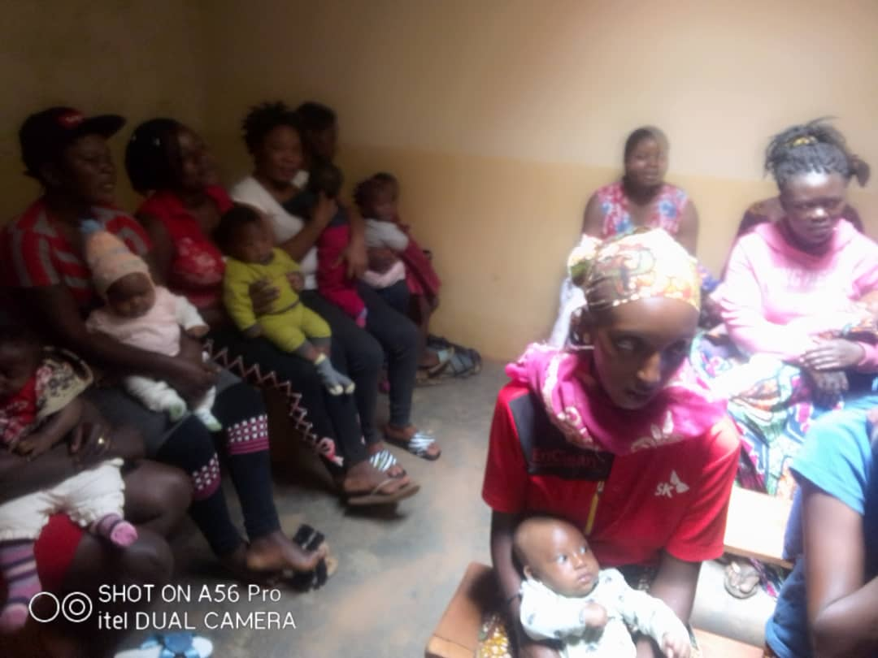

Organized Children Vaccination Program for the Internally Displaced People at Mbam rural Community

Sixth Photo

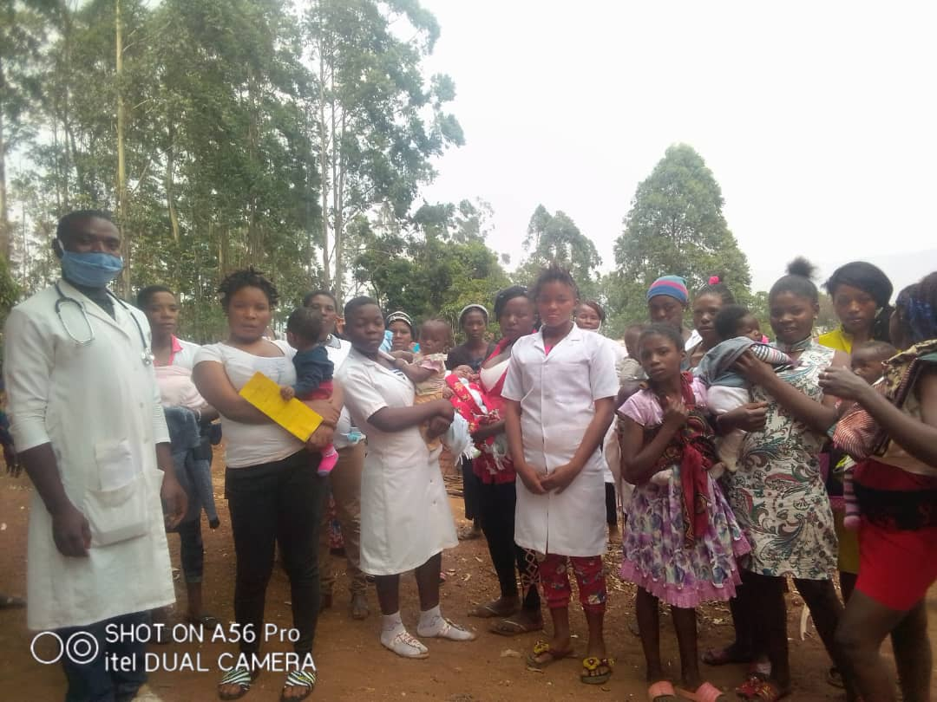

Organized Children Vaccination Program for the Internally Displaced People at Muteff rural Community

