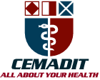
Research Center for Analytic Diagnosis and Imaging Trends (RECEADIT)
School of Health, Biomedical and Computer Sciences (SHBCS)
2017-2018 Academic Year
P.O. Box 19, Belo-Kom, Belo Sub-Division, Boyo Division, Cameroon, North-West Region,
West Africa - Tel: (237) 6 83 41 86 00 or (237) 6 77 68 99 32
CEMADIT@yahoo.com http://www.meditech-group.org

Motto: Health Care Research and Education for Services to Humanity

MEDITECH GROUP
CEMADIT
ALL ABOUT YOUR HEALTH

MEDITECH GROUP
RECEADIT
ALL ABOUT YOUR HEALTH

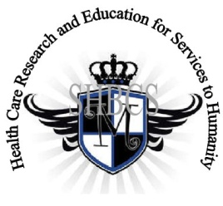

Ministry of Higher Education Ministry of Public Health Registration No. 3342 of August 31, 2011 Registration No. 4042 of August 31, 2011

GlobalGiving RECEADIT Drug Assistance for Internally Displaced People (39386) Project
Second Project Report of Friday, September 27th, 2019
On behalf of our RECEADIT Humanitarian Team, I take this opportunity to thank you so very much for your generosity and willingness to join us and to partnership with us in our journey of serving humanity through the Guidance, the Blessings, the Love and the Grace of God Almighty.
We are glad to provide you with the following progress report and updates for our “Drug Assistance for Internally Displaced People (39386)” thanks to your generosity:
1) As we reported in our First Project Report of June 30th, 2019, we found and recruited two female nurses for this project, all graduates of our School of Health, Biomedical and Computer Sciences (SHBCS). They continue to provide medical assistance to the internally displaced people; (See First, Second, and Third Photos). One of them was injured and she is slowly recovering; and

2) We have not been able to find and recruit any more female nurses for the Project due to the ongoing war. We will continue the search and will hopefully find and recruit four more female nurses for the Project.

We will continue to provide you with monthly reports and updates of our other projects, activities, accomplishments, and challenges.
We hope that you will continue with us on this our journey of serving humanity through the Guidance, the Blessings, the Love and the Grace of God Almighty, a journey which has taken us to this our “Drug Assistance for Internally Displaced People (39386)” through our new link: https://goto.gg/39386

Jilly M. Ngwainmbi, RECEADIT Project Leader

Illustration Photos

First Photo
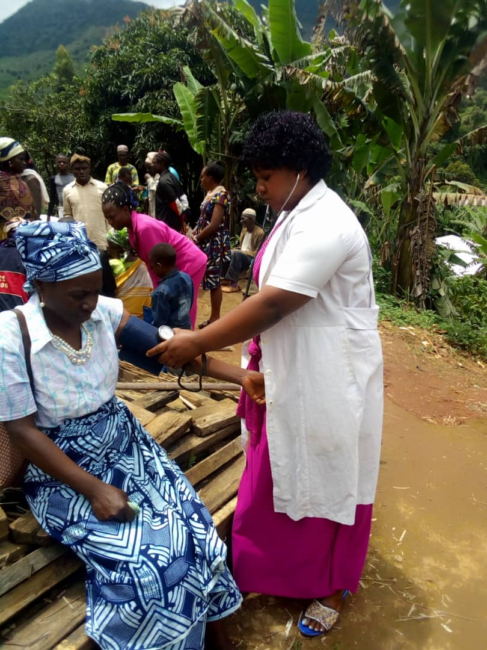
Female Nurse attending to Internally Displaced Female

Second Photo

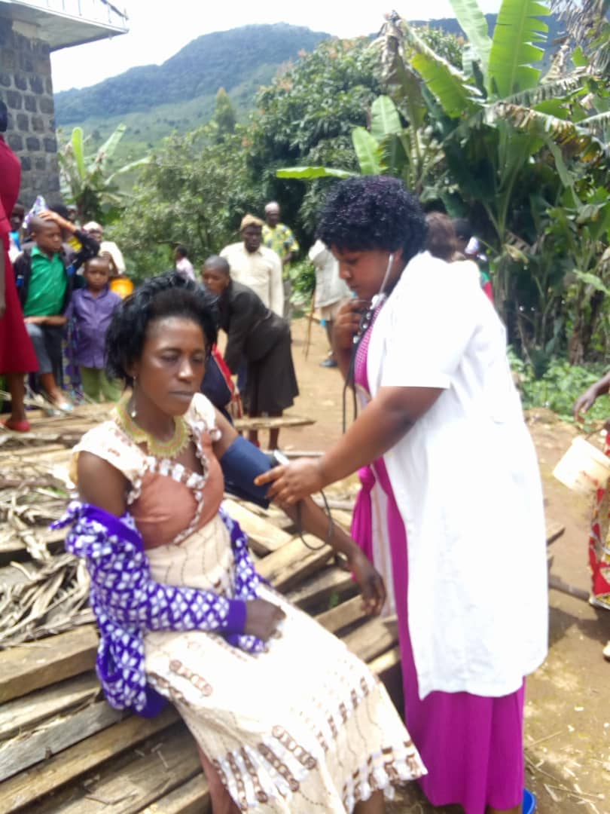
Female Nurse attending to an Internally Displaced Female

Third Photo

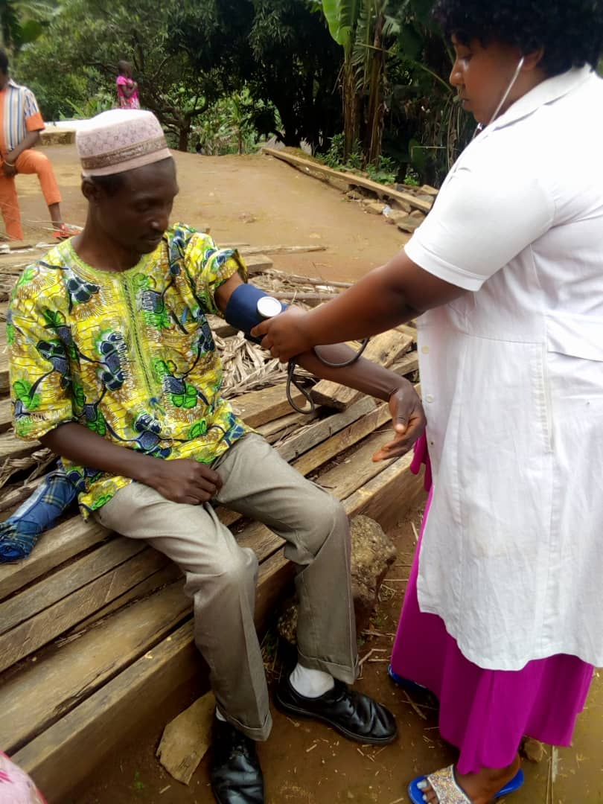

Female Nurse attending to an Internally Displaced Male

