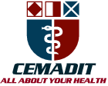
Research Center for Analytic Diagnosis and Imaging Trends (RECEADIT)
School of Health, Biomedical and Computer Sciences (SHBCS)
2020-2021 Academic Year
P.O. Box 19, Belo-Kom, Belo Sub-Division, Boyo Division, Cameroon, North-West Region,
West Africa - Tel: (237) 6 83 41 86 00 or (237) 6 77 68 99 32
CEMADIT@yahoo.com http://www.meditech-group.org

Motto: Health Care Research and Education for Services to Humanity

MEDITECH GROUP
CEMADIT
ALL ABOUT YOUR HEALTH

MEDITECH GROUP
RECEADIT
ALL ABOUT YOUR HEALTH

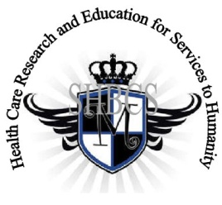

Ministry of Higher Education Ministry of Public Health Registration No. 3342 of August 31, 2011 Registration No. 4042 of August 31, 2011

GlobalGiving RECEADIT Drug Assistance for Internally Displaced People (39386) Project
Ninth Project Report of Monday, November 8th, 2021
On behalf of our RECEADIT Humanitarian Team, I take this opportunity to thank you so very much for your generosity and willingness to join us and to partnership with us on our journey of serving humanity through the Guidance, the Blessings, the Love, and the Grace of God Almighty.
We are glad to provide you with the following progress report and updates for our “Drug Assistance for Internally Displaced People Project (39386)” thanks to your generosity:
1) As we indicated in our Eighth Project Report of Tuesday, July 13th, 2021, in order to improve upon its Drug/Medication Assistance Program, RECEADIT has added a Reserved pharmacy Section to each of its Clinics within the Kitchu, Mbam, Muteff, and Ngemsibo rural communities, with the New Distribution Pharmacy located on the Fourth Floor of the RCEADIT Main Building at Kitchu;

2) The threat posed by Covid -19 and the intensification of the war in the English speaking part of Cameroon where our RECEADIT Clinics at Kitchu, Mbam, Muteff, and Ngemsibo rural communities are located, RECEADIT has turned its attention to and its focus on drugs/medication for the Internally Displaced People . This explains why all the Illustration Photos are about drugs/medication, drug/medication transportation and distribution to Our four Clinics (See First, Second, Third, Fourth, Fifth, Sixth, Seventh, and Eighth Photos);

3) RECEADIT’s focus on drugs/medication, their purchase, transportation, distribution, and the use of them for the treatment of the Internally Displaced People has created major challenges and problems for RECADIT and its Humanitarian Team, such as the stopping and detaining of Our RECEADIT Transportation Team members transporting drugs/medication to Kom from Bamenda; and

4) Our RECEADIT Medical Team is facing also challenges related to the vaccines and the vaccination of children in some of the remote, rural Communities, such as Muteff and Ngemsibo.

We will continue to provide you with monthly reports and updates of our other projects, activities, accomplishments, and challenges.
We hope that you will continue with us on this our journey of serving humanity through the Guidance, the Blessings, the Love and the Grace of God Almighty, a journey which has now taken us to this our “Drug Assistance for Internally Displaced People (39386)” through our new link: https://goto.gg/39386

Jilly M. Ngwainmbi, RECEADIT Project Leader

Illustration Photos

First Photo

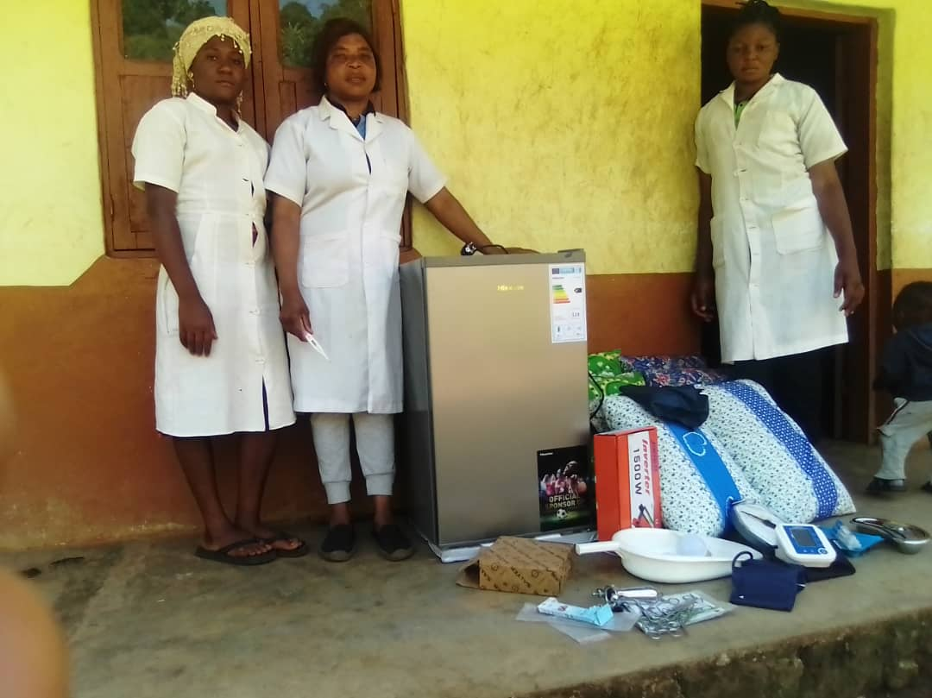

RECEADIT Female Nurses at the RECEADIT Community Health Center at Muteff Preparing to Receive their drugs/medication from our Drug/Medication Transportation Team.

Second Photo Below: This is our RECEADIT Truck which provides all RECEADIT’s Transportation Needs, especially Drug/Medication transportation to all our Four Clinics in Kom.
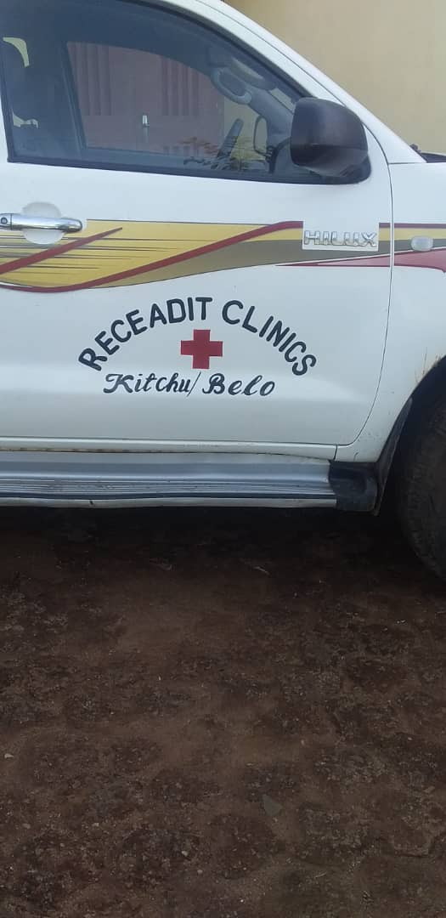
Third Photo

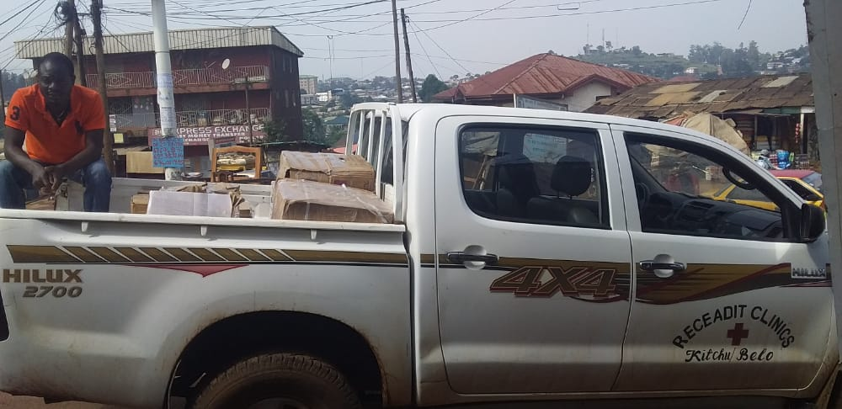

RECEADIT Truck with Our Transportation Team Members loading Drugs/Medication and other medical equipment in the city of Bamenda and to transport them to our Four Clinics in Kom.

Fourth Photo

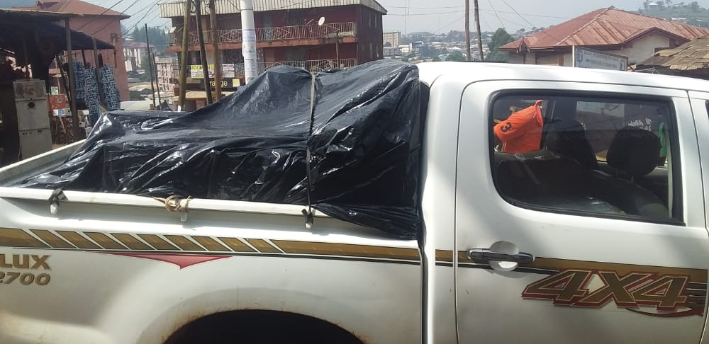

RECEADIT Truck on its way to Kom to deliver Drugs/Medication and other medical equipment from the city of Bamenda to our Four Clinics in Kom.

Fifth Photo

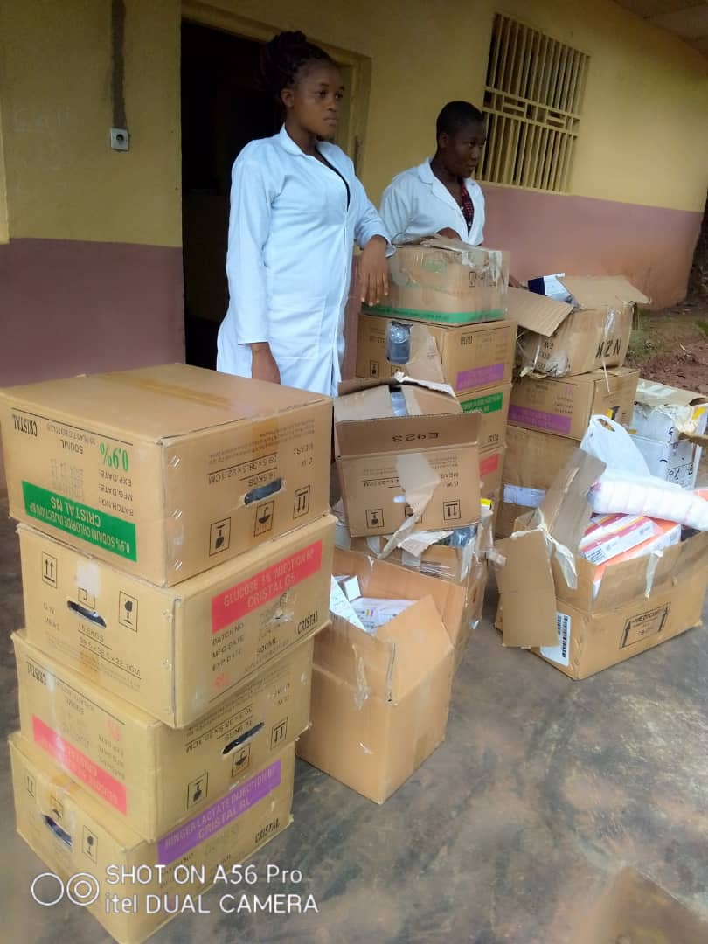

RECEADIT Nurses receiving drugs/medication from our RECEADIT Transportation Team from the City of Bamenda.

Sixth Photo

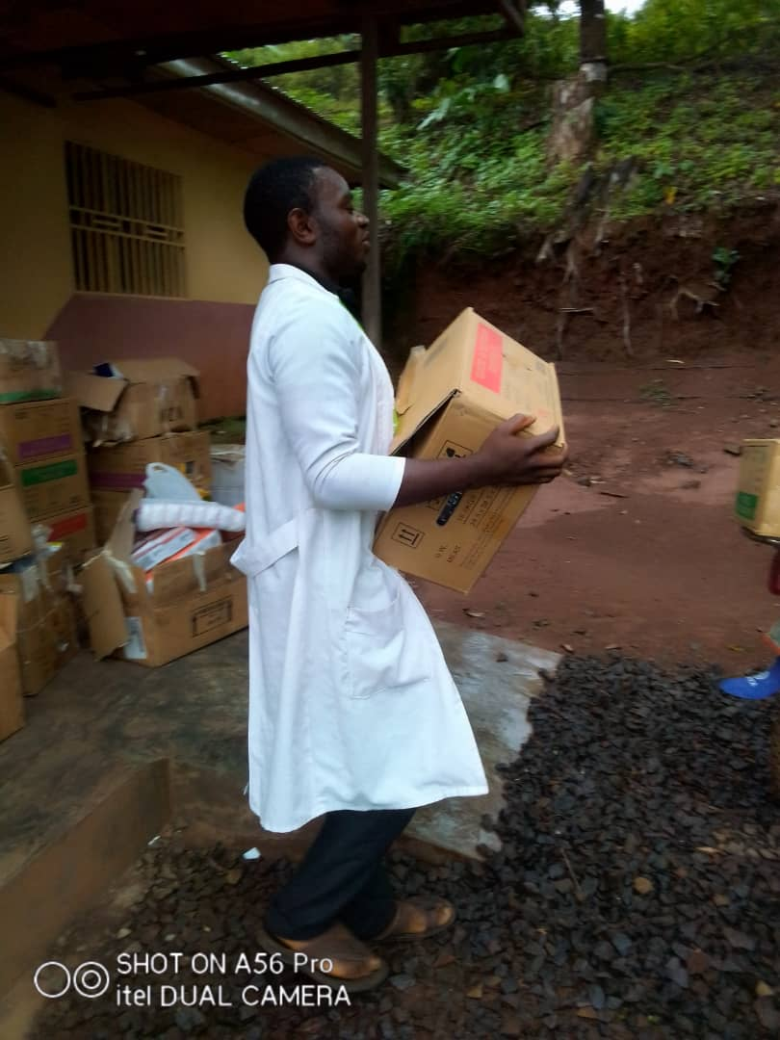
RECEADIT Nurse and Drug/Medication Transportation Team Member at our RECEADIT-GlobalGiving Partnership Community Health Center at Mbam, getting ready to transport drugs/medication to RECEADIT Community Health Center at Muteff in Kom.

Seventh Photo

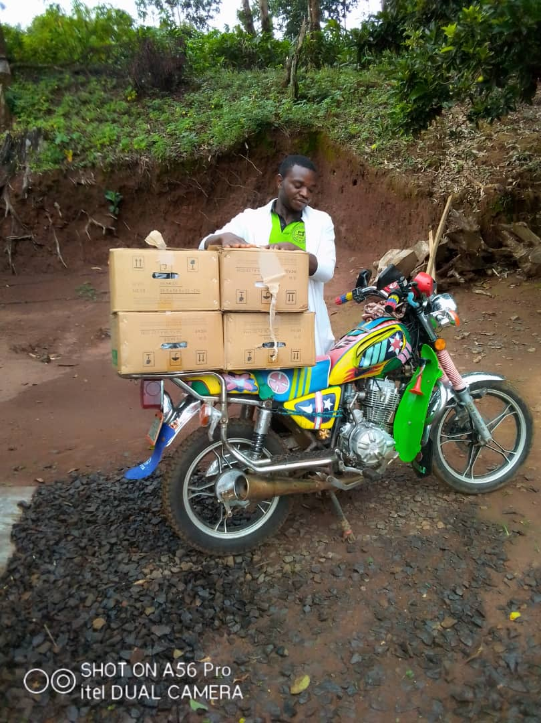
RECEADIT Nurse and Drug/Medication Transportation Team Member with the new RECEADIT Bike at our RECEADIT-GlobalGiving Partnership Community Health Center at Mbam, getting ready to transport drugs/medication to RECEADIT Community Health Center at Muteff in Kom.

Eighth Photo
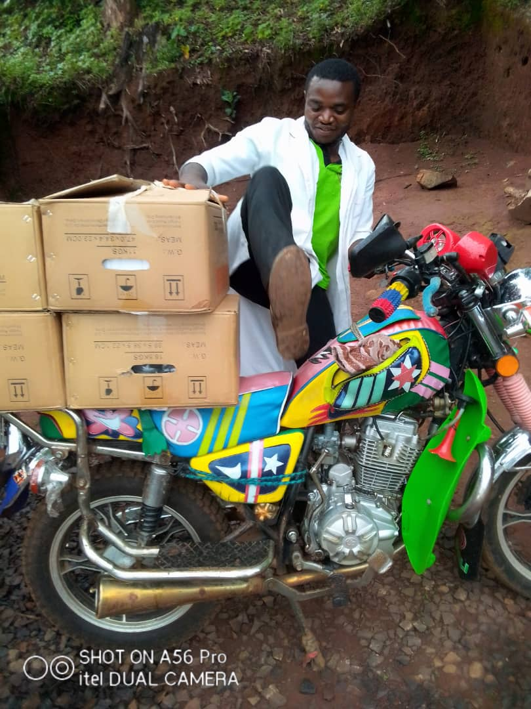

RECEADIT Nurse and Drug/Medication Transportation Team Member with the new RECEADIT Bike at our RECEADIT-GlobalGiving Partnership Community Health Center at Mbam, getting ready to transport drugs/medication to RECEADIT Community Health Center at Muteff in Kom.

