Research Center for Analytic Diagnosis and Imaging Trends (RECEADIT)
School of Health, Biomedical and Computer Sciences (SHBCS)
2020-2021 Academic Year
P.O. Box 19, Belo-Kom, Belo Sub-Division, Boyo Division, Cameroon, North-West Region,
West Africa - Tel: (237) 6 83 41 86 00 or (237) 6 77 68 99 32
CEMADIT@yahoo.com http://www.meditech-group.org

Motto: Health Care Research and Education for Services to Humanity

MEDITECH GROUP
CEMADIT
ALL ABOUT YOUR HEALTH

MEDITECH GROUP
RECEADIT
ALL ABOUT YOUR HEALTH

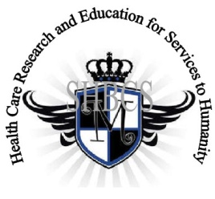

Ministry of Higher Education Ministry of Public Health Registration No. 3342 of August 31, 2011 Registration No. 4042 of August 31, 2011

GlobalGiving RECEADIT Drug Assistance for Internally Displaced People (39386) Project
Eighth Project Report of Tuesday, July13th, 2021
On behalf of our RECEADIT Humanitarian Team, I take this opportunity to thank you so very much for your generosity and willingness to join us and to partnership with us on our journey of serving humanity through the Guidance, the Blessings, the Love, and the Grace of God Almighty.
We are glad to provide you with the following progress report and updates for our “Drug Assistance for Internally Displaced People Project (39386)” thanks to your generosity:
1) Our RECEADIT Medical Team is very impressed by the leadership and work of Dr. Nsom Marcel, the former World Health Organization (WHO) trained personnel who is an eye specialist and a dentist. In addition to the organized medical training programs for all our RECEADIT workers (See First Photo), he has now, with the assistance of five other medical personnel, recruited twenty new students for the One Year Intensive Medical Training Program as nurse assistants, assistant laboratory technicians, pharmacy assistants, and assistant eye specialists (See Second Photo);

2) With the assistance and leadership of Dr. Nsom Marcel, RECEADIT has intensified its Covid 19 Vaccination Drive within the Kitchu, Mbam, Muteff, and Ngemsibo rural communities (See Third, Fourth, Fifth, Sixth, Seventh, Eighth, Ninth, and Tenth Photos);

3) RECEADIT has also increased its Masks distribution efforts, especially to children in the Kitchu, Mbam, Muteff, nd Ngemsibo Rural Communities (See Eleventh Photo);

4) In order to improve upon its Drug/Medication Assistance Program, RECEADIT has added a Reserved pharmacy Section to each of its Clinics within the Kitchu, Mbam, Muteff, and Ngemsibo rural communities, with the New Distribution Pharmacy located on the Fourth Floor of the RCEADIT Main Building at Kitchu (See Fourteenth Photo); and

5) Our RECEADIT Medical Team continues to provide food assistance to the Internally Displaced People in the Mbam, Muteff, and Ngemsibo rural Communities (See Twelfth and Thirteenth Photos).

We will continue to provide you with monthly reports and updates of our other projects, activities, accomplishments, and challenges.
We hope that you will continue with us on this our journey of serving humanity through the Guidance, the Blessings, the Love and the Grace of God Almighty, a journey which has now taken us to this our “Drug Assistance for Internally Displaced People (39386)” through our new link: https://goto.gg/39386

Jilly M. Ngwainmbi, RECEADIT Project Leader

Illustration Photos

First Photo

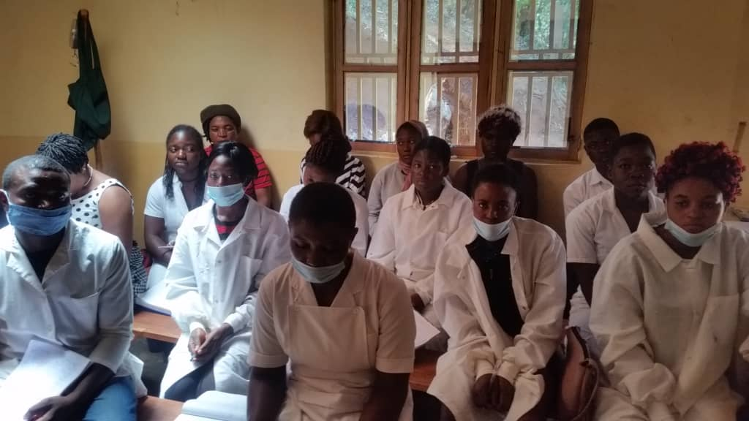
Students in the Organized, Medical Training Program for all our RECEADIT workers at the RECEADIT Community Health Center at Mbam

Second Photo

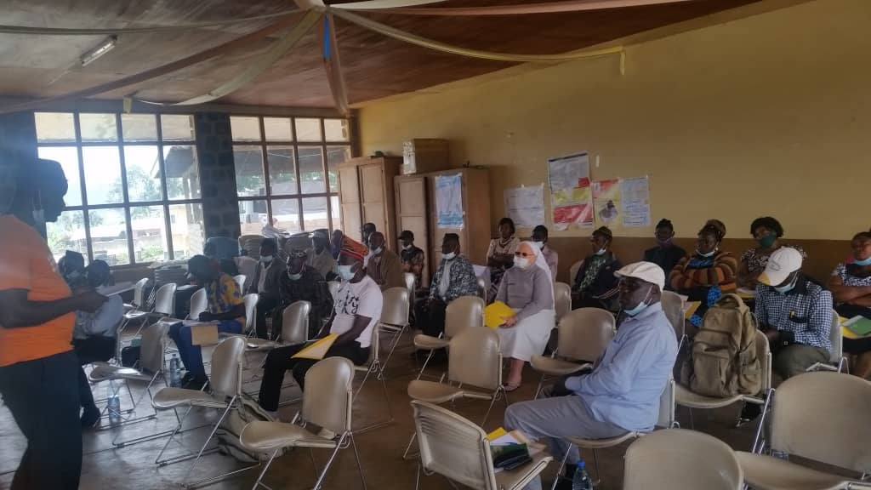

Students in the New One Year Medical Training Program at the RECEADIT Community Health Center at Mbam

Third Photo

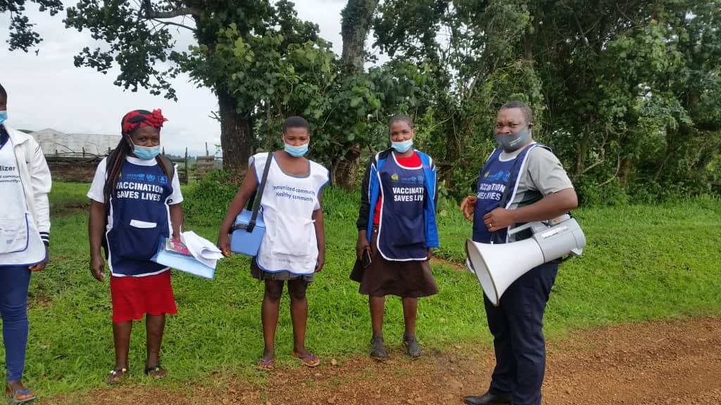

Dr. Nsom Marcel and His Vaccination Team

Fourth Photo Below on the Next Page, Page 4 Below: The Vaccination Team Attending to a Child’s teeth and Vaccinating the Child

Third Photo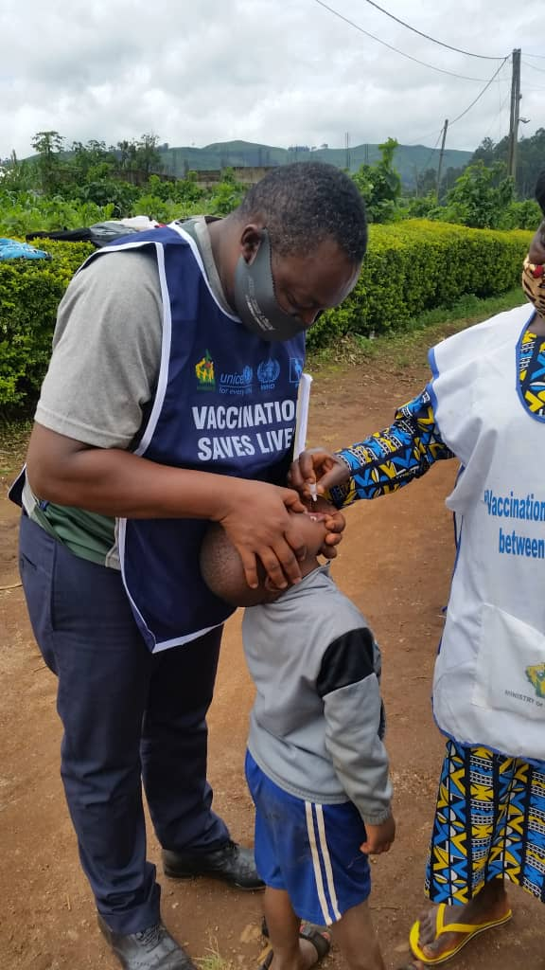

Fifth Photo

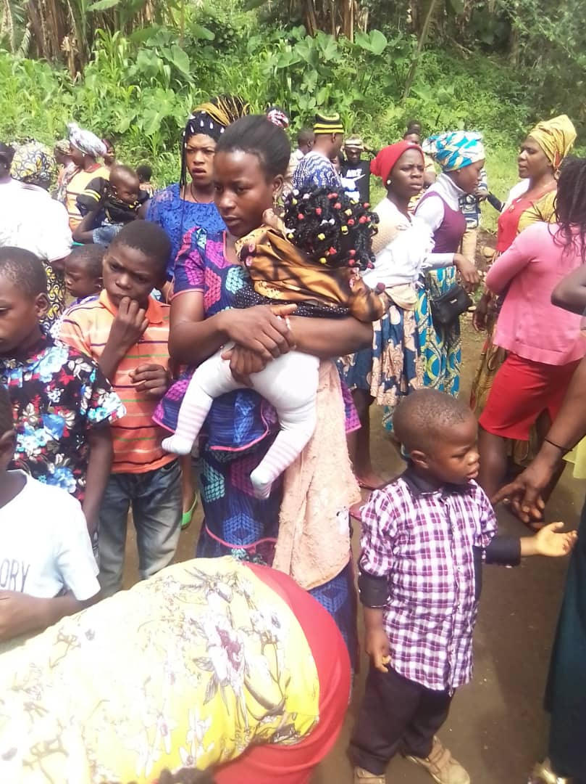

Organized Children Vaccination Program for the Internally Displaced People at Muteff rural Community

Sixth Photo

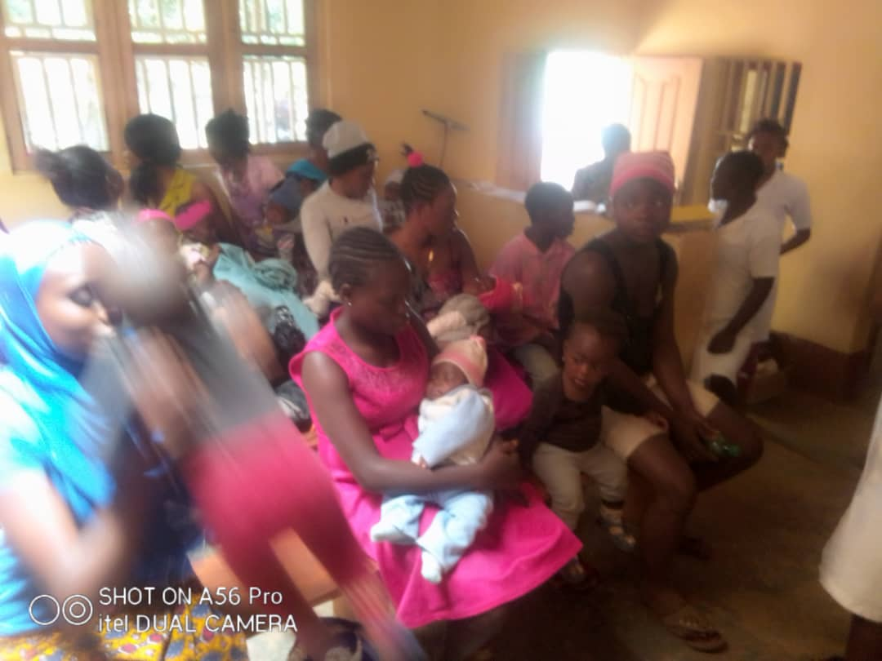

Organized Children Vaccination Program for the Internally Displaced People at Muteff Rural Community

Seventh Photo

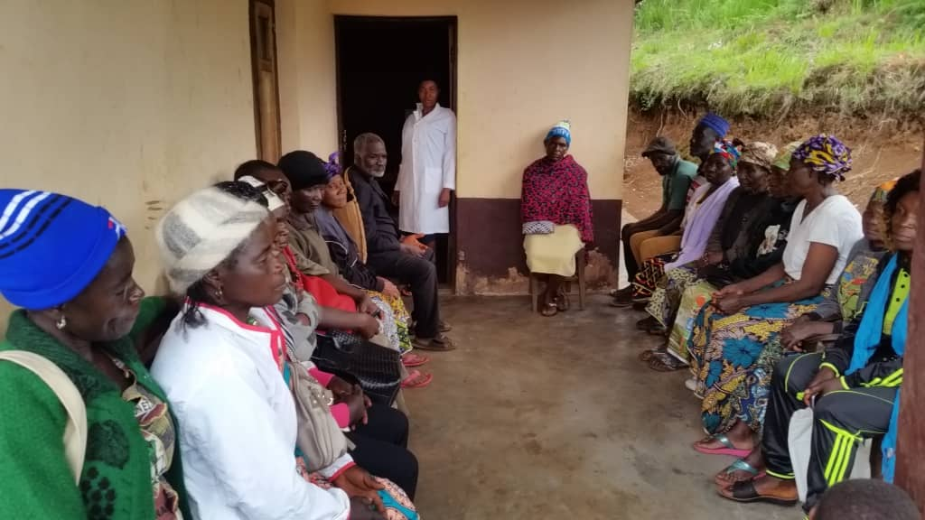

Adults taking advantage of the RECEADIT Organized Adult Vaccination Program for the Internally Displaced People at the RECEADIT Clinic at Ngemsibo Rural Community

Eighth Photo: Internally Displaced People waiting for Vaccination at Muteff
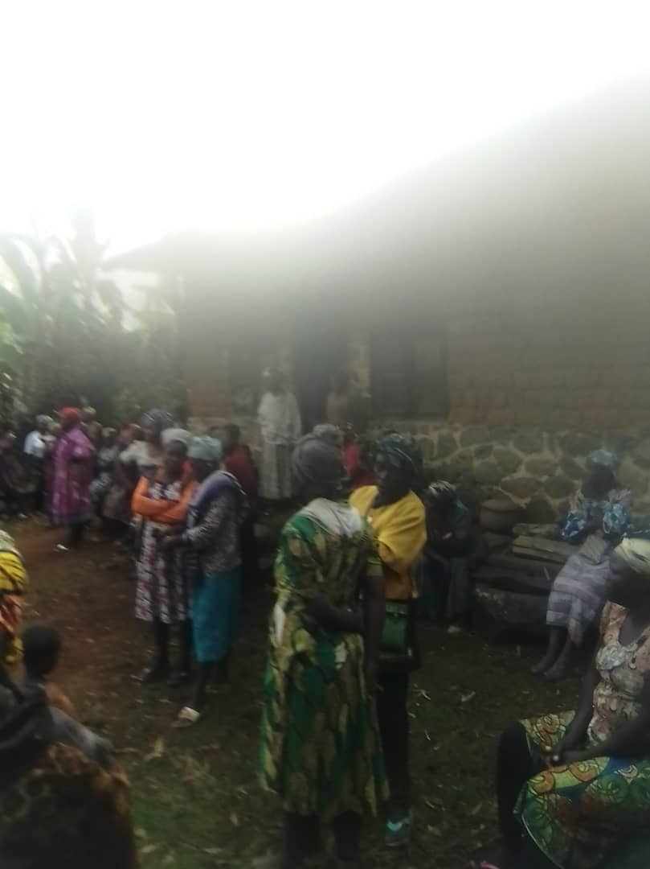

Ninth Photo

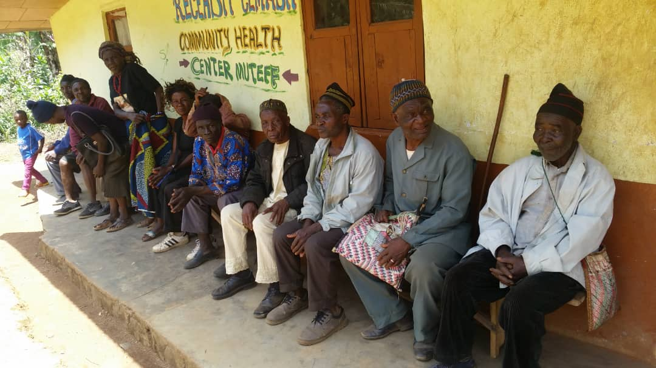

Internally Displaced Adults waiting for their Vaccination at the RECEADIT Community Health Center at Muteff rural Community

Ninth Photo Below: Internally Displaced Adults waiting for their Vaccination at the RECEADIT Community Health Center at Muteff rural Community

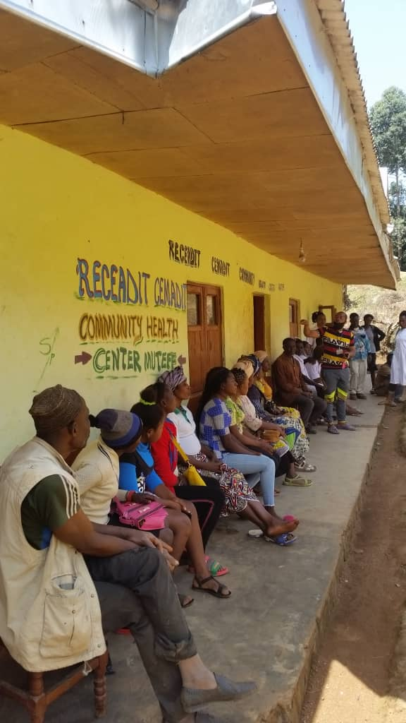
Tenth Photo

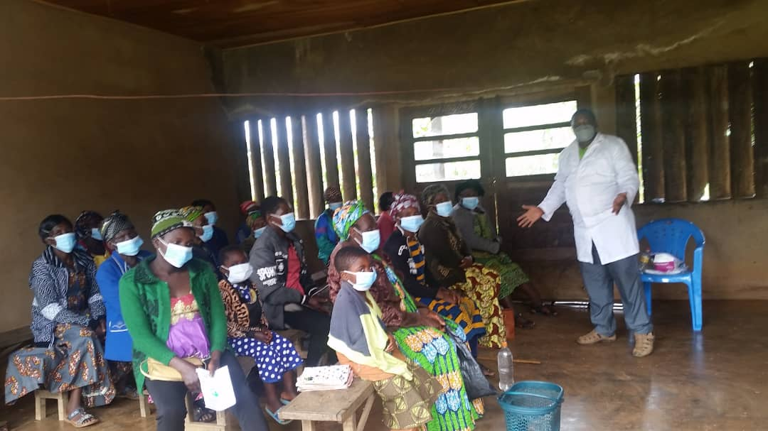
Internally Displaced Adults waiting for their Vaccination at the RECEADIT Community Health Center at Mbam rural Community

Eleventh Photo

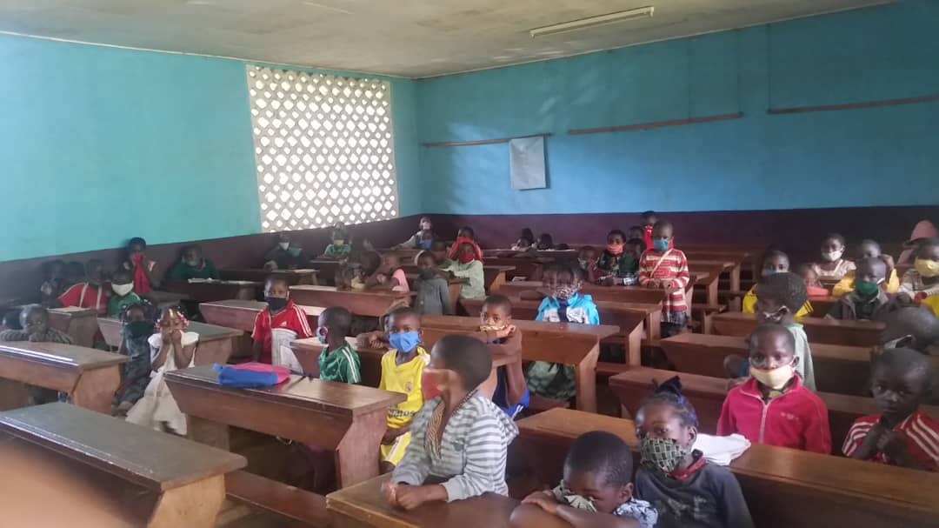

Masks Distribution Session for Children at RECEADIT Community Health Center at Mbam

Twelfth Photo

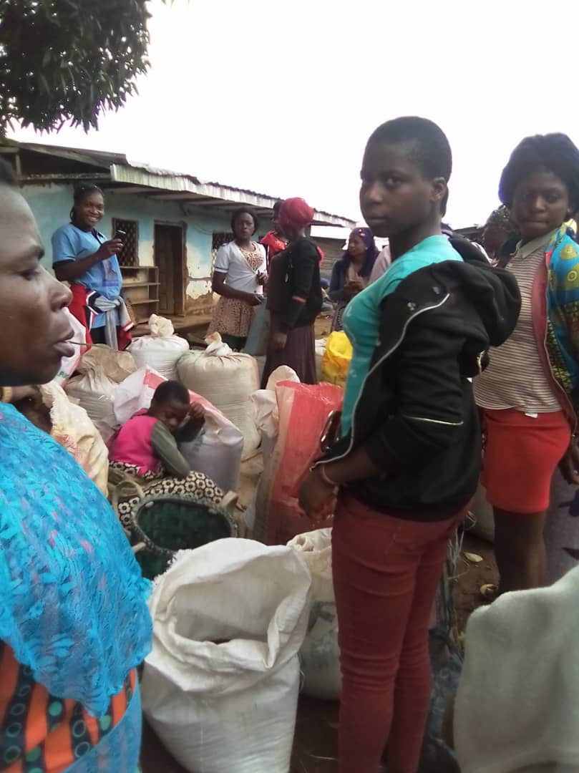

RECEADIT Providing Food Assistance to the Internally Displaced People at Muteff Rural Community

Thirteenth Photo

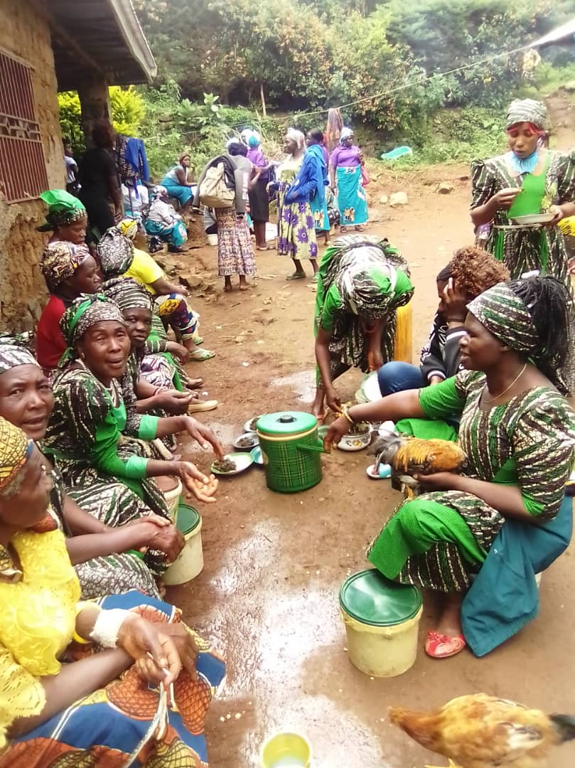

RECEADIT Providing Food Assistance to the Internally Displaced People at Muteff Rural Community

Fourteenth Photo
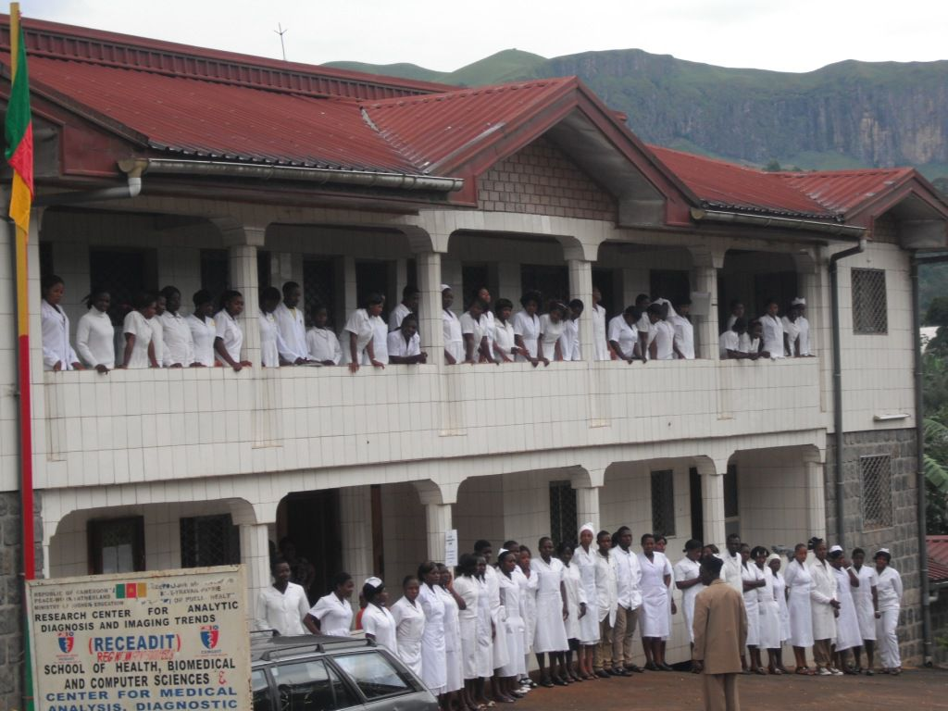

RECEADIT New Distribution Pharmacy is Located on the Fourth Floor of this RCEADIT Main Building

