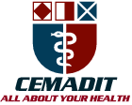
Research Center for Analytic Diagnosis and Imaging Trends (RECEADIT)
School of Health, Biomedical and Computer Sciences (SHBCS)
2019-2020 Academic Year
P.O. Box 19, Belo-Kom, Belo Sub-Division, Boyo Division, Cameroon, North-West Region,
West Africa - Tel: (237) 6 83 41 86 00 or (237) 6 77 68 99 32
CEMADIT@yahoo.com http://www.meditech-group.org

Motto: Health Care Research and Education for Services to Humanity

MEDITECH GROUP
CEMADIT
ALL ABOUT YOUR HEALTH

MEDITECH GROUP
RECEADIT
ALL ABOUT YOUR HEALTH

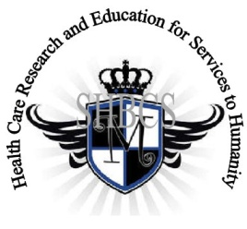

Ministry of Higher Education Ministry of Public Health Registration No. 3342 of August 31, 2011 Registration No. 4042 of August 31, 2011

GlobalGiving RECEADIT Drug Assistance for Internally Displaced People (39386) Project
Fourth Project Report of Sunday, March 22nd, 2020
On behalf of our RECEADIT Humanitarian Team, I take this opportunity to thank you so very much for your generosity and willingness to join us and to partnership with us in our journey of serving humanity through the Guidance, the Blessings, the Love, and the Grace of God Almighty.
We are glad to provide you with the following progress report and updates for our “Drug Assistance for Internally Displaced People Project (39386)” thanks to your generosity:
1) As we reported in our Third Project Report of Wednesday, December 25th, 2019, we found and recruited two female nurses for this project, all graduates of our School of Health, Biomedical and Computer Sciences (SHBCS). They continue to provide medical assistance to our internally displaced people; (See First, Third, and Fourth Photos). We are very glad to report that one of the female nurses who was injured has fully recovered now and we have found and hired a male nurse (See Fourth Photo);

2) We have built huts/shelters and found innovative, creative, protective equipment for our nurses and our internally displaced people and we hope they become much more effective (See Second Photo);

3) We have found a brave, courageous, and resilient young man, the husband of one of our female nurses, who is now assisting us with the transportation of drugs/medication and other medical equipment to the RECEADIT Clinic Annexes at Mbam, Muteff, and Ngemsibo remote, rural communities (See the Fifth and Sixth Photos); and

4) We still have not been able to find and recruit any more female nurses for the Project due to the ongoing war. We will continue the search and will hopefully find and recruit three more female nurses for the Project.

We will continue to provide you with monthly reports and updates of our other projects, activities, accomplishments, and challenges.
We hope that you will continue with us on this our journey of serving humanity through the Guidance, the Blessings, the Love and the Grace of God Almighty, a journey which has now taken us to this our “Drug Assistance for Internally Displaced People (39386)” through our new link: https://goto.gg/39386

Jilly M. Ngwainmbi, RECEADIT Project Leader

Illustration Photos

First Photo

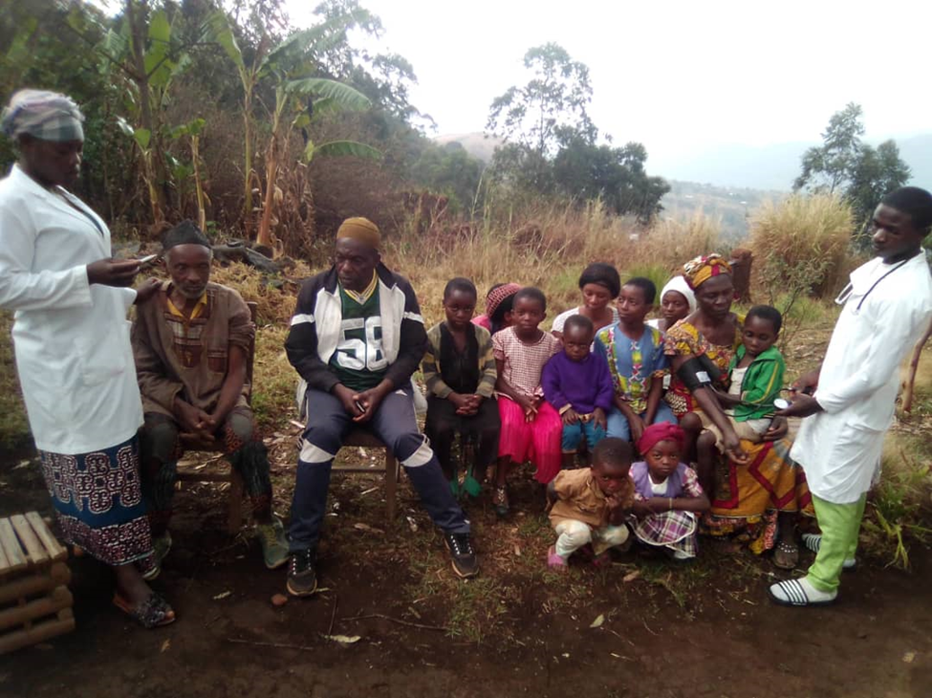

Two Nurses attending to Internally Displaced Village People at Ngemsibo

Second Photo

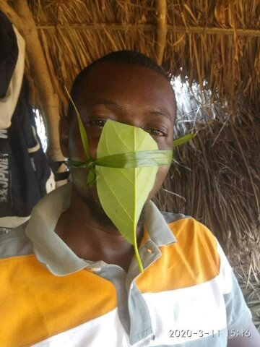

An Internally Displaced Person with our Innovative, Creative, protective Equipment in one of the Huts or Shelters we have built for the Internally Displaced People

Third Photo

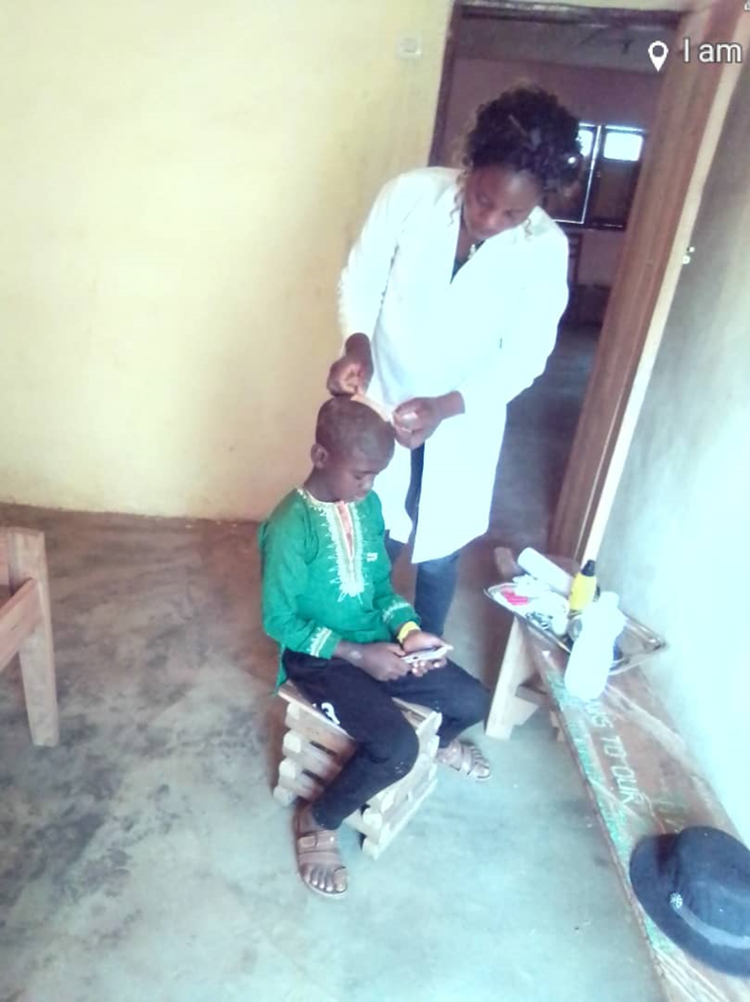

Female Nurse attending to a wounded Young Man in Our RECEADIT Clinic Annex at Ngemsibo

Fourth Photo

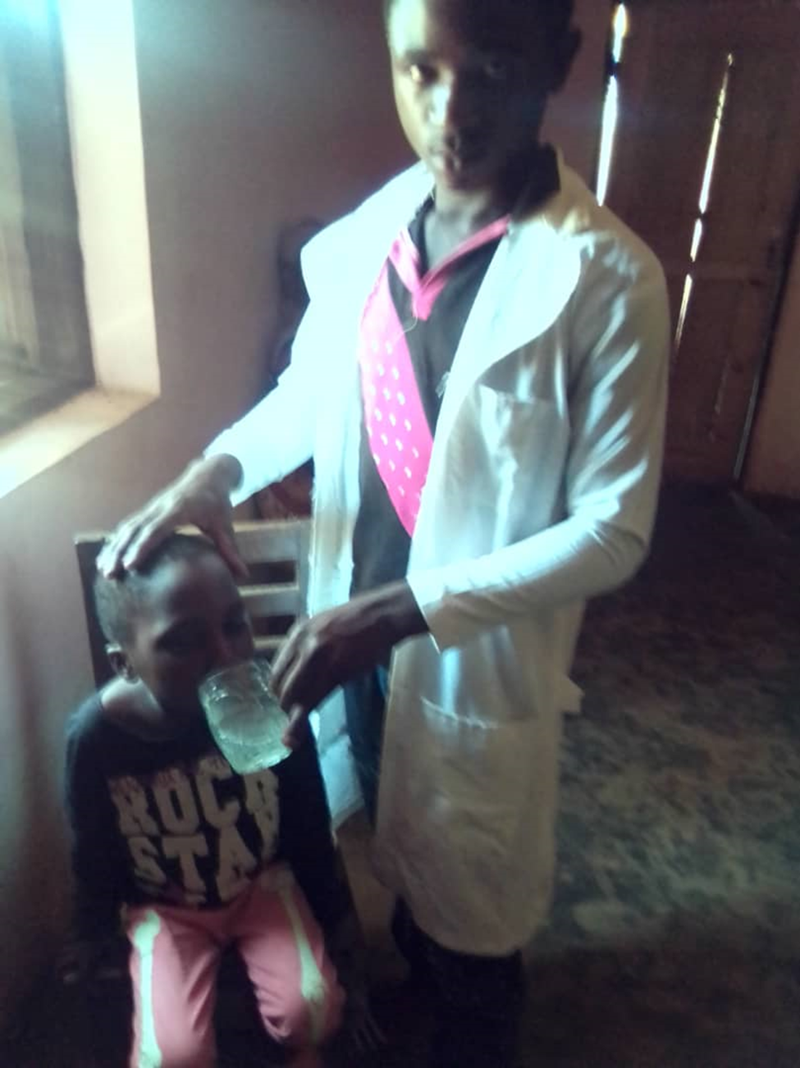
Male Nurse attending to a Young Man with Malaria in Our RECEADIT Clinic Annex at Ngemsibo

Fifth Photo
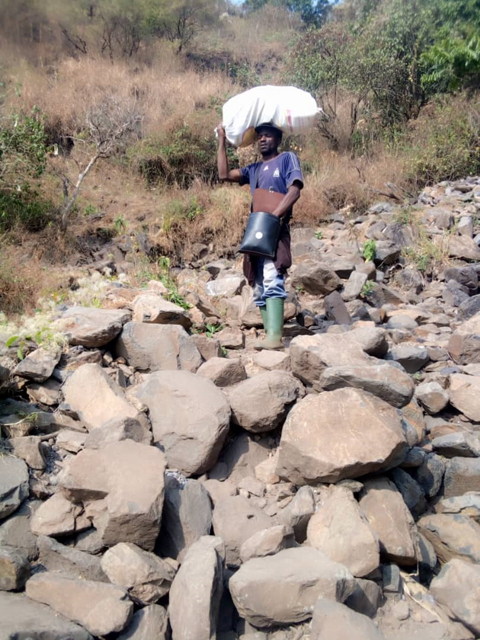
Young Man Helping to Transport Drugs/Medication to Female nurses Caring for the Internally Displaced People in the Muteff and Ngemsibo Remote, Rural Communities
Sixth Photo
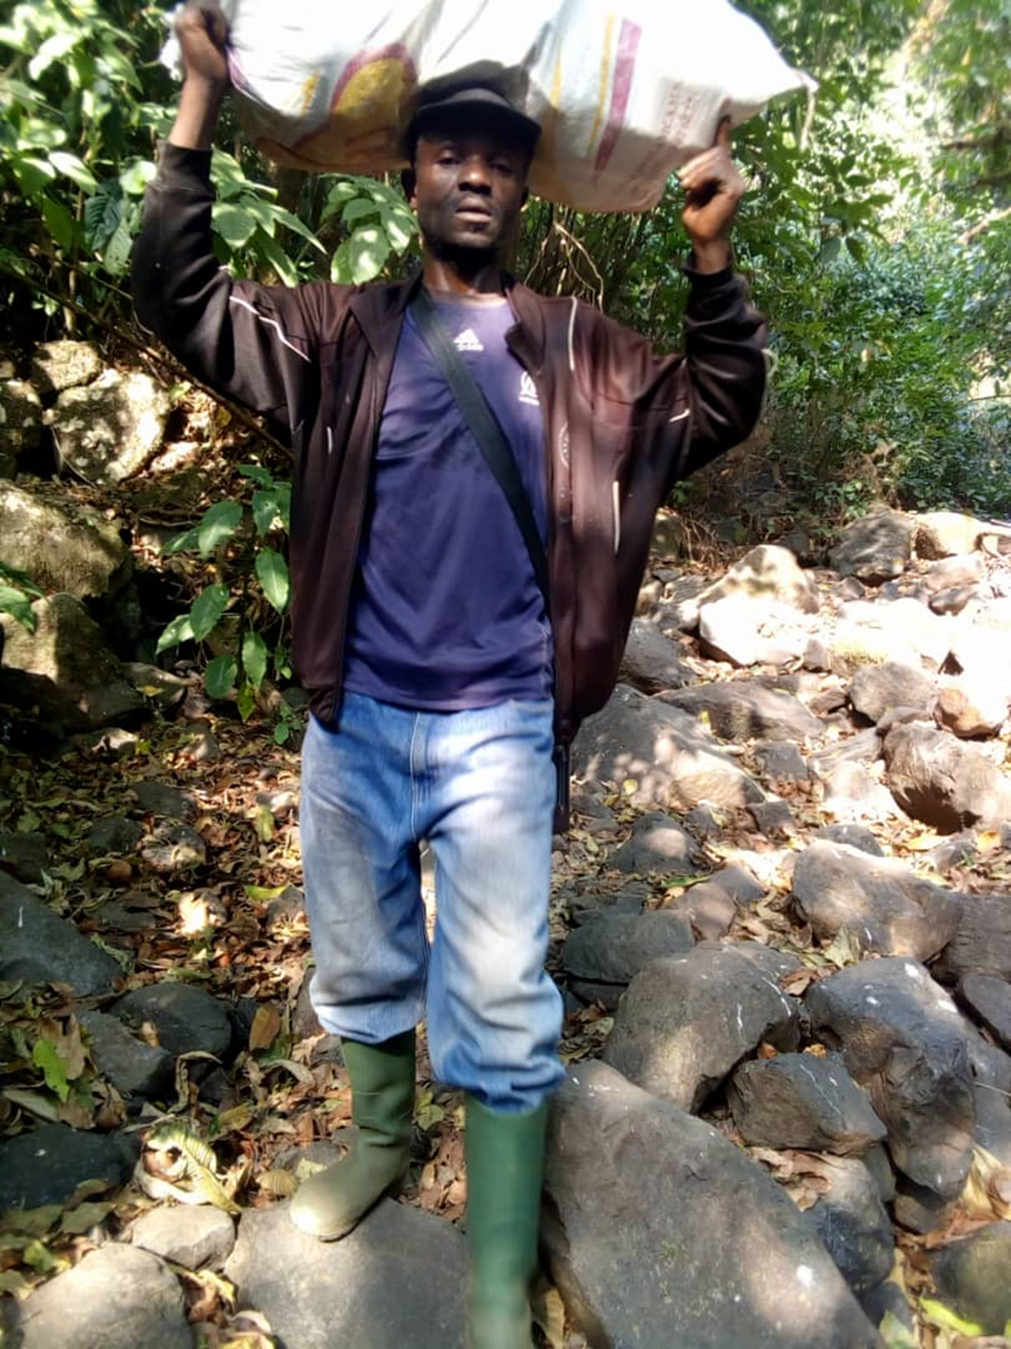
Young Man Helping to Transport Drugs/Medication to Female nurses Caring for the Internally Displaced People in the Muteff and Ngemsibo Remote, Rural Communities

