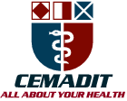
ResearchCenter for Analytic Diagnosis and Imaging Trends (RECEADIT)
School of Health, Biomedical and Computer Sciences (SHBCS)
2019-2020 Academic Year
P.O. Box 19, Belo-Kom, Belo Sub-Division, Boyo Division, Cameroon, North-West Region,
West Africa - Tel: (237) 6 83 41 86 00 or (237) 6 77 68 99 32
CEMADIT@yahoo.comhttp://www.meditech-group.org

Motto: Health Care Research and Education for Services to Humanity

MEDITECH GROUP
CEMADIT
ALL ABOUT YOUR HEALTH

MEDITECH GROUP
RECEADIT
ALL ABOUT YOUR HEALTH

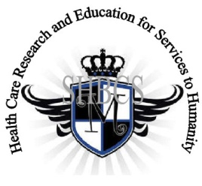

Ministry of Higher EducationMinistry of Public Health Registration No. 3342 ofAugust 31, 2011Registration No. 4042 of August 31, 2011

GlobalGiving RECEADIT Drug Assistance for Internally Displaced People (39386) Project
Fifth Project Report of Monday, July 20th, 2020
On behalf of our RECEADIT Humanitarian Team, I take this opportunity to thank you so very much for your generosity and willingness to join us and to partnership with us in our journey of serving humanity through the Guidance, the Blessings, the Love, and the Grace of God Almighty.
We are glad to provide you with the following progress report and updates for our “Drug Assistance for Internally Displaced PeopleProject (39386)” thanks to your generosity:
1) As we reported in our Fourth Project Report of Sunday, March 22nd, 2020, we now have two female nurses and one male nurse for this project, all graduates of our School of Health, Biomedical and Computer Sciences (SHBCS). They continue to provide medical assistance to our internally displaced people (See First Photo);

2) We have intensified our Face Masks Wearing and Distribution Campaign among the Internally Displaced People within the Mbam, Muteff, and Ngemsibo remote, rural communities (see (See First, Second, and Third Photos);

3) Our brave, courageous, and resilient young man, the husband of one of our female nurses, continues to assist us with the transportation of drugs/medication and other medical equipment to the RECEADIT Clinic Annexes at Mbam, Muteff, and Ngemsibo remote, rural communities (See Fourth Photo); and

4) As we reported in our Fourth Project Report of Sunday, March 22nd, 2020, we still have not been able to find and recruit any more female nurses for the Project due to the ongoing war. We will continue the search and will hopefully find and recruit three more female nurses for the Project.

We will continue to provide you with monthly reports and updates of our other projects, activities, accomplishments, and challenges.
We hope that you will continue with us on this our journey of serving humanity through the Guidance, the Blessings, the Love and the Grace of God Almighty, a journey which has now taken us to this our “Drug Assistance for Internally Displaced People (39386)” through our new link: https://goto.gg/39386

Jilly M. Ngwainmbi, RECEADIT Project Leader

Illustration Photos

First Photo
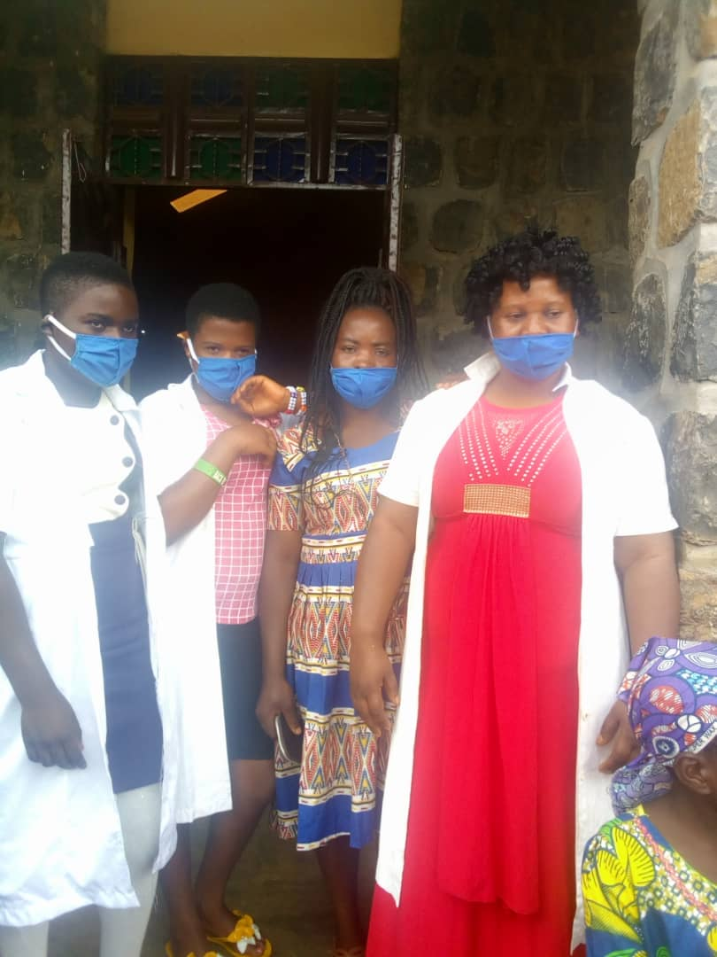

Nurses Getting Ready to distribute Face Masks to Internally Displaced Village People at a Remote Location at Ngemsibo.

Second Photo

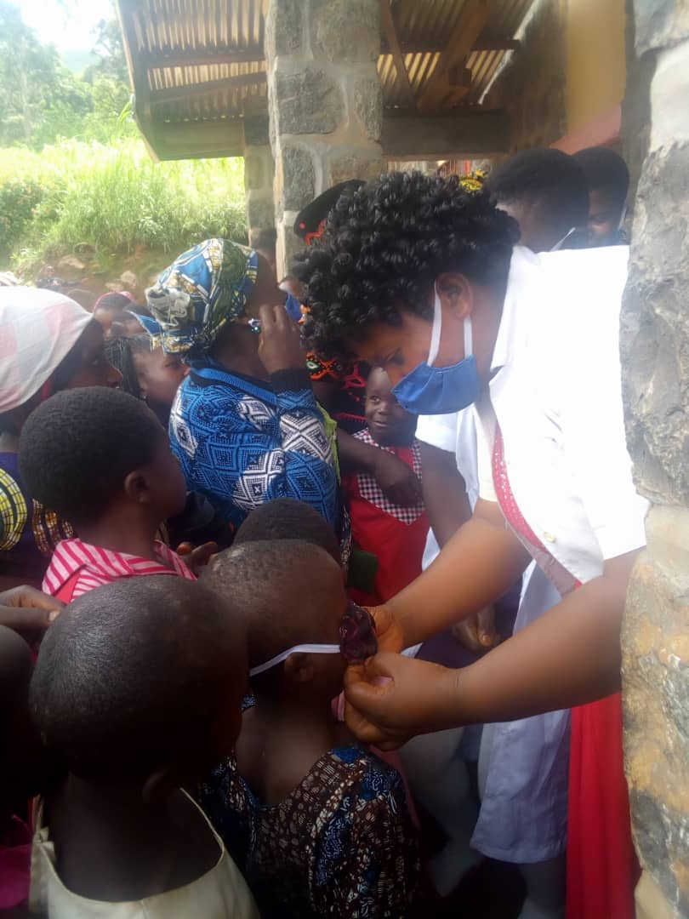

Female Nurse Assisting Internally Displaced Children put on their Face Masks at a Remote Location in Muteff Rural Community

Third Photo

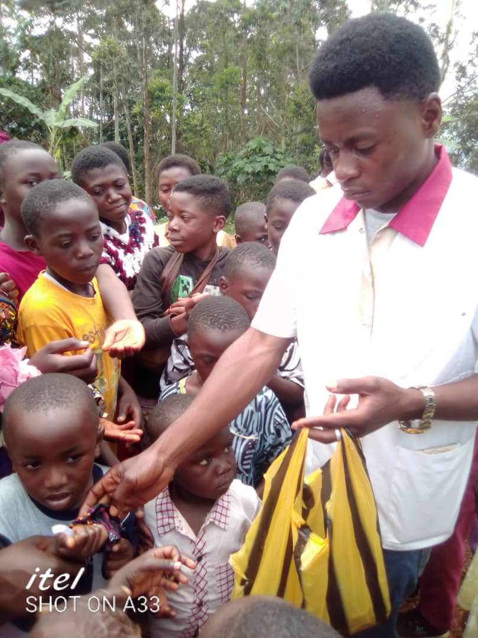

Male Nurse distributing Face Masks to Internally Displaced Village People at a Remote Location at Mbam

Fourth Photo
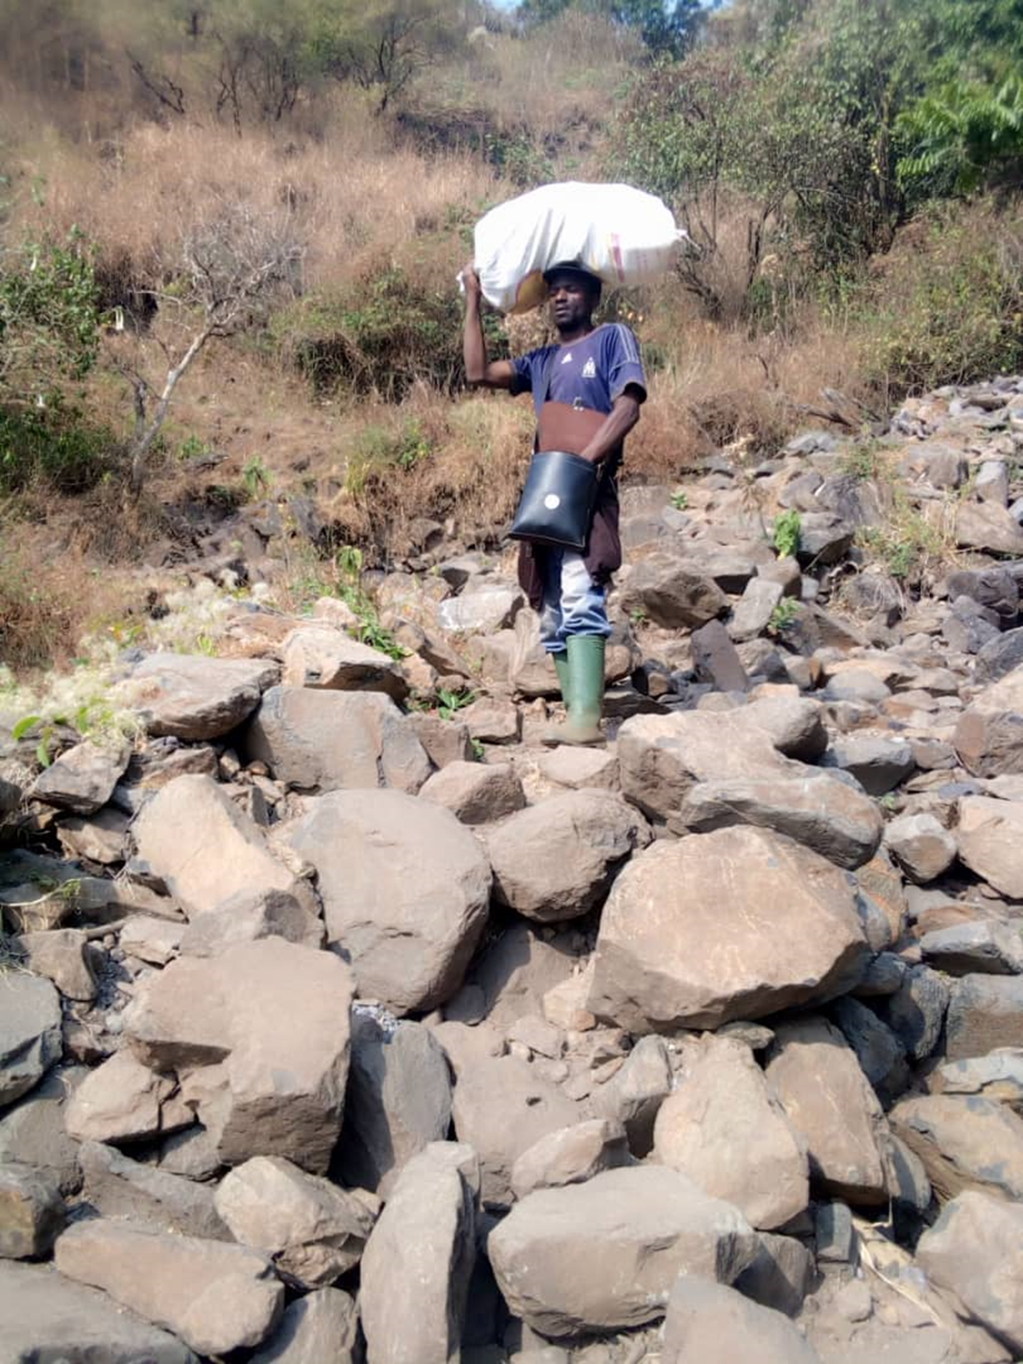
Young Man Helping to Transport Drugs/Medication to Female nurses Caring for the Internally Displaced People in the Muteff and Ngemsibo Remote, Rural Communities

