
Project update January 2010
Project Title: Indonesia Earthquake; Provide Necessities
By Asriadi - Team leader
The earthquake that has destroyed the West Sumatra made many houses were destroyed and even loss of property, families and their jobs. The lack of assistance for victims of the earthquake so that most of them build their own makeshift house with the crumbling remains of their house and occupied it. Their sufferings today are very painful to remember they have to stay at home with the help of makeshift emergency.

On January 5, 2010, we have been carrying out activities to provide assistance for earthquake victims in Padang West Sumatera. We have received donation $ 170.00 from GlobalGiving donors and And we've used to buy necessities such as rice, noodles, side dishes and drinking water, and have been distributed to 35 families of the earthquake victims in Padang, West Sumatra. Baharuddin one earthquake victims say; that this assistance is very valuable for us, and many other earthquake victims who live in trouble and need help from us all.
In this program the most urgent needs is necessary;
1. Material assistance for home repairs
2. Relief food and drink
3. Clothing assistance
4. Assistance to business capital (this assistance is for those who previously had a business to return to continue their efforts).

Please see the video when incident SR 7.3 earthquake in Padang, West Sumatra;
http://www.youtube.com/watch?v=reQqxqNa1Jk

Therefore, your help will mean so much to rebuild their life after an earthquake destroyed this province. Again, we wish you many thanks for all your help and attention to Padangnese of earthquake victims in West Sumatra.
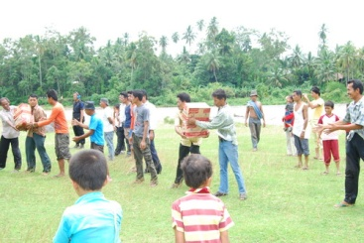  Provide necessities for earthquake victims in Padang West Sumatera | 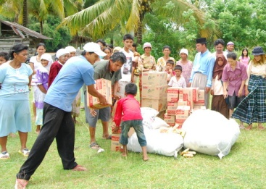  Provide necessities for earthquake victims in Padang West Sumatera
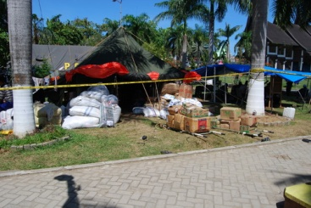  Tents evacuation in Padang Pariaman | 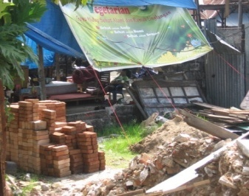  Some of earthquake victims still stay in emergency houses
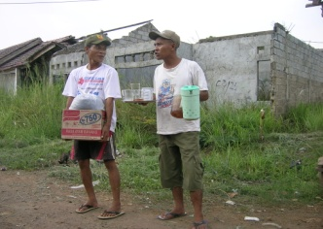  Baharuddin and Wisnu after received assistance from Puspem | 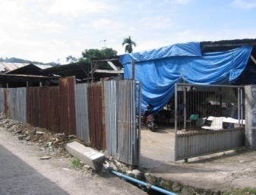  Some of earthquake victims still stay in emergency houses

