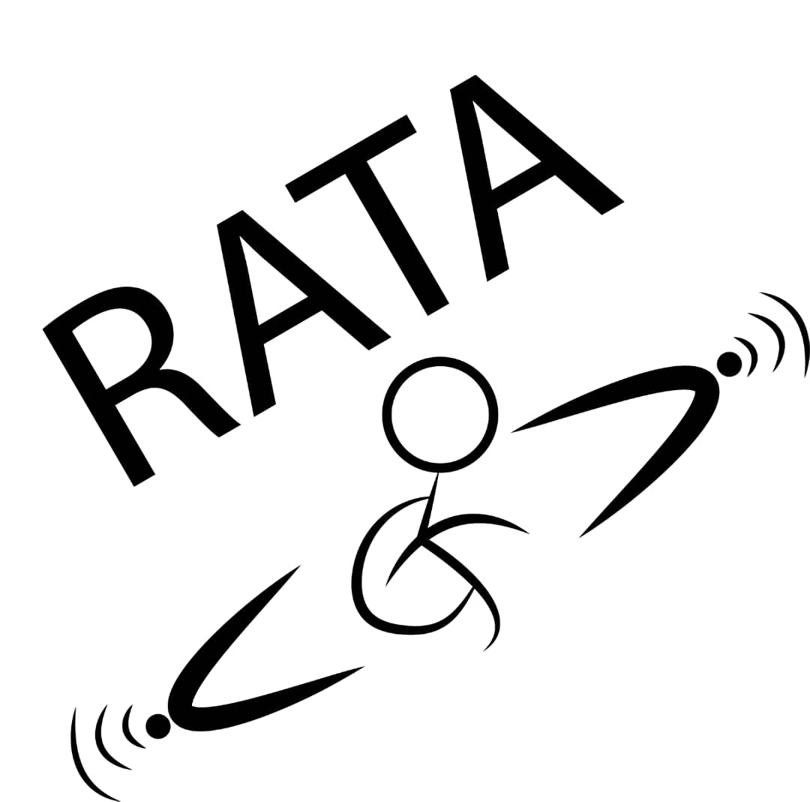

**Can you imagine a visually impaired person sending you an e-mail?**

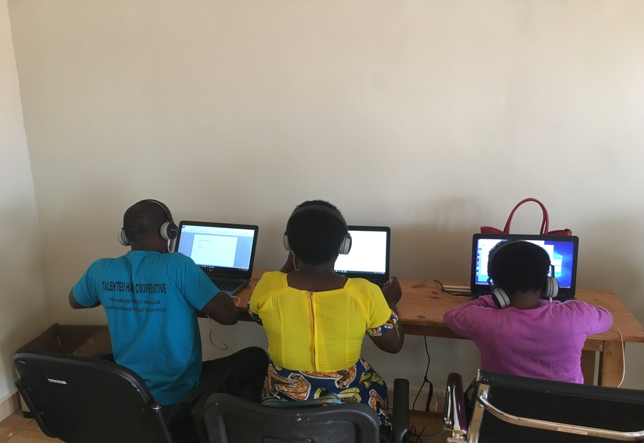

In 12 million people in Rwanda, 1/100 is visually impaired and many of them don't have a job. Youth with disabilities in Rwanda mostly visually impaired can access assistive devices while at school (special schools) but after finishing school it's not easy for them to access those devices. The assistive devices help them to access information for employment opportunities and use them in their daily activities.

Therefore, from May, 14th 2019 to 24th May 2019, Rwanda Assistive Technology Access (RATA) conducted its first phase of training for people with visual impairments on ICT. The project was called: “Empower visually impaired for employment in Rwanda” funded by Globalgiving donors.

RATA is a local non -governmental organization in Rwanda registered under the law N0 422/RGB/NGO/OC/07/2018 founded on 4th January 2018 with mission of ensuring accessible ICTs (Assistive technologies) for people with disabilities in Rwanda.

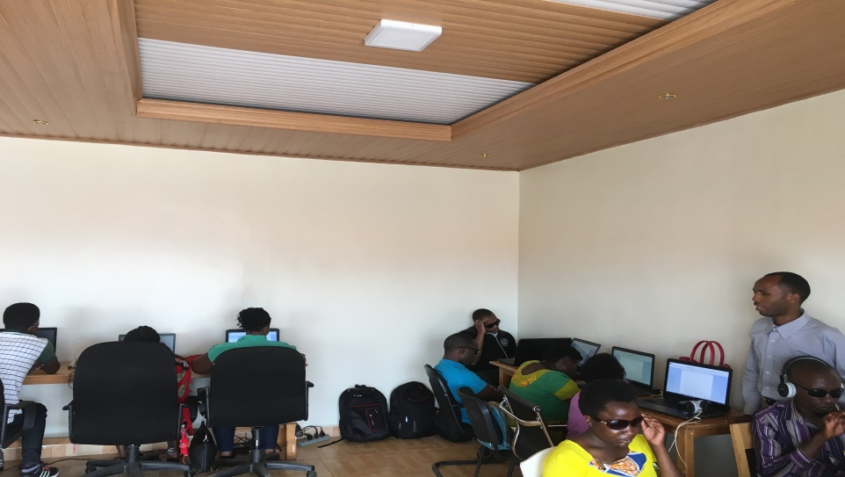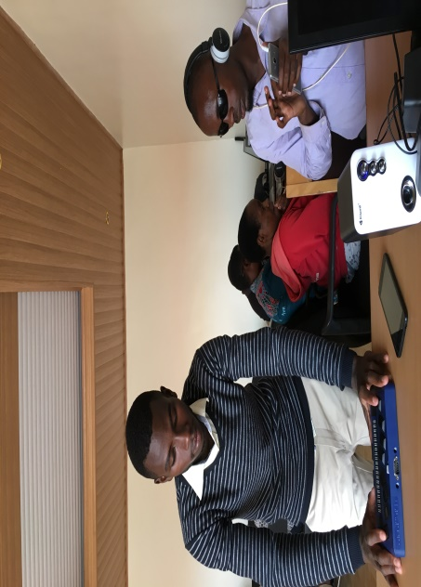

10 participants were in an intensive training everyday from 8 am up to 2 pm. Lessons such as keyboard typing using braillino braille display, text formatting, Microsoft word and excel, using internet and sending e-mails, and on how to use a smartphone were covered.

**Testimonies from participants**



“In this training, I have learnt how to use Microsoft office and excel which will be useful in my further studies as I am about to start my university studies. I was also happy to learn how to use a smartphone and to get it. It will help me to live more independently as it has applications that help visual impaired people in their daily activities” – Perlin Majyambere



“ I thank RATA and Globalgiving donors for this opportunity. We have learnt a lot of things in the training, we wish there could be more trainings like this. I would love to ask RATA to have a training Centre so that we can always come for training and for further practices.” - Florida Nibyobyiza

**Different visitors were impressed by learners’ capabilities.**

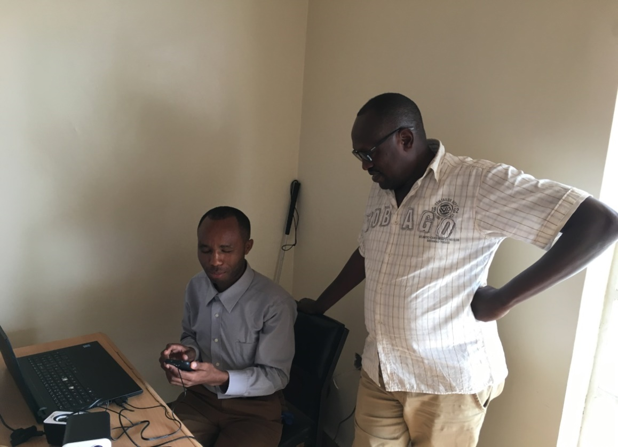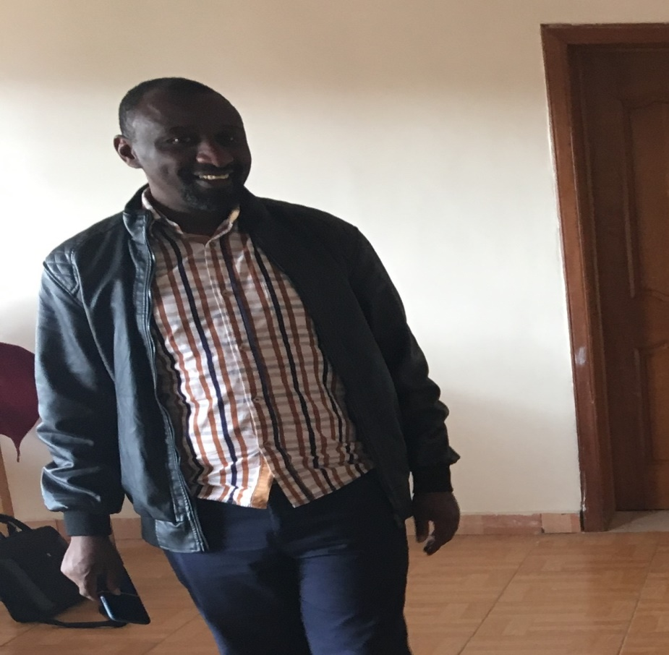

And some of the participants could be given soon internships.

**At the end of the training, best performers were given smartphones.**

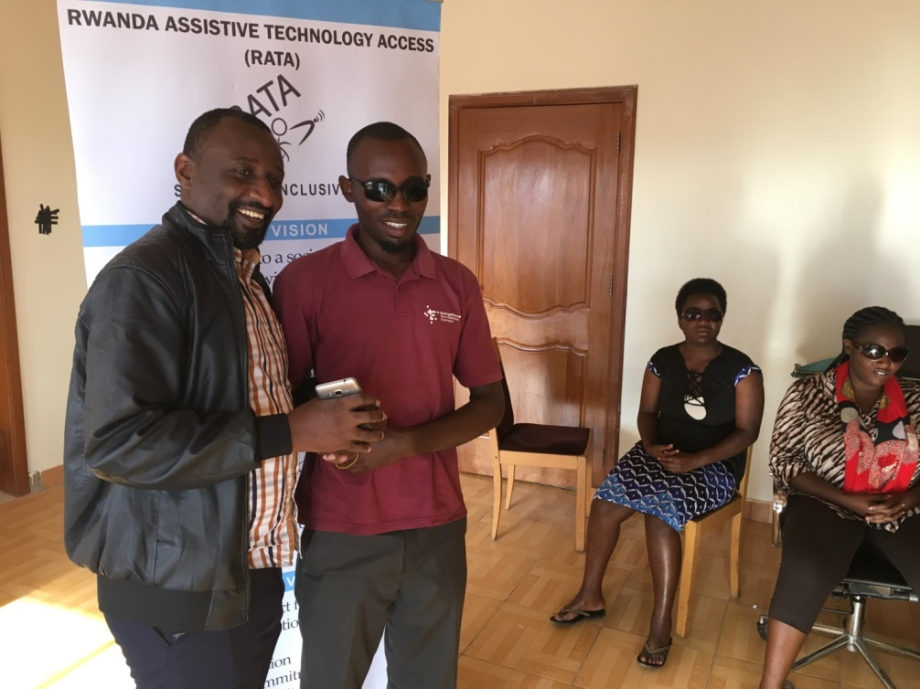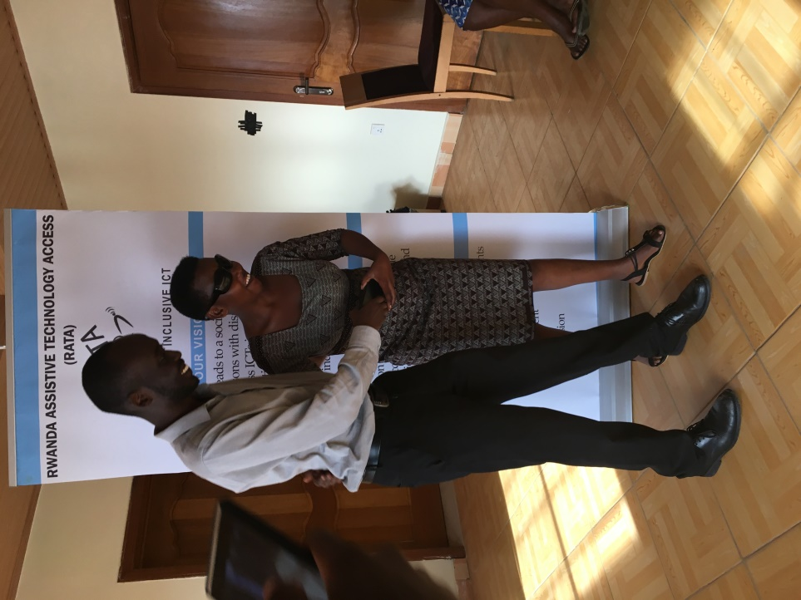

The next phase/session is scheduled in July 2019.

**Thank you Globalgiving donors!!!**

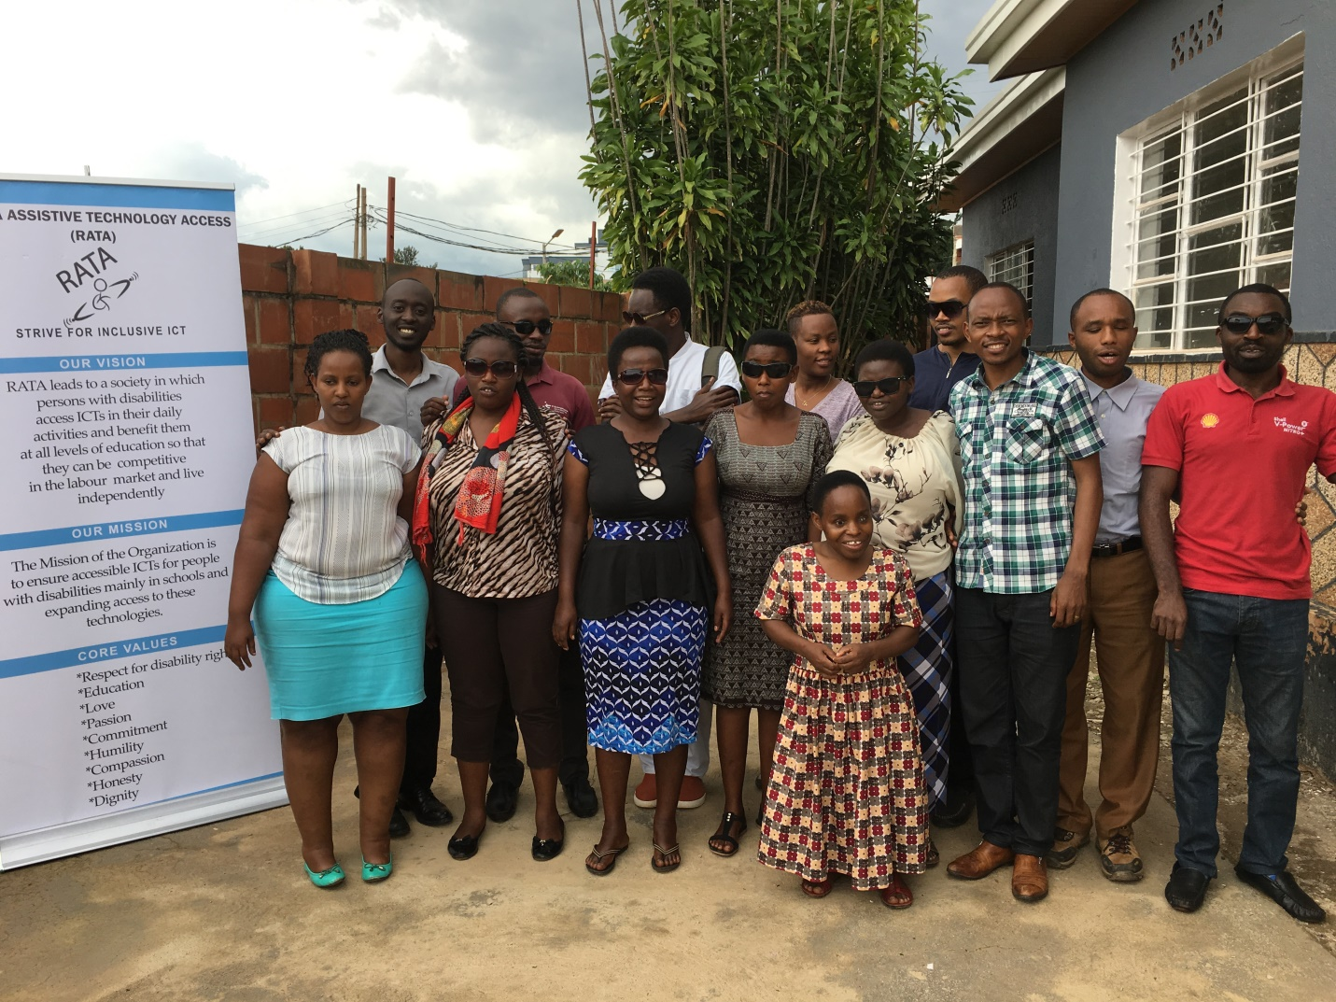

We couldn’t have done this without your generous support! We are deeply grateful for your contribution!

Website: [www.rata.rw](http://www.rata.rw)

E-mail: info@rata.rw

Address: Kigali- Rwanda

Remera- Gasabo KG 1 AV 23