Rotary Project – Build a Vision Clinic:
- Dr. Kate Coleman initiative
- Build a small Vision Clinic
- Solve problems locally
- Right to Sight have visited the village
- RTS Indian doctor also visited & gave eq list
- RTS use Dr Helen Roberts in Kenya for surgery
- The Health Centre will employ the technician

Who will benefit:
Year 1 ROMBO / ENTERARRA DIVISION: POP 40,000
- 28 Primary School
- 4 Secondary School
- 20 Nursery school

Year 2 KUKU / LOITOKITOK DIVISION: POP 43,000
- 27 Primary School
- 7 Secondary School
- 15 Nursery School

Year 1:
- Set up Vision Centre in a room in existing Health Centre
- Purchase initial round of equipment
- Employ Ophthalmic Clinic officer and an assistant
- 40 Cataract operations improving employment
- 4000 school children eye tested improving education
- 900 people (walk-in) tested at Vision Centre
Year 2

- Build purpose built Clinic
- 100 Cataract operations improving employment
- 5000 school children eye tested improving education
- 1000 people (walk-in) tested at Vision Centre

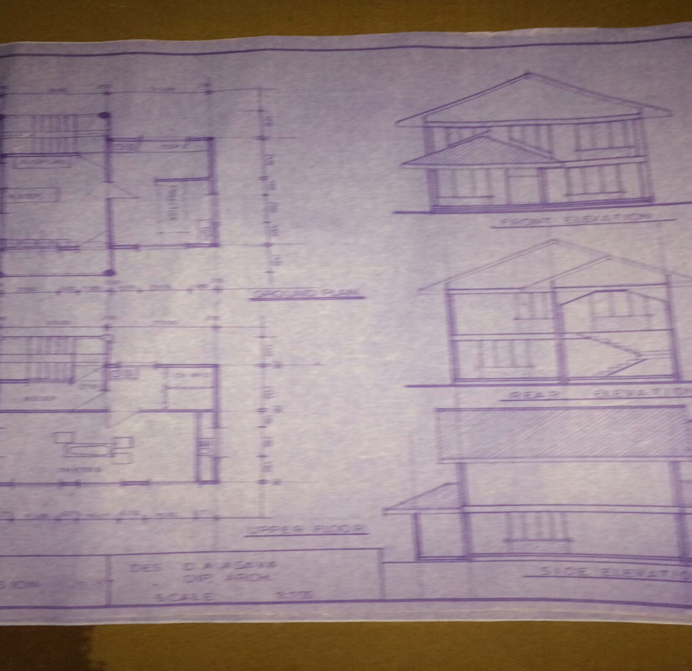
Before and after photos:

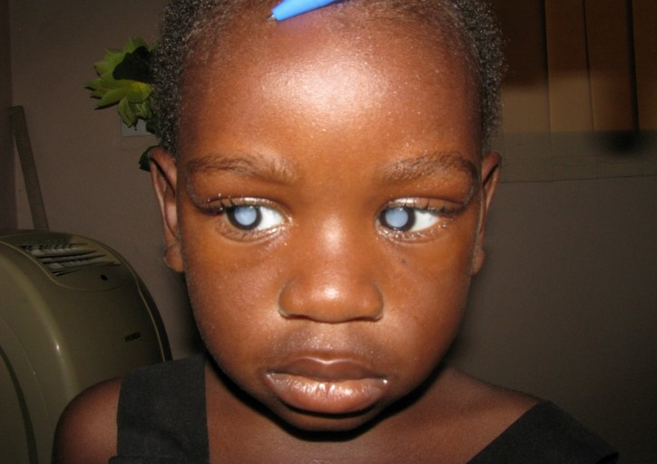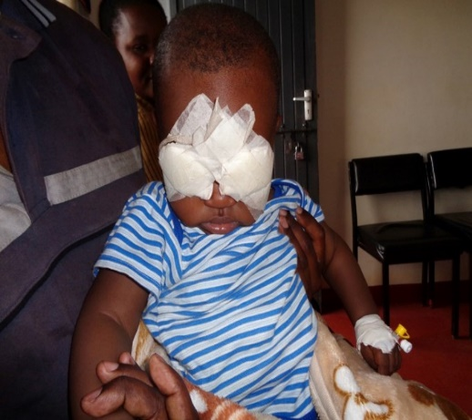

1st postoperative day after cataract surgery by RTS
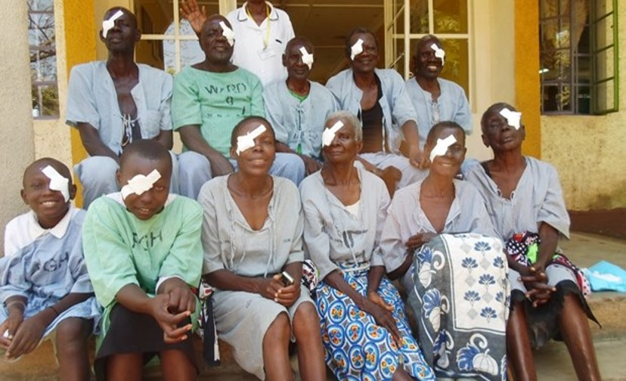

Fundus Eye Camera / mobile phone
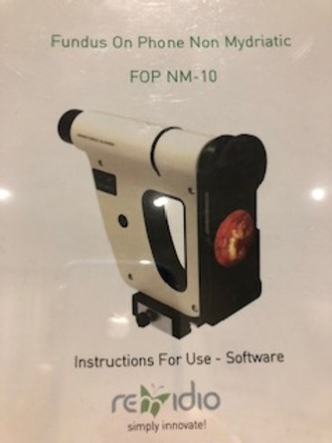
Budget

Phase 1:
    - Ophthalmic Clinical Officer £6,000
    - Assistant £2,500
    - Equipment £9,000
    - Fundus Camera £7,000
    - Outreach program £2,000
    - Dr Helen cataract surgery £5,000
Phase 2:
    - Building & fit out £25,000

Outcome

Happy Children of Rombo

