Self Help Group Program
Six Monthly Report (Apr-Sep. 2010)
Submitted to
Global Giving

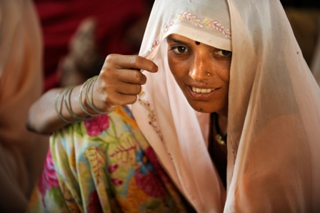

SEVA MANDIR
Udaipur Rajasthan, India
info@sevamandir.org
www.sevamandir.org

Introduction:

The Self Help Groups bring women together in saving and credit activities, eventually giving them the opportunity to access external finance to support a variety of productive activities or consumption needs.

The Self Help Group program is a significant part of Seva Mandir’s women empowerment Programme. More than twenty-five years old women’s empowerment programme has helped Seva Mandir to develop a deep understanding of gender issues in the local context. This is reflected in the evolving strategies that are more effective in transforming gender relations and enable women to gain greater control over their own lives and to become agents of positive social change.

The progress -

At present there are 493 SHGs with a membership of 7516. During this period 22 new SHGs were formed and 23 SHGs were closed due to various reasons. During the last six months a lot of efforts were directed towards vision development and capacity building of staff, as well as of the SHGs. The vision of the SHG programme was reviewed and revised and it has been one of the most significant achievements of this period. Regular monthly meetings of SHGs were organized in this period.

The records of these 493 SHGs are maintained by 152 accountants. For all these SHGs the account books have completely been computerized. This is very encouraging and it helps us keeping up the records easily. The table below given an account of the Self Help Groups in all the blocks of Seva Mandir –

Name of Block | No of SHGs |  | Membership
Name of Block | Mar-10 | Sep-10 | Mar-10 | Sep-10
Urban | 60 | 66 | 1192 | 1315
Badgaon | 60 | 56 | 963 | 874
Girwa | 52 | 56 | 842 | 901
Jhadol | 109 | 111 | 1479 | 1501
Kherwara | 135 | 116 | 1982 | 1697
Kumbhalgarh | 78 | 88 | 1086 | 1228
Total | 494 | 493 | 7544 | 7516

Financial Status of SHGs (in INR)

The net-owned fund of 493 SHGs till September 2010 is Rs. 17,308,217 (USD 384,627). The total savings stands at Rs. 13,854,243 (USD 307,872). The cash at bank is Rs. 4,416,187 (USD 98,138); the cash in hand is Rs. 8,28,853 (USD 18,419) and the loan outstanding is Rs. 12,408,863 (USD 275,753).

The savings to loan ratio is almost 1:1 which indicates that members are rotating all their savings for credit; it is 3:1 in Girwa and 2:1 in Kumbhalgarh which reflects need of greater loan rotation in these two blocks.

The cash at bank is 25.5% of the total funds. It is highest in Jhadol (85.8%) and Girwa (50.2%) block and lowest in Kherwara (18.3%) and Urban (4.5%) block. This indicates that members are still not using their funds, though there is ample demand for credit. This issue will be addressed through regular monitoring of SHGs and motivating members to follow group values and norms. The table below explains the current status of funds in all the SHGs-

Name of Block | Savings | Cash in hand | Cash at bank | Loan outstanding
Urban | 5,790,350 | 37,754 | 1,329,283 | 5,891,400
Badgaon | 2,504,545 | 87,238 | 902,633 | 2,737,500
Girwa | 854,090 | 110,731 | 456,419 | 311,888
Jhadol | 1,277,482 | 189,078 | 1,266,045 | 945,667
Kherwara | 2,708,246 | 274,183 | 168,505 | 2,166,714
Kumbhalgarh | 719,530 | 129,869 | 293,302 | 355,694
Total | 13,854,243 | 828,853 | 4,416,187 | 12,408,863

The total cash in hand is 4.8% of the net owned fund. It is highest in Jhadol (12.8%) and Girwa (12.2%) and lowest in Urban (0.5%) and Badgaon block (2.7%).

Performance of SHGs on the basis of main indicators

Name of Block | Meeting Regularity (%) | Attendance Regularity (%) | Saving Regularity (%) | Interest Re-payment (%)
Urban | 97.0 | 94.4 | 87.9 | 100
Badgaon | 93.3 | 80.2 | 78.4 | 100
Girwa | 89.8 | 81.5 | 78.2 | 100
Jhadol | 92.3 | 75.2 | 71.8 | 73
Kherwara | 91.4 | 80.8 | 74.3 | 100
Kumbhalgarh | 97.3 | 88.5 | 87.6 | 100

The performance of SHGs on the basis of the main indicators – meeting regularity, savings regularity, attendance regularity and interest repayment shows that Urban block outperforms other blocks in all indicators. Interest repayment rate is 100% in all blocks except Jhadol.

Profit distribution
After the audit in March 2010, for the first time, during April – June 10, profit distribution was done in all the SHGs. For this initially the criteria for profit distribution was discussed with the groups and it was decided that since it was being done for the first time, it should be based on total savings of members. The members received a profit of Rs. 2,385,169 (USD 53,004) from their SHGs.

The process of profit distribution has greatly contributed in strengthening SHGs by making them realize importance of financial discipline and increasing their funds in SHGs. 65 SHGs have raised their accountant’s honorarium.

Rodi Devi is a member of “Shakti Swayam Sayayta Samuh” in village Mohamed Phalasia of Jhadol block, since 2001. There are 12 members in her group. Rodi Bai has been involved in brick kiln business for the past many years. She wanted to upscale her business and therefore applied for loan to the group. Her group applied to the bank and was sanctioned a loan of Rs. 312,500 by Punjab National Bank, under a government scheme “Swarn Jayanti Swarojgar Yojana (SGSY), owing to groups good performance. As a result of this, Rodi Bai received a loan of Rs. 50,000 ($ 1,150) from the group for her business.
The loan has helped Rodi Bai in up scaling her business. She has now started supplying bricks to Ogna, Jhadol, Magwas and other nearby villages. As a result her financial and economic status has improved significantly. Now, she is also able to pay her loan installments easily and till date she has repaid Rs. 21,500 (nearly 44% of her total loan amount).

Capacity building of SHGs

Supporting women for the income generation activities entails providing trainings, securing access to loans and government schemes, facilitating access to required materials and providing various forms of advice and business support. Financial management is kept as priority for these women to learn. Following is the detail of the trainings imparted during the reporting period -

a. Campaigns
During this period 36 campaigns (one day) in all blocks were organized, in which 1,216 women from 99 SHGs participated. These campaigns mainly focused on the concepts of SHGs, performance indicators and addressing the specific problems of the SHGs. These campaigns have proved very effective in improving the group performance in terms of regular meetings, attendance, savings and repayment of their loans.

b. Training of accountants
To make the Accounting system more effective and efficient it was decided to categorize accountants into different categories as per their skills and to strengthen their capacity systematically. Six training programmes were organized for some accountants in this period. The trainings focused on enhancing their accountancy skills. The trainings were being facilitated by staff members of Seva Mandir.

In addition, regular monthly meetings at all zone offices were organized to further build accountancy skills and ensuring the exchange of data from villages to block offices.

Income Generation Initiatives

The existing income generation activities include goatery, dairy, fisheries, pottery; individual enterprises etc were continued during this period.

One day training on flower cultivation was organized on 13 May 2010 in Girwa block. 55 people including women and men from 4 villages viz Peepalwas, Kheriya, Wadafala and Kaliwas - participated in this training. These people have been involved in flower cultivation but wanted to learn about the new techniques for improving their production of flower. The training was facilitated by a local resource person who himself is involved in this business.

In Kherwara block, one woman from village Nichlatalab started selling milk through a kiosk provided by the Government, The two SHGs of the same village received a kiosk set for selling fishes from the Department of Fisheries.

1. Ornamental fishery
In village Kaya, Girwa 13 women have been rearing ornamental fisheries since 2008. These women raise different types of ornamental fishes like black molly, silver fish, gold fish etc and earn around Rs. 500-1000 every year from the sales of these fishes.

2. Soy processing micro-enterprise

In village Kaya, there are 4 SHGs of women. The members meet every month and save up. They use the funds for loaning it out to one another for meeting their credit needs. In 2006 a group of 13 women from these SHGs took up ornamental fisheries for income generation with support of Seva Mandir and Department of Fisheries. It was the first time that such an activity was undertaken by tribal women in Seva Mandir’s area of operation. The success of this activity helped the members of the SHG and their families realize the significance of initiating village based livelihood activities. As a result, during monthly meetings, continuous demands from these women started coming up to take up more such intervention for the youths in their families.

Seva Mandir in partnership with YES Bank and Malnutrition Matters, Canada initiated a soy processing microenterprise with youths of Kaya village in February 2010. Through this partnership Seva Mandir purchased a soy processing system known as Vita Goat. With an input of soy beans, Vita Goat produces soy milk, tofu and yogurt. The goals of this microenterprise are to –
1) provide a steady source of employment and income for the tribal villagers and
2) address the problem of malnutrition in Rajasthan through the promotion of healthy food products.

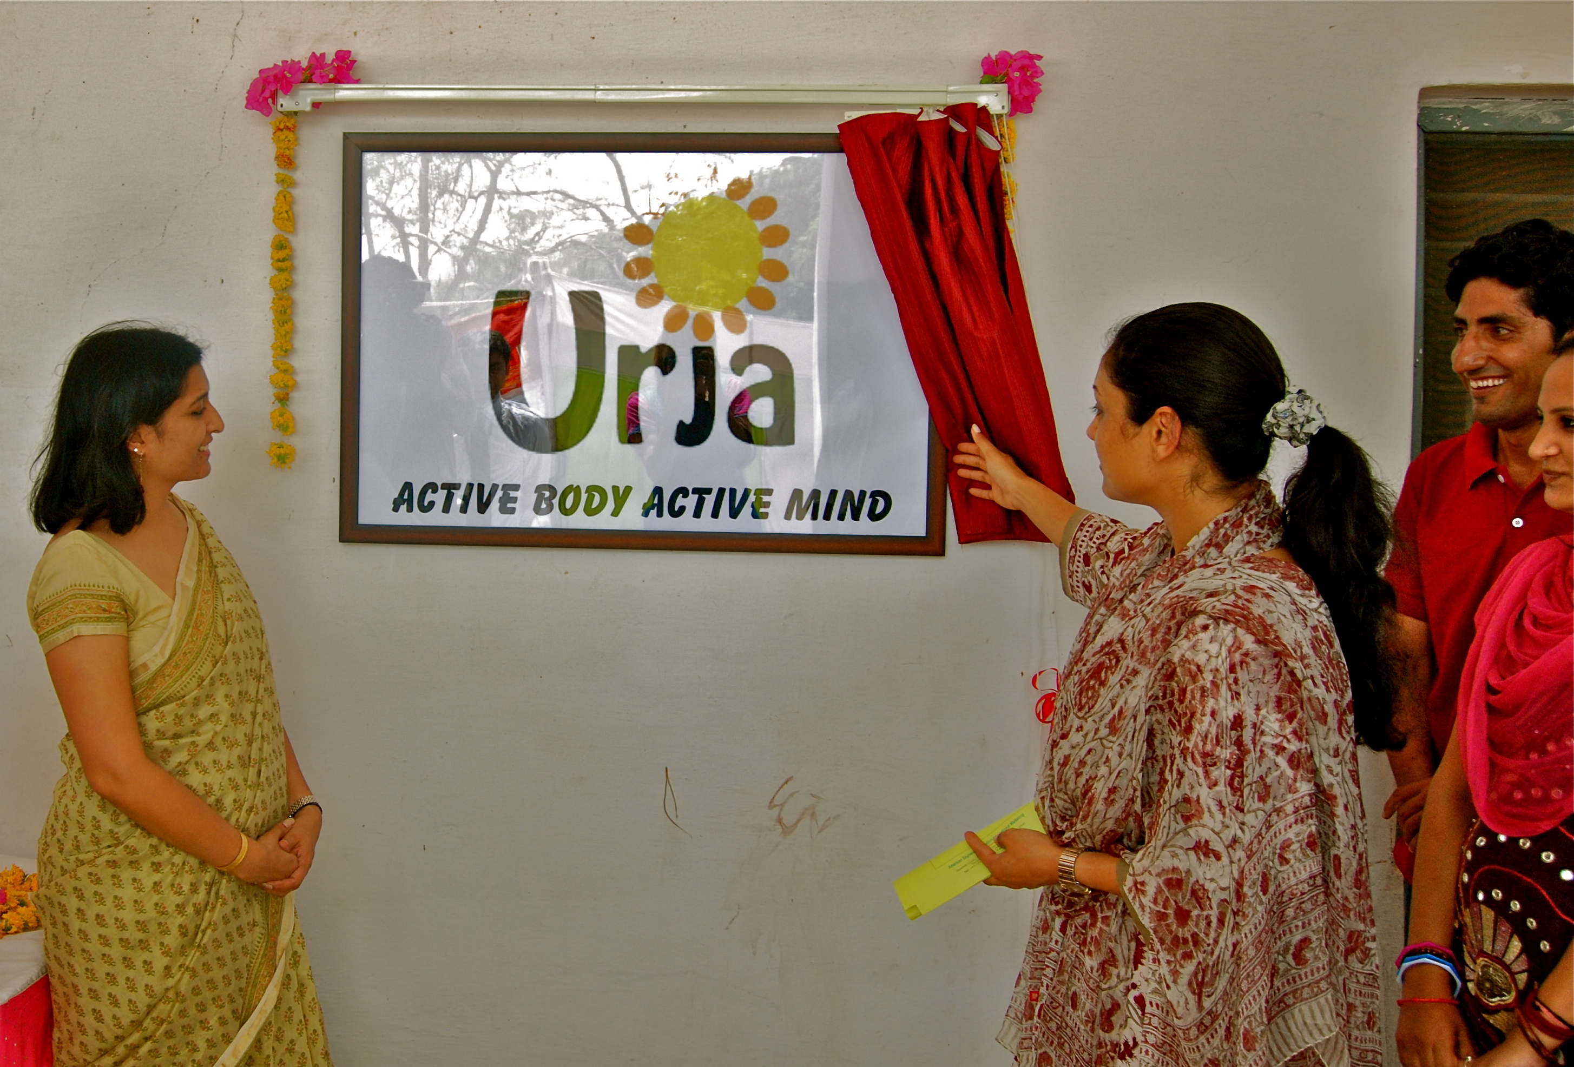
On June 29th 2010, Seva Mandir in collaboration with Yes Bank inaugurated the organic Soy Product. The guests of honor were Ms. Padmaja Kumari Mewar, Managing Director of Historic Resorts and Hotels (HRH) Udaipur and Ms. Rita Soni, Vice President of Responsible Banking at Yes Bank. Both these guests inaugurated the machine by paddling the Vita Goat machine, unveiling the brand logo (Urja) followed by speeches and sharing of experience by the first consumers “the children from the seasonal residential learning camp”.
Soy brand logo being unveiled by the Chief Guests.
The representatives from other organizations, hospitality industry and media, community members from Kaya village and Seva Mandir staff members also attended the event. This was also an opportunity to supply Urja tofu (The brand name of their product) and Soya milk to the hotels of HRH group and school run by the Maharana Mewar Charitable Foundation.

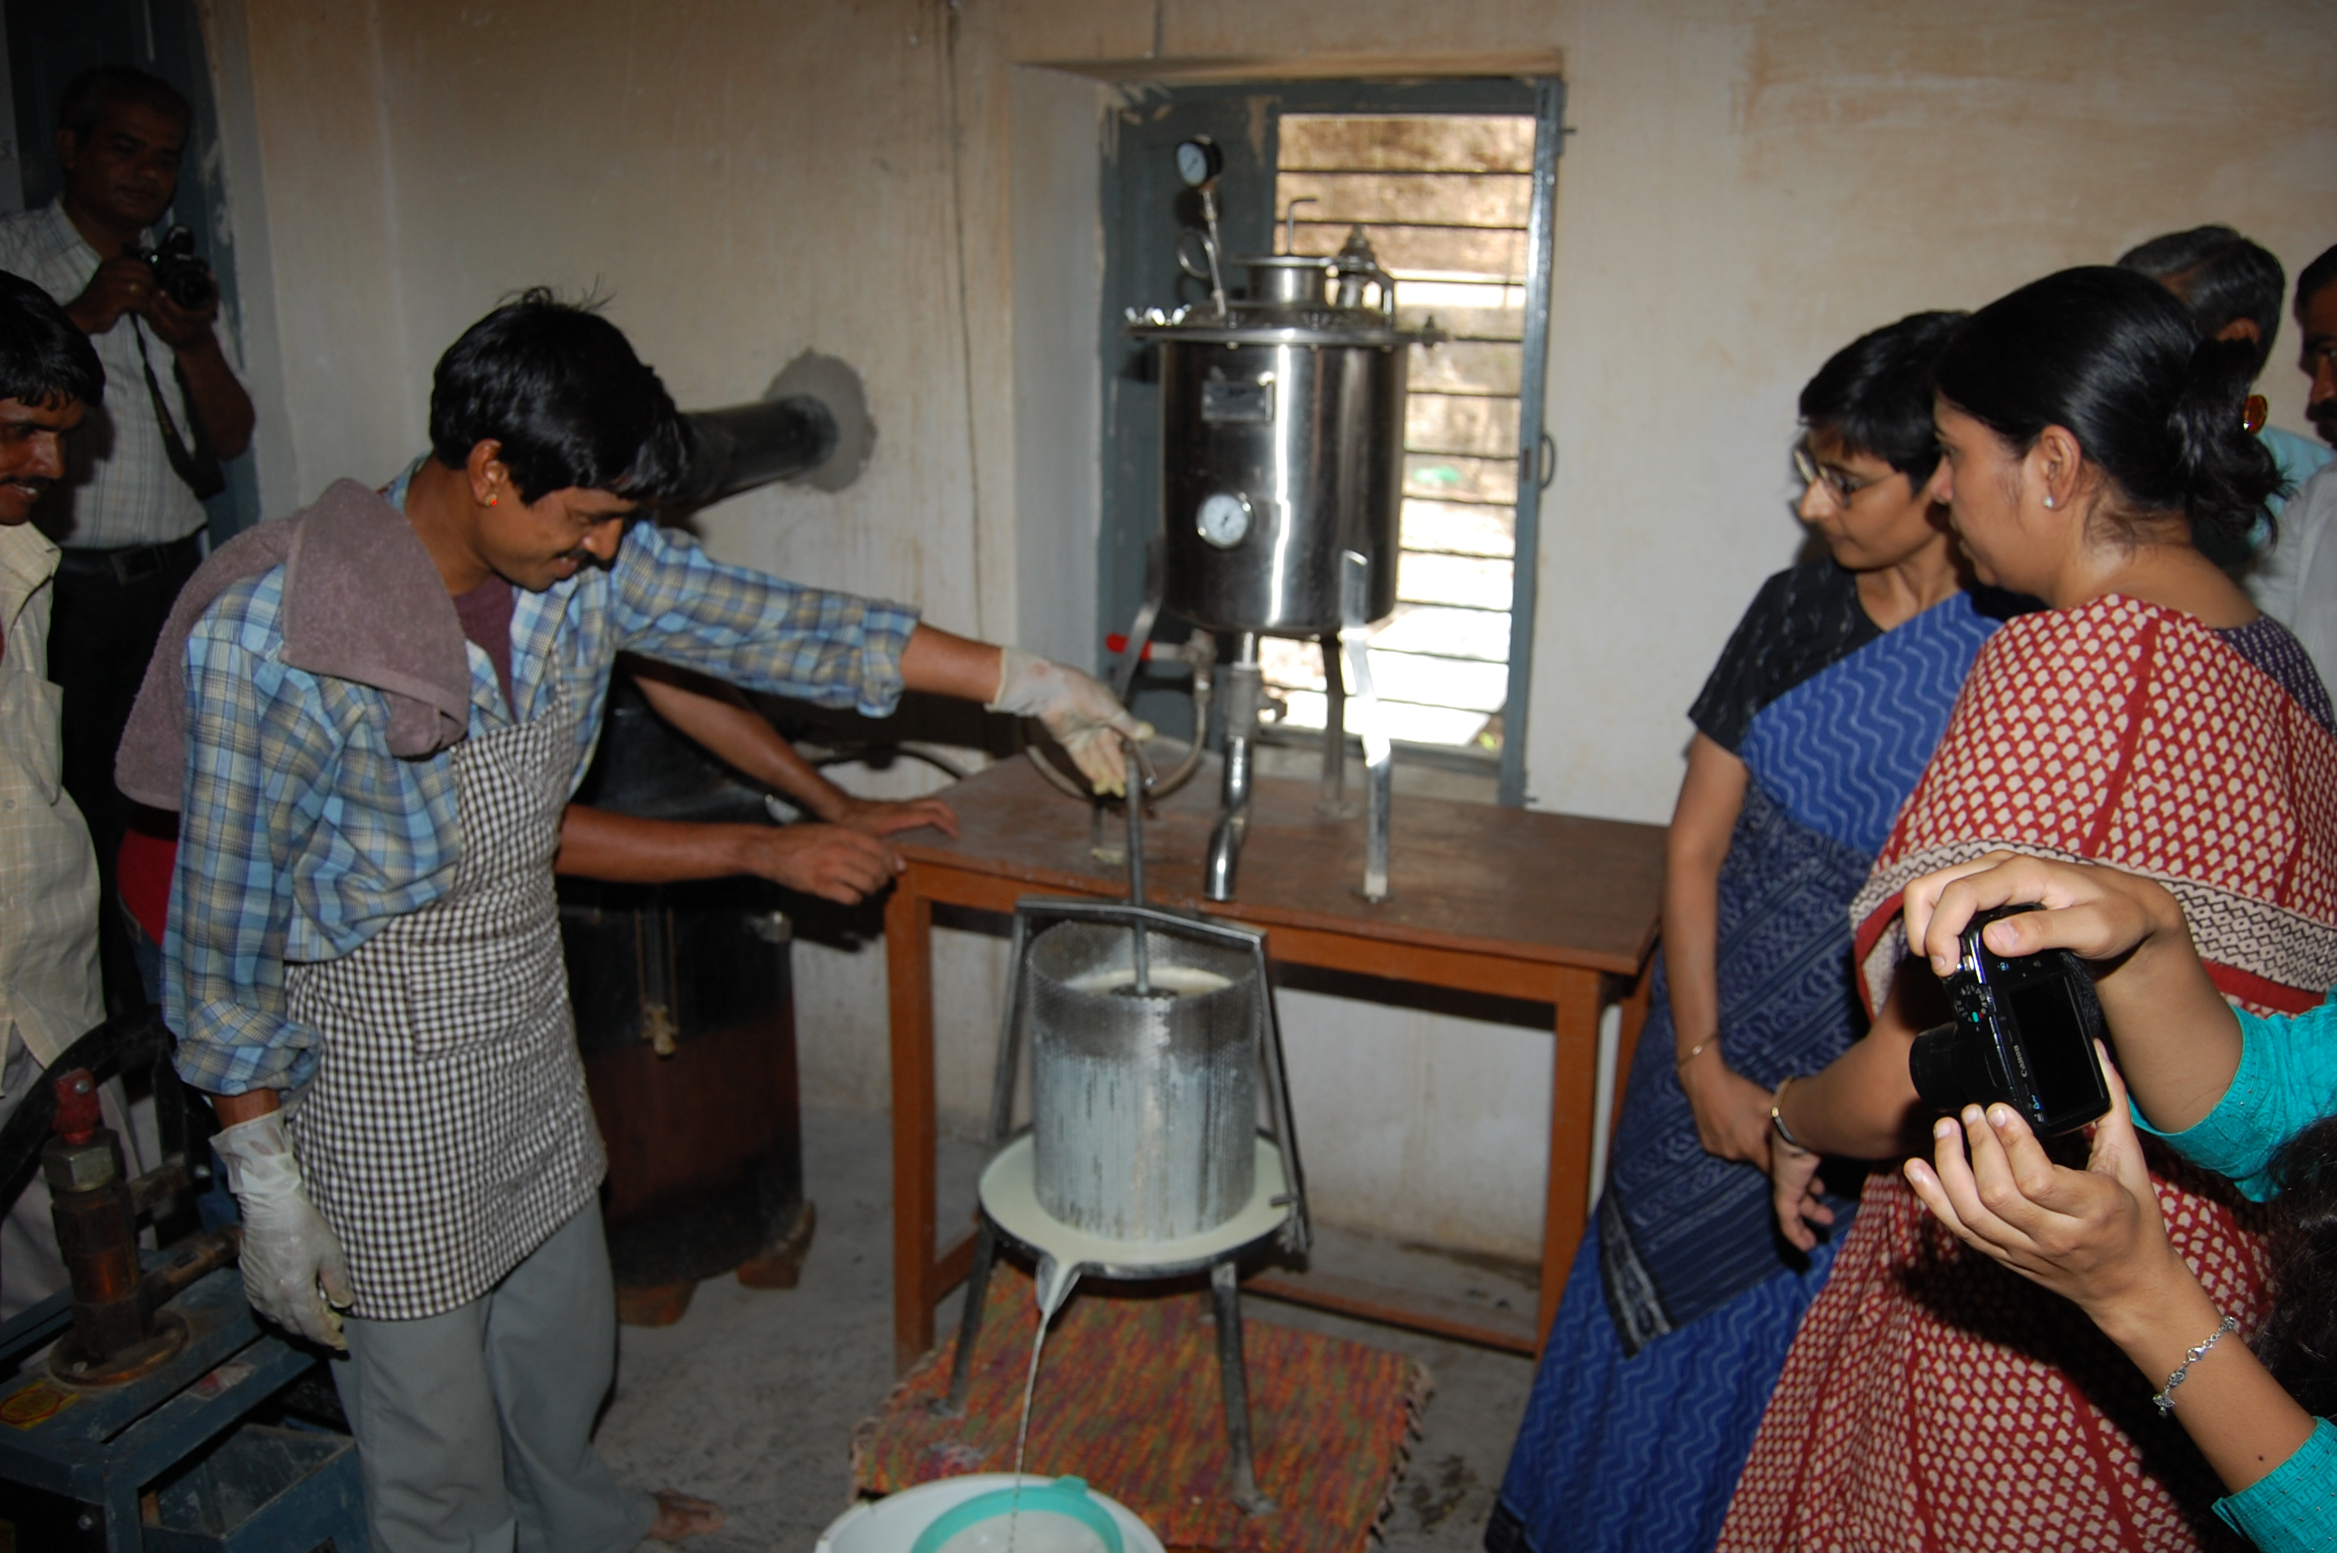
At different stages of the project three volunteers with varied background were associated for a certain time period and did all the ground work required to set up the enterprise. For further strengthening of the enterprise two fellows – Mr. Akshay Nikam from ICICI and Mr Kishore from American India Foundation were appointed under this project. A lot of efforts were undertaken for marketing of Soy produce in this period.
A youth of Kaya explaining the production process during the event
A logo and the punch line, an attractive pamphlet, both in English and Hindi and information brochure were also developed as the promotional materials.

In order to introduce the Soy products to Udaipur civilians a stall was also set up at the Udaipur Rotary Club Fair, held on 24th October. During the event, the raw tofu and a cuisine made of tofu “tofu chilly” was also sold to the public. The public showed a strong interest in the product and a sale of Rs. 1,100 was made. The fair also gave us fresh insight into marketing possibilities for the product in the local areas.
Till date 926.6 litres of soymilk and 115 Kg of tofu has been produced and supplied to Seasonal Residential Learning Camps (Seva Mandir run), Maharana Mewar Public School, HRH group of hotels and numerous individuals.
The primary challenge lying ahead is to create more awareness on the product and establish consistent buyers for the product. For this various markets possibilities will be explored in the coming months such as a stall in the old city (tourist market), tie ups with hotels, gyms, home stays, residential schools, training institutes etc.

Achievements

- Vision of the SHG programme was reviewed and revised
- For the first time profit distribution was done in all the SHGs as a result of which many SHGs raised their monthly savings and honorarium to their accountants.
- The financial data of all SHGs was completely computerized
- Process of strengthening of accounting system began. Accountants were categorized into different grades for their skills. This helped us organize relevant trainings for them.

Learning

- It is very important to standardize norms in SHGs to ensure financial discipline.
- In order to improve the performance of SHGs; it is essential to have an effective monitoring system.
- Profit distribution should become a regular process in all SHGs to make all the members realize the importance of savings and credit.

Challenges

- The portfolio at risk in many SHGs has been very high because of delay in repayments and in certain groups convincing and motivating members hasn’t been of much help. In such groups reducing portfolio at risk is a bit challenging
- In the tribal settlements the houses are scattered as a result of which women find it difficult to meet on scheduled time for the monthly meetings. So at times, ensuring regular meetings is a big challenge
- There are a number of challenges in the marketing and promotion of the products produced by some women groups involved in income generation activities. For example - the marketing and sale of the soy products is still a challenge because the product isn’t popular among local people as yet.

